**Online paid movie watching and managing system**

**Intructor: Do Tien Thanh**

Name: Truong Van Dat

Aprirl, 2021

# Abstract

# Table of Contents

1 Abstract 2

2 Table of Contents 3

3 Introduction 4

4 Literacture review 4

4.1 Over view of online video platform domain 4

4.2 History of on online movie domain (online video platform) 5

4.2.1 History and development website 6

4.2.2 History and development of online video platform 6

4.3 Similar product 6

4.3.1 NetFlix 6

4.3.2 Youtube 8

4.3.3 Fpt Play 9

4.3.4 Analysys these product 12

4.4 Implementation technologies 12

4.4.1 System architecture 12

4.4.2 Video streaming technology(protocol) 15

4.4.3 Video protection technology 16

4.4.4 Optimize performance 16

4.4.5 Client-side technology 17

4.4.6 Server-side technology 17

4.5 Development methodologies 17

4.5.1 Agile 17

4.5.2 Scrum 17

4.5.3 WaterFall 17

4.5.4 RAD 17

5 Requirement gathering 17

6 Implementation 17

7 Testing 17

8 Deployment 17

9 Ethical and Legal 17

10 Evaluation 17

11 Future work 18

12 Conclusion 18

13 References 18

Figure 1 Net Flix development 6

Figure 2 FPT play home page 10

Figure 3 online payment 11

Figure 4 continue from previous interupt 12

Figure 5 lazy load image issue 13

Figure 6 use case diagram 19

Figure 7 php storm 28

# Introduction

# Literacture review

## Over view of online video platform domain

Review about your domain ( what is contribution of this domain to the world industry, how current status of this domain, review current product in market/domain in brief; trends; technolges applied in this domain; existing problems need to be tackle in the future -----🡪 narrow the domain to your topic to raise the question “why you need to build up your project” Or “How your topic will contribute to your domain or reinforce shortcoming, improve problems in your domain ” ( only introduce some brief about your topic reasons, we will introduce it in detail later)

Nowadays, with the development of internet and information technology, Online Entertainment has become an indispensable spiritual food for everyone. In particular, online movie watching accounts for a high proportion in the online entertainment industry.

## History of on online movie domain (online video platform)

Review history of your domain (for example, if you choose topic is e-commerce website, you need to review about history of website development and e-commerce)

The online movie-watching industry encompasses all internet video sharing platforms from free to paid platforms, from copyrighted and non-copyrighted. The most famous of those platforms are Netflix, Youtube, Facebook, HBO and wandisney. . .

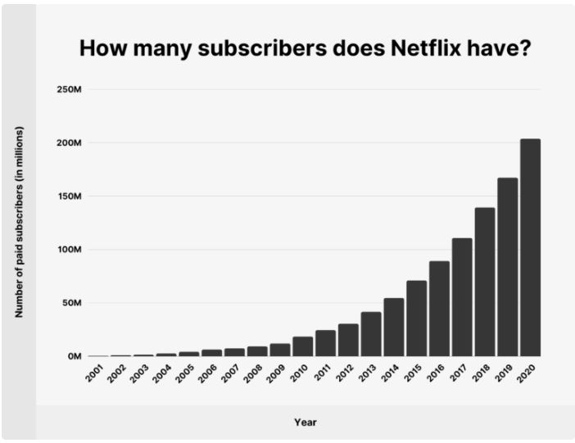

Figure 1 Net Flix development

### History and development website

When it comes to the Internet, people often refer to the standard set of TCP / IP and its most typical services are email, FTP (File Transfer Protocol) and WWW (World Wide Web). However, WWW plays the most important role because it determines the model of the internet.

// The movie-watching web concept started after WWW was created by Tim Berner lee in 1990

### History and development of online video platform

## Similar product

- Review about how many and the quality of each similar solution/product in the market (evaluating pros and cons), related to your solution/product.

- Indicate the outstanding points in your solution/product, compared to others., how it contributes to industry and tackle these existing problem.

### NetFlix

Netflix was founded in 1997.It is the US online video streaming service that has been present in 200 countries around the world, including Vietnam, the content is mainly movies and popular TV shows. Currently, Netflix in Vietnam, some movies have Vietnamese subtitles.

The content of Netflix is mainly TV series and TV shows of all industries, both produced by Netflix and from other producers.

In addition to the "homemade" movies that are carefully invested in both script content as well as editing techniques, Netflix is favored by many users for its huge and attractive movie store such as: netflix's series , blockbuster movies, crime-detective films, Disney movies, sci-fi movies, dramas, comedies, Korean movies, cartoons, horror films, documentaries, ...

**Advantage of NetFlix**

* Watch movie immediately : Just like the giants in the digital content streaming industry, but Netflix is the leader in digital content streaming services and, more specifically, Netflix does not allow users to rent movies. Users have to sign up for a monthly paid membership and they can watch any good Netflix movie anywhere, at the time they want.
* Variety of movies: With Netflix, they have a number of high quality videos and movies that can satisfy different customers. Blockbuster movies, movies, short series, sitcoms, cartoons, ... spoiled for choice to watch and watch Netflix movies in Vietnam fast, smooth and search function works. quite effective.
* Intuitive movie recommendation system: With Netflix, the online movie service has a system that analyzes user behavior in depth based on their viewing history (cookies netflix) to recommend movies that match user preferences. This is quite useful and convenient because you don't have to search and find a good movie that suits you.
* Good price: When registering for a Netflix account, users will have to pay an average of 220,000 VND / month to use, in addition, do not lose any costs. With the above money, you can watch unlimited Netflix movies, the price is reasonable, but in terms of general price, it seems a bit high for consumers in Vietnam.

**Disadvantage of Netflix**

* Complicated payment process: when users wants to register to use Neflix's service, they must have an international payment account. Obviously, this makes it difficult for many customers, because not everyone has an international account.
* Outdate library: Netflix offers a ton of great movies with copyright. However, those movies are updated very late and you can barely watch the newly released TV series. There is even a movie coming out a few years before it appears on NetFlix.
* Movie list depend on location:Depending on the country and geography, Netflix will limit a number of movies that are incompatible with the politics and culture of certain countries. Specifically in Vietnam, Netflix will restrict some war films that defame the current government and some Chinese films with content that violates Vietnamese sovereignty.

### Youtube

Youtube social network is one of the products of Google. They are capable of storing the most popular online video sharing in the world today. Youtube appeared in 2005 and was immediately acquired by google in 2006. Soon after that, Youtube was significantly improved in terms of connection speed as well as other features.

There are many channels on Youtube, you can find different topics according to what you are looking for. Currently this social network has more than 2.3 billion users. There are over 80 different languages for youtube.

**Advantage**:

* Videos on youtube are diverse and many different genres and genres. Helping the seeker to choose the most comfortable way.
* It is easy for the users to post their own videos online. Make it accessible to all over the world just through an internet connection.
* Youtube has become one of the most important parts of online communication, on web pages.
* Thanks to YouTube, people can view moments, videos and events over time.
* Users can make money from their own videos through advertisement, sponsorship , afiliate links…
* Thanks to youtube, celebrities can interact. They will be known by many people faster with the speed of video spreading quickly.
* Fast video loading speed helps viewers have the most enjoyable experience whether you are watching on the phone or computer.
* Youtube is also a social network to evaluate an individual or organization to see if they have many people interested or disliked.
* Help to bring great benefits to users. For example, you can find a way to make a cake, plant a tree, study, work ... on youtube.
* The results of the search are always pleasing to the customer.

**Disadvantage:**

* Youtube itself has no control over the videos uploaded. So this results in a lot of inappropriate videos appearing.
* Video can be monetized, so many people have been defiant with posting inappropriate content. And even upload offensive videos for my own gain.
* There are many types of videos with uncontrolled or violent forms that do not limit the age of the viewer.
* Transforming videos in many different directions makes viewers feel uncomfortable.
* Everyone is free to comment and in many cases, vulgar and uncultured language were not reported or disproved.

### Fpt Play

FPT play is a famous movie-on-demand service in Vietnam. It offers a variety of premium and paid video content. For certain movies it doesn't require the user to log in, so the user will be interrupted by ads.

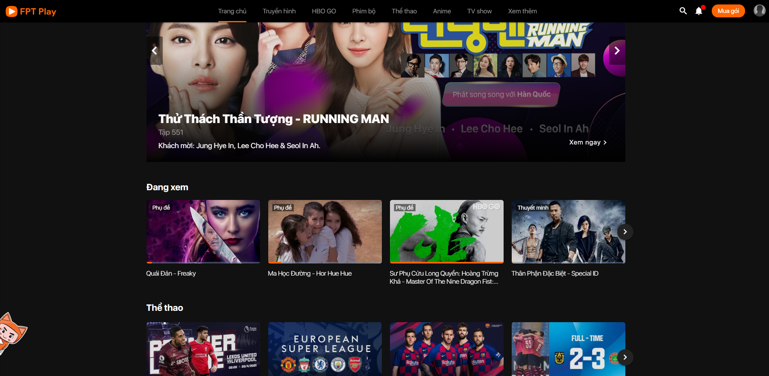

Figure 2 FPT play home page

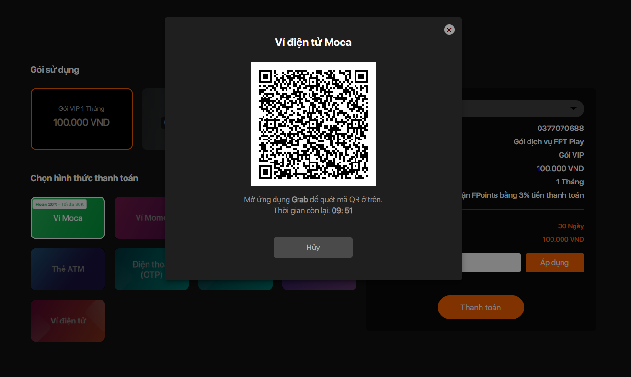

Figure 3 online payment

The picture below shows the homepage of FPT play. As you can see the interface of this site is simple, easy to use, suitable for most of Vietnamese people. Add to that a dark background that is great for the eyes at night. Viewers will not feel eye strain every time they visit the website at night.

The feature I love the most on FPT play is its payment convenience. It supports most of the current forms of payment, including online payment via e-wallet, domestic ATM card or Visa ... With a variety of payment methods. It is not liked by many users.

One of its great features is the ability to keep a record of the movies I am interrupting. Every time I turn off the web browser and then reopen it, I don't need to waste time searching for the viewed position and continue. The system will automatically ask me to continue watching from the interrupted position.

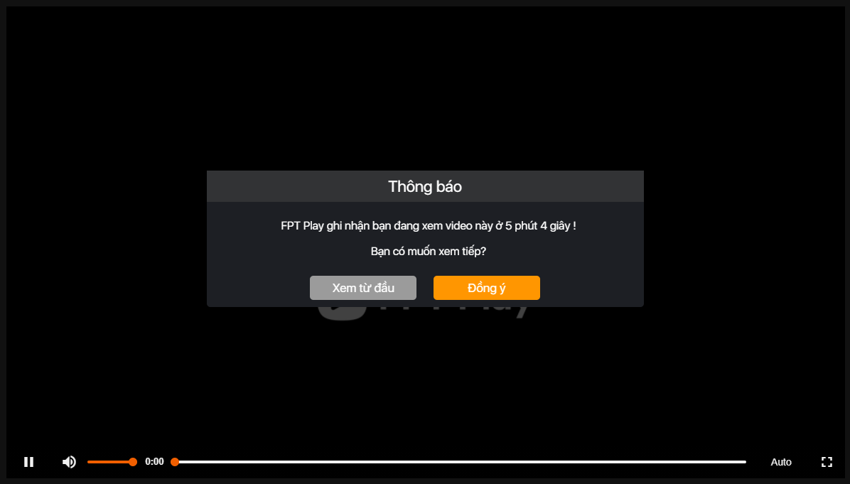

Figure 4 continue from previous interupt

However, it has a few limitations as follows. The movie loading speed will be slow if the user has internet bandwidth 20 Mbps. Website is very slow adaptive transmission so often lead to problems infinity loading problem.

Additionally, every time the web page scrolls too fast, the movie avatars will not load in time resulting in black boxes. That makes users uncomfortable.

Figure 5 lazy load image issue

### Analysys these product

First of all, we see, all 3 sites are applying single page application technology. That means the page won't reload every time a user clicks on a link or action and speeds up the page.

## Implementation technologies

Review tools, technologies in the market which are feasible using for your solution/product ( Compared to other tools so as to indicate how it is proper for your solution, pros and cons of each tools. Techs)

After evaluating each tools, technologies, you need to propose what is the best tools and techniques you choose for the project. (Why you choose it, how feasible it is)

### System architecture

The software architecture is a system organization consisting of many components such as Web Server, database, memory, and the layers that carry out communication. They are linked together or with a certain environment. The ultimate goal of system architecture is to solve business problems.

https://whatis.techtarget.com/definition/monolithic-architecture#:~:text=A%20monolithic%20architecture%20is%20the,and%20unable%20to%20be%20changed.

At the moment, there are two popular software architecture patterns that are being popularized:

* Monolith architecture
* Mircoservice architecture

#### Monolith

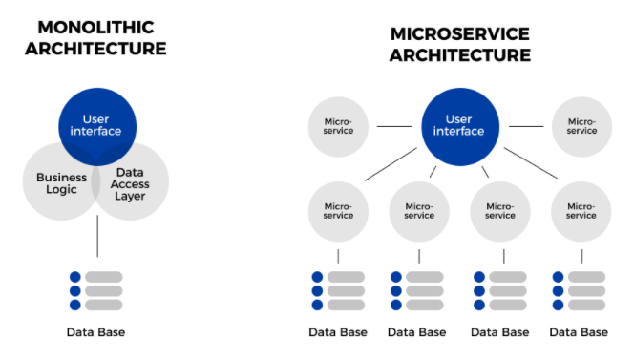

Monolith tends to be suitable for small projects. With the application of the monolith model, the benefits that can be mentioned are:

* Simple and direct development, centralized managenment, and basic development steps are not iterative.
* Effort for development is minimized: all development is on one project. Development flow is as simple as submit changes, review, merge code and continue.

However, the limitation that this model brings is also quite large:

* Difficulty in maintenance: coupling code problems, code blocks stick together, problems for new members will be difficult to know where to start in a large block
* The development process will lose its flexibility: the time to build the feature will be lengthened, blocked by each other. Any small changes need to rebuild the whole project takes quite a lot of time
* Stability is not high. Any one error can cause the entire application to crash.
* Scalibility is difficult to meet in case of having to respond to a large amount of traffic from the demand side of the business

#### Mircoservice

Microservice refers to the relatively small, independent development process in the direction of dividing the system into services. Each of these services has its own logic, a responsibility, and can be deployed separately. The concept of mircoservice also refers to the tendency to separate the architecture into loose coupling services, that is, these services will have a loose relationship with each other and the service relationship will be in a certain context.

The differences of the microservice model are componentization, loose coupling, autonomy, and decentralization, which are specifically reflected through the following aspects:

* Gather a small group of services: the granularity of a service is small and each of these services will take a specific responsibility (single responsiblity) and focus only on that task. For example, the storage service will be solely responsible for the storage
* Developing and extending a service is completely independent. This provides system flexibility. The deliver feature, release version process will be easy and fast. Furthermore, there will be no blockages like in monolith
* Offloading(giam load) concerns about the technology in use. Choosing the right technology for your business problem can be easily solved. Services communicate with each other through the API, so each service can use a separate language. Serivce A uses Java, Service B uses Javascript, it's ok !!!!
* For the team, the microservice brings independence and self-management for the team. One team will take full responsibility for the life-cycle of one or more services. They work in isolated contexts, able to manage their own decisions.

https://www.guru99.com/microservices-tutorial.html

### Video streaming technology(protocol)

This is a term that refers to the captured, processed and transmitted content and media data directly over the Internet to the recipient at the same time.

#### HLS

HLS stands for HTTP Live Streaming, which is a protocol for streaming video across the internet.

Developed by Apple, originally only the iPhone supported this protocol, but today all devices and software support it and it has become the most popular protocol.

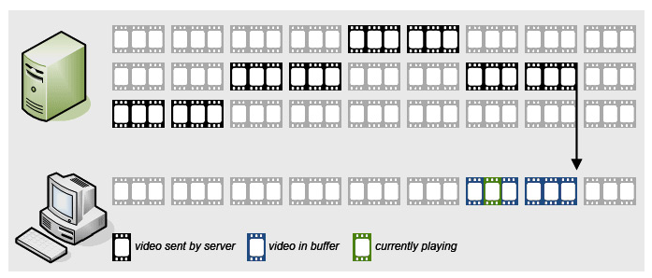

*https://kipalog.com/posts/Chong-download-file-video-tren-web-co-ban-bang-HLS--ket-hop-voi-Laravel*

HLS is http-based, it uses a web server to transmit content. This means you don't need special infrastructure, just have a web server or use a CDN. Also since the HLS is http-based it will also be less likely to be blocked by the Firewall

Video HLS will be divided into small segments, which is the adaptive video bitrate method, which means you can choose the appropriate video format (480p, 720p ...) to transmit over the Internet depending on your network speed.

Its downside is the high latency. For example, your whole neighborhood is watching soccer, you see the neighbor shouting "Goal !!!" then and you still haven't seen it yet. That kind of thing.

#### RTMP (Real-Time Messaging Protocol)

RTMP is a protocol developed by Adobe, used to transmit audio and video with Adobe Flash Player. It is like about 10 years ago when you went to the net, if you want to watch video, you have to install Adobe Flash Player for IE for example. Because back then, web flashes were very popular.

The advantage of RTMP is the very low latency. The downside is that it is Flash-based, nowadays Flash is out of date and less and less devices support it. There's also limited bit-rate streaming, and Apple devices don't support RTMP either.

Nowadays, browsers do not need to install Flash player anymore, html5 already supports playing video directly.

#### MPEG 4 through html 5

### Video protection technology

### Optimize performance

#### Optimize query

#### Caching

#### Hotlinking Protection

#### Encrypting the Video

### Client-side technology

#### Bootstrap

#### Jquery

#### Html 5, css

#### Angular

### Server-side technology

#### Asp.net MVC

#### Node js

#### Laravel(Php framework)

#### PHP

## Development methodologies

### Agile

### Scrum

### WaterFall

### RAD

# Requirement gathering

# Design

## Use-case diagram

Figure 6 use case diagram

## Database design

## GUI Design

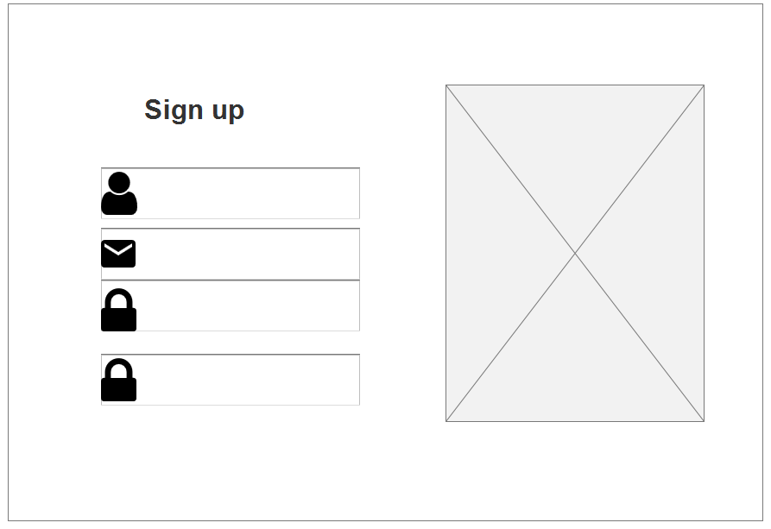

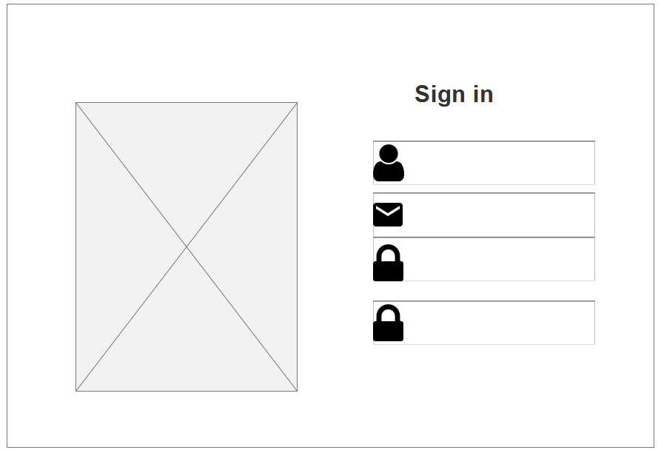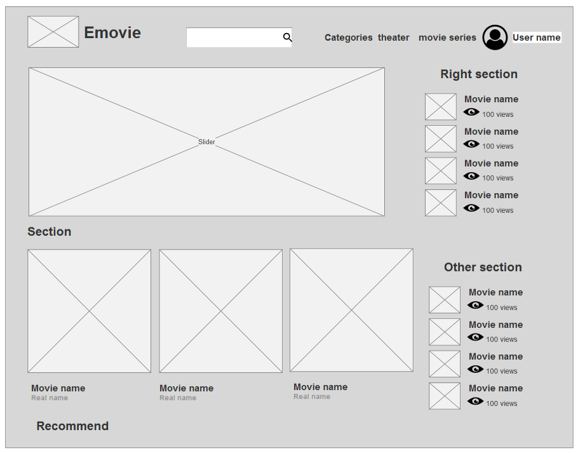

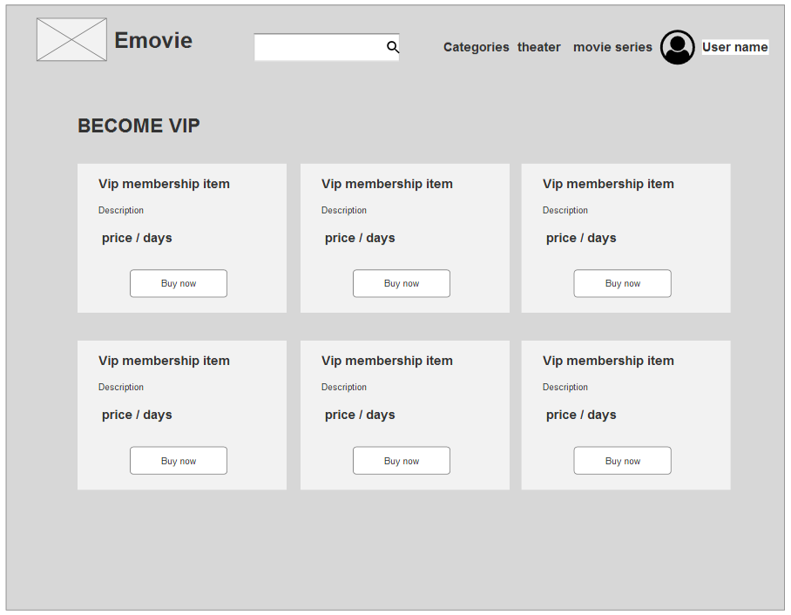

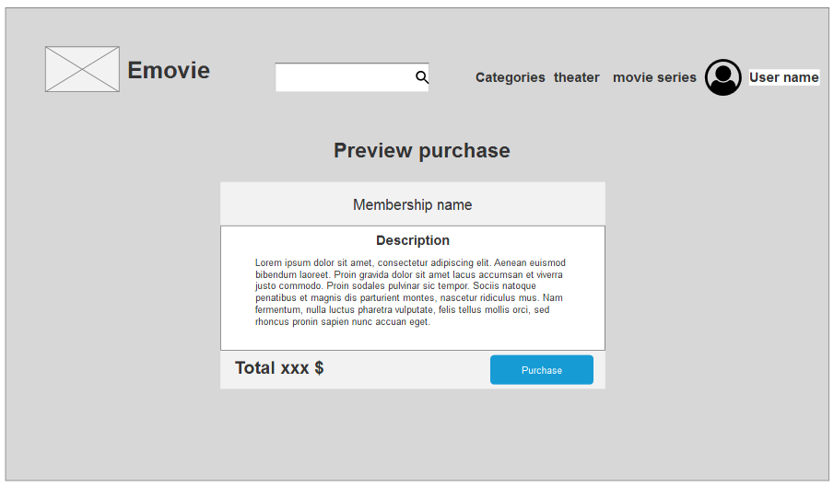

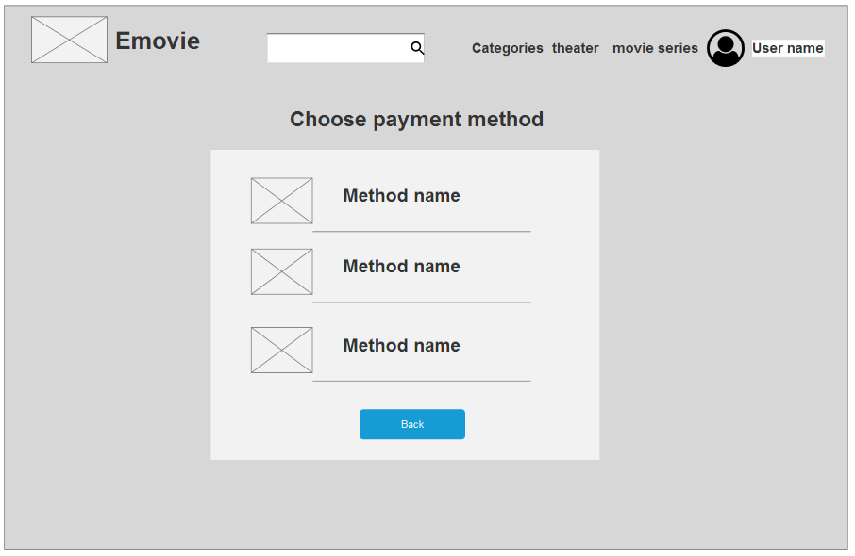

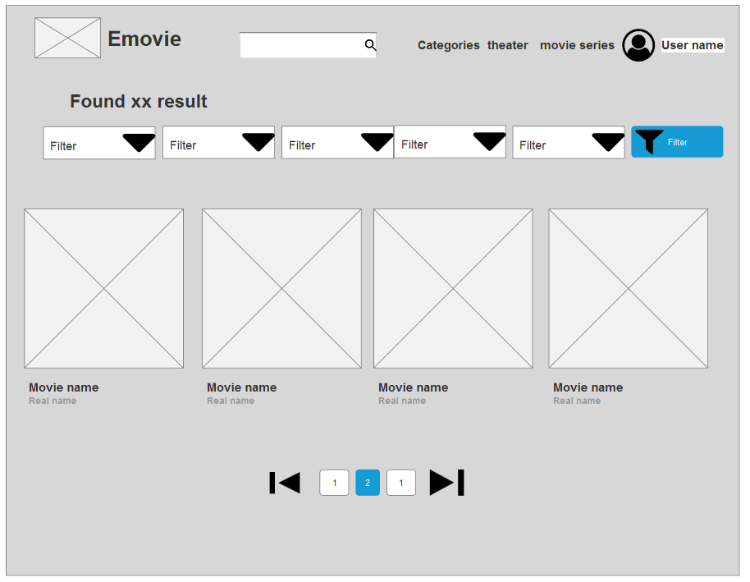

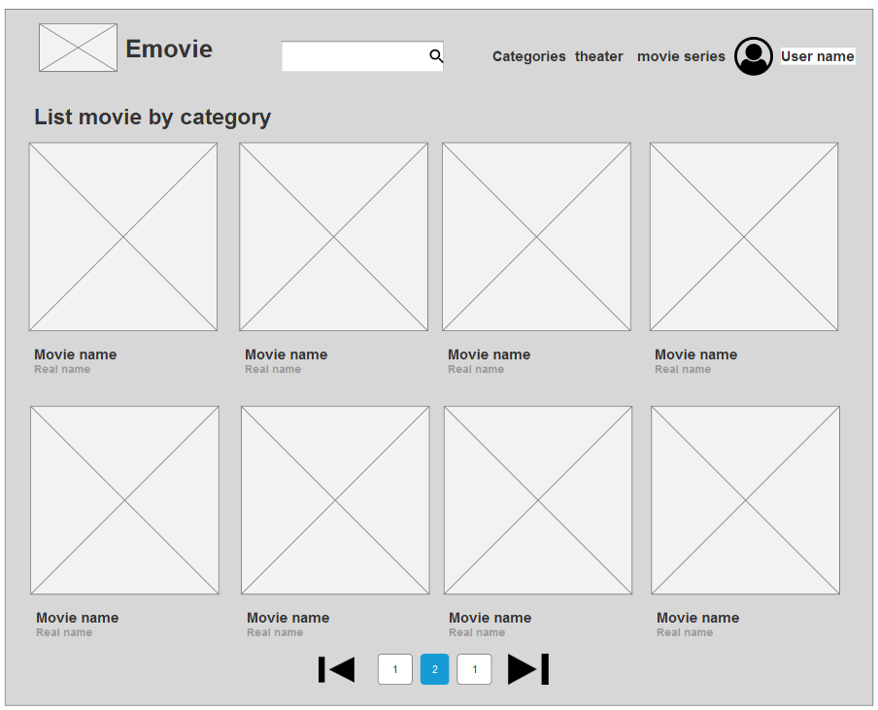

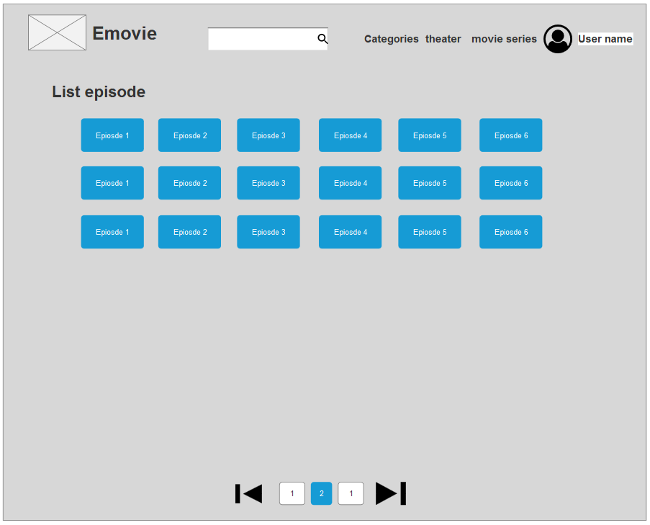

# Implementation

## Selected programming language

I choose the Laravel framework of the PHP language for the following reasons.

Firstly, Laravel is open source by PHP and is one of the most popular frameworks today, ranking # 1 on the popular frameworks rankings in 2020. With its popularity, Laravel has a large community of support. The source code is regularly updated and debugged, so web applications are built with highly stable source code.

Second, in terms of performance, Laravel is built from PHP, and it inherits the great features of PHP such as its high speed, lightweight library. This feature makes it suitable for large projects with high loads. For my project, it's a movie web project so it requires the ability to handle multiple requests at a time, so it is perfectly suited to the Laravel framework.

Finally, in terms of security, Laravel provides powerful security features to help users develop applications comfortably. The most preferred security feature is the Eloquent query model. With this feature, users will minimize writing raw queries that potentially potentially SQL injection. The queries will be compiled into SQL statements through PDO (PHP Data Object). PDO can be used for both procedural and object oriented programming.

## Selected DBMS

After choosing Laravel Framework to build your project, it is very important to choose the right DBMS. By using the open source Laravel, the most suitable DBMS is undoubtedly MySQL.

First of all, MySql is open source database management system, so obviously it will be suitable for open source programming languages like PHP. Second, Laravel is a framework built with the original purpose of being optimized for the MySQL database management system. Therefore, no candidate can be more suitable than MySQL

## Selected IDE



Figure php storm

## Project structure

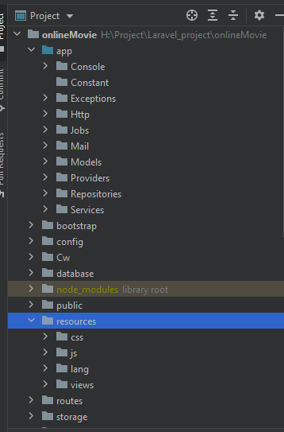

Figure project structure

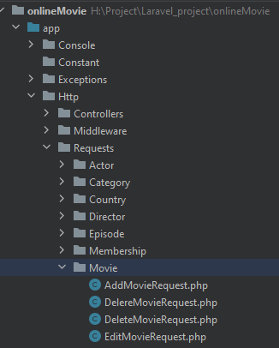

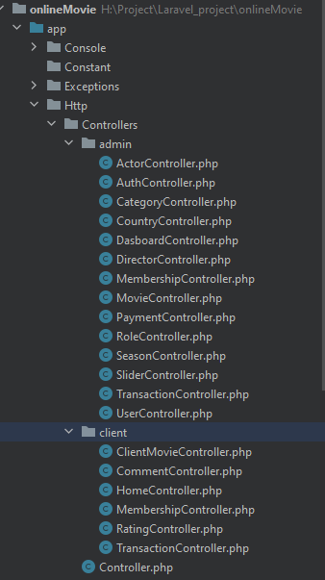

## Functionalities

## Apply Laravel Repository Design pattern

Repository design pattern is a famous design pattern in software development. For the purpose of separating the logical layer and the data processing layer.

Specifically, in my application the controller will get data through the Repository instead of getting data directly from the model. This way, whenever there is a change in the table from the database, we don't need to look for implementations of Query Object Model in the controller to update. The query functions are stored centrally in the Repository class. So we just need to update the query functions still in the Repository without wasting time looking for the implementations of the Model class. It also makes the project's code cleaner and easier to read.

To use Repositories, the Repository Interfaces will be injected through the Controller's constructor.

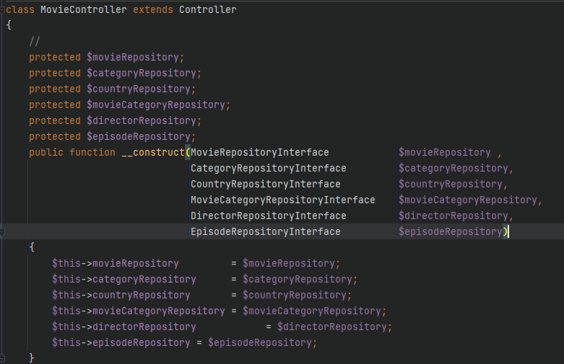

The figure above shows how to inject repositories into MovieController via constructor.

## Security

### SQL injection prevention

### Cross-site Scriptiong prevention

### XSS protection

## Validation

# Testing

## Scope

## Test Case

## Test Evaluation

# Deployment

# Ethical and Legal

# Evaluation

# Future work

# Conclusion

# References