Year 8 Chemistry

**LESSON OBJECTIVES:**

• **Understand and identify** types of chemical reactions (combustion).

• **Predict products** of given reactions.

• **Balance chemical equations** both by hand and using a programming tool.

• **Model chemical reactions** using physical models.

# Setting Up

There are two online places where you can access these sessions. The first one is for if you can use a google email, please ask your teacher. Otherwise JupyterLab can be used.

## With A Google Email: Google Colab

**Go to this link:**

* [Google Colab Notebook](https://colab.research.google.com/drive/1fSbrd54814vMdQjYW9t-Xh45BwYSwMI1#scrollTo=_5_-jns1oDwC).

**Save a copy to your Google Drive:**

* Click on "File" in the top left corner.
* Select "Save a copy in Drive."
* This will create your own copy of the document where you can make changes.

**Running the code:**

* Each grey box contains code. To run the code, click the "Run" button (it looks like a play button) in the top left of the grey box.
* **Important:** Run the boxes in order, starting from the top. If you skip a box or run them out of order, you might see an error message.

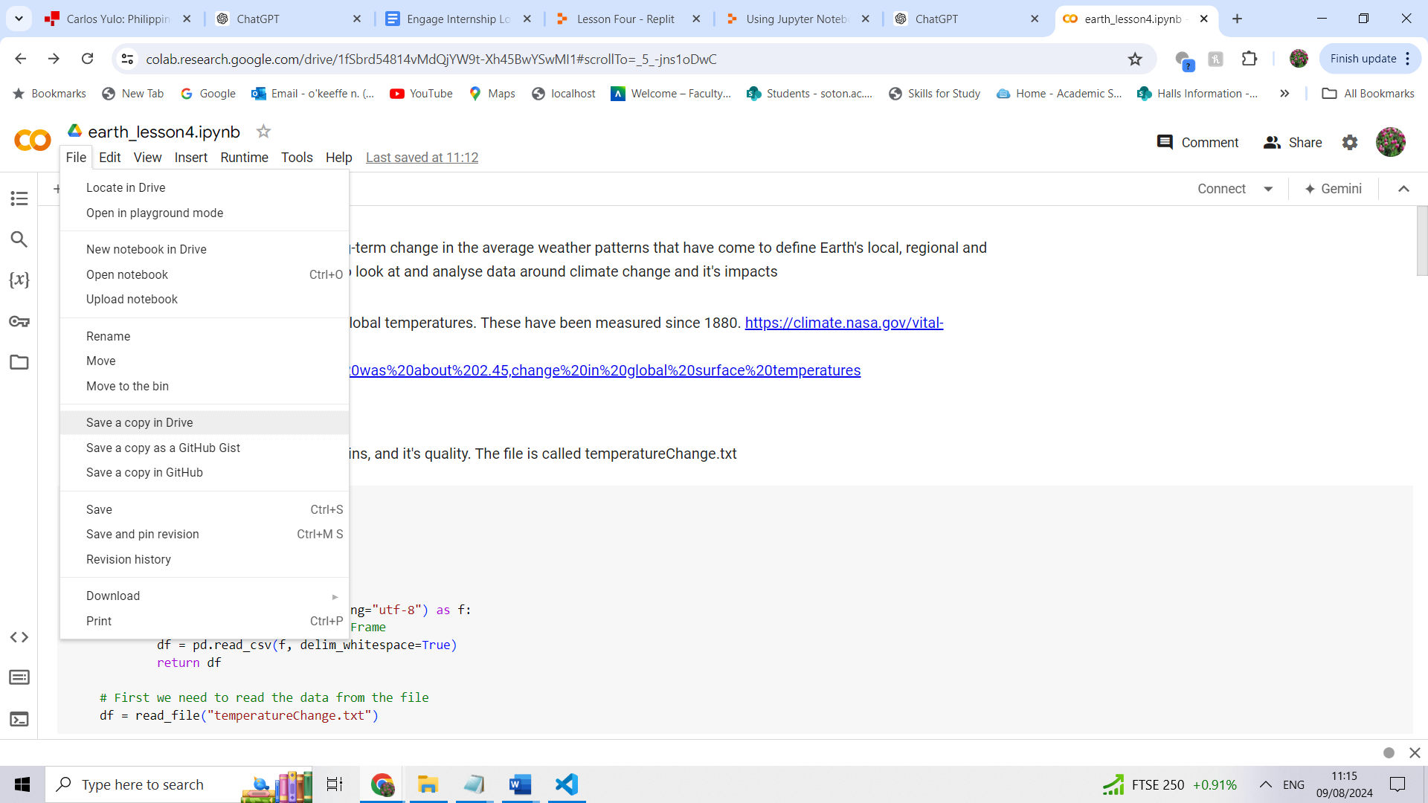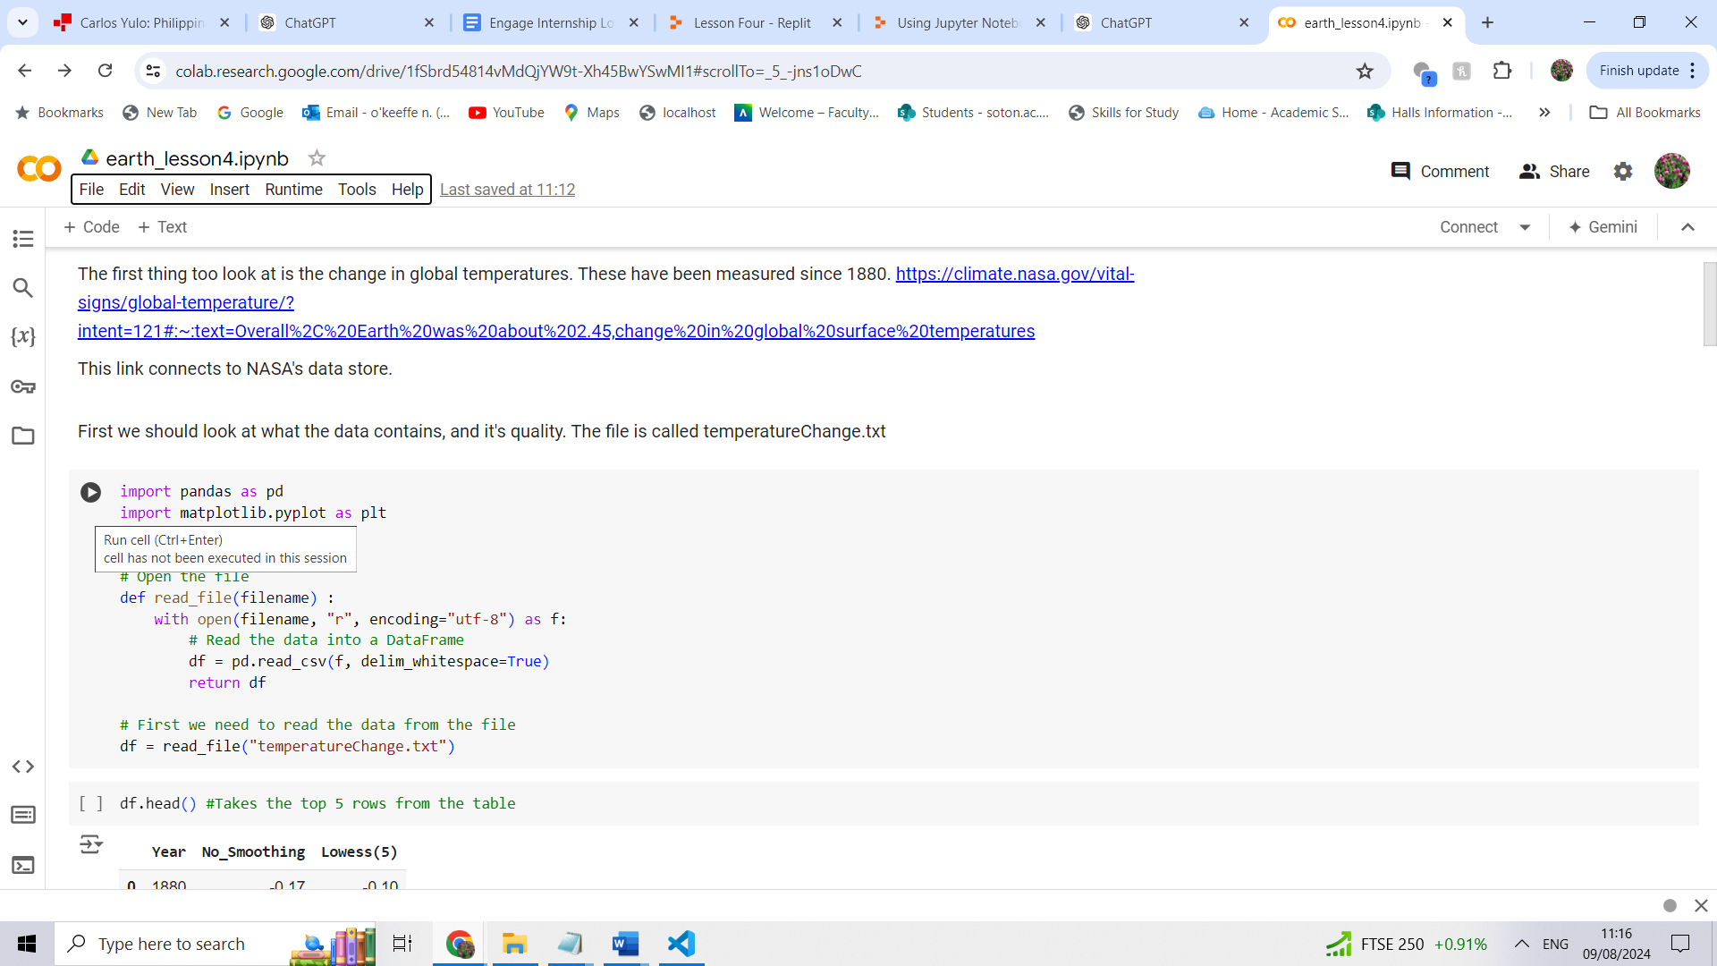

## Jupyter Lab

**Opening the Notebook:**

* Launch JupyterLab on your computer or through <https://jupyter.org/try-jupyter/lab/>
* Upload the engage_lesson1.ipynb to the website
* Double-click on the notebook file to open it.

**Running the Code:**

* The notebook contains cells, which are the grey boxes with code or text.
* To run a cell, select it by clicking on it, and then click the "Run" button (which looks like a play button ▶️) in the toolbar at the top.
* You can also run a cell by pressing Shift + Enter on your keyboard.

**Important:**

* Ensure you run the cells in sequential order, starting from the top. Running them out of order or skipping cells may lead to errors.
* If a cell takes time to run, be patient and wait for it to finish before moving on to the next one.

**Troubleshooting:**

* If you encounter any issues or get stuck, refer to the provided code walkthrough or help documentation for guidance.

Follow the instructions in the codebook.