Year 8 Science: Earth - Climate Change

**LESSON OBJECTIVES:**

* Understand the causes and effects of climate change.
* Analyse data related to climate change, such as temperature, carbon dioxide levels, and sea levels.
* Discuss personal and collective actions to reduce carbon footprints.

**Introduction:**

In this lesson, you will explore the impacts of climate change by examining data on global temperatures and greenhouse gas emissions. You will use Python to analyse this data and draw conclusions about how our planet is changing.

# Setting Up

• **Go to this link:**  
[Google Colab Notebook](https://colab.research.google.com/drive/1fSbrd54814vMdQjYW9t-Xh45BwYSwMI1#scrollTo=_5_-jns1oDwC).

• **Save a copy to your Google Drive:**

* Click on "File" in the top left corner.
* Select "Save a copy in Drive."
* This will create your own copy of the document where you can make changes.

• **Running the code:**

* Each grey box contains code. To run the code, click the "Run" button (it looks like a play button) in the top left of the grey box.
* **Important:** Run the boxes in order, starting from the top. If you skip a box or run them out of order, you might see an error message.
* **If you are stuck look through the code walkthrough document.**

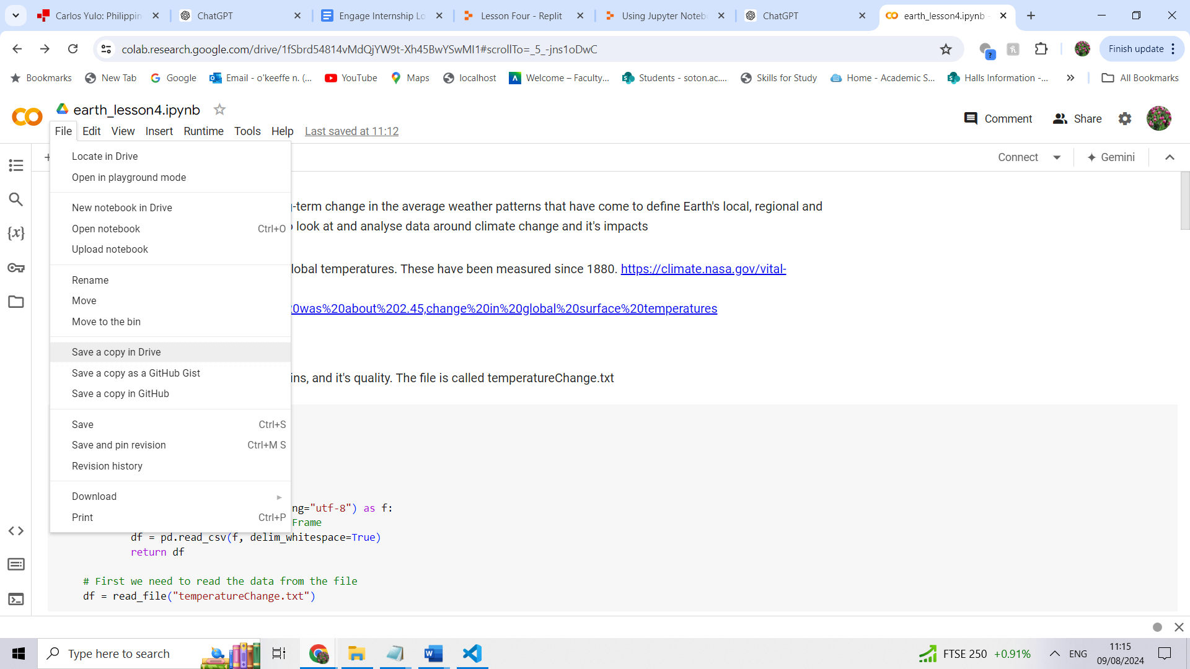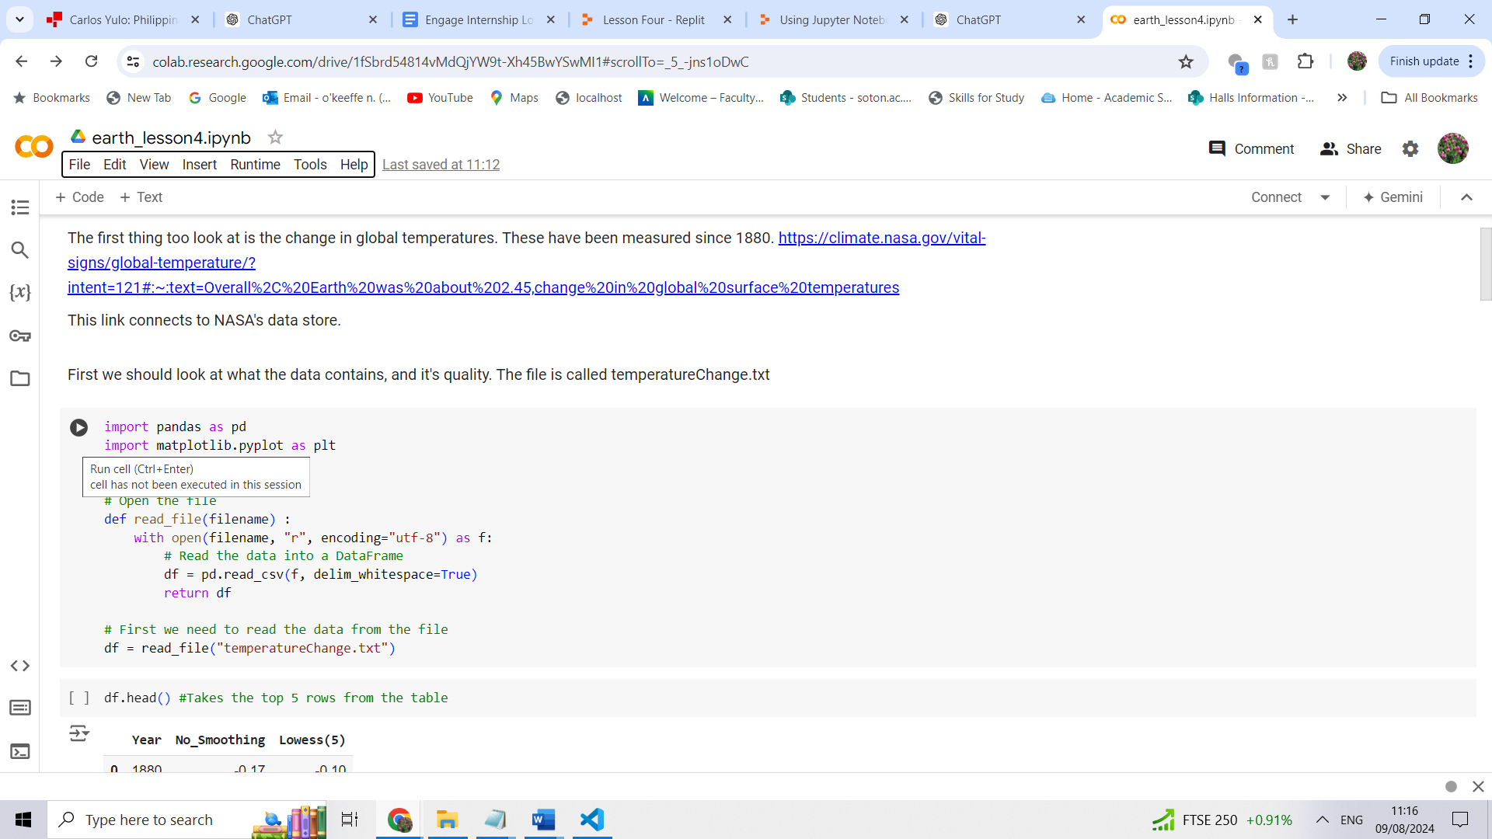

# Section 1: Understanding Global Temperature Changes

How do you view the first five rows of a table in Python?

What does the describe() method show?

What has happened to global temperatures since 1880?

What do you expect will happen to global temperatures in the next 50 years?

# Section 2: Greenhouse Gas Emissions by Country

What five countries release the most amount of green house gases?

Why might these countries produce more?

Draw a diagram of the chart

Compare the chart from Section 2 and the data from Section 1 – what does it show? What’s different?

# Additional Activities:

Create a chart for sea level data.

Hint: Re-use the code from section one.