Noah Kessler

Lab 1

1.

|  |  |  |  |  |  |  |  |  |
| --- | --- | --- | --- | --- | --- | --- | --- | --- |
| a | b | c | d | a’b’c’d’ | a’bc’d | ab’cd | abcd’ | Z1 |
| 0 | 0 | 0 | 0 | 1 | 0 | 0 | 0 | 1 |
| 0 | 0 | 0 | 1 | 0 | 0 | 0 | 0 | 0 |
| 0 | 0 | 1 | 0 | 0 | 0 | 0 | 0 | 0 |
| 0 | 0 | 1 | 1 | 0 | 0 | 0 | 0 | 0 |
| 0 | 1 | 0 | 0 | 0 | 0 | 0 | 0 | 0 |
| 0 | 1 | 0 | 1 | 0 | 1 | 0 | 0 | 1 |
| 0 | 1 | 1 | 0 | 0 | 0 | 0 | 0 | 0 |
| 0 | 1 | 1 | 1 | 0 | 0 | 0 | 0 | 0 |
| 1 | 0 | 0 | 0 | 0 | 0 | 0 | 0 | 0 |
| 1 | 0 | 0 | 1 | 0 | 0 | 0 | 0 | 0 |
| 1 | 0 | 1 | 0 | 0 | 0 | 0 | 0 | 0 |
| 1 | 0 | 1 | 1 | 0 | 0 | 1 | 0 | 1 |
| 1 | 1 | 0 | 0 | 0 | 0 | 0 | 0 | 0 |
| 1 | 1 | 0 | 1 | 0 | 0 | 0 | 0 | 0 |
| 1 | 1 | 1 | 0 | 0 | 0 | 0 | 1 | 1 |
| 1 | 1 | 1 | 1 | 0 | 0 | 0 | 0 | 0 |

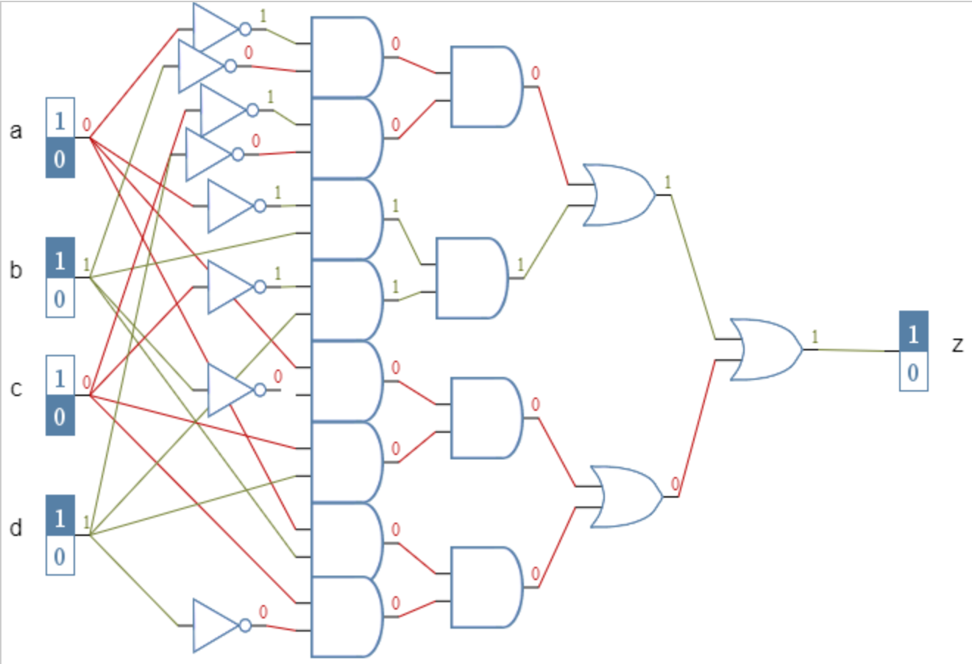

The output for Z1 is HIGH only when the inputs are all low, or a and c are low while b and d are high, or b is low and the other inputs are high, or d is low and the other inputs are high.

2.

|  |  |  |  |  |  |  |  |  |
| --- | --- | --- | --- | --- | --- | --- | --- | --- |
| a | b | c | d | bd | b’d’ | bd+b’d’ | a’c’ | Z2 |
| 0 | 0 | 0 | 0 | 0 | 1 | 1 | 1 | 1 |
| 0 | 0 | 0 | 1 | 0 | 0 | 0 | 1 | 0 |
| 0 | 0 | 1 | 0 | 0 | 1 | 1 | 0 | 0 |
| 0 | 0 | 1 | 1 | 0 | 0 | 0 | 0 | 0 |
| 0 | 1 | 0 | 0 | 0 | 0 | 0 | 1 | 0 |
| 0 | 1 | 0 | 1 | 1 | 0 | 1 | 1 | 1 |
| 0 | 1 | 1 | 0 | 0 | 0 | 0 | 0 | 0 |
| 0 | 1 | 1 | 1 | 1 | 0 | 1 | 0 | 0 |
| 1 | 0 | 0 | 0 | 0 | 1 | 1 | 0 | 0 |
| 1 | 0 | 0 | 1 | 0 | 0 | 0 | 0 | 0 |
| 1 | 0 | 1 | 0 | 0 | 1 | 1 | 0 | 0 |
| 1 | 0 | 1 | 1 | 0 | 0 | 0 | 0 | 0 |
| 1 | 1 | 0 | 0 | 0 | 0 | 0 | 0 | 0 |
| 1 | 1 | 0 | 1 | 1 | 0 | 1 | 0 | 0 |
| 1 | 1 | 1 | 0 | 0 | 0 | 0 | 0 | 0 |
| 1 | 1 | 1 | 1 | 1 | 0 | 1 | 0 | 0 |

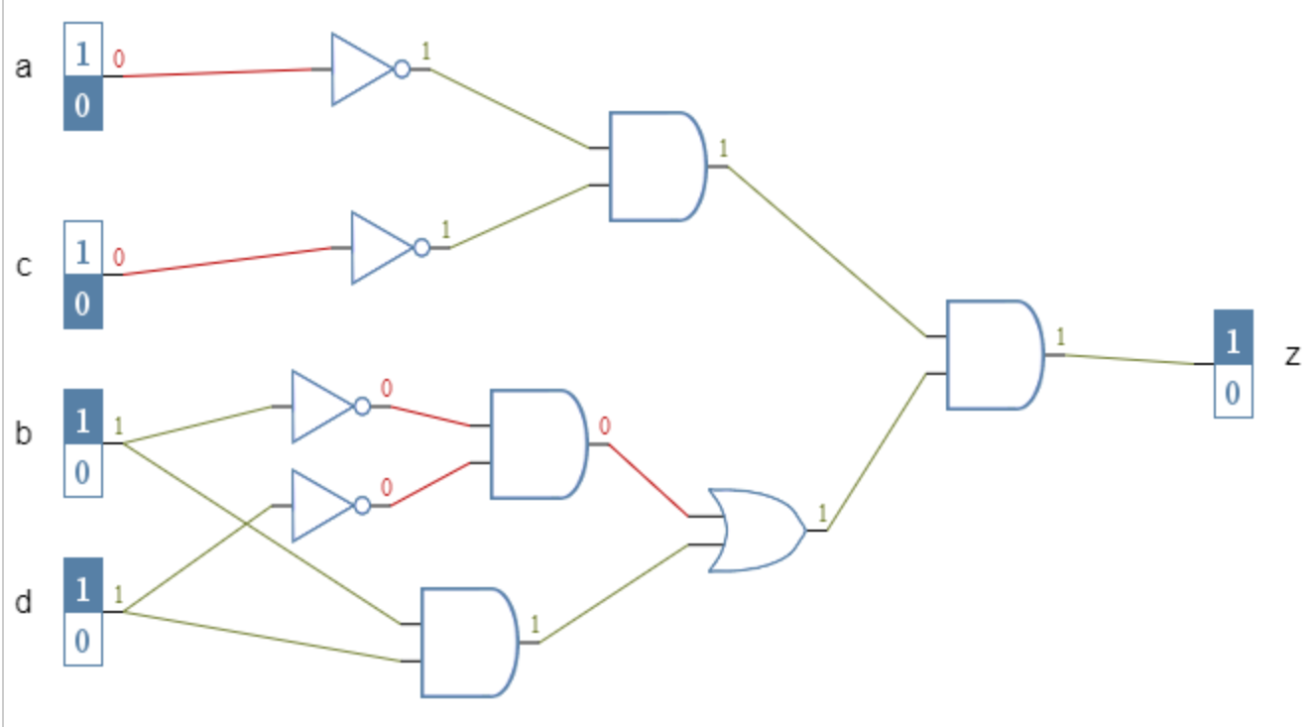

The output for Z2 is HIGH only when a and c are both low and b and c are the same.

3.

|  |  |  |  |  |  |  |  |  |
| --- | --- | --- | --- | --- | --- | --- | --- | --- |
| a | b | c | d | bd’ | b’d | bd’+b’d | ac | Z3 |
| 0 | 0 | 0 | 0 | 0 | 0 | 0 | 0 | 0 |
| 0 | 0 | 0 | 1 | 0 | 1 | 1 | 0 | 0 |
| 0 | 0 | 1 | 0 | 0 | 0 | 0 | 0 | 0 |
| 0 | 0 | 1 | 1 | 0 | 1 | 1 | 0 | 0 |
| 0 | 1 | 0 | 0 | 1 | 0 | 1 | 0 | 0 |
| 0 | 1 | 0 | 1 | 0 | 0 | 0 | 0 | 0 |
| 0 | 1 | 1 | 0 | 1 | 0 | 1 | 0 | 0 |
| 0 | 1 | 1 | 1 | 0 | 0 | 0 | 0 | 0 |
| 1 | 0 | 0 | 0 | 0 | 0 | 0 | 0 | 0 |
| 1 | 0 | 0 | 1 | 0 | 1 | 1 | 0 | 0 |
| 1 | 0 | 1 | 0 | 0 | 0 | 0 | 1 | 0 |
| 1 | 0 | 1 | 1 | 0 | 1 | 1 | 1 | 1 |
| 1 | 1 | 0 | 0 | 1 | 0 | 1 | 0 | 0 |
| 1 | 1 | 0 | 1 | 0 | 0 | 0 | 0 | 0 |
| 1 | 1 | 1 | 0 | 1 | 0 | 1 | 1 | 1 |
| 1 | 1 | 1 | 1 | 0 | 0 | 0 | 1 | 0 |

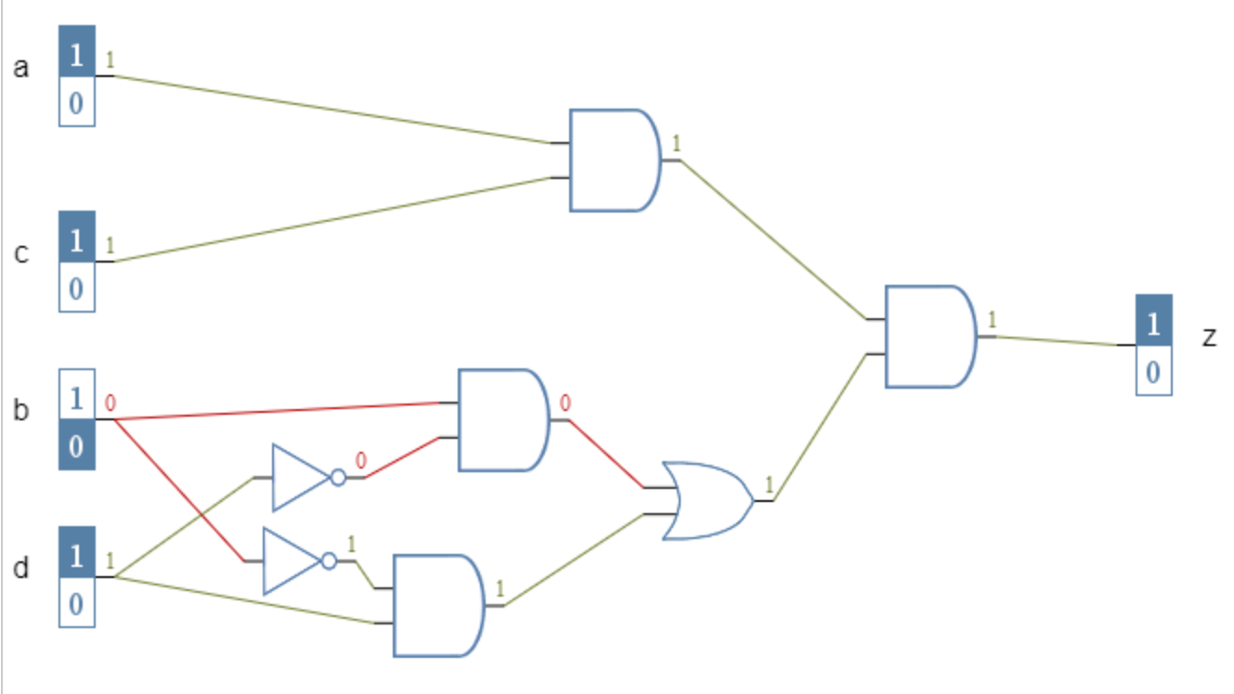

The output for Z3 is HIGH only when a and c are both high and b and d are different.

The output for Z4 is HIGH only when a and c are both low and b and c are the same or a and c are both high and b and d are different.

5. Z1 and Z4 are equivalent

6.

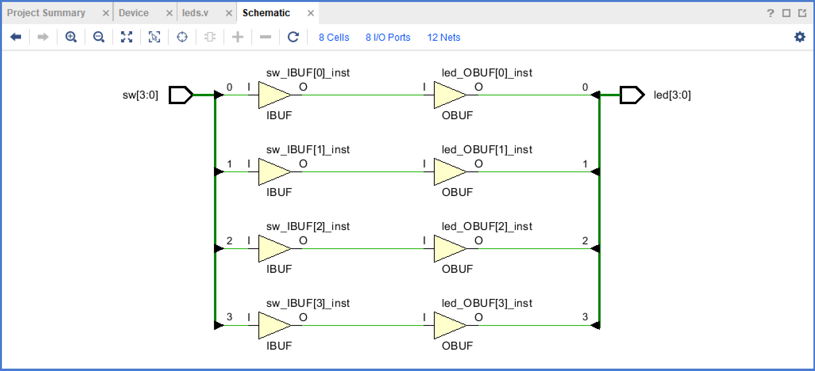

|  |  |  |  |
| --- | --- | --- | --- |
| Inputs | Package Pin | Outputs | Package Pin |
| sw[0] | U15 | led[0] | U14 |
| sw[1] | W14 | led[1] | V14 |
| sw[2] | W13 | led[2] | V13 |
| sw[3] | W15 | led[3] | U16 |