behavioral

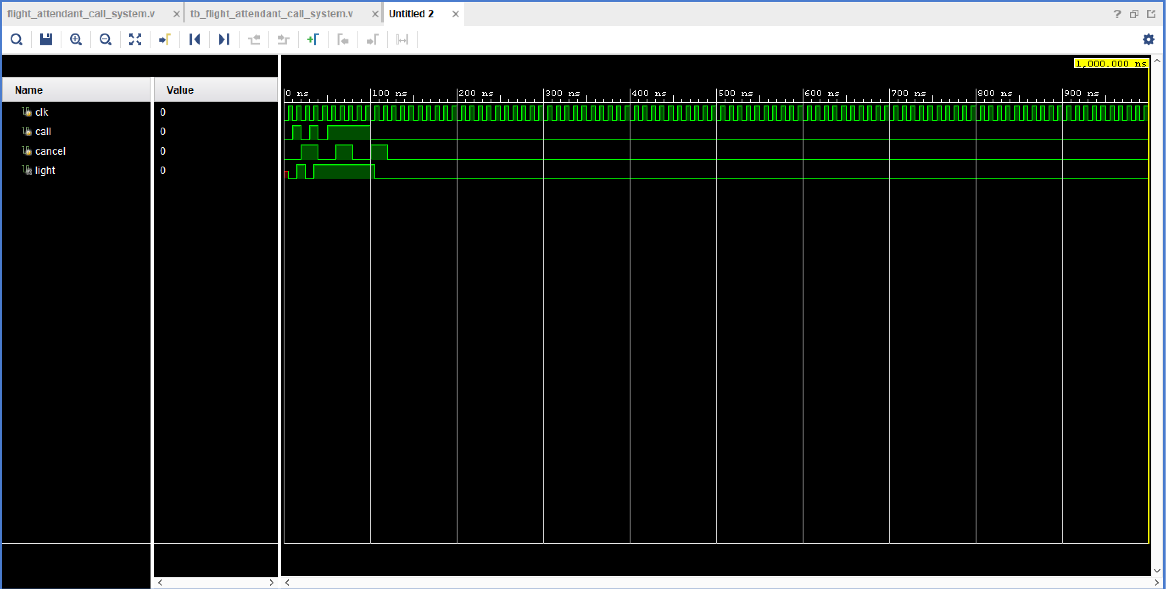

dataflow

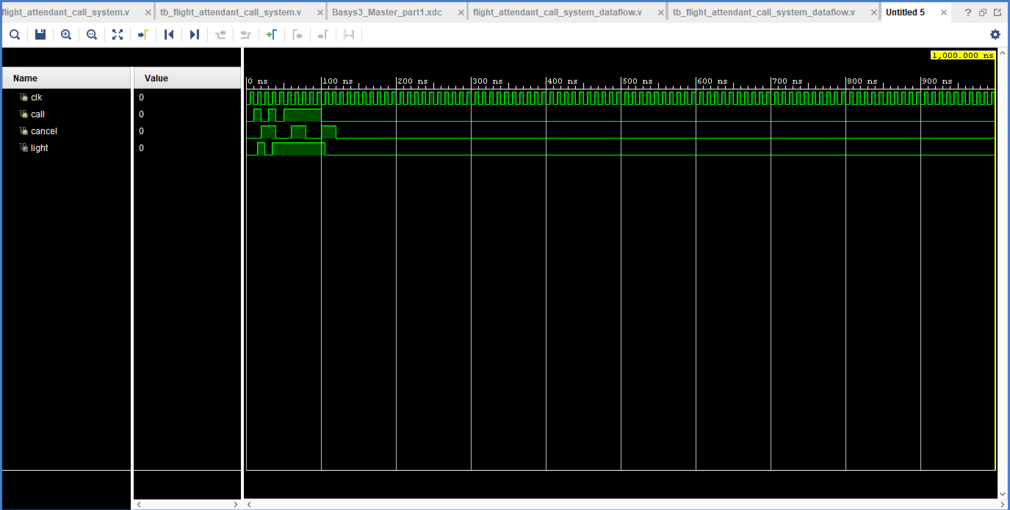

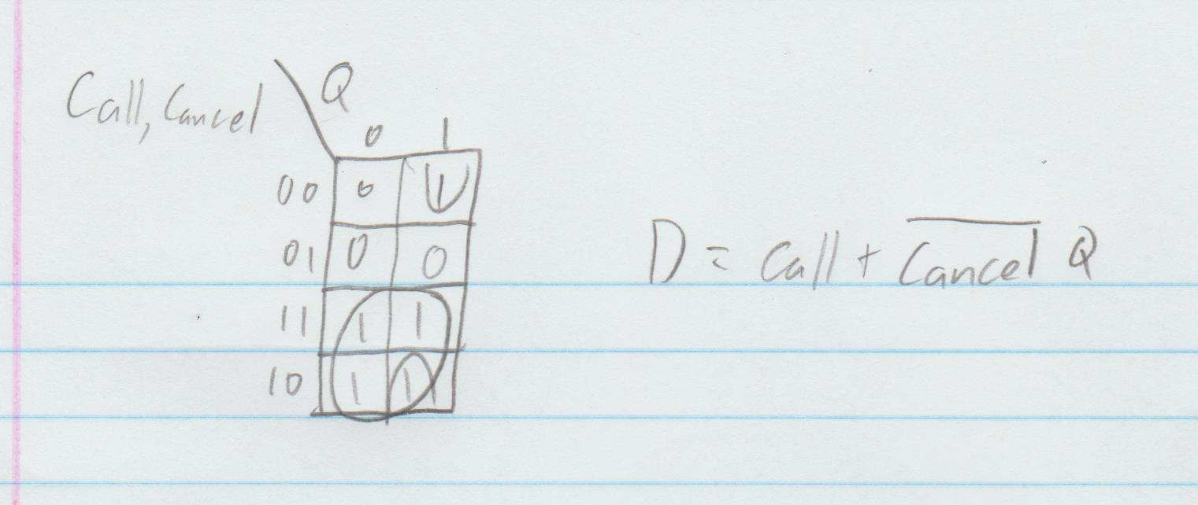

Part 2

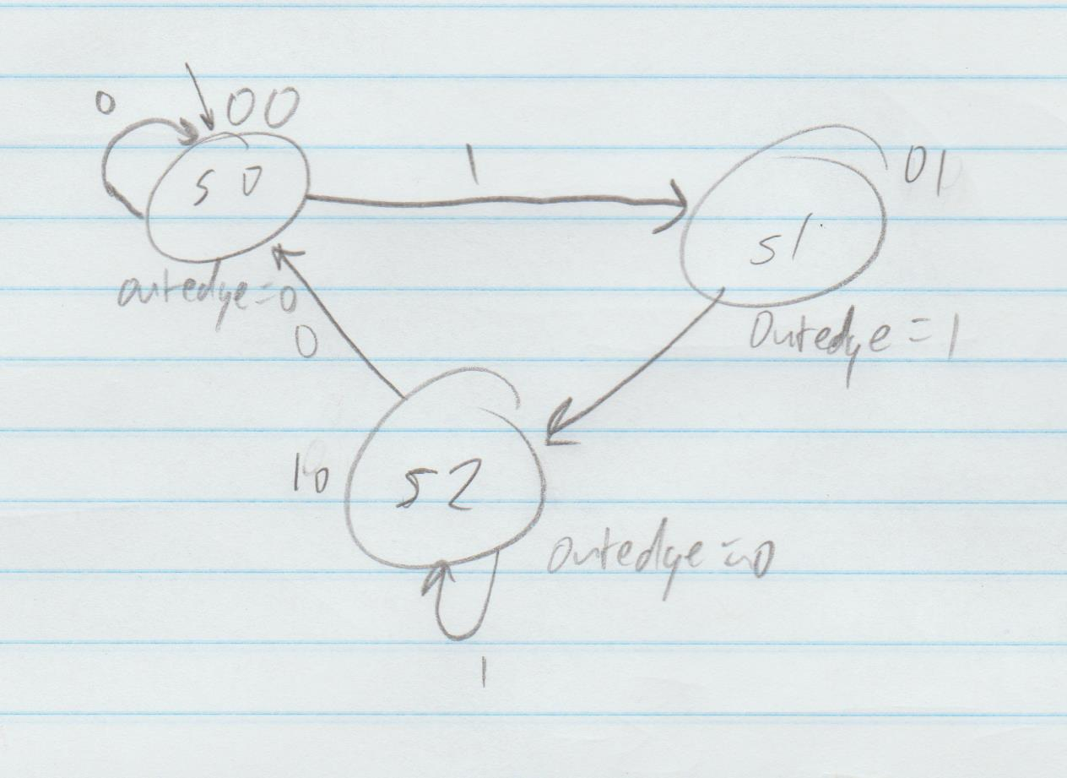

module tb_rising_edge_detector;

reg clk;

reg signal;

reg reset;

wire outedge;

rising_edge_detector uut (

.clk(clk),

.signal(signal),

.reset(reset),

.outedge(outedge)

);

initial begin

clk = 0;

signal = 0;

reset = 0;

#50;

signal = 1;

#50;

signal = 0;

#50;

signal = 1;

#50;

reset = 1;

#50;

reset = 0;

#50;

signal = 0;

end

always

#5 clk = ~clk;

Endmodule

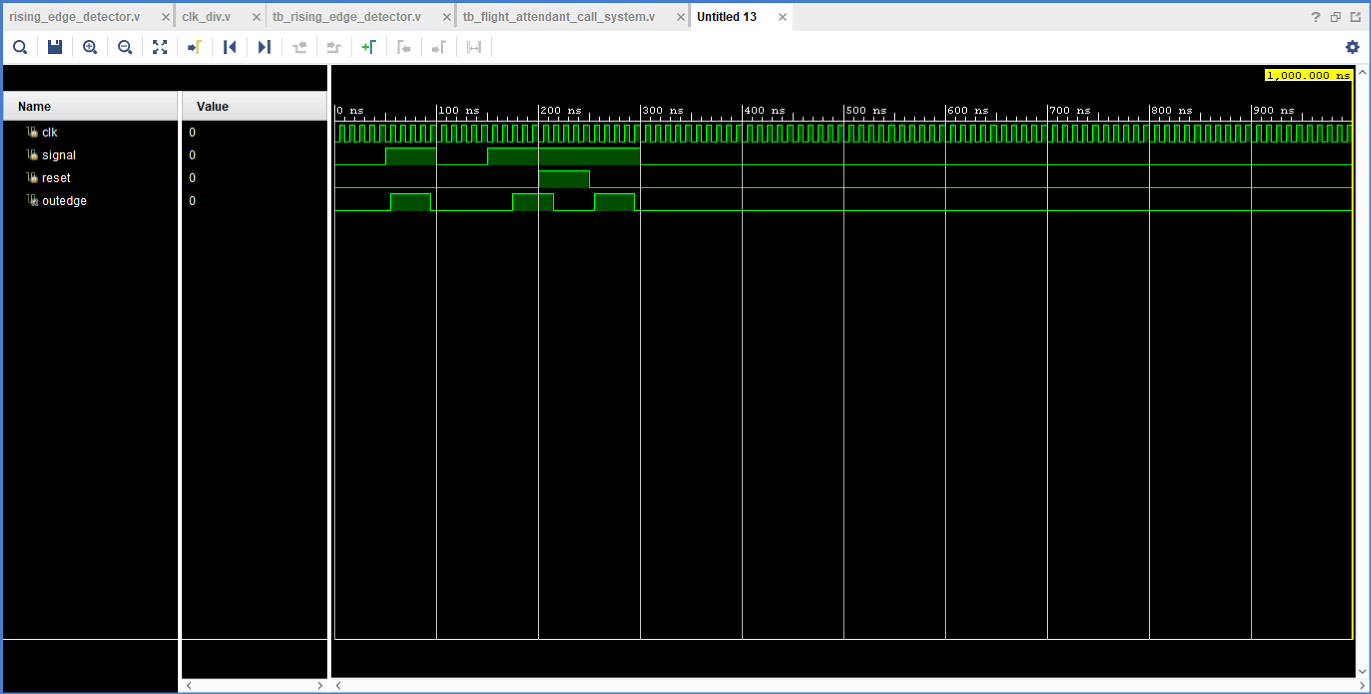

## Clock signal

set_property PACKAGE_PIN W5 [get_ports clk]

set_property IOSTANDARD LVCMOS33 [get_ports clk]

create_clock -add -name sys_clk_pin -period 10.00 -waveform {0 5} [get_ports clk]

## Switches

set_property PACKAGE_PIN V17 [get_ports {signal}]

set_property IOSTANDARD LVCMOS33 [get_ports {signal}]

## LEDs

set_property PACKAGE_PIN U16 [get_ports {outedge}]

set_property IOSTANDARD LVCMOS33 [get_ports {outedge}]

##Buttons

set_property PACKAGE_PIN U18 [get_ports {reset}]

set_property IOSTANDARD LVCMOS33 [get_ports {reset}]

Part 3

module tb_time_multiplexing_main;

reg clk;

reg reset;

reg[15:0] sw;

wire[3:0] an;

wire[6:0] sseg;

time_multiplexing_main uut (

.clk(clk),

.reset(reset),

.sw(sw),

.an(an),

.sseg(sseg)

);

initial begin

clk = 0;

reset = 1;

sw = 0;

#50;

reset = 0;

sw = 16'h3210;

#50;

sw = 16'h7654;

#50;

sw = 16'hBA98;

#50;

sw = 16'hFEDC;

#50;

sw = 16'h5555;

reset = 1;

#100;

reset = 0;

#50;

sw = 16'h0000;

end

always

#5 clk = ~clk;

endmodule

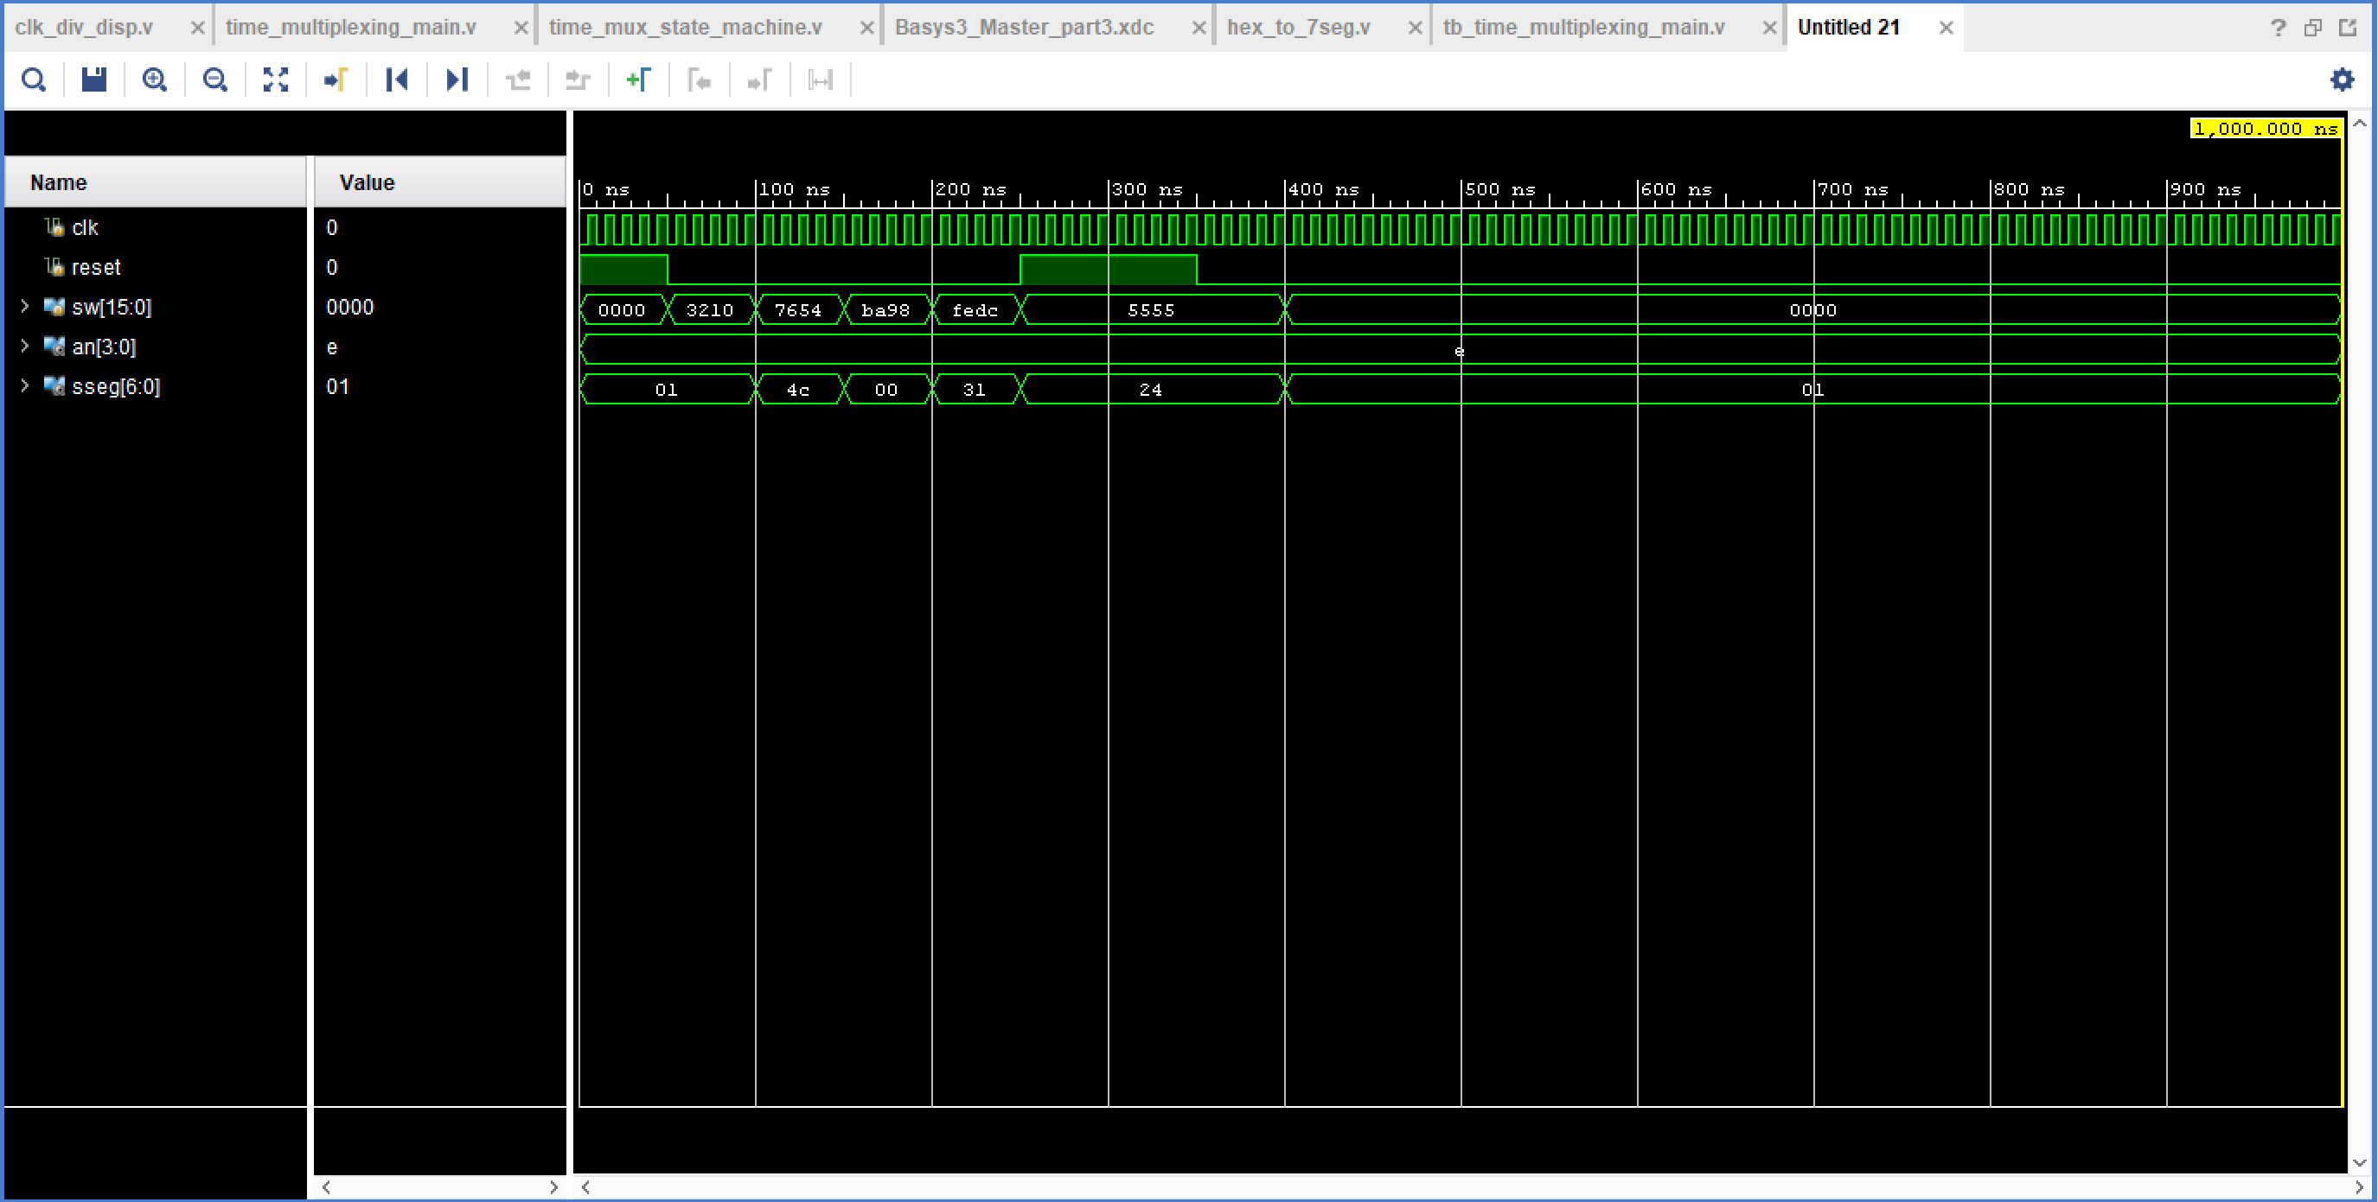

## Clock signal

set_property PACKAGE_PIN W5 [get_ports clk]

set_property IOSTANDARD LVCMOS33 [get_ports clk]

create_clock -add -name sys_clk_pin -period 10.00 -waveform {0 5} [get_ports clk]

## Switches

set_property PACKAGE_PIN V17 [get_ports {sw[0]}]

set_property IOSTANDARD LVCMOS33 [get_ports {sw[0]}]

set_property PACKAGE_PIN V16 [get_ports {sw[1]}]

set_property IOSTANDARD LVCMOS33 [get_ports {sw[1]}]

set_property PACKAGE_PIN W16 [get_ports {sw[2]}]

set_property IOSTANDARD LVCMOS33 [get_ports {sw[2]}]

set_property PACKAGE_PIN W17 [get_ports {sw[3]}]

set_property IOSTANDARD LVCMOS33 [get_ports {sw[3]}]

set_property PACKAGE_PIN W15 [get_ports {sw[4]}]

set_property IOSTANDARD LVCMOS33 [get_ports {sw[4]}]

set_property PACKAGE_PIN V15 [get_ports {sw[5]}]

set_property IOSTANDARD LVCMOS33 [get_ports {sw[5]}]

set_property PACKAGE_PIN W14 [get_ports {sw[6]}]

set_property IOSTANDARD LVCMOS33 [get_ports {sw[6]}]

set_property PACKAGE_PIN W13 [get_ports {sw[7]}]

set_property IOSTANDARD LVCMOS33 [get_ports {sw[7]}]

set_property PACKAGE_PIN V2 [get_ports {sw[8]}]

set_property IOSTANDARD LVCMOS33 [get_ports {sw[8]}]

set_property PACKAGE_PIN T3 [get_ports {sw[9]}]

set_property IOSTANDARD LVCMOS33 [get_ports {sw[9]}]

set_property PACKAGE_PIN T2 [get_ports {sw[10]}]

set_property IOSTANDARD LVCMOS33 [get_ports {sw[10]}]

set_property PACKAGE_PIN R3 [get_ports {sw[11]}]

set_property IOSTANDARD LVCMOS33 [get_ports {sw[11]}]

set_property PACKAGE_PIN W2 [get_ports {sw[12]}]

set_property IOSTANDARD LVCMOS33 [get_ports {sw[12]}]

set_property PACKAGE_PIN U1 [get_ports {sw[13]}]

set_property IOSTANDARD LVCMOS33 [get_ports {sw[13]}]

set_property PACKAGE_PIN T1 [get_ports {sw[14]}]

set_property IOSTANDARD LVCMOS33 [get_ports {sw[14]}]

set_property PACKAGE_PIN R2 [get_ports {sw[15]}]

set_property IOSTANDARD LVCMOS33 [get_ports {sw[15]}]

##7 segment display

set_property PACKAGE_PIN W7 [get_ports {sseg[6]}]

set_property IOSTANDARD LVCMOS33 [get_ports {sseg[6]}]

set_property PACKAGE_PIN W6 [get_ports {sseg[5]}]

set_property IOSTANDARD LVCMOS33 [get_ports {sseg[5]}]

set_property PACKAGE_PIN U8 [get_ports {sseg[4]}]

set_property IOSTANDARD LVCMOS33 [get_ports {sseg[4]}]

set_property PACKAGE_PIN V8 [get_ports {sseg[3]}]

set_property IOSTANDARD LVCMOS33 [get_ports {sseg[3]}]

set_property PACKAGE_PIN U5 [get_ports {sseg[2]}]

set_property IOSTANDARD LVCMOS33 [get_ports {sseg[2]}]

set_property PACKAGE_PIN V5 [get_ports {sseg[1]}]

set_property IOSTANDARD LVCMOS33 [get_ports {sseg[1]}]

set_property PACKAGE_PIN U7 [get_ports {sseg[0]}]

set_property IOSTANDARD LVCMOS33 [get_ports {sseg[0]}]

set_property PACKAGE_PIN U2 [get_ports {an[0]}]

set_property IOSTANDARD LVCMOS33 [get_ports {an[0]}]

set_property PACKAGE_PIN U4 [get_ports {an[1]}]

set_property IOSTANDARD LVCMOS33 [get_ports {an[1]}]

set_property PACKAGE_PIN V4 [get_ports {an[2]}]

set_property IOSTANDARD LVCMOS33 [get_ports {an[2]}]

set_property PACKAGE_PIN W4 [get_ports {an[3]}]

set_property IOSTANDARD LVCMOS33 [get_ports {an[3]}]

##Buttons

set_property PACKAGE_PIN U18 [get_ports {reset}]

set_property IOSTANDARD LVCMOS33 [get_ports {reset}]