Part 1

module RCA_4bits(

input clk,

input enable,

input[3:0] A,

input[3:0] B,

input Cin,

output[4:0] Q

);

wire s0, s1, s2, s3, o0, o1, o2, o3;

reg[4:0] Data;

full_adder c1 (.A(A[0]), .B(B[0]), .Cin(Cin), .S(s0), .Cout(o0));

full_adder c2 (.A(A[1]), .B(B[1]), .Cin(o0), .S(s1), .Cout(o1));

full_adder c3 (.A(A[2]), .B(B[2]), .Cin(o1), .S(s2), .Cout(o2));

full_adder c4 (.A(A[3]), .B(B[3]), .Cin(o2), .S(s3), .Cout(o3));

always @(*) begin

Data = {o3, s3, s2, s1, s0};

end

register_logic c5 (.clk(clk), .enable(enable), .Data(Data), .Q(Q));

endmodule

module full_adder(

input A,

input B,

input Cin,

output S,

output Cout

);

assign S = (A ^ B ^ Cin);

assign Cout = ((A & B) | (A & Cin) | (B & Cin));

endmodule

module register_logic(

input clk,

input enable,

input[4:0] Data,

output reg[4:0] Q

);

always @(posedge clk) begin

if(enable) Q = Data;

else Q = 0;

end

endmodule

module tb_RCA_4bits;

reg clk;

reg enable;

reg[3:0] A;

reg[3:0] B;

reg Cin;

wire[4:0] Q;

RCA_4bits uut (

.clk(clk),

.enable(enable),

.A(A),

.B(B),

.Cin(Cin),

.Q(Q)

);

initial begin

clk = 0;

enable = 0;

A = 4'b0001;

B = 4'b0101;

Cin = 1'b0;

#50;

enable = 1;

#50;

A = 4'b0111;

B = 4'b0111;

Cin = 1'b0;

#50;

A = 4'b1000;

B = 4'b0111;

Cin = 1'b1;

#50;

A = 4'b1100;

B = 4'b0100;

Cin = 1'b0;

#50;

A = 4'b1000;

B = 4'b1000;

Cin = 1'b1;

#50;

A = 4'b1001;

B = 4'b1010;

Cin = 1'b1;

#50;

A = 4'b1111;

B = 4'b1111;

Cin = 1'b0;

#50;

end

always

#1 clk = ~clk;

endmodule

|  |  |  |  |  |
| --- | --- | --- | --- | --- |
| A[3:0] | B[3:0] | Cin | Sum[3:0] | Cout |
| 0001 | 0101 | 0 | 0110 | 0 |
| 0111 | 0111 | 0 | 1110 | 0 |
| 1000 | 0111 | 1 | 0000 | 1 |
| 1100 | 0100 | 0 | 0000 | 1 |
| 1000 | 1000 | 1 | 0001 | 1 |
| 1001 | 1010 | 1 | 0100 | 1 |
| 1111 | 1111 | 0 | 1110 | 1 |

# Clock signal

set_property PACKAGE_PIN W5 [get_ports clk]

set_property IOSTANDARD LVCMOS33 [get_ports clk]

create_clock -add -name sys_clk_pin -period 10.00 -waveform {0 5} [get_ports clk]

## Switches

set_property PACKAGE_PIN V17 [get_ports {A[0]}]

set_property IOSTANDARD LVCMOS33 [get_ports {A[0]}]

set_property PACKAGE_PIN V16 [get_ports {A[1]}]

set_property IOSTANDARD LVCMOS33 [get_ports {A[1]}]

set_property PACKAGE_PIN W16 [get_ports {A[2]}]

set_property IOSTANDARD LVCMOS33 [get_ports {A[2]}]

set_property PACKAGE_PIN W17 [get_ports {A[3]}]

set_property IOSTANDARD LVCMOS33 [get_ports {A[3]}]

set_property PACKAGE_PIN W15 [get_ports {B[0]}]

set_property IOSTANDARD LVCMOS33 [get_ports {B[0]}]

set_property PACKAGE_PIN V15 [get_ports {B[1]}]

set_property IOSTANDARD LVCMOS33 [get_ports {B[1]}]

set_property PACKAGE_PIN W14 [get_ports {B[2]}]

set_property IOSTANDARD LVCMOS33 [get_ports {B[2]}]

set_property PACKAGE_PIN W13 [get_ports {B[3]}]

set_property IOSTANDARD LVCMOS33 [get_ports {B[3]}]

set_property PACKAGE_PIN V2 [get_ports {Cin}]

set_property IOSTANDARD LVCMOS33 [get_ports {Cin}]

## LEDs

set_property PACKAGE_PIN U16 [get_ports {Q[0]}]

set_property IOSTANDARD LVCMOS33 [get_ports {Q[0]}]

set_property PACKAGE_PIN E19 [get_ports {Q[1]}]

set_property IOSTANDARD LVCMOS33 [get_ports {Q[1]}]

set_property PACKAGE_PIN U19 [get_ports {Q[2]}]

set_property IOSTANDARD LVCMOS33 [get_ports {Q[2]}]

set_property PACKAGE_PIN V19 [get_ports {Q[3]}]

set_property IOSTANDARD LVCMOS33 [get_ports {Q[3]}]

set_property PACKAGE_PIN W18 [get_ports {Q[4]}]

set_property IOSTANDARD LVCMOS33 [get_ports {Q[4]}]

##Buttons

set_property PACKAGE_PIN U18 [get_ports {enable}]

set_property IOSTANDARD LVCMOS33 [get_ports {enable}]

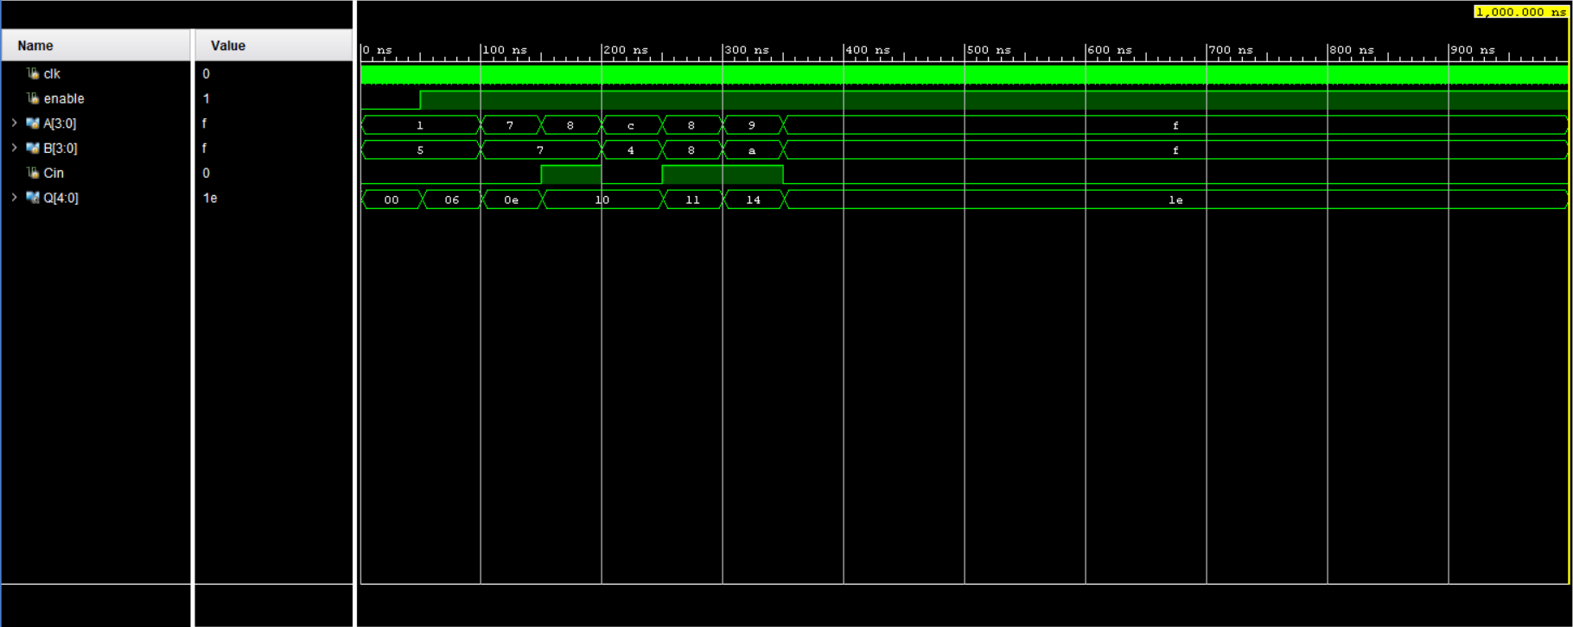

Part 2

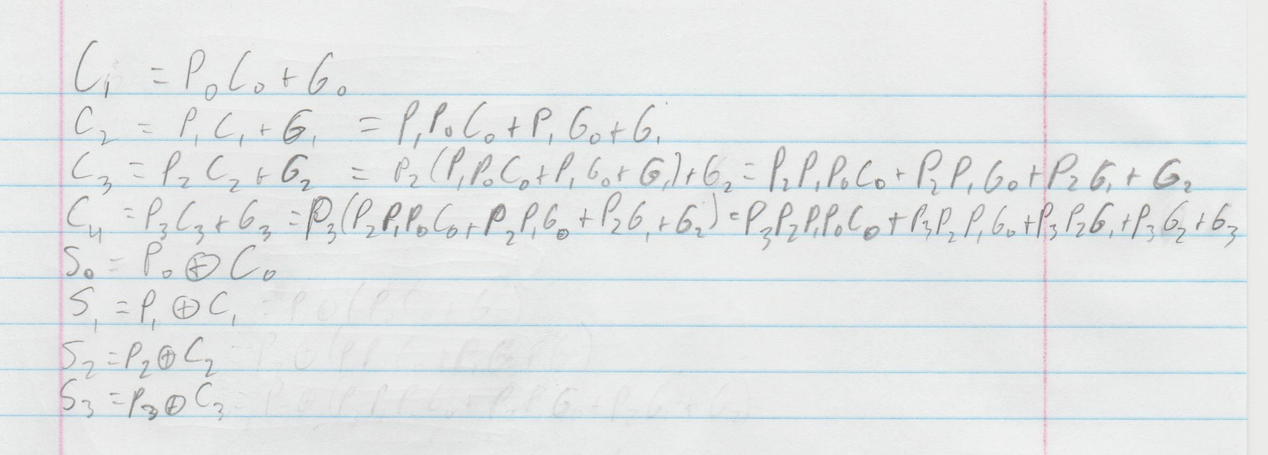

module CLA_4bits(

input clk,

input enable,

input[3:0] A,

input[3:0] B,

input Cin,

output[4:0] Q

);

wire[3:0] G, P, S;

wire[4:0] C;

wire Cout;

assign C[0] = Cin;

assign G[0] = A[0] & B[0];

assign G[1] = A[1] & B[1];

assign G[2] = A[2] & B[2];

assign G[3] = A[3] & B[3];

assign P[0] = A[0] ^ B[0];

assign P[1] = A[1] ^ B[1];

assign P[2] = A[2] ^ B[2];

assign P[3] = A[3] ^ B[3];

assign C[1] = (P[0] & C[0]) | G[0];

assign C[2] = (P[1] & P[0] & C[0]) | (P[1] & G[0]) | G[1];

assign C[3] = (P[2] & P[1] & P[0] & C[0]) | (P[2] & P[1] & G[0]) | (P[2] & G[1]) | G[2];

assign C[4] = (P[3] & P[2] & P[1] & P[0] & C[0]) | (P[3] & P[2] & P[1] & G[0]) | (P[3] & P[2] & G[1]) | (P[3] & G[2]) | G[3];

assign S[0] = P[0] ^ C[0];

assign S[1] = P[1] ^ C[1];

assign S[2] = P[2] ^ C[2];

assign S[3] = P[3] ^ C[3];

register_logic c1 (.clk(clk), .enable(enable), .Data({C[4], S}), .Q(Q));

endmodule

module register_logic(

input clk,

input enable,

input[4:0] Data,

output reg[4:0] Q

);

always @(posedge clk) begin

if(enable) Q = Data;

else Q = 0;

end

endmodule

module tb_CLA_4bits;

reg clk;

reg enable;

reg[3:0] A;

reg[3:0] B;

reg Cin;

wire[4:0] Q;

CLA_4bits uut (

.clk(clk),

.enable(enable),

.A(A),

.B(B),

.Cin(Cin),

.Q(Q)

);

initial begin

clk = 0;

enable = 0;

A = 4'b0000;

B = 4'b0101;

Cin = 1'b0;

#50;

enable = 1;

#50;

A = 4'b0101;

B = 4'b0111;

Cin = 1'b0;

#50;

A = 4'b1000;

B = 4'b0111;

Cin = 1'b1;

#50;

A = 4'b1001;

B = 4'b0100;

Cin = 1'b0;

#50;

A = 4'b1000;

B = 4'b1000;

Cin = 1'b1;

#50;

A = 4'b1101;

B = 4'b1010;

Cin = 1'b1;

#50;

A = 4'b1111;

B = 4'b1111;

Cin = 1'b0;

#50;

end

|  |  |  |  |  |
| --- | --- | --- | --- | --- |
| A[3:0] | B[3:0] | Cin | Sum[3:0] | Cout |
| 0000 | 0101 | 0 | 0110 | 0 |
| 0101 | 0111 | 0 | 1110 | 0 |
| 1000 | 0111 | 1 | 0000 | 1 |
| 1001 | 0100 | 0 | 0000 | 1 |
| 1000 | 1000 | 1 | 0001 | 1 |
| 1101 | 1010 | 1 | 0100 | 1 |
| 1111 | 1111 | 0 | 1110 | 1 |

# Clock signal

set_property PACKAGE_PIN W5 [get_ports clk]

set_property IOSTANDARD LVCMOS33 [get_ports clk]

create_clock -add -name sys_clk_pin -period 10.00 -waveform {0 5} [get_ports clk]

## Switches

set_property PACKAGE_PIN V17 [get_ports {A[0]}]

set_property IOSTANDARD LVCMOS33 [get_ports {A[0]}]

set_property PACKAGE_PIN V16 [get_ports {A[1]}]

set_property IOSTANDARD LVCMOS33 [get_ports {A[1]}]

set_property PACKAGE_PIN W16 [get_ports {A[2]}]

set_property IOSTANDARD LVCMOS33 [get_ports {A[2]}]

set_property PACKAGE_PIN W17 [get_ports {A[3]}]

set_property IOSTANDARD LVCMOS33 [get_ports {A[3]}]

set_property PACKAGE_PIN W15 [get_ports {B[0]}]

set_property IOSTANDARD LVCMOS33 [get_ports {B[0]}]

set_property PACKAGE_PIN V15 [get_ports {B[1]}]

set_property IOSTANDARD LVCMOS33 [get_ports {B[1]}]

set_property PACKAGE_PIN W14 [get_ports {B[2]}]

set_property IOSTANDARD LVCMOS33 [get_ports {B[2]}]

set_property PACKAGE_PIN W13 [get_ports {B[3]}]

set_property IOSTANDARD LVCMOS33 [get_ports {B[3]}]

set_property PACKAGE_PIN V2 [get_ports {Cin}]

set_property IOSTANDARD LVCMOS33 [get_ports {Cin}]

## LEDs

set_property PACKAGE_PIN U16 [get_ports {Q[0]}]

set_property IOSTANDARD LVCMOS33 [get_ports {Q[0]}]

set_property PACKAGE_PIN E19 [get_ports {Q[1]}]

set_property IOSTANDARD LVCMOS33 [get_ports {Q[1]}]

set_property PACKAGE_PIN U19 [get_ports {Q[2]}]

set_property IOSTANDARD LVCMOS33 [get_ports {Q[2]}]

set_property PACKAGE_PIN V19 [get_ports {Q[3]}]

set_property IOSTANDARD LVCMOS33 [get_ports {Q[3]}]

set_property PACKAGE_PIN W18 [get_ports {Q[4]}]

set_property IOSTANDARD LVCMOS33 [get_ports {Q[4]}]

##Buttons

set_property PACKAGE_PIN U18 [get_ports {enable}]

set_property IOSTANDARD LVCMOS33 [get_ports {enable}]

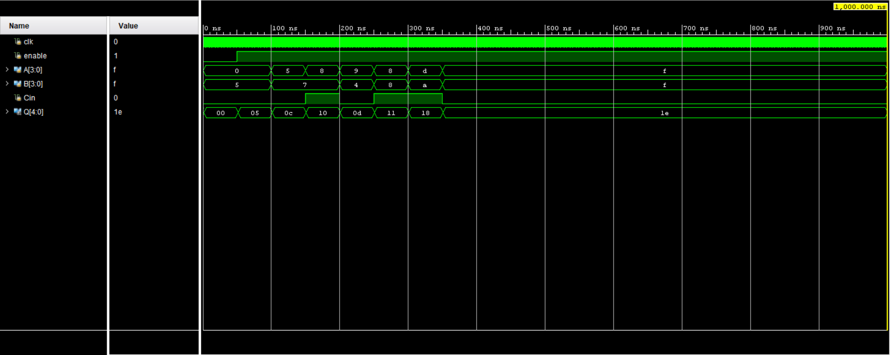

Part 3

RCA

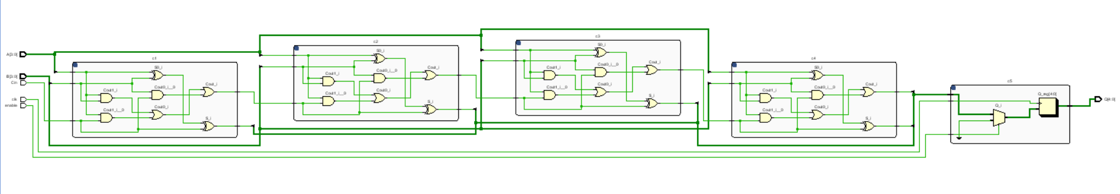

CLA

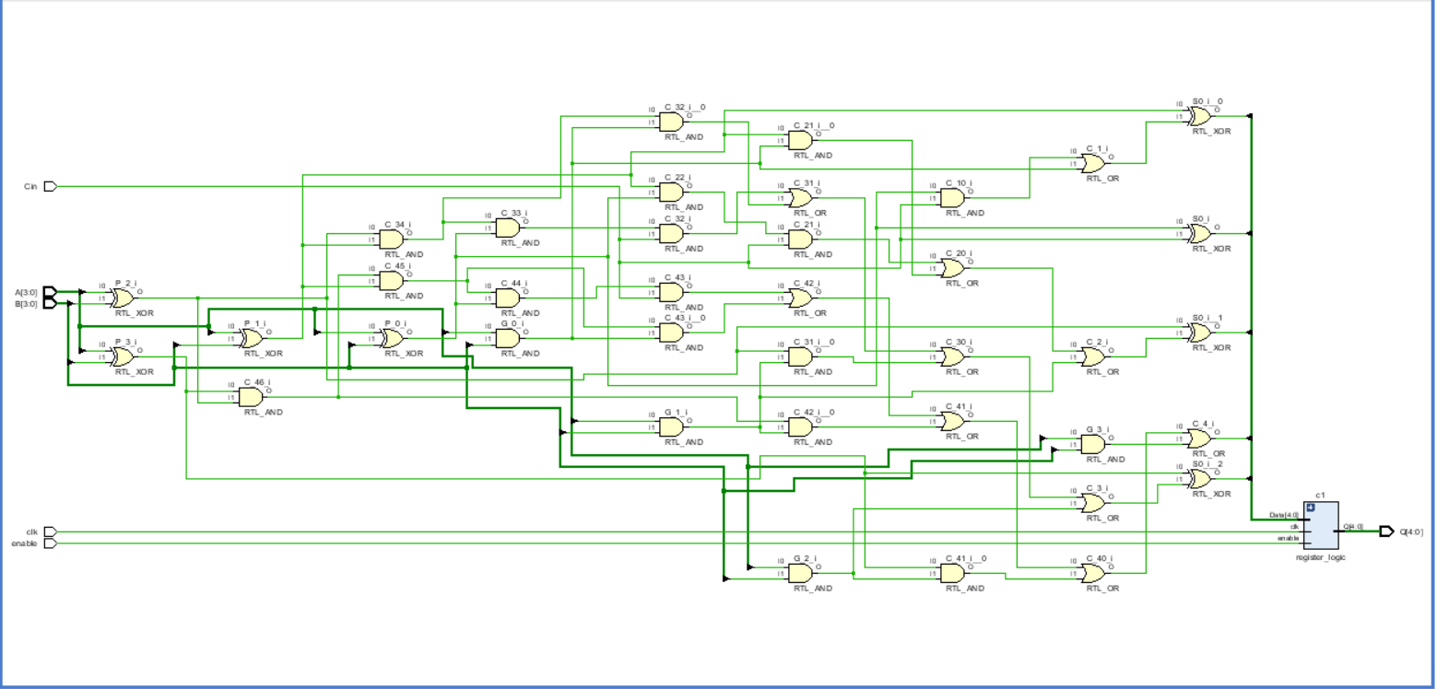

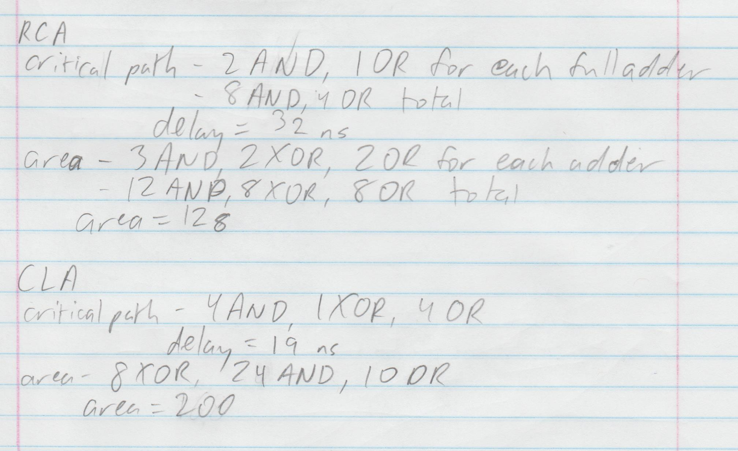

The ripple carry adder is very easy to design due to the small number of gates and being able to string together many identical full adders to add longer operands, it uses fewer gates so would be cheaper to build and takes up less space. The carry look ahead adder uses more gates, takes up more space, and the design would have to be modified to change the length of the operands. However, the carry look ahead adder has a significantly shorter delay than the ripple carry adder, because the ripple carry has to add each bit one at a time to get the carry into the next, and the carry look ahead only needs the original carry in.