Noah Kessler

The goal of the design process was to make all the code simple and to use as much of the code from previous labs as possible. I wanted to have one module that would take the switch inputs and do all the reset logic and the counting both up and down. That way the only totally new code would be this module and everything else could be taken from old labs and modified to simplify the design process. I made this module work by splitting up the digits on the seven segments into their own registers before going through the counting logic. The counting works by first checking if the lowest digit is equal to nine. If not then it adds one, if it is then it sets it to zero and adds one to the next digit. If that is also nine, it sets that to zero and increments the next. If they are all equal to nine, then it leaves them all as nine. Counting down works the same except it checks if it is zero instead of nine. One of the main problems I had was getting the start button to work correctly. I initially just checked every cycle to see if the start button was pressed but that didn’t work because it would change states every cycle as long as the button was held down. I resolved this issue by changing the button logic to a simple state machine with four states, two with the output high and two with the output low. If you push the button, the output is high, and it waits until the button is released before changing states. Then the output is still high until the button is pressed again, when it turns low. It then waits in the same state until the button is released again when it changes to the second state where the output is low and waits there until the button is pressed, when it starts the cycle over again. This way once the button is pressed the output remains the same until it is released and pressed again.

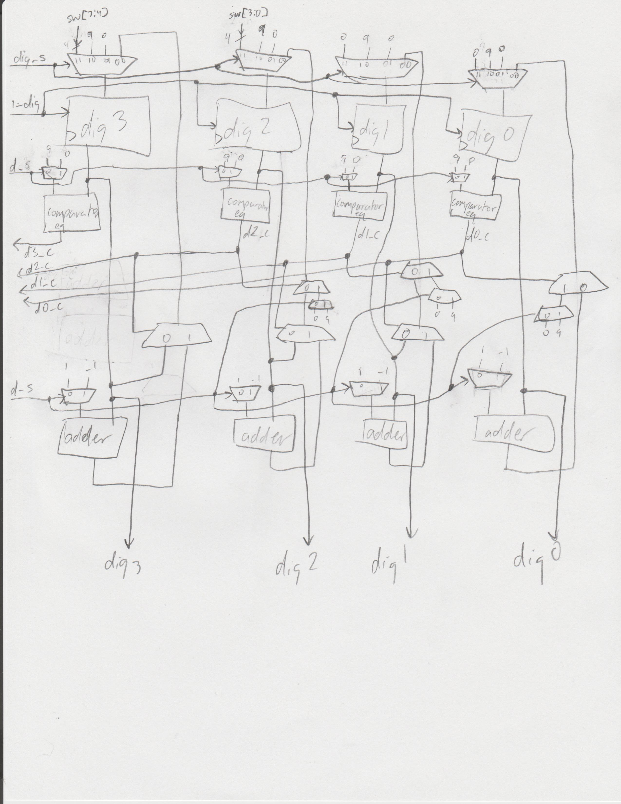

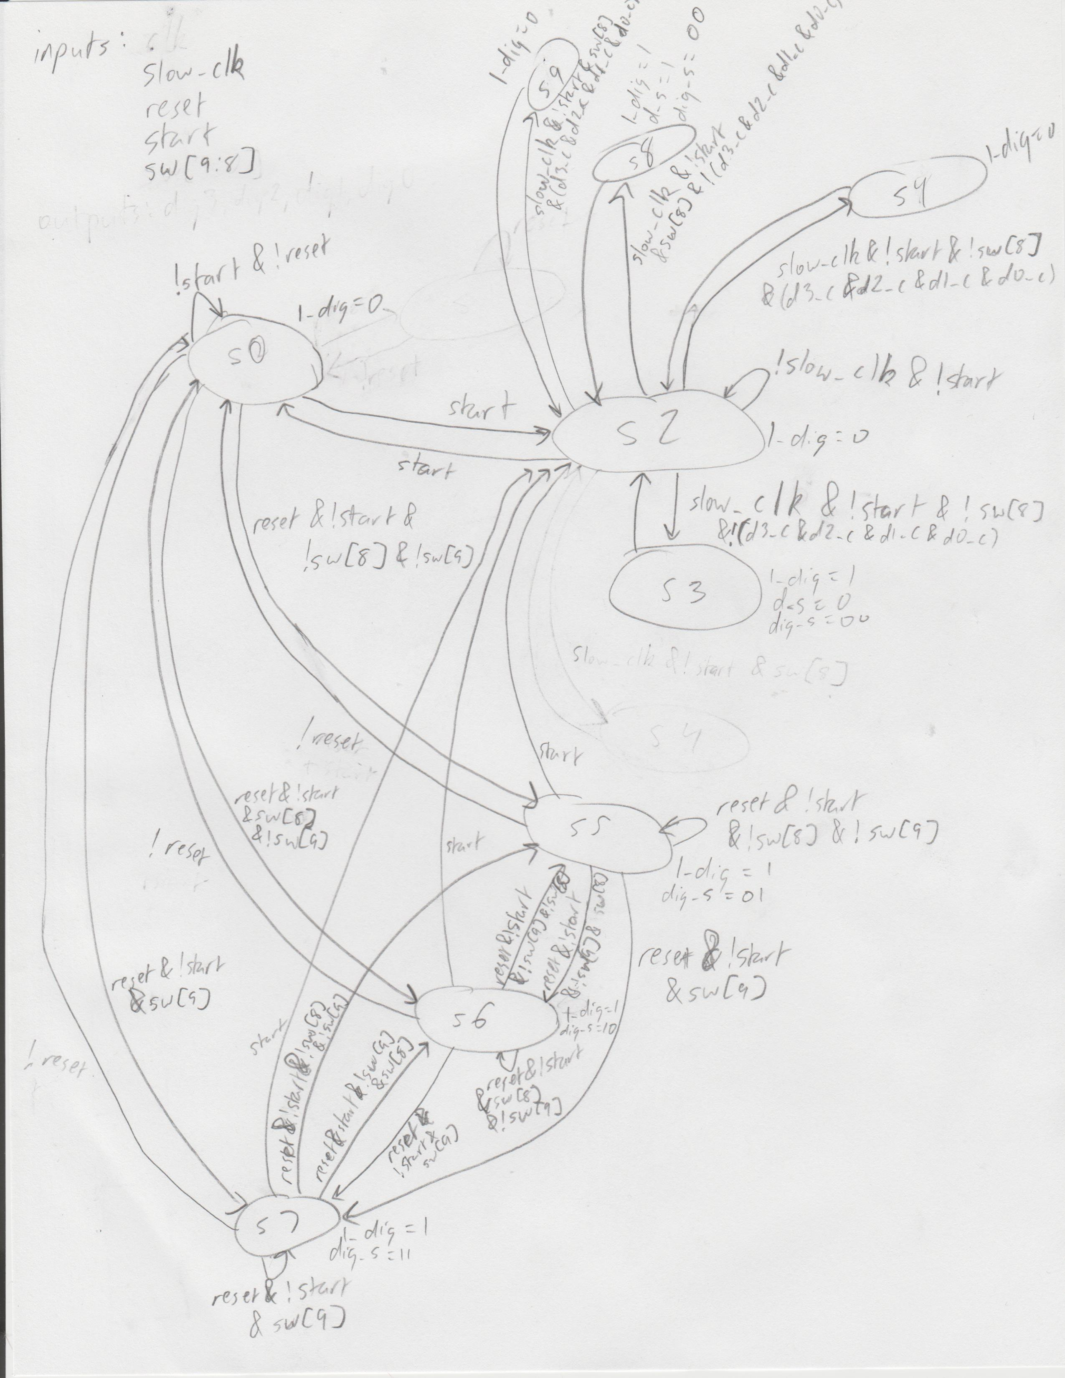

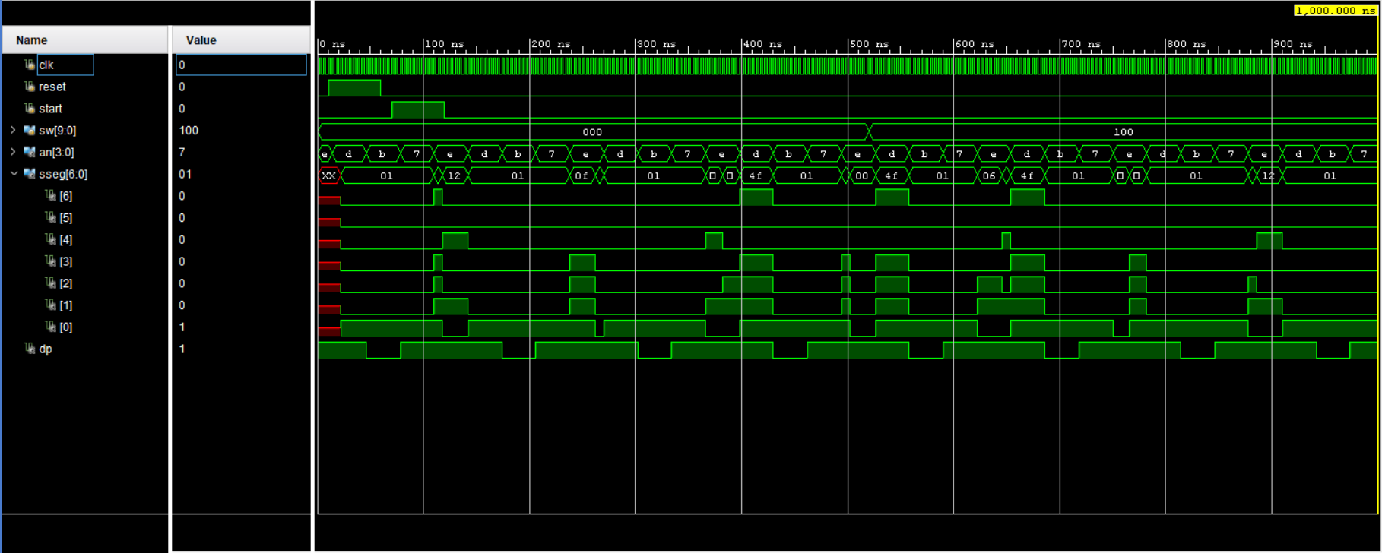

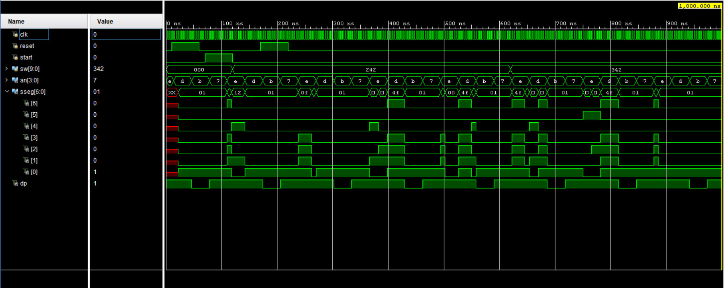

module stopwatch_main(

input clk,

input reset,

input start,

input[9:0] sw,

output[3:0] an,

output[6:0] sseg,

output dp

);

wire[3:0] dig0, dig1, dig2, dig3;

wire time_clk;

wire display_clk;

wire[6:0] in0, in1, in2, in3;

wire go;

rising_edge_detector c1 (.clk(clk), .signal(start), .out(go));

clk_div_time c2 (.clk(clk), .clk_out(time_clk));

counter c3 (.clk(time_clk), .reset(reset), .go(go), .sw(sw), .in0(dig0), .in1(dig1), .in2(dig2), .in3(dig3), .out0(dig0), .out1(dig1), .out2(dig2), .out3(dig3));

hex_to_7seg c4 (.x(dig0), .r(in0));

hex_to_7seg c5 (.x(dig1), .r(in1));

hex_to_7seg c6 (.x(dig2), .r(in2));

hex_to_7seg c7 (.x(dig3), .r(in3));

clk_div_disp c8 (.clk(clk), .clk_out(display_clk));

time_mux_state_machine c9 (.clk(display_clk), .in0(in0), .in1(in1), .in2(in2), .in3(in3), .dp(dp), .an(an), .sseg(sseg));

endmodule

module rising_edge_detector(

input clk,

input signal,

output reg out

);

reg[1:0] state;

reg[1:0] next_state;

always @(*) begin

case(state)

2'b00: begin

out = 1'b0;

if(~signal) next_state = 2'b00;

else next_state = 2'b01;

end

2'b01: begin

out = 1'b1;

if(signal) next_state = 2'b01;

else next_state = 2'b10;

end

2'b10: begin

out = 1'b1;

if(~signal) next_state = 2'b10;

else next_state = 2'b11;

end

2'b11: begin

out = 1'b0;

if(signal) next_state = 2'b11;

else next_state = 2'b00;

end

default: begin

next_state = 2'b00;

out = 1'b0;

end

endcase

end

always @(posedge clk) begin

state <= next_state;

end

module clk_div_time(

input clk,

output reg clk_out

);

reg[19:0] COUNT = 0;

always @(posedge clk) begin

if(COUNT >= 1000000) begin

clk_out = 1;

COUNT = 0;

end

else begin

COUNT = COUNT + 1;

clk_out = 0;

end

end

endmodule

module counter(

input clk,

input reset,

input go,

input[9:0] sw,

input[3:0] in0,

input[3:0] in1,

input[3:0] in2,

input[3:0] in3,

output reg[3:0] out0,

output reg[3:0] out1,

output reg[3:0] out2,

output reg[3:0] out3

);

always @ (posedge clk) begin

if(!go) begin

if(reset) begin

if(sw[9]) begin

out0 = 0; out1 = 0; out2 = sw[3:0]; out3 = sw[7:4];

if(out2 > 9) out2 = 0;

if(out3 > 9) out3 = 0;

end

else if(sw[8]) begin

out0 = 9; out1 = 9; out2 = 9; out3 = 9;

end

else begin

out0 = 0; out1 = 0; out2 = 0; out3 = 0;

end

end

else begin

out0 = in0; out1 = in1; out2 = in2; out3 = in3;

end

end

else begin

if(!sw[8]) begin

if((out3 == 4'd9) && (out2 == 4'd9) && (out1 == 4'd9) && (out0 == 4'd9)) begin

out0 = in0; out1 = in1; out2 = in2; out3 = in3;

end

else begin

if(out0 == 4'd9) begin

out0 = 0;

if(out1 == 4'd9) begin

out1 = 0;

if(out2 == 4'd9) begin

out2 = 0;

out3 = out3 + 1;

end

else out2 = out2 + 1;

end

else out1 = out1 + 1;

end

else out0 = out0 + 1;

end

end

else begin

if((out3 == 4'd0) && (out2 == 4'd0) && (out1 == 4'd0) && (out0 == 4'd0)) begin

out0 = in0; out1 = in1; out2 = in2; out3 = in3;

end

else begin

if(out0 == 4'd0) begin

out0 = 9;

if(out1 == 4'd0) begin

out1 = 9;

if(out2 == 4'd0) begin

out2 = 9;

out3 = out3 - 1;

end

else out2 = out2 - 1;

end

else out1 = out1 - 1;

end

else out0 = out0 - 1;

end

end

end

end

endmodule

module hex_to_7seg(

input[3:0] x,

output reg[6:0] r

);

always @(*)

case(x)

4'b0000: r = 7'b0000001;

4'b0001: r = 7'b1001111;

4'b0010: r = 7'b0010010;

4'b0011: r = 7'b0000110;

4'b0100: r = 7'b1001100;

4'b0101: r = 7'b0100100;

4'b0110: r = 7'b0100000;

4'b0111: r = 7'b0001111;

4'b1000: r = 7'b0000000;

4'b1001: r = 7'b0001100;

endcase

endmodule

module clk_div_disp(

input clk,

output clk_out

);

reg[15:0] COUNT = 0;

assign clk_out = COUNT[15];

always @(posedge clk) begin

COUNT = COUNT + 1;

end

endmodule

module time_mux_state_machine(

input clk,

input [6:0] in0,

input [6:0] in1,

input [6:0] in2,

input [6:0] in3,

output reg dp,

output reg[3:0] an,

output reg[6:0] sseg

);

reg[1:0] state = 0;

reg[1:0] next_state;

always @(*) begin

case(state)

2'b00: next_state = 2'b01;

2'b01: next_state = 2'b10;

2'b10: next_state = 2'b11;

2'b11: next_state = 2'b00;

endcase

end

always @(*) begin

case(state)

2'b00: begin sseg = in0; dp = 1; end

2'b01: begin sseg = in1; dp = 1; end

2'b10: begin sseg = in2; dp = 0; end

2'b11: begin sseg = in3; dp = 1; end

endcase

end

always @(*) begin

case(state)

2'b00: an = 4'b1110;

2'b01: an = 4'b1101;

2'b10: an = 4'b1011;

2'b11: an = 4'b0111;

endcase

end

always @(posedge clk) begin

state <= next_state;

end

endmodule