Nokia Education Delivery
User Guide
Change history:

Version | Date | Status | Comments
0.1 | 2011.06.09 | Draft | Initial version
0.2 | 2011-06-13 | Draft | Major Changes
0.3 | 2011-06-14 | Draft | More changes based of feedback
1.0 | 2011-06-15 | Final | Initial Release
1.1 | 2011-06-15 | Final | Addition of FAQ
1.2 | 2012-09-04 | Final | Minor changes

Table of contents:

0. Glossary 4
1. Introduction 4
2. First usage 4
3. Login 5
4. Libraries 6
5. Browsing 7
5.1 Library 7
5.2 Catalog/Category 8
5.3 Media Items 9
6. Downloads 10

Glossary

Abbreviation
NED | Nokia Education Delivery
Library | Level 1 directory, the top level
Catalog | Level 2 directory
Category | Level 3 directory, the lowest level

Introduction
This document describes the functionality of the NED 2.0 java client, also applicable to the NED 2.2 java client. It is a complete re-write of the previous version and the user interface is significantly different.
Nokia Education Delivery is a client server application which means that the client pulls the information from a server somewhere. Consequently the end user must be aware that sometimes the software does not react immediately when it is requesting an update from the server. Additionally, the end user must keep in mind that NED does not pull information automatically, meaning the user needs to check for updates regularly.

First usage
Before user starts using application there is a need to define NED server which will deliver content for our client. This is done only once and the user cannot switch between different servers without losing all information
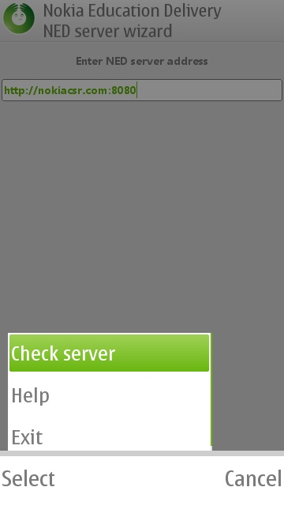
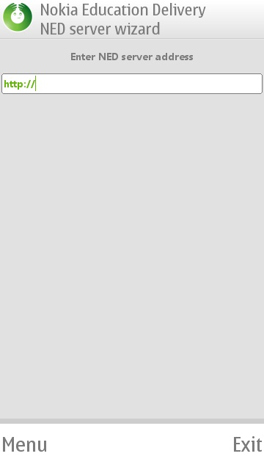

The server information will be given to you by the system administrator. You have to do this only during initial installation. Afterwards, you will not be able to switch server URL unless you do a complete reset. A complete reset does exactly that: It erases all user data, including all the media items as well as all other data that another user might have saved.
The typical server URL will be something like http://servername.com:8080 . The server name will be given to you by the administrator or it might be just an IP address. Both forms will work.
Please note that whenever the system is contacting the server may be a delay of up to 10 seconds or more. Be patient and do not press the check server button more than once as this will only delay the installation.
Help files exist on every screen to help the user with all aspects of the software
Menu Items
- Check Server – Press to connect to the URL selected. Please be patient during initial connection to server
- Help – Help
- Exit - Exit

Login

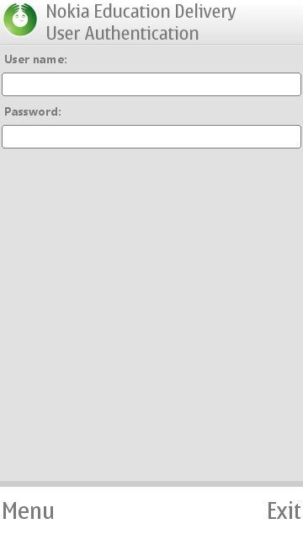
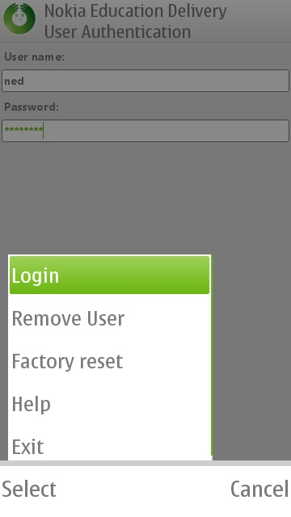

Your username and password will be provided to you by the administrator during initial installation. You may choose the username, but not the password. The password is computer generated for security and cannot be changed. The administrator also does not have access to the password chosen for security purposes. Administrators should keep a separate list of passwords just in case the end user loses the said information. End users should keep the password on a secure place. If you forget or misplace the password a new one will have to be created for you and you may lose information
More than one user can use the same device.
Once you have entered the credentials on this screen, please select login.
Menu Items:
- Login – press after entering credentials
- Remove User – User removed completely. All data is lost. Other users of the same device remain. Server URL will stay the same
- Factory Reset – All data lost. Used only when a switch to an entirely new server is required
- Help – Help
- Exit – Exit

Libraries
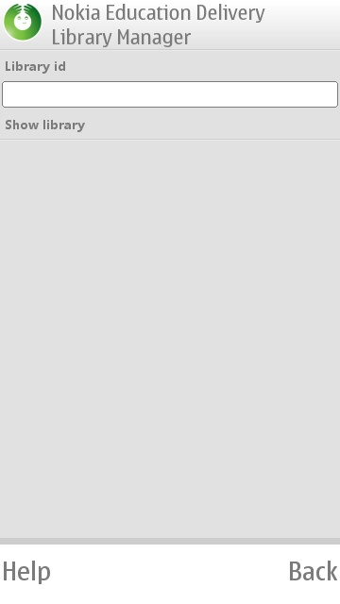
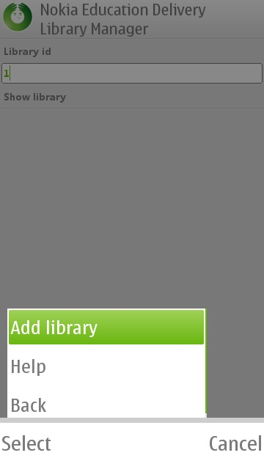
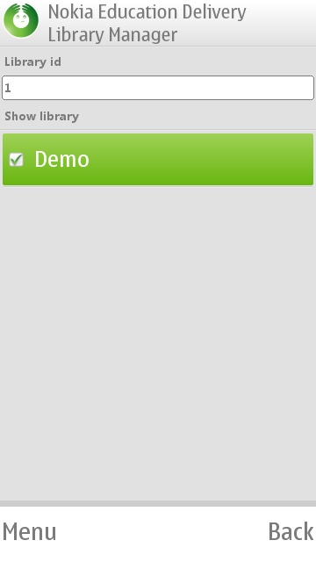

In this screen you can enter the libraries assigned to you by the administrator. The format for the libraries is any string, meaning a series of numbers or characters. Enter this number to connect to the library and wait until the system checks that the library actually exists.

Please make sure that the library to be used is selected. In the above case, we have selected the Demo library. Make sure that there is a check mark next to the library that you have selected to add.

Menu Items

- Add library – Press this button after you have entered the numerical id number of the library you are interested in accessing
- Help – Help
- Back – Previous screen

NOTE: Once you have selected your library successfully press the back button to go to the home page and continue with the program selections.

Browsing
NED allows for the administrator to add a number of additional fields to enrich and add information to the media items.
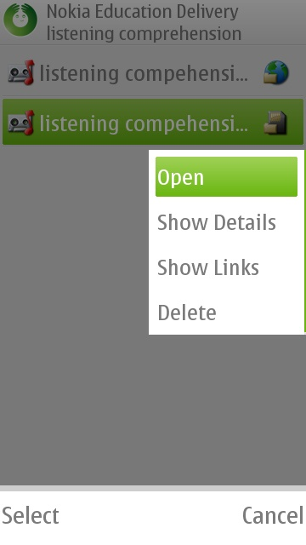
One of the fields available to the administrator is the ability to attach a link to the media item as shown on the image below.
If your device has a browser, you will be able to click on this item and click on the subsequent link to launch a browser.
The browser will go automatically to the link and you will be able to navigate the link via the default browser of your device.
To get back to NED, simply close the browser and you will be taken back to this screen.

Library
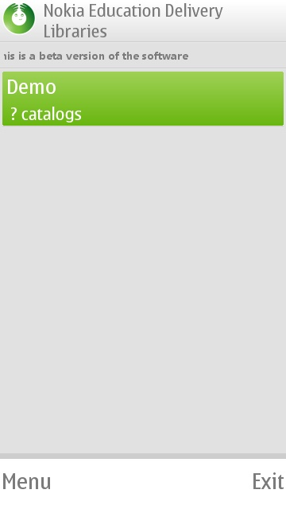
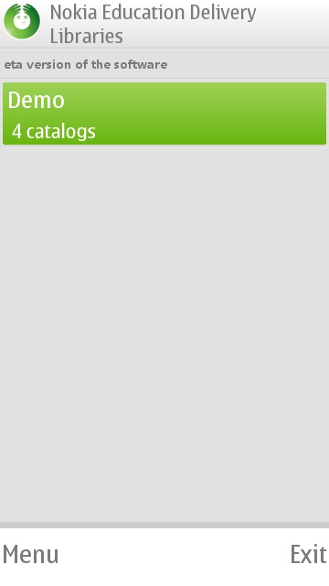
MOTD

This is the screen that follows immediately after initial login. This is also the home screen. From here you can access all the information that pertains to you.

Under the description of the library, NED will fill in the details of the next directory once connection to the server has been established. Note the description below Demo has changed from “?” to 4, denoting the number of catalogs present under this particular Library. There may be a short delay while the information is updated.

On the top you will also see any message that the administrator has chosen to broadcast to all users of the system. This is the MOTD (message of the day).

Menu Items

- Search – Search your library for particular files
- Library Manager – Where you can add additional libraries
- Settings – Where you select how to send the statistics back to the server, whether you prefer automatic or manual downloading. Here is where you switch users
- Downloads – Checks the status of your download queue
- Statistics – Shows the user what is being reported back to the administrator as far as usage is concerned.
- History – Used only when there are files associated to other versions of NED
- Help – Help
- Exit – Exit

Catalog/Category

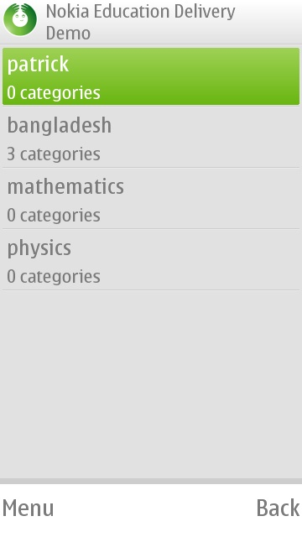
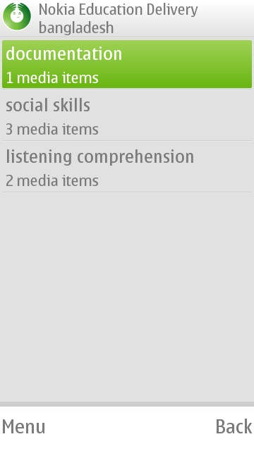
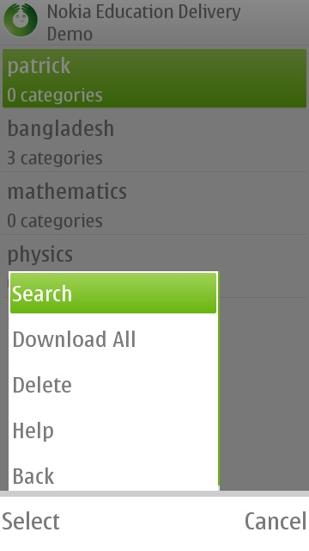

Here is where the user will find the categories related to the library in question. When the user selects the particular catalog, then NED proceeds further down the file directory and informs the user of the media of the items available in each category.

Media items are a general term as NED can accept different types of files. The types of media items are:

- Videos- .mp4 base format, or 3gp compatible
- Audio – mp3 or wav
- Photos – jpg
- Documents – in xhtml format ( and pdf only on certain devices, such as the C7)

Menu items:

- Search – Searches the user Library
- Download all – Download all elements in a category regardless of the status of the downloader (either manual or auto, it doesn’t matter)
- Delete – Deletes the highlighted category
- Help - Help
- Back – Back to previous screen

Media Items

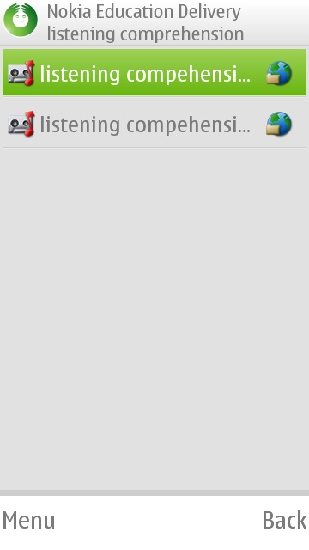
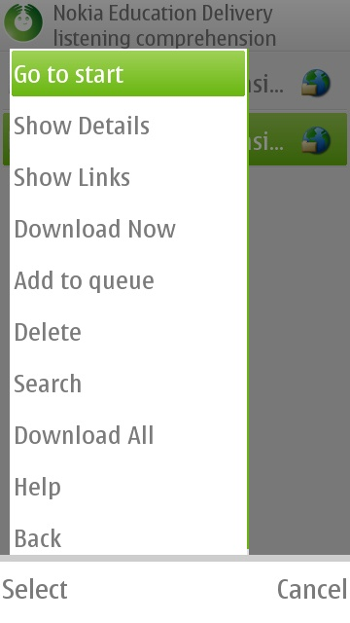

The media items available are found under each category. Each of the type of media item can be recognized by the icon immediately to the left of the associated name.

Each of the media items, audio , video , photo , or document  has a different icon.

On the example show above one can see that there are two media items in the listening comprehension category and both media items are audio files.

The icon to the right of the name indicates whether the item is available locally or remotely.
If it is local, then the icon is a memory card , which signifies that the item has already been downloaded to the device and is available immediately.
If the icon looks like a small planet earth , it signifies that the item is available remotely. In other words the item exists at the server side and is waiting to be downloaded.

Menu items:

- Go to start – Takes you to the home screen
- Show details – Shows a short description associated with the item
- Show Links – Shows hyperlinks associated with the item
- Download Now – Download remote Item
- Add to queue – Add item to the download queue. Will not download on manual setting. User must go to the download manager and start downloads from there
- Delete – Delete item
- Search – Search items on the library
- Download all – Download all items in the category
- Help – Help
- Back – Back to previous screen

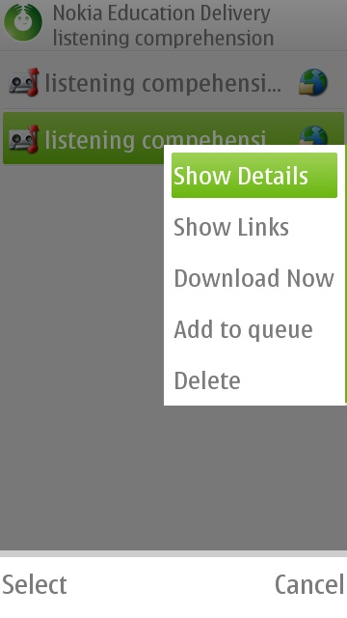

Each of the media items has a slightly different available menu depending whether it is available locally or remotely. For example the figure to the left is a remote item and thus shows the option of downloading. The figure on the right is for a local item that has already been downloaded.

Downloads

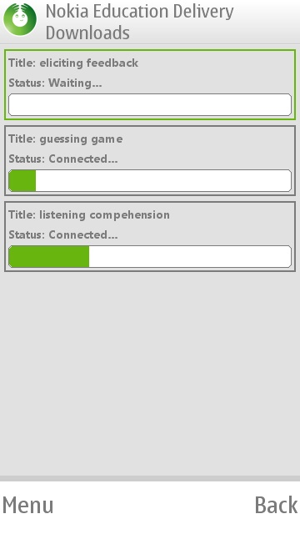
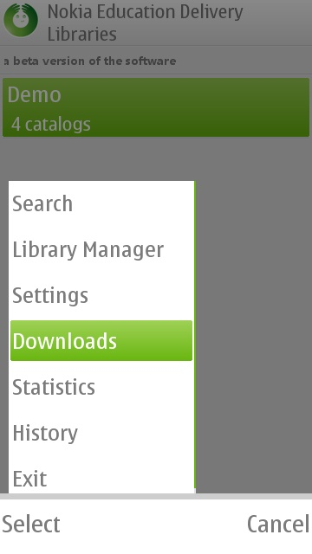

The download manager is where the user is taken immediately upon selecting an item to be downloaded. In this screen the user given feedback on the status of the downloader and well as a progress bar related to the progress.

The downloader is capable of multiple downloads. Once the item is finished being downloaded then it will be removed from the queue.

The user may cancel a download at any time via the menu

Menu Items (only when there are items waiting in the queue):

- Start – Start the download ( in the manual mode)
- Remove – Remove the item on the queue
- Help – Help
- Back – Back to the media item list on the category selected.

Frequently asked questions:

- What is the use of the checkmarks on the Library Manager?
You may add as many libraries are you would like. However only those libraries check are the ones that will be displayed for your usage. In addition the search item only works on those libraries that are selected

- How do I change the language of the application?
At this time, English, Spanish and Tamil are supported. The content can be created in any language that is supported by the used mobile devices. To change language, you must change the language of the phone operating system itself and the application automatically will change the language.

- Why doesn’t search find the items that I already have?
Search only works at the level you are on and below. For example if you search at the library level, all items at that level and below will be found. If you search at the category level, all items at that level will be found. Items at the catalog level or library level will not be found.

- Why don’t I see the new content available to me?
Please make sure that your catalog is up to date and follow the instructions below

This is the home screen

From the home screen->Menu->Library Manager->Choose Library->Check for update. Do not forget to click on the library of interest or you will not see the contents even though they have been updated.

More questions and answers are available on the Nokia Education Delivery Developer site: https://projects.developer.nokia.com/NED/wiki

