Nokia Education Delivery
NED Server
Installation Guide

Change history:

Version | Date | Status | Comments
0.1 | 2011.05.25 | Draft | Initial version
0.2 | 2011.05.25 | Draft | Added screen snapshots
0.3 | 2011 | Draft | Added more information
0.4 | 2011.06.02 | Draft | Added new screens. More information.
0.5 | 2011.06.06 | Draft | More detailed instruction.
0.6 | 2011.06.09 | Draft | Editorial changes
0.7 | 2011.06.27 | Draft | Licenses chapter added
1.0 | 2011-06-13 | Final | Initial release of the installation guide
1.1 | 2011-06-15 | Final | Added section on how to upgrade the binaries
1.2 | 2012-01-04 | Final | Merging changes. Spellings and typos.
1.3 | 2012-04-27 | Final | Update to 2.2 version.

Table of contents:

0. Glossary 4
1. Introduction 4
2. Installation 5
2.1 JDK / JRE 5
2.2 Tomcat 5
2.3 PostgreSQL 6
2.4 PostgreSQL JDBC Driver 7
2.5 NED server binaries 7
3. Configuration 8
3.1 PostgreSQL DB configuration 9
3.2 Tomcat final configuration 12
3.2.1 Login page 13
3.2.1.1 Welcome page 14
3.2.1.2 Direct login 14
3.3 NED binaries upgrade procedure 15
3.4 Password recovery 16
3.5 Support 18
4. Licenses 19
4.1 Tomcat 19
4.2 PostgreSQL 22
4.3 PostgreSQL JDBC Driver 23
4.4 Opencsv 24

Glossary

Abbreviation
NED | Nokia Education Delivery
JDBC | Java DataBase Connectivity
TOMCAT_HOME | Path where Tomcat is installed, i.e. C:\Program Files\Apache Software Foundation\Tomcat 5.5
POSTGRESQL_HOME | Path where PostgreSQL is installed, i.e. C:\Program Files\PostgreSQL

Introduction
This document introduces the way to set up the NED platform to create and manage NED libraries. Please note that NED server uses external tools, like Tomcat server and PostgreSQL database, therefore some advanced setup issues related to those are not covered in this document. We encourage looking for those components’ original documentation to find answers to some of your questions.
Before you start, read carefully this Installation Guide and make sure you understand the sequence of installation.
Make sure you write down all the installation paths to facilitate error correction during installation.

Installation
In order to use NEDAdminConsole (old NEDCatalogTool) for creating and managing NED libraries, you must first install it together with the software it depends on. The required steps are outlined in the following subsections.

The installation requires the installation of several software packages necessary for the functionality of the NEDCatalogTool. We recommend that the software is installed in the following order.

JDK / JRE

Before installing please check that if JRE has already been installed. Use a java version checker from the internet to make sure you understand what you have. There are many such checkers and a good one can be found at http://www.javatester.org/version.html

Required Java Runtime Environments for many platforms (or links to where they can be found) are available at http://www.oracle.com/technetwork/java/javase/downloads/index.html.
Normally JRE version 6 is necessary. Please install JRE in the default directory and store the exact path where the Java environment was installed. You will need this information during the installation of Tomcat.

Tomcat
Binary downloads of the Tomcat server are available at http://tomcat.apache.org/. We recommend using the most recent stable release of Tomcat 7. Select the 32bit version.
Detailed instructions for downloading and installing Tomcat are available at http://tomcat.apache.org/tomcat-7.0-doc/setup.html
The application works also with Tomcat 5.5, so there is no need to update it if you have installed it with a previous version of NED. Please note that in Tomcat 5.5 some paths might differ from version 7.0. Do not use the administrator login (optional) if available. Just leave it blank.
Tomcat will attempt to start at port 8080 for access. This is the default value. Do not change this value. During the installation Tomcat may ask for the installation path of the Java Runtime Environment. If you have installed JRE at the default path, this will not be a problem. Otherwise, you will need to specify the path as instructed in step 2.1 above. Typically JRE is installed to C:\Program Files\Java\jre6.

PostgreSQL
Binary downloads of the PostgreSQL database are available at http://www.postgresql.org/. We recommend using the most recent stable release of PostgreSQL 9. Detailed instructions for downloading and installing PostgreSQL are available at http://www.postgresql.org/docs/manuals/
At the time of writing, the latest release is 9.0.4. Please install this version. Use the Windows installer specified at the PostgreSQL website. During the installation you will need to specify the administrator password. Please use the password ‘text2teach’
We recommend using default values for installation (i.e. port 5432).
After the installation is finished, PostgreSQL will ask you to launch the “Stack Builder” tool. You will be able to select the required DB drivers from a list. Please select the appropriate JDBC drivers, normally specified as pgJDBCv8.4-702-1 and let the tool do its work and accept all default values. If you don’t want to use Stack Builder you will have to manually download PostgreSQL JDBC Driver. You will find details how to do it in the next chapter.

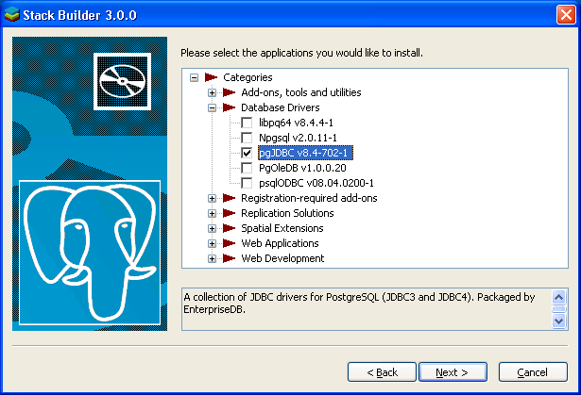

PostgreSQL JDBC Driver

If you installed PostgreSQL as described in step 2.3 above, you have been given the option to install the JDBC drivers at that point and this step will not be necessary.
JDBC provides a standard set of interfaces to SQL-compliant databases. Latest divers can be downloaded from http://jdbc.postgresql.org/.
Detailed instructions for downloading and installing PostgreSQL JDBC Diver are available at http://jdbc.postgresql.org/documentation/docs.html

NED server binaries
All necessary binaries and scripts can be found at:
- Project page - https://projects.forum.nokia.com/NED/files
- Github - https://github.com/nokiaeducationdelivery
- NED test server - http://nokiacsr.com/ned/stable/

The files that must be downloaded are:
- NEDCatalogTool2.war
- NEDAdminConsol.war
- tables_all.sql
Place all files on a folder and remember the name of the folder.

Configuration
After successful installation of Tomcat and PostgreSQL, user can start to configure the NED server.
- PostgreSQL JDBC Drivers must be copied to:
  - Tomcat 7.0 - {TOMCAT_HOME}\lib\ directory.
  - Tomcat 5.5 - {TOMCAT_HOME}\common\lib\ directory.

Typically {TOMCAT_HOME} is c:\program files\apache software foundation\tomcat 7.0

The drivers to be copied are those that were installed in steps 2.3 or 2.4 and reside in the PostgreSQL home directory {POSTGRESQL_HOME}\pgJDBC.

Typically {POSTGRESQL_HOME} is c:\program files\postgresql

Please copy files called postgresql-8.4-702.jdbc3 and postgresql-8.4-702.jdbc4 or postgresql-9.0-801.jdbc3.jar and postgresql-9.0-801.jdbc4.jar.
- If using Tomcat 7.0:
Tomcat 7.0 must be additionally configured. To do so open the ‘server.xml’ file located in {TOMCAT_HOME}\conf, find <Host> elements and add the copyXML = “true” attribute. It should look like this:
<Host name="localhost" appBase="webapps" unpackWARs="true" autoDeploy="true" copyXML="true" >
Tomcat 5.5 has this attribute set to true by default.
- All NED server binaries (NEDCatalofTool2.war and NEDAdminConsole.war) must be copied into {TOMCAT_HOME}\webapps directory.
Now the environment is ready, but to use NEDServer tools additional configuration is needed. To create necessary configuration files the Tomcat server must decompress NED servlets and its configuration files. To do so, please start the Tomcat server, for example, using the batch file ‘startup.bat ‘from {TOMCAT_HOME}\bin\. You can also launch: tomcat5.exe or tomcat5w.exe. If you installed Tomcat as a windows service, you will find an appropriate icon in the system tray.

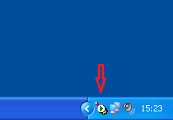

PostgreSQL DB configuration

The next thing which needs to be configured is a PostgreSQL database. To configure it you can use the ‘pgAdmin III’ application installed together with PostgreSQL. You can find it in: ‘Start’->’PostgreSQL 9.0-0’>’ pgAdmin III’.
In order to start the setup procedure you will need to log in to the database. In order to do this, double-click on PostgreSQL9.0 (localhost:5432). Use the password used during the installation which is ‘text2teach’.
After successful database login, please create a new ‘Role’. A ‘Role’ can be added in ‘LoginRoles’ branch.
To do this, right click on login roles and select a new login role
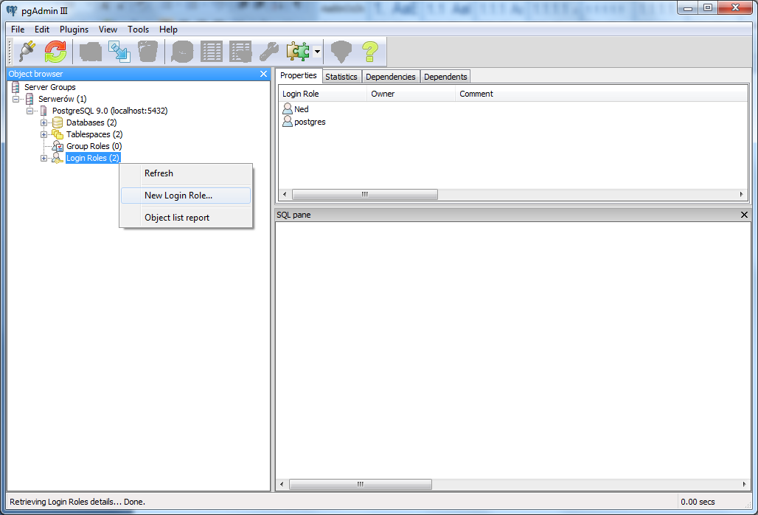

Please use ned for the name of the Role and ned for the password. Remember the password as it will be needed in the next steps.

The database can be created from the ‘Databases’ branch. Let’s name the DB - ‘ned’. From the ‘Owner’ combo-box please select the Role created in the previous step (i.e. ‘ned’). Other values can remain with default values.
To do this, right click on the Databases menu to create a new database. Please select the following values
- Name: ned
- Owner: ned (from the pull down menu)
- Leave all other values as they are

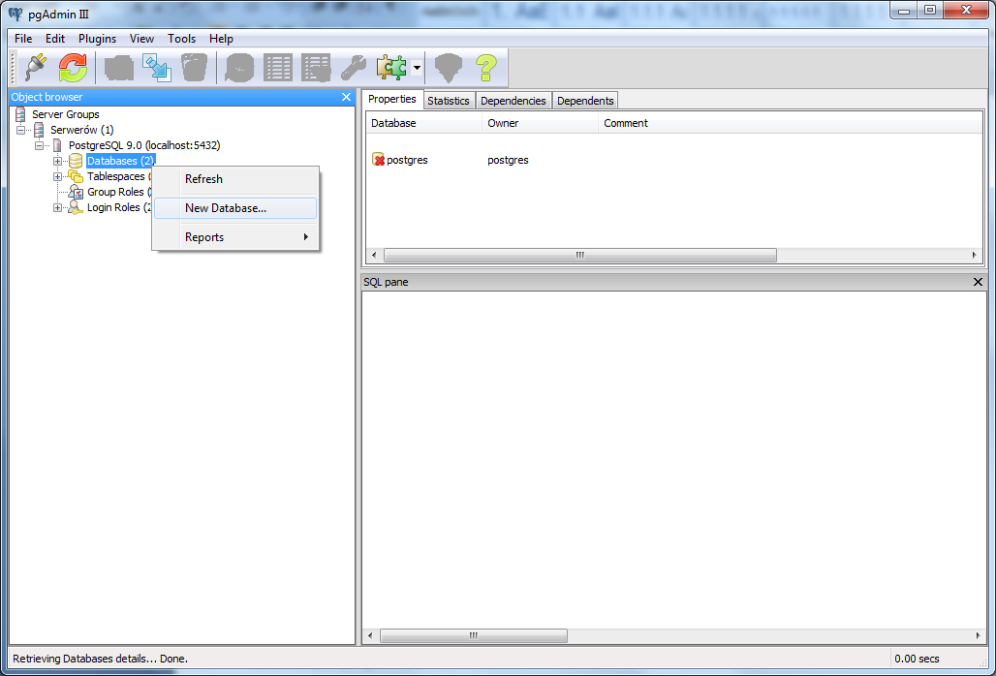

Creating the tables is a last thing to do. Please select the previously created database ‘ned’ and select ‘Tools’ -> ‘Query tool’ (Ctrl+E) from menu or from toolbox (this is the small bubble with the SQL letters inside) ‘Execute arbitrary SQL queries’.
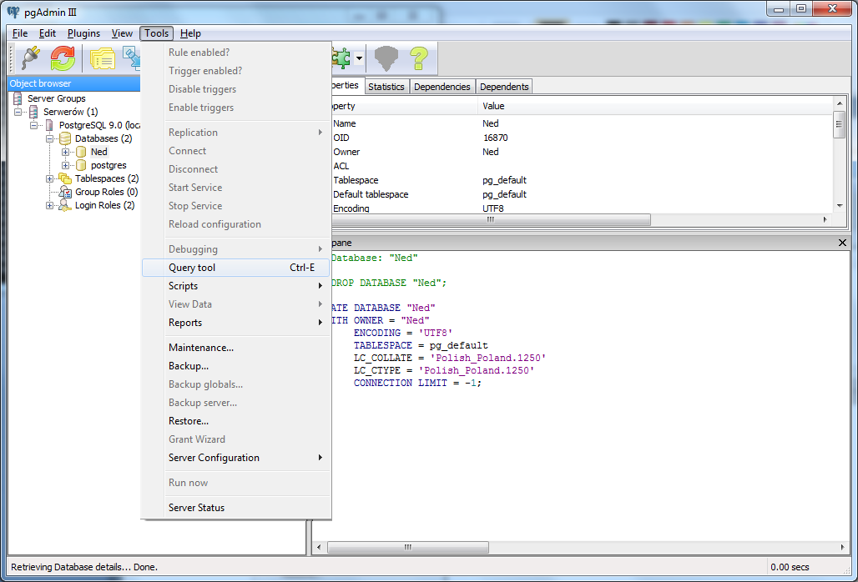
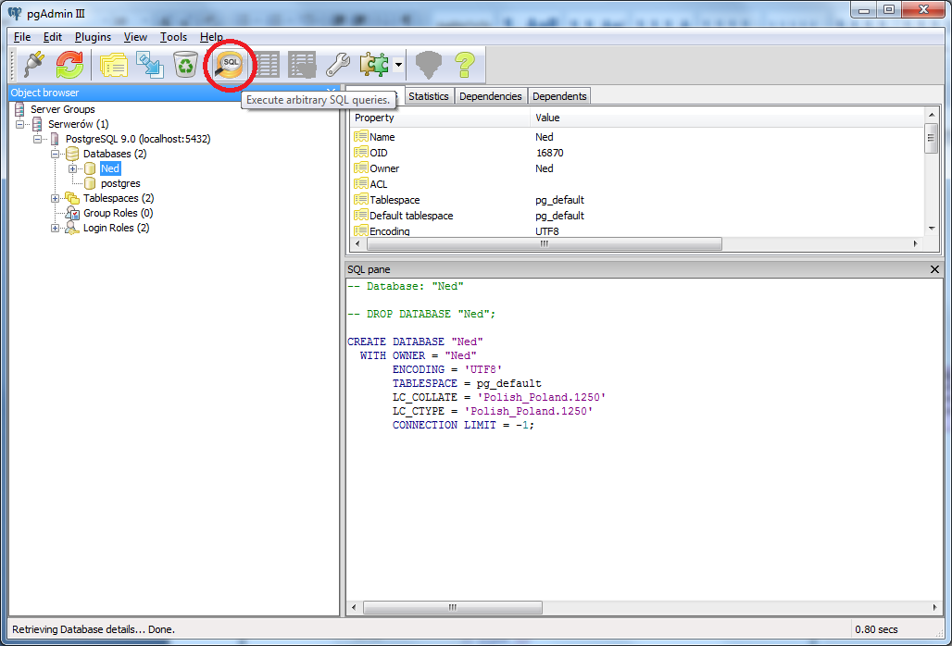

In the new window load the provided script ‘tables_all.sql’ (File->Open…) and execute it (Query->Execute). When the script completes, all required tables and function will be created in local database, on the screen some status messages will be displayed, i.e.
Query result with 1 row discarded.
Query result with 1 row discarded.
Query result with 1 row discarded.
Query result with 1 row discarded.
Query returned successfully with no result in 1315 ms.

Tomcat final configuration
Finally, configure the NEDServer services to use the previously created database. If in the previous steps you have used default values and recommended names and passwords you can skip the rest of this chapter. You are done! Your application is ready to use, just start the Tomcat server again.
Please take a look at {TOMCAT_HOME}\conf\Catalina\localhost\ and make sure that the files NEDConsoleAdmin.xml’ and ‘NEDCatalogTool2.xml’ files exist. If they do not exist then stop and re-start TOMCAT service.
In {TOMCAT_HOME}\conf\Catalina\localhost\ - you can find ‘NEDConsoleAdmin.xml’ and ‘NEDCatalogTool2.xml’ files. You need to change the default passwords to the ones you selected during PostgreSQL DB ’Role’ creation.
In the following lines of NEDCansoleAdmin.xml, please check the highlighted items and in particular the password field. Pay attention to the correct format of every field and check for correctness

<Context antiJARLocking="true" path="/NEDAdminConsole">
<Resource name="jdbc/postgres" auth="Container" type="javax.sql.DataSource" driverClassName="org.postgresql.Driver" url="jdbc:postgresql://localhost:5432/ned" username="ned" password="ned" maxActive="200" maxIdle="100" maxWait="-1" />
<Realm className="org.apache.catalina.realm.JDBCRealm" driverName="org.postgresql.Driver" connectionURL="jdbc:postgresql://localhost:5432/ned?user=ned&password=ned" userTable="users" userNameCol="name" userCredCol="password" userRoleTable="userroles" roleNameCol="role" />
</Context>

In the following lines of NEDCatalogTool2.xml, please check the highlighted items and in particular the password field. Pay attention to the correct format of every field and check for correctness

<Context antiJARLocking="true" path="/NEDCatalogTool2">
<Resource name="jdbc/postgres" auth="Container" type="javax.sql.DataSource" driverClassName="org.postgresql.Driver" url="jdbc:postgresql://127.0.0.1:5432/ned" username="ned" password="ned" maxActive="200" maxIdle="100" maxWait="-1" />
<Realm className="org.apache.catalina.realm.JDBCRealm" driverName="org.postgresql.Driver" connectionURL="jdbc:postgresql://127.0.0.1:5432/ned?user=ned&password=ned" userTable="users" userNameCol="name" userCredCol="password" userRoleTable="userroles" roleNameCol="role" />
</Context>

Note: 127.0.0.1 and the string localhost are equivalent and refer to the local loop back to your own server

Change the highlighted passwords. Now the environment is ready to use. Just start Tomcat as described in 3.0 Configuration chapter. To validate if the installation is successful, try open NEDAdminConsole (http://localhost:8080/NEDAdminConsole ) with your web browser.

Use the username admin and the password text2teach

Login page

To simplify access to administrator console user can do additional Tomcat configuration. It allows using base server address to access NED service. Instead of using http://localhost:8080/NEDAdminConsole it is enough to type http://localhost:8080
There are two possible configurations:
- Display welcome page
- Login directly to NED service
On the welcome page there are two links, one to administrator panel and another one to official project’s web page.

Welcome page
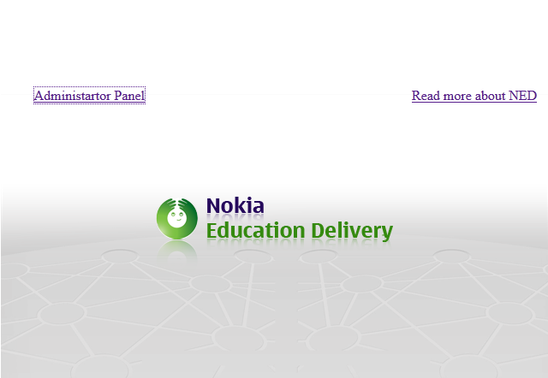

Unzip all files from ‘'welcomepage.zip’ into {TOMCAT_HOME}\webapps\ROOT\
Now instead of login dialog you will see welcome page as presented above.

Direct login

The only change in this setup is a shorter address to administrator panel.
To achieve this you need to extract ‘index.html’ from ‘autoredirect.zip’ and copy it into
{TOMCAT_HOME}\webapps\ROOT\

NED binaries upgrade procedure

In cases where there is an existing installation, you must follow this procedure to upgrade the NED binaries.

Be careful when handling the database as you could easily wipe out all the data stored. Please read the procedure carefully before proceeding

- Please do the following steps
  - On a working TOMCAT delete ‘NEDAdminConsole.war’ and ‘NEDCatalogTool.war’ from {TOMCAT_HOME}\webapps\ catalog
  - Copy new, updated version of ‘NEDAdminConsole.war’ and ‘NEDCatalogTool.war’
  - (OPTIONAL)Log in to ‘pgAdmin III’ tool and:
->Servers->PostgreSQL9.0 (localhost:5432) ->Databases->ned use action ‘Delete/Drop’ (see image) and delete the ned database. Caution, you are now deleting the ned database. Make sure this is what you want to do.

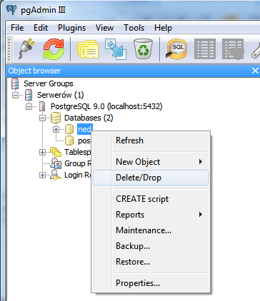
- Recreate the table as specified on section 3.1 of this manual : PostgreSQL DB configuration
- Restart Tomcat if necessary

- The latest binaries you can always be found at the NED project in Forum Nokia at https://projects.developer.nokia.com/NED/files

Password recovery

Since version 2.1 it is possible to change user password from “User Manager” tap on NEDAdmineConsole.

Although the user manual for the NED client states that a password lost cannot be recovered, this is not entirely true.
We discourage administrators from accessing this information for security reasons, but we realize that there may be occasions where accessing passwords is necessary.

Under those conditions, please use the following procedure to recover a password

Start ‘pgAdmin III’ form Start->PostgreSQL9.0->pgAdmin3 and Log in. If you have followed the default procedure in this document then the password will be text2teach
It will be different if you have chosen to do a custom installation. DB Admin passwords cannot be recovered.

Navigate to ->Servers->PostgreSQL9.0 (localhost:5432) ->Databases->ned->Schemas->public->table->users

You should now see a screen as shown on the next page:

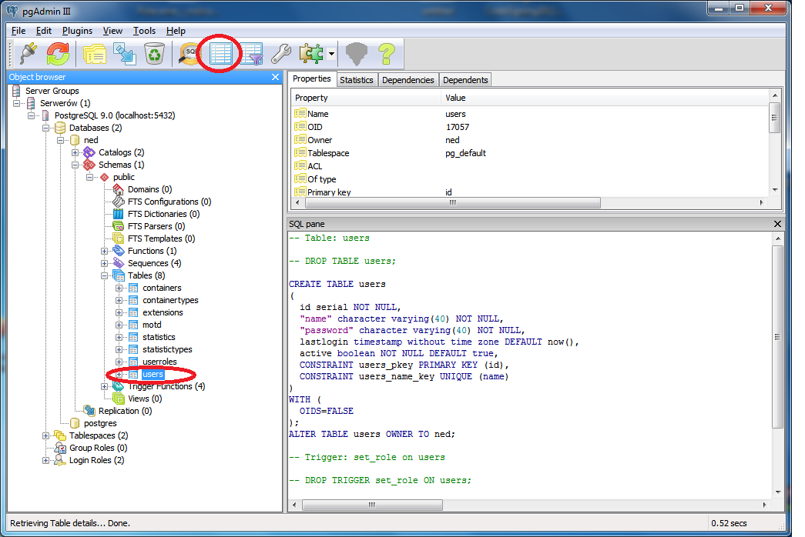

The press the “table” symbol in menu bar to reveal the database with all the user passwords, as shown below:

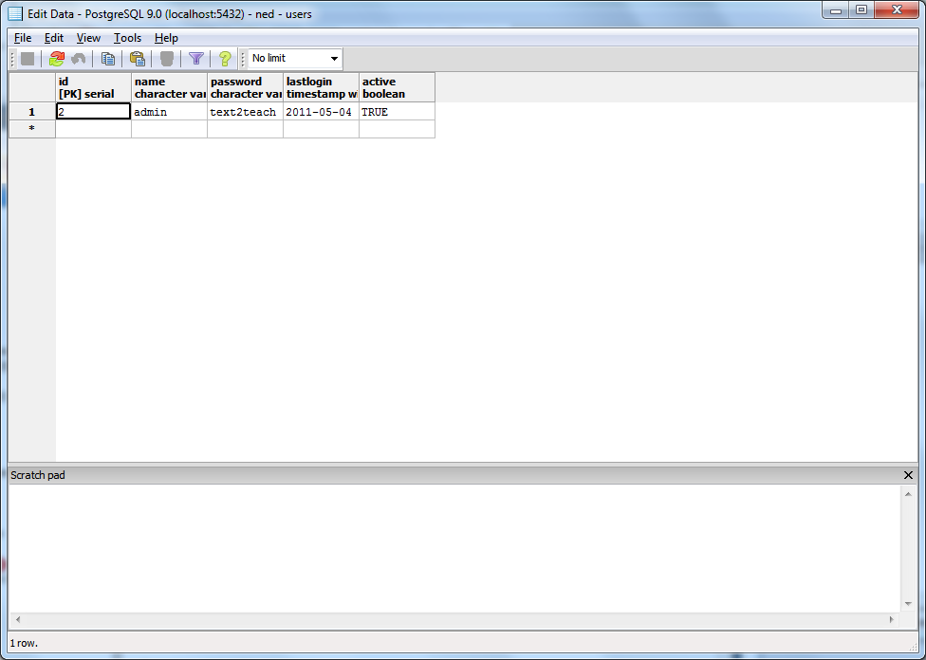

Support

We are aware that this document might not cover all topics. If you encounter any problem during installation or NED usage please contact us.

ned@freelists.org

Licenses

Tomcat

Apache Tomcat is developed in an open and participatory environment and released under the Apache License version 2

Apache License
Version 2.0, January 2004
http://www.apache.org/licenses/

TERMS AND CONDITIONS FOR USE, REPRODUCTION, AND DISTRIBUTION

1. Definitions.
"License" shall mean the terms and conditions for use, reproduction, and distribution as defined by Sections 1 through 9 of this document.
"Licensor" shall mean the copyright owner or entity authorized by the copyright owner that is granting the License.
"Legal Entity" shall mean the union of the acting entity and all other entities that control, are controlled by, or are under common control with that entity. For the purposes of this definition, "control" means (i) the power, direct or indirect, to cause the direction or management of such entity, whether by contract or otherwise, or (ii) ownership of fifty percent (50%) or more of the outstanding shares, or (iii) beneficial ownership of such entity.
"You" (or "Your") shall mean an individual or Legal Entity exercising permissions granted by this License.
"Source" form shall mean the preferred form for making modifications, including but not limited to software source code, documentation source, and configuration files.
"Object" form shall mean any form resulting from mechanical transformation or translation of a Source form, including but not limited to compiled object code, generated documentation, and conversions to other media types.
"Work" shall mean the work of authorship, whether in Source or Object form, made available under the License, as indicated by a copyright notice that is included in or attached to the work (an example is provided in the Appendix below).
"Derivative Works" shall mean any work, whether in Source or Object form, that is based on (or derived from) the Work and for which the editorial revisions, annotations, elaborations, or other modifications represent, as a whole, an original work of authorship. For the purposes of this License, Derivative Works shall not include works that remain separable from, or merely link (or bind by name) to the interfaces of, the Work and Derivative Works thereof.
"Contribution" shall mean any work of authorship, including the original version of the Work and any modifications or additions to that Work or Derivative Works thereof, that is intentionally submitted to Licensor for inclusion in the Work by the copyright owner or by an individual or Legal Entity authorized to submit on behalf of the copyright owner. For the purposes of this definition, "submitted" means any form of electronic, verbal, or written communication sent to the Licensor or its representatives, including but not limited to communication on electronic mailing lists, source code control systems, and issue tracking systems that are managed by, or on behalf of, the Licensor for the purpose of discussing and improving the Work, but excluding communication that is conspicuously marked or otherwise designated in writing by the copyright owner as "Not a Contribution."
"Contributor" shall mean Licensor and any individual or Legal Entity on behalf of whom a Contribution has been received by Licensor and subsequently incorporated within the Work.
2. Grant of Copyright License. Subject to the terms and conditions of this License, each Contributor hereby grants to You a perpetual, worldwide, non-exclusive, no-charge, royalty-free, irrevocable copyright license to reproduce, prepare Derivative Works of, publicly display, publicly perform, sublicense, and distribute the Work and such Derivative Works in Source or Object form.
3. Grant of Patent License. Subject to the terms and conditions of this License, each Contributor hereby grants to You a perpetual, worldwide, non-exclusive, no-charge, royalty-free, irrevocable (except as stated in this section) patent license to make, have made, use, offer to sell, sell, import, and otherwise transfer the Work, where such license applies only to those patent claims licensable by such Contributor that are necessarily infringed by their Contribution(s) alone or by combination of their Contribution(s) with the Work to which such Contribution(s) was submitted. If You institute patent litigation against any entity (including a cross-claim or counterclaim in a lawsuit) alleging that the Work or a Contribution incorporated within the Work constitutes direct or contributory patent infringement, then any patent licenses granted to You under this License for that Work shall terminate as of the date such litigation is filed.
4. Redistribution. You may reproduce and distribute copies of the Work or Derivative Works thereof in any medium, with or without modifications, and in Source or Object form, provided that You meet the following conditions:
- You must give any other recipients of the Work or Derivative Works a copy of this License; and
- You must cause any modified files to carry prominent notices stating that You changed the files; and
- You must retain, in the Source form of any Derivative Works that You distribute, all copyright, patent, trademark, and attribution notices from the Source form of the Work, excluding those notices that do not pertain to any part of the Derivative Works; and
- If the Work includes a "NOTICE" text file as part of its distribution, then any Derivative Works that You distribute must include a readable copy of the attribution notices contained within such NOTICE file, excluding those notices that do not pertain to any part of the Derivative Works, in at least one of the following places: within a NOTICE text file distributed as part of the Derivative Works; within the Source form or documentation, if provided along with the Derivative Works; or, within a display generated by the Derivative Works, if and wherever such third-party notices normally appear. The contents of the NOTICE file are for informational purposes only and do not modify the License. You may add Your own attribution notices within Derivative Works that You distribute, alongside or as an addendum to the NOTICE text from the Work, provided that such additional attribution notices cannot be construed as modifying the License. You may add Your own copyright statement to Your modifications and may provide additional or different license terms and conditions for use, reproduction, or distribution of Your modifications, or for any such Derivative Works as a whole, provided Your use, reproduction, and distribution of the Work otherwise complies with the conditions stated in this License.
5. Submission of Contributions. Unless You explicitly state otherwise, any Contribution intentionally submitted for inclusion in the Work by You to the Licensor shall be under the terms and conditions of this License, without any additional terms or conditions. Notwithstanding the above, nothing herein shall supersede or modify the terms of any separate license agreement you may have executed with Licensor regarding such Contributions.
6. Trademarks. This License does not grant permission to use the trade names, trademarks, service marks, or product names of the Licensor, except as required for reasonable and customary use in describing the origin of the Work and reproducing the content of the NOTICE file.
7. Disclaimer of Warranty. Unless required by applicable law or agreed to in writing, Licensor provides the Work (and each Contributor provides its Contributions) on an "AS IS" BASIS, WITHOUT WARRANTIES OR CONDITIONS OF ANY KIND, either express or implied, including, without limitation, any warranties or conditions of TITLE, NON-INFRINGEMENT, MERCHANTABILITY, or FITNESS FOR A PARTICULAR PURPOSE. You are solely responsible for determining the appropriateness of using or redistributing the Work and assume any risks associated with Your exercise of permissions under this License.
8. Limitation of Liability. In no event and under no legal theory, whether in tort (including negligence), contract, or otherwise, unless required by applicable law (such as deliberate and grossly negligent acts) or agreed to in writing, shall any Contributor be liable to You for damages, including any direct, indirect, special, incidental, or consequential damages of any character arising as a result of this License or out of the use or inability to use the Work (including but not limited to damages for loss of goodwill, work stoppage, computer failure or malfunction, or any and all other commercial damages or losses), even if such Contributor has been advised of the possibility of such damages.
9. Accepting Warranty or Additional Liability. While redistributing the Work or Derivative Works thereof, You may choose to offer, and charge a fee for, acceptance of support, warranty, indemnity, or other liability obligations and/or rights consistent with this License. However, in accepting such obligations, You may act only on Your own behalf and on Your sole responsibility, not on behalf of any other Contributor, and only if You agree to indemnify, defend, and hold each Contributor harmless for any liability incurred by, or claims asserted against, such Contributor by reason of your accepting any such warranty or additional liability.
END OF TERMS AND CONDITIONS

PostgreSQL
License

PostgreSQL is released under the PostgreSQL License, a liberal Open Source license, similar to the BSD or MIT licenses.
PostgreSQL Database Management System
(formerly known as Postgres, then as Postgres95)
Portions Copyright (c) 1996-2010, The PostgreSQL Global Development Group
Portions Copyright (c) 1994, The Regents of the University of California
Permission to use, copy, modify, and distribute this software and its documentation for any purpose, without fee, and without a written agreement is hereby granted, provided that the above copyright notice and this paragraph and the following two paragraphs appear in all copies.
IN NO EVENT SHALL THE UNIVERSITY OF CALIFORNIA BE LIABLE TO ANY PARTY FOR DIRECT, INDIRECT, SPECIAL, INCIDENTAL, OR CONSEQUENTIAL DAMAGES, INCLUDING LOST PROFITS, ARISING OUT OF THE USE OF THIS SOFTWARE AND ITS DOCUMENTATION, EVEN IF THE UNIVERSITY OF CALIFORNIA HAS BEEN ADVISED OF THE POSSIBILITY OF SUCH DAMAGE.
THE UNIVERSITY OF CALIFORNIA SPECIFICALLY DISCLAIMS ANY WARRANTIES, INCLUDING, BUT NOT LIMITED TO, THE IMPLIED WARRANTIES OF MERCHANTABILITY AND FITNESS FOR A PARTICULAR PURPOSE. THE SOFTWARE PROVIDED HEREUNDER IS ON AN "AS IS" BASIS, AND THE UNIVERSITY OF CALIFORNIA HAS NO OBLIGATIONS TO PROVIDE MAINTENANCE, SUPPORT, UPDATES, ENHANCEMENTS, OR MODIFICATIONS.

PostgreSQL JDBC Driver

BSD License

Copyright (c) 1997-2010, PostgreSQL Global Development Group
All rights reserved.

Redistribution and use in source and binary forms, with or without
modification, are permitted provided that the following conditions are met:

1. Redistributions of source code must retain the above copyright notice,
this list of conditions and the following disclaimer.
2. Redistributions in binary form must reproduce the above copyright notice,
this list of conditions and the following disclaimer in the documentation
and/or other materials provided with the distribution.
3. Neither the name of the PostgreSQL Global Development Group nor the names
of its contributors may be used to endorse or promote products derived
from this software without specific prior written permission.

THIS SOFTWARE IS PROVIDED BY THE COPYRIGHT HOLDERS AND CONTRIBUTORS "AS IS"
AND ANY EXPRESS OR IMPLIED WARRANTIES, INCLUDING, BUT NOT LIMITED TO, THE
IMPLIED WARRANTIES OF MERCHANTABILITY AND FITNESS FOR A PARTICULAR PURPOSE
ARE DISCLAIMED. IN NO EVENT SHALL THE COPYRIGHT OWNER OR CONTRIBUTORS BE
LIABLE FOR ANY DIRECT, INDIRECT, INCIDENTAL, SPECIAL, EXEMPLARY, OR
CONSEQUENTIAL DAMAGES (INCLUDING, BUT NOT LIMITED TO, PROCUREMENT OF
SUBSTITUTE GOODS OR SERVICES; LOSS OF USE, DATA, OR PROFITS; OR BUSINESS
INTERRUPTION) HOWEVER CAUSED AND ON ANY THEORY OF LIABILITY, WHETHER IN
CONTRACT, STRICT LIABILITY, OR TORT (INCLUDING NEGLIGENCE OR OTHERWISE)
ARISING IN ANY WAY OUT OF THE USE OF THIS SOFTWARE, EVEN IF ADVISED OF THE
POSSIBILITY OF SUCH DAMAGE.

Opencsv

Opencsv is developed in an open and participatory environment and released under the Apache License version 2.

Apache License
Version 2.0, January 2004
http://www.apache.org/licenses/

TERMS AND CONDITIONS FOR USE, REPRODUCTION, AND DISTRIBUTION

1. Definitions.
"License" shall mean the terms and conditions for use, reproduction, and distribution as defined by Sections 1 through 9 of this document.
"Licensor" shall mean the copyright owner or entity authorized by the copyright owner that is granting the License.
"Legal Entity" shall mean the union of the acting entity and all other entities that control, are controlled by, or are under common control with that entity. For the purposes of this definition, "control" means (i) the power, direct or indirect, to cause the direction or management of such entity, whether by contract or otherwise, or (ii) ownership of fifty percent (50%) or more of the outstanding shares, or (iii) beneficial ownership of such entity.
"You" (or "Your") shall mean an individual or Legal Entity exercising permissions granted by this License.
"Source" form shall mean the preferred form for making modifications, including but not limited to software source code, documentation source, and configuration files.
"Object" form shall mean any form resulting from mechanical transformation or translation of a Source form, including but not limited to compiled object code, generated documentation, and conversions to other media types.
"Work" shall mean the work of authorship, whether in Source or Object form, made available under the License, as indicated by a copyright notice that is included in or attached to the work (an example is provided in the Appendix below).
"Derivative Works" shall mean any work, whether in Source or Object form, that is based on (or derived from) the Work and for which the editorial revisions, annotations, elaborations, or other modifications represent, as a whole, an original work of authorship. For the purposes of this License, Derivative Works shall not include works that remain separable from, or merely link (or bind by name) to the interfaces of, the Work and Derivative Works thereof.
"Contribution" shall mean any work of authorship, including the original version of the Work and any modifications or additions to that Work or Derivative Works thereof, that is intentionally submitted to Licensor for inclusion in the Work by the copyright owner or by an individual or Legal Entity authorized to submit on behalf of the copyright owner. For the purposes of this definition, "submitted" means any form of electronic, verbal, or written communication sent to the Licensor or its representatives, including but not limited to communication on electronic mailing lists, source code control systems, and issue tracking systems that are managed by, or on behalf of, the Licensor for the purpose of discussing and improving the Work, but excluding communication that is conspicuously marked or otherwise designated in writing by the copyright owner as "Not a Contribution."
"Contributor" shall mean Licensor and any individual or Legal Entity on behalf of whom a Contribution has been received by Licensor and subsequently incorporated within the Work.
2. Grant of Copyright License. Subject to the terms and conditions of this License, each Contributor hereby grants to You a perpetual, worldwide, non-exclusive, no-charge, royalty-free, irrevocable copyright license to reproduce, prepare Derivative Works of, publicly display, publicly perform, sublicense, and distribute the Work and such Derivative Works in Source or Object form.
3. Grant of Patent License. Subject to the terms and conditions of this License, each Contributor hereby grants to You a perpetual, worldwide, non-exclusive, no-charge, royalty-free, irrevocable (except as stated in this section) patent license to make, have made, use, offer to sell, sell, import, and otherwise transfer the Work, where such license applies only to those patent claims licensable by such Contributor that are necessarily infringed by their Contribution(s) alone or by combination of their Contribution(s) with the Work to which such Contribution(s) was submitted. If You institute patent litigation against any entity (including a cross-claim or counterclaim in a lawsuit) alleging that the Work or a Contribution incorporated within the Work constitutes direct or contributory patent infringement, then any patent licenses granted to You under this License for that Work shall terminate as of the date such litigation is filed.
4. Redistribution. You may reproduce and distribute copies of the Work or Derivative Works thereof in any medium, with or without modifications, and in Source or Object form, provided that You meet the following conditions:
- You must give any other recipients of the Work or Derivative Works a copy of this License; and
- You must cause any modified files to carry prominent notices stating that You changed the files; and
- You must retain, in the Source form of any Derivative Works that You distribute, all copyright, patent, trademark, and attribution notices from the Source form of the Work, excluding those notices that do not pertain to any part of the Derivative Works; and
- If the Work includes a "NOTICE" text file as part of its distribution, then any Derivative Works that You distribute must include a readable copy of the attribution notices contained within such NOTICE file, excluding those notices that do not pertain to any part of the Derivative Works, in at least one of the following places: within a NOTICE text file distributed as part of the Derivative Works; within the Source form or documentation, if provided along with the Derivative Works; or, within a display generated by the Derivative Works, if and wherever such third-party notices normally appear. The contents of the NOTICE file are for informational purposes only and do not modify the License. You may add Your own attribution notices within Derivative Works that You distribute, alongside or as an addendum to the NOTICE text from the Work, provided that such additional attribution notices cannot be construed as modifying the License. You may add Your own copyright statement to Your modifications and may provide additional or different license terms and conditions for use, reproduction, or distribution of Your modifications, or for any such Derivative Works as a whole, provided Your use, reproduction, and distribution of the Work otherwise complies with the conditions stated in this License.
5. Submission of Contributions. Unless You explicitly state otherwise, any Contribution intentionally submitted for inclusion in the Work by You to the Licensor shall be under the terms and conditions of this License, without any additional terms or conditions. Notwithstanding the above, nothing herein shall supersede or modify the terms of any separate license agreement you may have executed with Licensor regarding such Contributions.
6. Trademarks. This License does not grant permission to use the trade names, trademarks, service marks, or product names of the Licensor, except as required for reasonable and customary use in describing the origin of the Work and reproducing the content of the NOTICE file.
7. Disclaimer of Warranty. Unless required by applicable law or agreed to in writing, Licensor provides the Work (and each Contributor provides its Contributions) on an "AS IS" BASIS, WITHOUT WARRANTIES OR CONDITIONS OF ANY KIND, either express or implied, including, without limitation, any warranties or conditions of TITLE, NON-INFRINGEMENT, MERCHANTABILITY, or FITNESS FOR A PARTICULAR PURPOSE. You are solely responsible for determining the appropriateness of using or redistributing the Work and assume any risks associated with Your exercise of permissions under this License.
8. Limitation of Liability. In no event and under no legal theory, whether in tort (including negligence), contract, or otherwise, unless required by applicable law (such as deliberate and grossly negligent acts) or agreed to in writing, shall any Contributor be liable to You for damages, including any direct, indirect, special, incidental, or consequential damages of any character arising as a result of this License or out of the use or inability to use the Work (including but not limited to damages for loss of goodwill, work stoppage, computer failure or malfunction, or any and all other commercial damages or losses), even if such Contributor has been advised of the possibility of such damages.
9. Accepting Warranty or Additional Liability. While redistributing the Work or Derivative Works thereof, You may choose to offer, and charge a fee for, acceptance of support, warranty, indemnity, or other liability obligations and/or rights consistent with this License. However, in accepting such obligations, You may act only on Your own behalf and on Your sole responsibility, not on behalf of any other Contributor, and only if You agree to indemnify, defend, and hold each Contributor harmless for any liability incurred by, or claims asserted against, such Contributor by reason of your accepting any such warranty or additional liability.
END OF TERMS AND CONDITIONS

