Nokia Education Delivery
Client Design
Team name | Author

Change history:

Version | Date | Status | Comments
0.1 | 2012.01.05 | Draft | Initial version

Glossary:

Abbreviation
NED | Nokia Education Delivery

Table of contents:

1. Packages description 3
1.1 org.ned.client 3
1.2 org.ned.client.command 3
1.3 org.ned.client.contentdata 3
1.4 org.ned.client.help 3
1.5 org.ned.client.library 4
1.6 org.ned.client.lwuitExtended 4
1.7 org.ned.client.statistics 4
1.8 org.ned.client.transfer 4
1.9 org.ned.client.utils 4
1.10 org.ned.client.view 4
1.11 org.ned.client.view.customComponents 4
1.12 org.ned.client.view.renderer 4
1.13 org.ned.client.view.style 4
2. Design overview 5

Packages description

org.ned.client
The ned package wraps helper functionality like the Logger.java class or SettingsManager.java class

org.ned.client.command
Objects in this package encapsulate mobile client actions. They are named with the suffix “Command” and inherit from the NedCommand class. Those objects link user actions, like menu selection or pressing a button, with operations on data.

For example when user wants to display help, a proper action will execute. In this case “HelpCommand”.

1  2  3  4  5  6  7 | if(param != null){  try {  new HelpView(param).show();  } catch ( Exception ex ) {  GeneralAlert.show( NedResources.DOC_NOT_SUPPORTED, GeneralAlert.WARNING );  }  }
#3 Help view will be displayed.
#5 Alert for unexisting help will be displayed

org.ned.client.contentdata
This package holds the model component which represents each level (tree branch) of a library. For example it can represent a list of items or a list of categories.

org.ned.client.help
This package contains files which hold html representation of help content.
Here is an example (StatisticsOptionScreen):

<html>
<head>
<style type="text/css">
body { background-color:#e1e1e1; }
h1 { color:#6225; text-align:left; }
p { color:#69b510; }
</style>
</head>
<body>
<p> This are settings for statistics.</p>
<h1>Manual</h1> <p>You chose when to upload usage statistics to NED server.</p>
<h1>Auto</h1> <p>Statistics are uploaded automatically.<p>
<h1></h1><p></p>
</body>
</html>

org.ned.client.library
This module contains all classes related to Library management, catalogue, category, media item models. The class VisibleLibraryModel represents a model for libraries which are enabled (marked as visible).

org.ned.client.lwuitExtended
Deliver help content to LWUIT HTMLComponent used by the help view.

org.ned.client.statistics
Classes for statistics gathering and uploading to server. The StatisticsManager class takes care of storing statistics to the file system and sends statistics information to the NED server if online connection is available. Statistics can be sent on user demand also (also handled by StatisticsManager – logically).

org.ned.client.transfer
Transfer components store to the file system, queue, and download media items. All the actual network downloading and uploading of files (also statistics) happens in this module.

org.ned.client.utils
Provides utils classes for various functionality, e.g. file and folder creation, xml parsing, media type resolving.

org.ned.client.view
This package contains all form used to display data for user. Here we have screens responsible for displaying a library list, list of catalogues/categories/media items, preview of statistics, and many, many other. This component is also responsible for interaction with user. So we also have menus, and handler responsible for key events. Each operation on UI is translates to one of action form “org.ned.client.command” package.

org.ned.client.view.customComponents
Extensions for the basic component LWUIT functionality, e.g. animated list (AnimatedList) or new progress bar (ProgressBar).

org.ned.client.view.renderer
Custom list cells for various types of lists. For example a media item requires displaying two icons and text. This is rendered here in the org.ned.client.view.rederer.MediaItemsListCellRenderer component.

org.ned.client.view.style
Defines colors which are not defined in the LWUIT resource file.

Design overview

The Diagram presented below (Diagram 1 Ned client design) is the complete map of the UI flow between Nokia Education Delivery classes in the NED java client.
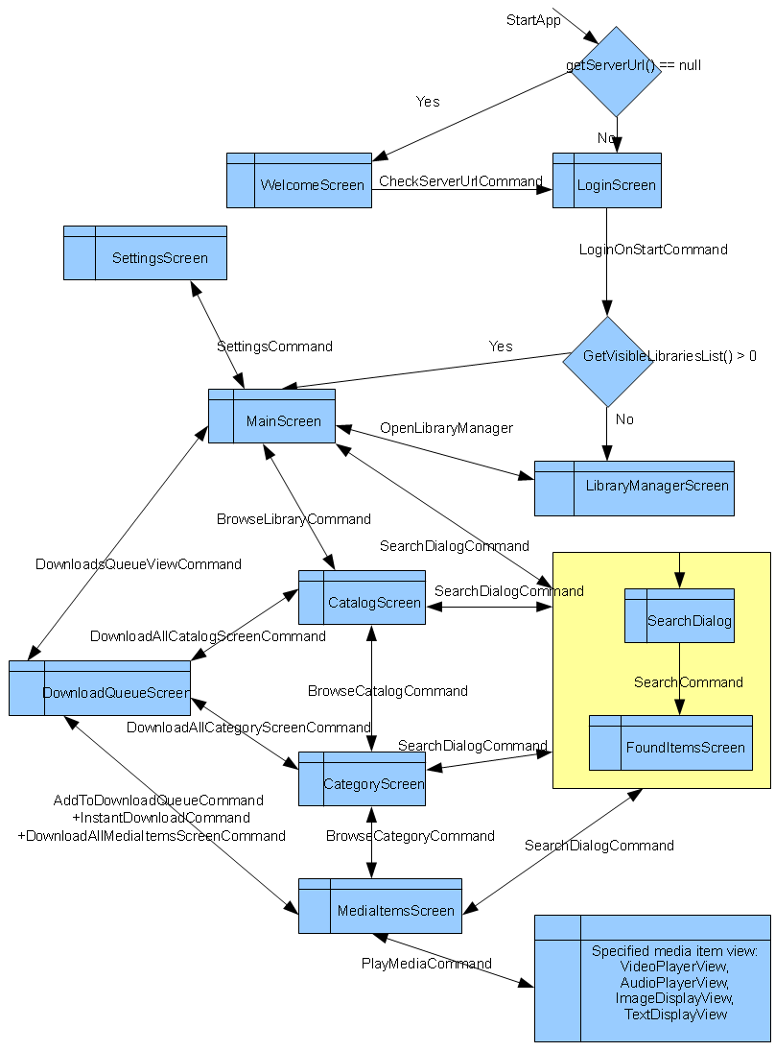
Diagram 1 Ned client design

Arrows describe the flow direction, the description texts represent commands or button actions, boxes are UI classes. To make the diagram more readable back and cancel commands are marked only as two way arrows with only one description. The “+” sign at the beginning of a description means that two actions trigger the same UI flow.
At initial startup the application directs the user to a Welcome screen, where the address of the host server can be specified. Consecutive startups will omit the Welcome screen and open the Login screen. When login succeeds the user is directed to the Main screen. If no libraries have been downloaded previously, or all of the libraries are set to be invisible, the LibraryManager screen will be displayed.
To keep the diagram clear the HelpView screen was not included. The user is directed to the help screen from every view when the HelpCommand is executed.

