Nokia Education Delivery
Server Design
Team name | Author

Change history:

Version | Date | Status | Comments
0.1 | 2012.01.05 | Draft | Initial version

Glossary:

Abbreviation
NED | Nokia Education Delivery

Table of contents:

1. NED Catalog tool 2 3
1.1.1 conf 3
1.1.2 org.ned.server.nedcatalogtool2.server 3
1.1.3 org.ned.server.nedcatalogtool2.datasource 3
1.1.4 org.ned.server.nedcatalogtool2.statistics 3
1.1.5 org.ned.server.nedcatalogtool2.utils 3
2. NED Admin Console 4
2.1.1 org.ned.server.nedadminconsole 4
2.1.2 org.ned.server.nedadminconsole.client 4
2.1.3 org.ned.server.nedadminconsole.client.callbacks 4
2.1.4 org.ned.server.nedadminconsole.client.dialogs 4
2.1.5 org.ned.server.nedadminconsole.client.interfaces 4
2.1.6 org.ned.server.nedadminconsole.client.widgets 4
2.1.7 org.ned.server.nedadminconsole.datasource 4
2.1.8 org.ned.server.nedadminconsole.server 4
2.1.9 org.ned.server.nedadminconsole.shared 4
3. Design overview 5

NED Catalog tool 2

conf
Default manifest file

org.ned.server.nedcatalogtool2.server
Exposes services for NED clients, e.g. online browsing, login, statistics uploading, etc…

org.ned.server.nedcatalogtool2.datasource
This component connects to the Postgres database and handles serialization of xml data.

org.ned.server.nedcatalogtool2.statistics
This component contains the statistics model, parses statistics coming from clients and saves them to the proper database table.

org.ned.server.nedcatalogtool2.utils
Server’s constants.

NED Admin Console

org.ned.server.nedadminconsole
Contains configuration file for gwt-servlet module and custom styles which override the default GWT styles.

org.ned.server.nedadminconsole.client
Defines services available for the web client and contains an entry point for the GWT (NedMainPage). This class is launched when the user enters the NEDAdminConsole start page.

org.ned.server.nedadminconsole.client.callbacks
Callbacks are used to handle server responses. The callbacks are set for server requests for example when we want to fetch a NED library e.g.:

void getLibraryList(AsyncCallback<List<NedObject>> callback);
where we set a NedLibraryListCallback object as callback.

org.ned.server.nedadminconsole.client.dialogs
Files which should be opened by GWT UI designer to change the page UI components.

org.ned.server.nedadminconsole.client.interfaces
Interfaces for various UI modules e.g. NedUsernameListener is an interface which represents a username input receiver (used by a text input dialog).

org.ned.server.nedadminconsole.client.widgets
Similar to dialogs, but widgets are static components, while dialogs (which are widgets) are modal components.

org.ned.server.nedadminconsole.datasource
This module is responsible for data fetching and saving to database. The class PostgresConnection contains main database connection functionality e.g. translates actions to sql statements.

org.ned.server.nedadminconsole.server
Implementation of server remote services provided to client. This includes file uploading (adding new files to NED, generating CSV file with statistics, message of the day updating etc.).

org.ned.server.nedadminconsole.shared
Shared classes used both by client and server e.g. to encapsulate data model structures.

Design overview

The following diagram (Diagram 1 Ned server design) shows basic components of the NEDAdminConsole web application.

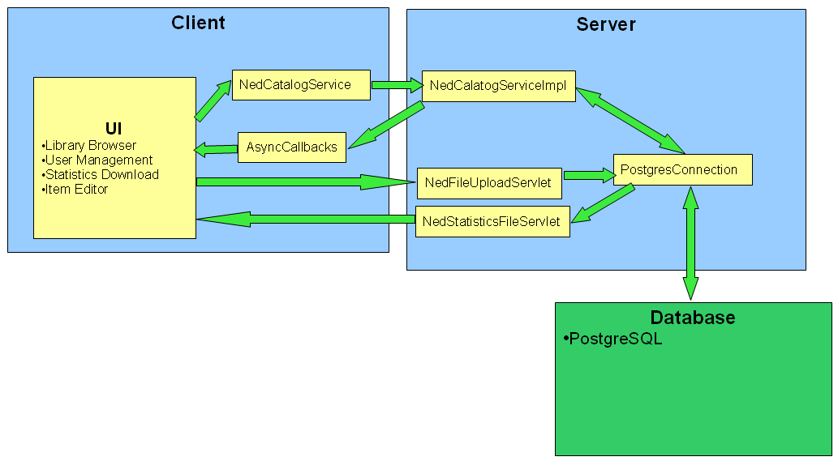
Diagram 1 Ned server design

It consists of a server part and a client part, communication between whom is performed by Asynchronous calls using a common interface which is implemented on the server part.

Communication between them is hindered by the GWT (Google Web Toolkit) Framework (which in fact is done using XMLHttpRequests). The client part must be written using only GWT libraries and contains UI code. The server side can use any available Java libraries, it provides access to database, should only contain logic to generate and parse data from database.

The server part communicates with a database using plain JDBC queries - java.sql package.

