Nokia Education Delivery
WP Client Design
Team name | Author

Change history:

Version | Date | Status | Comments
0.1 | 2012.01.05 | Draft | Initial version

Glossary:

Abbreviation
NED | Nokia Education Delivery
WP | Windows Phone

Table of contents:

1. Packages 3
1.1 nedwp 3
1.2 nedwp.Commands 3
1.3 nedwp.Controls 3
1.4 nedwp.Engine 3
1.5 nedwp.Resources 3
1.6 nedwp.Resources.Icons 3
1.7 nedwp.Resources.MediaItemIcons 3
1.8 nedwp.Resources.OriginalPlatrormIcons 3
1.9 nedwp.Resources.Languages 3
2. Design overview 4

Packages

nedwp
Main package of the project, contains App.xml/.cs which describe application, indicates main application page. Package also contains all application pages for example SettingsPage.xaml, StatisticsPage.xaml and related to them *.cs files.

nedwp.Commands
Package contains frequently executed commands like DownloadCommand DeleteLibraryItemCommand etc. All commands implements ICommand interface.

nedwp.Controls
This package holds user controls made to play media items and shows them in list boxes. In this package you can find also ProgressDialog which is used to indicate long term operation in progress.

nedwp.Engine
This package contains all application business. Main class in this package is Engine. In application is only one instance of this class located in App object. Engine class contains a few managers which are responsible for downloads, statistic operations, database operations etc.
Package holds also implementation of each manager and data models like User which contains user data, for example Username, Password, Downloads, Libraries.

nedwp.Resources
This module contains all resource files. Languages translations, icons, help data. HelpData.xml is responsible for deliver help content to help view.

nedwp.Resources.Icons
In this package you can find icons to user controls.

nedwp.Resources.MediaItemIcons
Contains icons which are shown in media items lists.

nedwp.Resources.OriginalPlatrormIcons
Deliver icons to show in applications bar.

nedwp.Resources.Languages
This package holds resource tables with each language translations and one class responsible for deliver translation to controls content in xml files.

Design overview

The Diagram presented below is the complete map of the UI flow between Nokia Education Delivery pages in the NED Windows Phone 7 client.
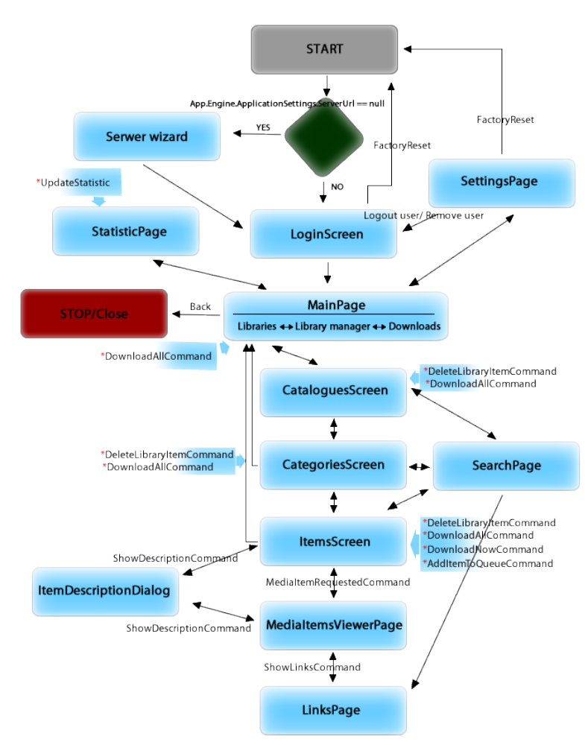
Diagram NED client design
Arrows describe the flow direction, the description texts represent commands or button actions, boxes are UI classes. To make the diagram more readable back and cancel commands are marked only as two way arrows with only one description. The “*” sign at the beginning of a description, means that action don’t navigate User to different page, just make some action and refresh UI.
To keep the diagram clear the HelpPage screen was not included. The user is directed to the help screen from every view when the Help button is clicked.

