Nokia Education Delivery
Content Publishing
Team name | Author

Change history:

Version | Date | Status | Comments
0.1 | 2011.06.14 | Draft | Initial version
0.2 | 2011.06.15 | Candidate | Some corrections
0.3 | 2011.06.16 | Candidate | Merge with document creation
0.4 | 2012.01.05 | Candidate | Update to 2.1. Editorial changes. Spellings & typos

Glossary:

Abbreviation
NED | Nokia Education Delivery

Table of contents:

1. Library creation 3
1.1 Main panel 4
1.2 Creating Library 4
1.3 Creating Catalogue and Category 7
1.4 Adding Media Item to Category 8
1.5 Removing an element 10
2. Text document creation 11
3. PDF support 14

Library creation
This document describes and illustrates the process of creating the NED library in NEDAdminConsole. All media management to be used by the NED software is maintained via the NEDAdminConsole.
During the installation of the system, the admin will have set up the administrator password. You will need to know this password before you are allowed to enter the management system.
You will also need to know the URL of the machine that is serving the content. The URL is normally in terms of http://xxx.xxx.xxx.xxx:8080/NEDAdminConsole/ where xxx.xxx.xxx.xxx is the IP address of the server OR the name of the server.
For example if the name of the server is myserver then you would type http://myserver.com:8080/NEDAdminConsole/ . Note the format. It is very important you follow this format.
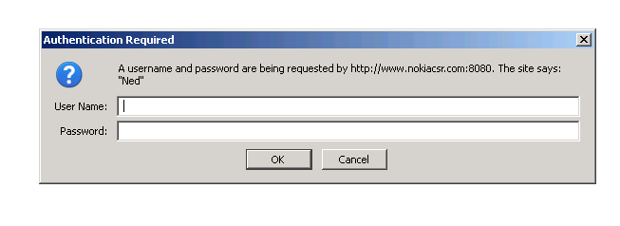
The username is always admin. The password is whatever you chose during the installation

The binaries have been tested under Windows XP, Windows Server 2008 and Windows 7. You may use other operating systems at your own discretion and we cannot guarantee it will display properly.
We recommend that you use Firefox version 4.0 or higher to access the tool. It also works well with Internet Explorer version 8 or higher. You may use other browsers at your own discretion and we cannot guarantee that it will display properly.
After you have entered your credentials you will be taken to the Main Panel

Main panel
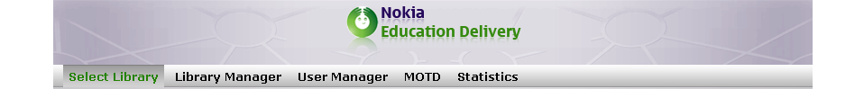
- Select Library: List of available libraries to choose
- Library Manager: Managing NED libraries.
- User Management: Panel to add/remove users and change passwords.
- MOTD: Panel with “Message of the Day” setup screen.
- Export statistics: allows to download a CSV file with statistics

Creating Library
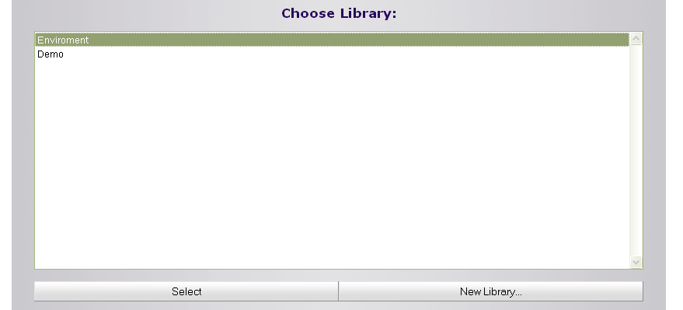
Open Library Select panel. It is displayed right after the website finishes loading or after pressing Select Library from the main screen. It allows to Select a working library or to create a New Library.
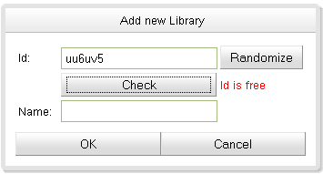
Create a new library: click the “New Library...” button and the following dialog will be displayed:
Enter or randomize the library Id. This is a unique sequence that will be used to identify the library. Enter the library Name.
Choose the created library by selecting it on the list and by pressing Select or double clicking it. The displayed Library Manager panel can be used to manage libraries’ content.

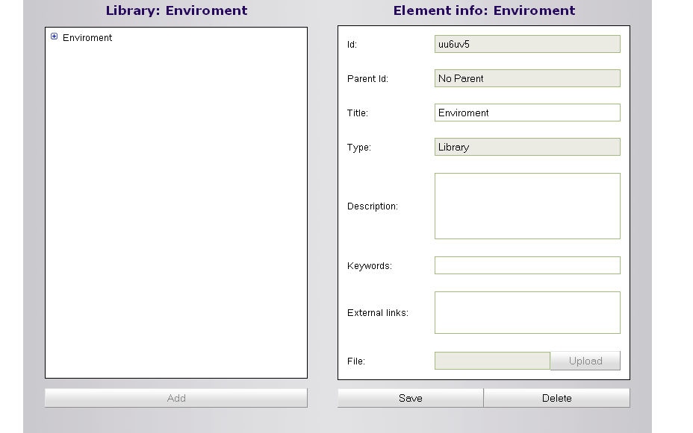

On the left panel there is a tree view that represents the library in the following form:
- Library
  - Catalogue 1
    - Category 1
      - Media Item 1
      - Media Item 2
      - Media Item 3
  - Catalogue 2
    - Category 2
      - Media Item 4
      - Media Item 5
      - Media Item 6
      - Media Item 7
    - Category 3
      - Media Item 8

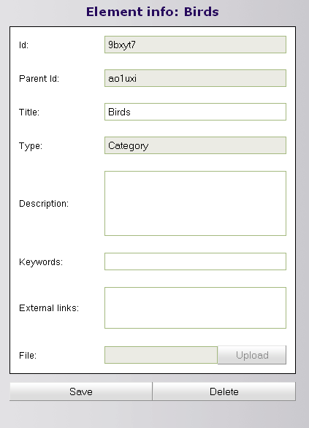
The right panel allows adding a description to an element (library, catalogue, category or item), keywords which are used for looking up the element (comma separated) and external links providing additional information on the subject (one link per line). To commit changes click Save.

Creating Catalogue and Category
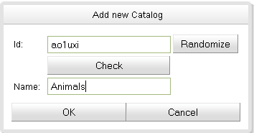
Select the newly created library (environment) and click Add Catalog. This will add a catalogue under library. Add an Id and choose the new catalogue’s Name.
Select the created catalogue and add a category in the same way. There can be many catalogues under a library and many categories under the same catalogue.
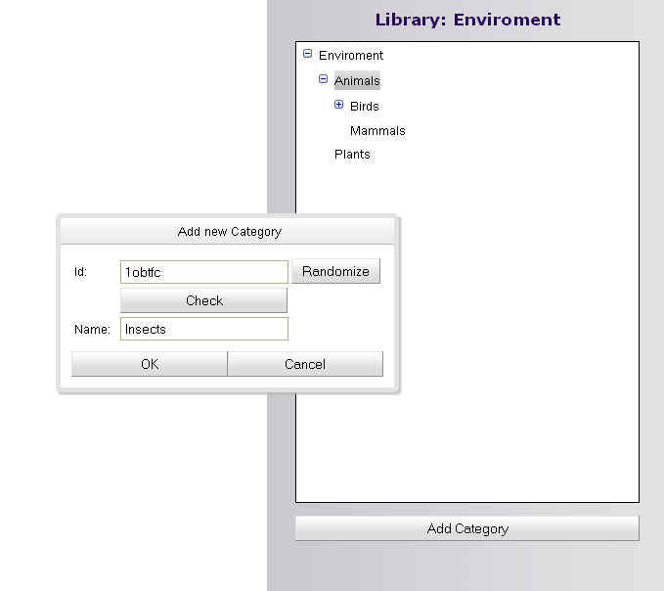

Adding Media Item to Category
Select the category where the new item should be placed and click Add Media Item. Enter the Id and Name and click save the. Select the new item and on the right panel add a Description, Keywords and External links if necessary.
On the right panel there is one option available in case of a media item: file Upload.
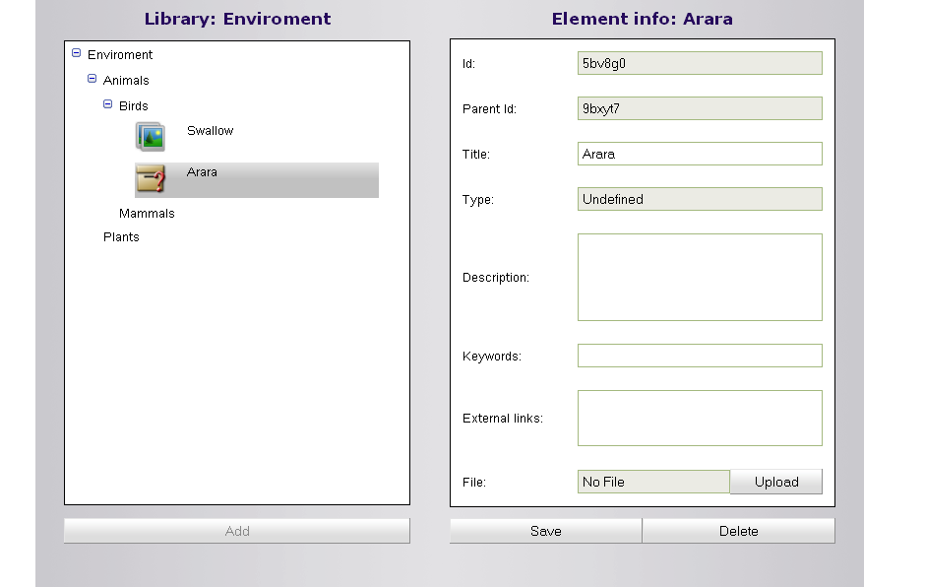

Click it and choose the media to upload. If the file is in an unsupported format a proper message will be displayed and the upload will be cancelled.
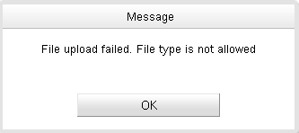

If the file is recognized it will be added to the item and a proper icon and type will be displayed.
Click Save to commit changes.
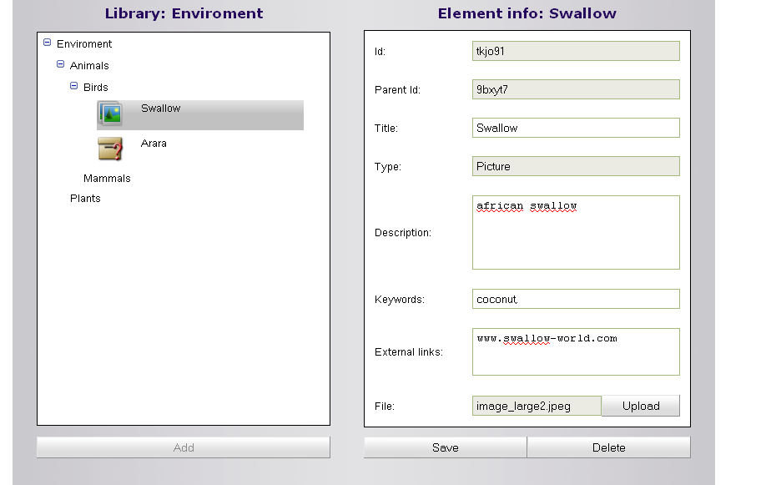

There are a few principles that you must keep in mind while updating the fields in the NEDAdminConsole. There are:
You may change all the white fields. Greyed out fields may not be changed. A title may not be more than 40 characters in length
You may add as many keywords as you see it fit to help in the search algorithm. All keywords MUST be separated by a comma. There is a limit of 15 characters for a keyword
You may also enter links of interest. There is a limit of 150 characters for the link Please be aware that long links are hard to see in small screens. You may also enter more than one link as long as each link is separated by a blank line.

Removing an element

Select the item to delete from the left panel and click Delete on the right panel. Deleting an item removes all its children. This will have an immediately effect so be sure to delete the correct items.

Text document creation
This chapter introduces instructions on how to create document for NED libraries. The NED client is able to display documents which follow the XHTML-MP 1.0 specification. Please note that not all elements of this standard are supported.
To create a document, which later can be displayed in NED2.0 we recommend using an on-line tool - Cross-Browser Rich Text Editor - which can be found at:
http://www.kevinroth.com/rte/demo.htm
This simple editor delivers all necessary functions to format text and create simple tables. Changing font sizes directly does not work on the client’s application. To change sizes please use the “Style” functionality.
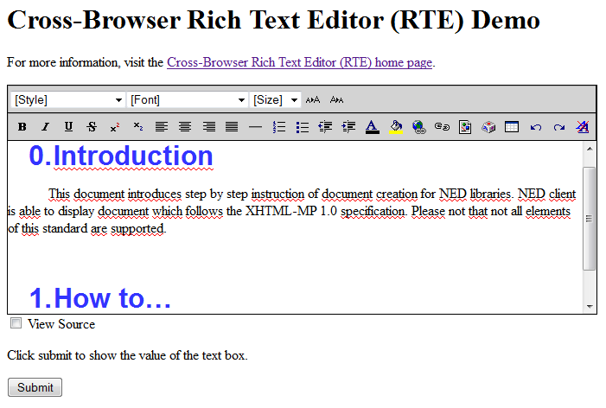
When the document is ready, the next step is to export it’s formatted text into rich text format and save it as a text file.
Here are the steps necessary to create a file that can be read and displayed properly in NED2.0
- Prepare a text file. You can do this using MS Windows Notepad and name the file with the extension “.rtf” (e.g. NED_Documentation.rtf). You can use any text file editor. DO NOT use a full featured editor like MS Word, etc.
- Open the link, with suggested Rich Text Editor, using a browser, to reveal an application for you to create the document.
- Create the document with all the features and highlights available to you on this application.
- When your text is ready, click on the ’View Source’ check box to obtain the actual HTML code that will display your text properly.
- Copy the content and paste it back to the document you created on step 1
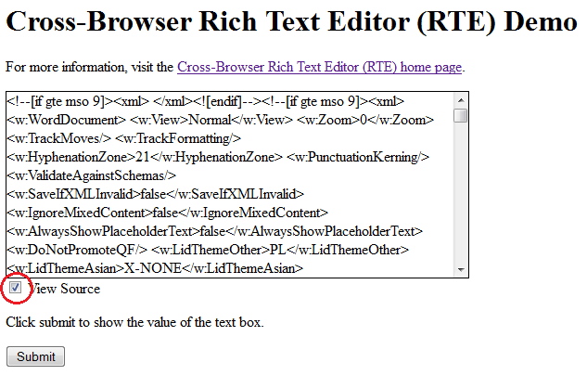
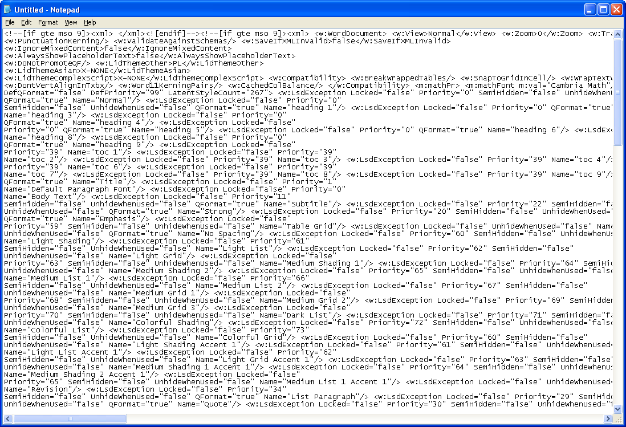

This text file can now be uploaded into the NED libraries by NEDAdminConsole as explained in chapter 1.4.

PDF support
Devices with Symbian S60 and Symbian^3 are able to render PDF documents, as long you have installed an external PDF viewer. On most devices Adobe Reader is preinstalled. Those devices can open standard PDF files in the same way you can open them on your PC. However, due to smaller screens on mobile devices, when creating learning materials dedicated for NED, we recommend using slightly bigger font sizes than usually used in such documents. The standard A4 page format with font sizes16 to18 pts looks fine on a phone’s screen.

