Assalamu Alikum, Now I will continue the presentation by giving a synthesis of our thesis.  
We started with a small wrist X-ray dataset and we trained five strong CNN Models EfficientNetB2, DenseNet169, InceptionV3, Xception, NASNetMobile.

After that we take best 2 model DenseNet169 and InceptionV3 then concatenate them and proposed a new model WristNet.

We see in previous slides the performance of our models and they performed very well all individuals.

And also, we augmented images better generalization to improve learning.

**And our Key Insight is Feature**-level fusion enables strong performance even with limited data.  
  
**Now Comparison of our proposed model WristNet and our base paper model LSNet**

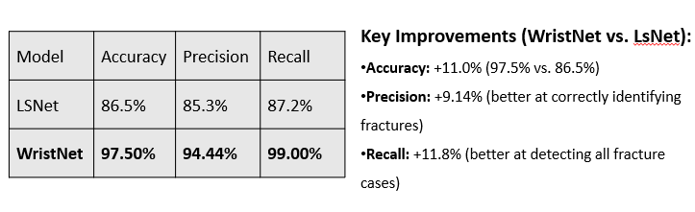

**In future work, we will build on these results in several ways.**

We can Expand the dataset with more diverse wrist X-ray images and other parts of human body.

Also, Explore other advanced CNN architectures for further improvement.

Third, Optimize WristNet for real-time clinical deployment on medical equipment.

And also Evaluate performance on external/public datasets for generalization.

Lastly, develop a user-friendly application for radiologists it will increases the robustness of this field.

**To conclude,**

**we have presented WristNet**, a **concatenation** of DenseNet169 and InceptionV3, achieved 97.50% accuracy, surpassing LSNet by 11%. We applied **feature concatenation** to combine the strengths of these models into a single fused model.

This work reflects our contribution to advancing deep learning in medical imaging, with the goal of improving diagnostic accuracy and efficiency in clinical practice.

**Thank you for your attention. We welcome any questions or discussion about the work.**