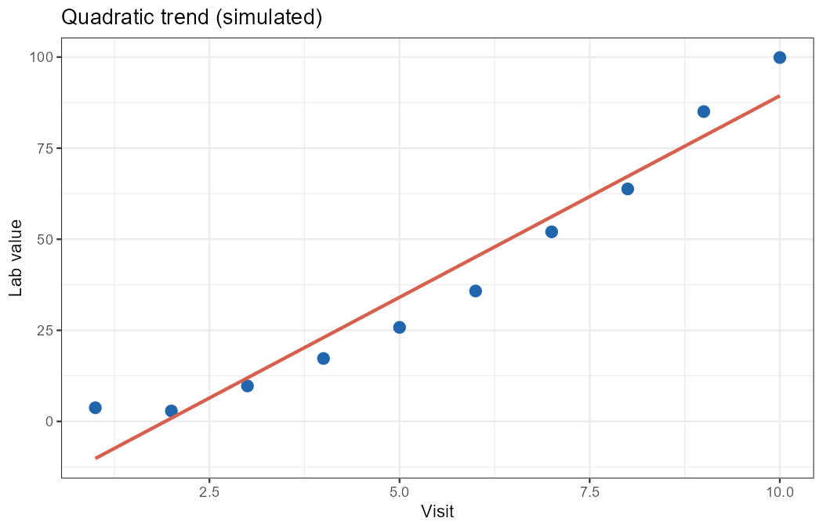
Subject | Age | Sex
001 | 34 | M
002 | 45 | F
003 | 28 | M

