Untitled

Bradley Ruiz

4/26/2021

auto.arima(narcotics_ts)

## Series: narcotics_ts   
## ARIMA(1,1,0)(2,0,1)[12]   
##   
## Coefficients:  
## ar1 sar1 sar2 sma1  
## -0.3554 -1.1224 -0.4691 0.8809  
## s.e. 0.0872 0.1112 0.0914 0.1802  
##   
## sigma^2 estimated as 2.796e-08: log likelihood=862.81  
## AIC=-1715.62 AICc=-1715.09 BIC=-1701.73

narcotics_model1 <- sarima(narcotics_ts,1,1,0,2,0,1,12)

## initial value -8.576288   
## iter 2 value -8.672638  
## iter 3 value -8.680780  
## iter 4 value -8.684208  
## iter 5 value -8.687024  
## iter 6 value -8.691130  
## iter 7 value -8.694727  
## iter 8 value -8.708317  
## iter 9 value -8.713666  
## iter 10 value -8.722006  
## iter 11 value -8.723199  
## iter 12 value -8.726295  
## iter 13 value -8.726343  
## iter 14 value -8.726382  
## iter 15 value -8.726397  
## iter 16 value -8.726408  
## iter 17 value -8.726408  
## iter 17 value -8.726408  
## iter 17 value -8.726408  
## final value -8.726408   
## converged  
## initial value -8.645542   
## iter 2 value -8.653096  
## iter 3 value -8.661761  
## iter 4 value -8.663257  
## iter 5 value -8.667075  
## iter 6 value -8.669409  
## iter 7 value -8.669940  
## iter 8 value -8.670155  
## iter 9 value -8.670204  
## iter 10 value -8.670216  
## iter 10 value -8.670216  
## iter 10 value -8.670216  
## final value -8.670216   
## converged

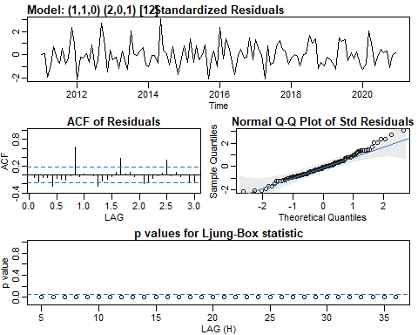

narcotics_model2 <- sarima(narcotics_ts,1,1,0,2,0,1,12, no.constant = TRUE)

## initial value -8.576240   
## iter 2 value -8.672340  
## iter 3 value -8.681242  
## iter 4 value -8.687701  
## iter 5 value -8.689898  
## iter 6 value -8.701934  
## iter 7 value -8.707652  
## iter 8 value -8.712810  
## iter 9 value -8.714159  
## iter 10 value -8.723105  
## iter 11 value -8.724429  
## iter 12 value -8.725023  
## iter 13 value -8.725401  
## iter 14 value -8.725530  
## iter 15 value -8.725532  
## iter 15 value -8.725532  
## iter 15 value -8.725532  
## final value -8.725532   
## converged  
## initial value -8.644710   
## iter 2 value -8.652407  
## iter 3 value -8.661501  
## iter 4 value -8.664631  
## iter 5 value -8.668409  
## iter 6 value -8.668849  
## iter 7 value -8.669183  
## iter 8 value -8.669351  
## iter 9 value -8.669422  
## iter 10 value -8.669457  
## iter 11 value -8.669459  
## iter 12 value -8.669460  
## iter 12 value -8.669460  
## iter 12 value -8.669460  
## final value -8.669460   
## converged

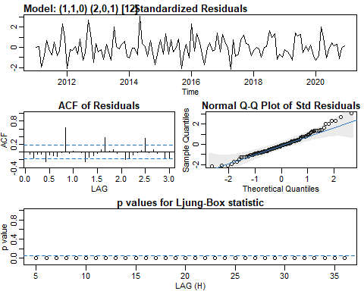

narcotics_model3 <- sarima(narcotics_ts,1,1,0,2,0,1,10)

## initial value -8.566221   
## iter 2 value -8.740712  
## iter 3 value -9.001212  
## iter 4 value -9.027547  
## iter 5 value -9.037502  
## iter 6 value -9.043121  
## iter 7 value -9.049066  
## iter 8 value -9.049871  
## iter 9 value -9.053085  
## iter 10 value -9.053735  
## iter 11 value -9.053823  
## iter 12 value -9.053824  
## iter 12 value -9.053824  
## final value -9.053824   
## converged  
## initial value -8.973909   
## iter 2 value -8.988252  
## iter 3 value -8.992367  
## iter 4 value -8.993155  
## iter 5 value -8.993583  
## iter 6 value -8.994687  
## iter 7 value -8.996163  
## iter 8 value -8.996869  
## iter 9 value -8.997653  
## iter 10 value -8.998505  
## iter 11 value -8.998608  
## iter 12 value -8.998618  
## iter 13 value -8.998620  
## iter 14 value -8.998621  
## iter 15 value -8.998621  
## iter 16 value -8.998621  
## iter 16 value -8.998622  
## iter 16 value -8.998622  
## final value -8.998622   
## converged

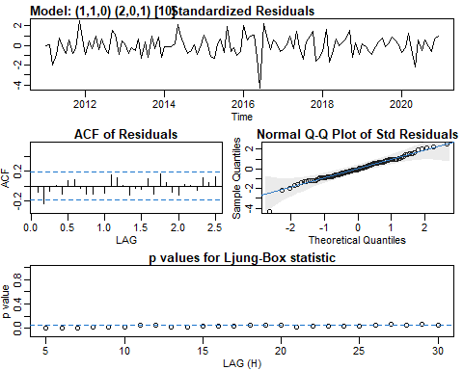

narcotics_model4 <- sarima(narcotics_ts,1,1,0,1,0,1,10, no.constant = TRUE)

## initial value -8.533517   
## iter 2 value -8.832104  
## iter 3 value -8.990947  
## iter 4 value -9.021689  
## iter 5 value -9.035378  
## iter 6 value -9.053348  
## iter 7 value -9.065221  
## iter 8 value -9.069569  
## iter 9 value -9.070441  
## iter 10 value -9.077106  
## iter 11 value -9.084935  
## iter 12 value -9.085105  
## iter 13 value -9.085109  
## iter 13 value -9.085109  
## iter 13 value -9.085109  
## final value -9.085109   
## converged  
## initial value -8.972975   
## iter 2 value -8.987621  
## iter 3 value -9.002280  
## iter 4 value -9.004237  
## iter 5 value -9.004635  
## iter 6 value -9.004663  
## iter 7 value -9.004750  
## iter 8 value -9.004782  
## iter 9 value -9.004790  
## iter 10 value -9.004791  
## iter 11 value -9.004792  
## iter 12 value -9.004794  
## iter 13 value -9.004794  
## iter 14 value -9.004794  
## iter 14 value -9.004794  
## iter 14 value -9.004794  
## final value -9.004794   
## converged

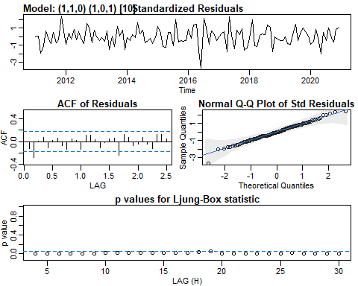

narcotics_model5 <- sarima(narcotics_ts,0,1,1,1,0,1,10, no.constant = TRUE)

## initial value -8.538114   
## iter 2 value -8.844789  
## iter 3 value -9.017328  
## iter 4 value -9.088363  
## iter 5 value -9.168584  
## iter 6 value -9.177777  
## iter 7 value -9.194900  
## iter 8 value -9.197756  
## iter 9 value -9.206883  
## iter 10 value -9.212545  
## iter 11 value -9.213694  
## iter 12 value -9.223048  
## iter 13 value -9.224407  
## iter 14 value -9.226223  
## iter 15 value -9.228803  
## iter 16 value -9.231961  
## iter 17 value -9.232135  
## iter 18 value -9.233498  
## iter 19 value -9.235192  
## iter 20 value -9.235832  
## iter 21 value -9.237077  
## iter 22 value -9.238102  
## iter 23 value -9.239253  
## iter 24 value -9.239263  
## iter 25 value -9.239532  
## iter 26 value -9.239891  
## iter 27 value -9.240464  
## iter 28 value -9.240931  
## iter 29 value -9.241362  
## iter 29 value -9.241362  
## iter 30 value -9.241369  
## iter 30 value -9.241369  
## iter 31 value -9.241370  
## iter 31 value -9.241370  
## iter 32 value -9.241371  
## iter 32 value -9.241371  
## iter 32 value -9.241371  
## final value -9.241371   
## converged  
## initial value -9.089464   
## iter 2 value -9.092311  
## iter 3 value -9.115891  
## iter 4 value -9.122499  
## iter 5 value -9.126889  
## iter 6 value -9.134854  
## iter 7 value -9.138055  
## iter 8 value -9.139097  
## iter 9 value -9.141113  
## iter 10 value -9.141468  
## iter 11 value -9.141518  
## iter 12 value -9.141586  
## iter 13 value -9.141628  
## iter 14 value -9.141634  
## iter 15 value -9.141653  
## iter 16 value -9.141672  
## iter 17 value -9.141753  
## iter 18 value -9.141754  
## iter 18 value -9.141754  
## iter 18 value -9.141754  
## final value -9.141754   
## converged

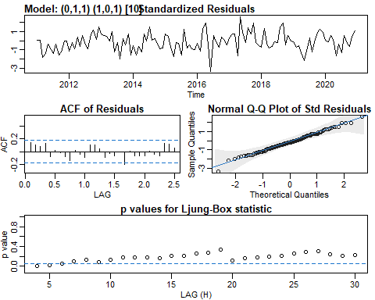

round(ARMAtoAR(ar = c(0,0,0,0,0,0,0,0,.9528), ma = c(-.9783,0,0,0,0,0,0,0,0,-.5613,.5491),   
 lag.max = 50))

## [1] 1 1 1 1 1 1 1 1 0 0 0 0 0 0 0 0 0 0 0 0 0 0 0 0 0 0 0 0 0 0 0 0 0 0 0 0 0 0  
## [39] 0 0 0 0 0 0 0 0 0 0 0 0

round(ARMAtoMA(ar = c(0,0,0,0,0,0,0,0,.9528), ma = c(-.9783,0,0,0,0,0,0,0,0,-.5613,.5491),   
 lag.max = 500))

## [1] -1 0 0 0 0 0 0 0 1 -1 1 0 0 0 0 0 0 1 -1 1 0 0 0 0 0  
## [26] 0 1 -1 0 0 0 0 0 0 0 1 -1 0 0 0 0 0 0 0 1 -1 0 0 0 0  
## [51] 0 0 0 1 -1 0 0 0 0 0 0 0 1 -1 0 0 0 0 0 0 0 1 -1 0 0  
## [76] 0 0 0 0 0 1 -1 0 0 0 0 0 0 0 1 -1 0 0 0 0 0 0 0 1 -1  
## [101] 0 0 0 0 0 0 0 1 -1 0 0 0 0 0 0 0 1 -1 0 0 0 0 0 0 0  
## [126] 1 -1 0 0 0 0 0 0 0 0 -1 0 0 0 0 0 0 0 0 -1 0 0 0 0 0  
## [151] 0 0 0 -1 0 0 0 0 0 0 0 0 -1 0 0 0 0 0 0 0 0 -1 0 0 0  
## [176] 0 0 0 0 0 -1 0 0 0 0 0 0 0 0 -1 0 0 0 0 0 0 0 0 -1 0  
## [201] 0 0 0 0 0 0 0 -1 0 0 0 0 0 0 0 0 0 0 0 0 0 0 0 0 0  
## [226] 0 0 0 0 0 0 0 0 0 0 0 0 0 0 0 0 0 0 0 0 0 0 0 0 0  
## [251] 0 0 0 0 0 0 0 0 0 0 0 0 0 0 0 0 0 0 0 0 0 0 0 0 0  
## [276] 0 0 0 0 0 0 0 0 0 0 0 0 0 0 0 0 0 0 0 0 0 0 0 0 0  
## [301] 0 0 0 0 0 0 0 0 0 0 0 0 0 0 0 0 0 0 0 0 0 0 0 0 0  
## [326] 0 0 0 0 0 0 0 0 0 0 0 0 0 0 0 0 0 0 0 0 0 0 0 0 0  
## [351] 0 0 0 0 0 0 0 0 0 0 0 0 0 0 0 0 0 0 0 0 0 0 0 0 0  
## [376] 0 0 0 0 0 0 0 0 0 0 0 0 0 0 0 0 0 0 0 0 0 0 0 0 0  
## [401] 0 0 0 0 0 0 0 0 0 0 0 0 0 0 0 0 0 0 0 0 0 0 0 0 0  
## [426] 0 0 0 0 0 0 0 0 0 0 0 0 0 0 0 0 0 0 0 0 0 0 0 0 0  
## [451] 0 0 0 0 0 0 0 0 0 0 0 0 0 0 0 0 0 0 0 0 0 0 0 0 0  
## [476] 0 0 0 0 0 0 0 0 0 0 0 0 0 0 0 0 0 0 0 0 0 0 0 0 0

polyroot(.9528)

## complex(0)

polyroot(c(-.9783, -.5613, .5491))

## [1] -0.9181828+0i 1.9404009+0i

narcotics_forecast <- sarima.for(narcotics_ts,24,0,1,1,1,0,1,10, no.constant = TRUE)

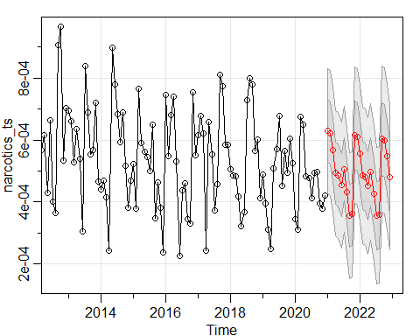

auto.arima(theft_ts)

## Series: theft_ts   
## ARIMA(2,0,2)(0,0,1)[12] with non-zero mean   
##   
## Coefficients:  
## ar1 ar2 ma1 ma2 sma1 mean  
## -0.0465 0.9223 0.0629 -0.7402 -0.2647 0.0013  
## s.e. 0.0622 0.0615 0.0921 0.0867 0.1176 0.0001  
##   
## sigma^2 estimated as 1.526e-08: log likelihood=911.97  
## AIC=-1809.95 AICc=-1808.95 BIC=-1790.44

theft_model1 <- sarima(theft_ts,2,0,2,0,0,1,12, no.constant = TRUE)

## initial value -6.631490   
## iter 2 value -7.078146  
## iter 3 value -7.120944  
## iter 4 value -7.490574  
## iter 5 value -8.170512  
## iter 6 value -8.173278  
## iter 7 value -8.325231  
## iter 8 value -8.370736  
## iter 9 value -8.469228  
## iter 10 value -8.516056  
## iter 11 value -8.568982  
## iter 12 value -8.649702  
## iter 13 value -8.666390  
## iter 14 value -8.714123  
## iter 15 value -8.771850  
## iter 16 value -8.835447  
## iter 17 value -8.906413  
## iter 18 value -8.938359  
## iter 19 value -8.952470  
## iter 20 value -8.954849  
## iter 21 value -8.964739  
## iter 22 value -8.965320  
## iter 23 value -8.976692  
## iter 24 value -8.978264  
## iter 25 value -8.982022  
## iter 26 value -8.986775  
## iter 27 value -8.991124  
## iter 28 value -8.991181  
## iter 29 value -8.991221  
## iter 30 value -8.991226  
## iter 31 value -8.991228  
## iter 32 value -8.991228  
## iter 32 value -8.991228  
## iter 32 value -8.991228  
## final value -8.991228   
## converged  
## initial value -8.965365   
## iter 2 value -8.968265  
## iter 3 value -8.969284  
## iter 4 value -8.971592  
## iter 5 value -8.973286  
## iter 6 value -8.975957  
## iter 7 value -8.976319  
## iter 8 value -8.976409  
## iter 9 value -8.976454  
## iter 10 value -8.976517  
## iter 11 value -8.976677  
## iter 12 value -8.977013  
## iter 13 value -8.977058  
## iter 14 value -8.977162  
## iter 15 value -8.977215  
## iter 16 value -8.977321  
## iter 17 value -8.977457  
## iter 18 value -8.977593  
## iter 19 value -8.977677  
## iter 20 value -8.977691  
## iter 21 value -8.977703  
## iter 22 value -8.977749  
## iter 23 value -8.977822  
## iter 24 value -8.977845  
## iter 25 value -8.977872  
## iter 26 value -8.977877  
## iter 27 value -8.977884  
## iter 28 value -8.977887  
## iter 29 value -8.977919  
## iter 30 value -8.977943  
## iter 31 value -8.977957  
## iter 32 value -8.977962  
## iter 33 value -8.977965  
## iter 34 value -8.977972  
## iter 35 value -8.977976  
## iter 36 value -8.977977  
## iter 37 value -8.977979  
## iter 38 value -8.977984  
## iter 39 value -8.977988  
## iter 40 value -8.977988  
## iter 41 value -8.977989  
## iter 42 value -8.977989  
## iter 43 value -8.977989  
## iter 44 value -8.977990  
## iter 45 value -8.977991  
## iter 46 value -8.977992  
## iter 47 value -8.977992  
## iter 47 value -8.977992  
## iter 47 value -8.977992  
## final value -8.977992   
## converged

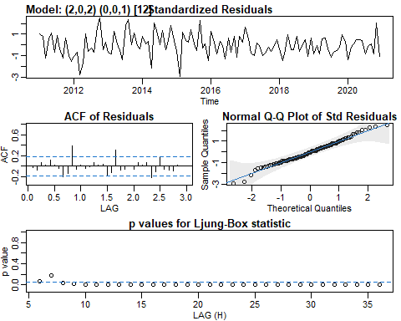

theft_model2 <- sarima(theft_ts,2,0,2,0,0,1,10)

## initial value -8.920035   
## iter 2 value -9.022911  
## iter 3 value -9.045953  
## iter 4 value -9.047057  
## iter 5 value -9.048858  
## iter 6 value -9.054722  
## iter 7 value -9.057693  
## iter 8 value -9.057987  
## iter 9 value -9.064852  
## iter 10 value -9.066747  
## iter 11 value -9.068141  
## iter 12 value -9.069133  
## iter 13 value -9.069833  
## iter 14 value -9.072698  
## iter 15 value -9.078886  
## iter 16 value -9.081801  
## iter 17 value -9.083051  
## iter 18 value -9.083472  
## iter 19 value -9.083680  
## iter 20 value -9.083765  
## iter 21 value -9.083812  
## iter 22 value -9.083821  
## iter 23 value -9.083829  
## iter 24 value -9.083831  
## iter 24 value -9.083831  
## iter 24 value -9.083831  
## final value -9.083831   
## converged  
## initial value -9.085012   
## iter 2 value -9.085373  
## iter 3 value -9.085770  
## iter 4 value -9.085916  
## iter 5 value -9.086128  
## iter 6 value -9.086147  
## iter 7 value -9.086209  
## iter 8 value -9.086306  
## iter 9 value -9.086412  
## iter 10 value -9.086465  
## iter 11 value -9.086476  
## iter 12 value -9.086479  
## iter 13 value -9.086484  
## iter 14 value -9.086488  
## iter 15 value -9.086488  
## iter 16 value -9.086489  
## iter 17 value -9.086489  
## iter 17 value -9.086490  
## iter 17 value -9.086490  
## final value -9.086490   
## converged

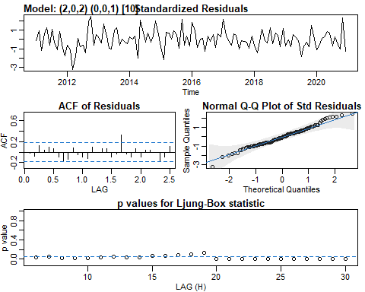

theft_model3 <- sarima(theft_ts,1,0,1,0,0,1,10)

## initial value -8.920676   
## iter 2 value -8.994927  
## iter 3 value -9.018358  
## iter 4 value -9.024271  
## iter 5 value -9.025023  
## iter 6 value -9.025061  
## iter 7 value -9.025087  
## iter 8 value -9.025234  
## iter 9 value -9.025746  
## iter 10 value -9.026163  
## iter 11 value -9.026466  
## iter 12 value -9.026653  
## iter 13 value -9.026854  
## iter 14 value -9.028206  
## iter 15 value -9.034687  
## iter 16 value -9.035895  
## iter 17 value -9.037350  
## iter 18 value -9.038652  
## iter 19 value -9.038962  
## iter 20 value -9.038981  
## iter 21 value -9.039008  
## iter 22 value -9.039012  
## iter 23 value -9.039013  
## iter 23 value -9.039013  
## iter 23 value -9.039013  
## final value -9.039013   
## converged  
## initial value -9.051632   
## iter 2 value -9.053045  
## iter 3 value -9.053241  
## iter 4 value -9.053523  
## iter 5 value -9.053577  
## iter 6 value -9.053643  
## iter 7 value -9.053657  
## iter 8 value -9.053667  
## iter 9 value -9.053680  
## iter 10 value -9.053691  
## iter 11 value -9.053692  
## iter 12 value -9.053693  
## iter 13 value -9.053694  
## iter 14 value -9.053694  
## iter 14 value -9.053694  
## iter 14 value -9.053694  
## final value -9.053694   
## converged

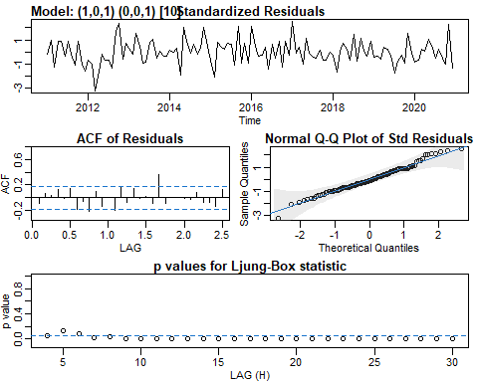

theft_model4 <- sarima(theft_ts,1,0,1,1,0,0,10)

## initial value -8.905733   
## iter 2 value -9.060610  
## iter 3 value -9.064687  
## iter 4 value -9.091230  
## iter 5 value -9.093233  
## iter 6 value -9.095667  
## iter 7 value -9.111904  
## iter 8 value -9.118496  
## iter 9 value -9.132282  
## iter 10 value -9.139016  
## iter 11 value -9.140219  
## iter 12 value -9.140255  
## iter 13 value -9.141505  
## iter 14 value -9.141911  
## iter 15 value -9.143118  
## iter 16 value -9.143760  
## iter 17 value -9.143967  
## iter 18 value -9.144007  
## iter 19 value -9.144014  
## iter 20 value -9.144014  
## iter 20 value -9.144014  
## iter 20 value -9.144014  
## final value -9.144014   
## converged  
## initial value -9.110664   
## iter 2 value -9.113339  
## iter 3 value -9.114794  
## iter 4 value -9.115399  
## iter 5 value -9.116474  
## iter 6 value -9.117449  
## iter 7 value -9.117673  
## iter 8 value -9.117745  
## iter 9 value -9.117756  
## iter 10 value -9.117771  
## iter 11 value -9.117775  
## iter 12 value -9.117780  
## iter 13 value -9.117784  
## iter 14 value -9.117788  
## iter 15 value -9.117790  
## iter 16 value -9.117790  
## iter 16 value -9.117790  
## iter 16 value -9.117790  
## final value -9.117790   
## converged

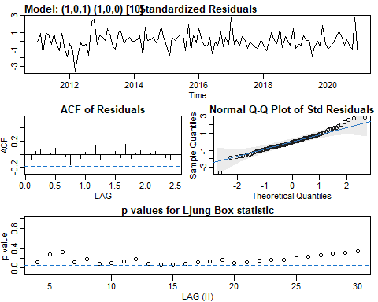

round(ARMAtoAR(ar = c(.7943,0,0,0,0,0,0,0,.9916), ma = -.6165,   
 lag.max = 50))

## [1] 0 0 0 0 0 0 0 0 -1 -1 0 0 0 0 0 0 0 0 0 0 0 0 0 0 0  
## [26] 0 0 0 0 0 0 0 0 0 0 0 0 0 0 0 0 0 0 0 0 0 0 0 0 0

round(ARMAtoMA(ar = c(.7943,0,0,0,0,0,0,0,.9916), ma = -.6165,   
 lag.max = 50))

## [1] 0 0 0 0 0 0 0 0 1 1 1 1 1 1 1 1 0 1 2 3 3 3 3 3 3  
## [26] 3 4 5 6 8 9 10 11 12 12 13 15 18 23 27 32 36 41 44 48 54 61 71 83 97

theft_model5 <- sarima(theft_ts,0,1,1,1,0,0,10, no.constant = TRUE)

## initial value -8.547611   
## iter 2 value -9.069800  
## iter 3 value -9.095730  
## iter 4 value -9.101996  
## iter 5 value -9.104671  
## iter 6 value -9.104776  
## iter 7 value -9.104779  
## iter 8 value -9.104787  
## iter 9 value -9.104787  
## iter 9 value -9.104787  
## iter 9 value -9.104787  
## final value -9.104787   
## converged  
## initial value -9.080607   
## iter 2 value -9.081084  
## iter 3 value -9.081408  
## iter 4 value -9.081421  
## iter 5 value -9.081421  
## iter 5 value -9.081421  
## iter 5 value -9.081421  
## final value -9.081421   
## converged

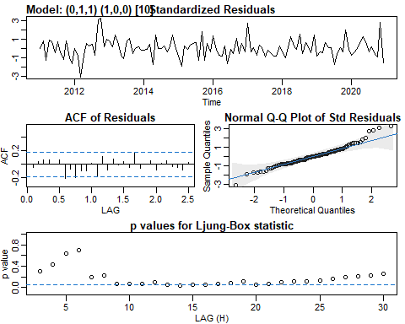

round(ARMAtoAR(ar = c(0,0,0,0,0,0,0,0,0,.5730), ma = -.7841,   
 lag.max = 50))

## [1] 1 1 0 0 0 0 0 0 0 0 0 0 0 0 0 0 0 0 0 0 0 0 0 0 0 0 0 0 0 0 0 0 0 0 0 0 0 0  
## [39] 0 0 0 0 0 0 0 0 0 0 0 0

round(ARMAtoMA(ar = c(0,0,0,0,0,0,0,0,0,.5730), ma = -.7841,   
 lag.max = 50))

## [1] -1 0 0 0 0 0 0 0 0 1 0 0 0 0 0 0 0 0 0 0 0 0 0 0 0  
## [26] 0 0 0 0 0 0 0 0 0 0 0 0 0 0 0 0 0 0 0 0 0 0 0 0 0

polyroot(.5730)

## complex(0)

polyroot(-.7841)

## complex(0)

theft_forecast <- sarima.for(theft_ts,24,0,1,1,1,0,0,10)

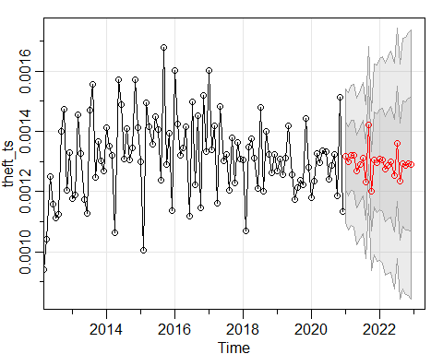

auto.arima(homicide_ts)

## Series: homicide_ts   
## ARIMA(0,0,0)(1,0,0)[12] with non-zero mean   
##   
## Coefficients:  
## sar1 mean  
## -0.2913 1e-04  
## s.e. 0.1019 1e-04  
##   
## sigma^2 estimated as 2.325e-10: log likelihood=1161.14  
## AIC=-2316.28 AICc=-2316.08 BIC=-2307.92

homicide_model1 <- sarima(homicide_ts,0,0,0,1,0,0,12)

## initial value -11.028479   
## iter 2 value -11.072925  
## iter 3 value -11.073343  
## iter 4 value -11.073349  
## iter 4 value -11.073349  
## iter 4 value -11.073349  
## final value -11.073349   
## converged  
## initial value -11.094969   
## iter 2 value -11.095108  
## iter 3 value -11.095113  
## iter 4 value -11.095113  
## iter 4 value -11.095113  
## iter 4 value -11.095113  
## final value -11.095113   
## converged

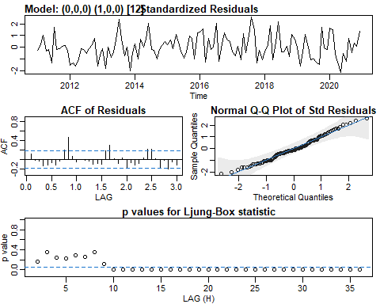

homicide_model2 <- sarima(homicide_ts,0,0,0,1,0,0,10)

## initial value -11.037324   
## iter 2 value -11.193017  
## iter 3 value -11.193345  
## iter 4 value -11.193423  
## iter 5 value -11.193461  
## iter 6 value -11.193475  
## iter 7 value -11.193477  
## iter 8 value -11.193477  
## iter 8 value -11.193477  
## iter 8 value -11.193477  
## final value -11.193477   
## converged  
## initial value -11.197502   
## iter 2 value -11.197742  
## iter 3 value -11.197796  
## iter 4 value -11.197805  
## iter 5 value -11.197809  
## iter 5 value -11.197809  
## iter 5 value -11.197809  
## final value -11.197809   
## converged

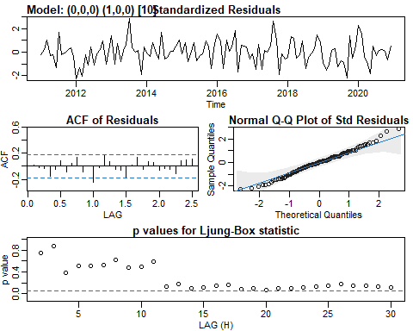

homicide_model3 <- sarima(homicide_ts,0,0,0,1,0,0,10, no.constant = TRUE)

## initial value -9.838954   
## iter 2 value -11.078718  
## iter 3 value -11.079258  
## iter 4 value -11.079530  
## iter 4 value -11.079530  
## final value -11.079530   
## converged  
## initial value -10.975899   
## iter 2 value -10.975976  
## iter 3 value -10.976082  
## iter 4 value -10.976082  
## iter 4 value -10.976082  
## final value -10.976082   
## converged

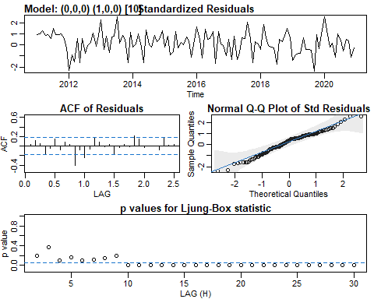

homicide_model4 <- sarima(homicide_ts,0,0,0,1,0,1,10)

## initial value -11.037324   
## iter 2 value -11.122012  
## iter 3 value -11.172372  
## iter 4 value -11.180390  
## iter 5 value -11.188908  
## iter 6 value -11.200388  
## iter 7 value -11.202545  
## iter 8 value -11.204575  
## iter 9 value -11.204685  
## iter 10 value -11.204809  
## iter 11 value -11.204888  
## iter 12 value -11.204915  
## iter 13 value -11.204920  
## iter 14 value -11.204922  
## iter 15 value -11.204924  
## iter 16 value -11.204924  
## iter 16 value -11.204924  
## iter 16 value -11.204924  
## final value -11.204924   
## converged  
## initial value -11.215930   
## iter 2 value -11.216903  
## iter 3 value -11.217531  
## iter 4 value -11.217784  
## iter 5 value -11.218394  
## iter 6 value -11.218444  
## iter 7 value -11.218449  
## iter 8 value -11.218451  
## iter 9 value -11.218452  
## iter 10 value -11.218452  
## iter 11 value -11.218453  
## iter 11 value -11.218453  
## iter 11 value -11.218453  
## final value -11.218453   
## converged

## Warning in sqrt(diag(fitit$var.coef)): NaNs produced  
  
## Warning in sqrt(diag(fitit$var.coef)): NaNs produced

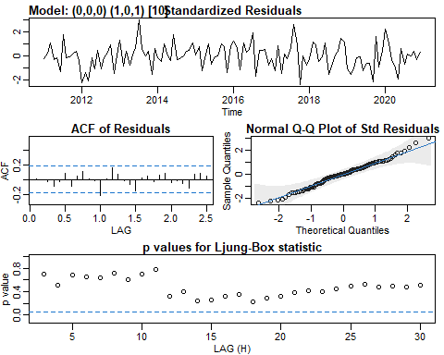

homicide_model5 <- sarima(homicide_ts,0,0,0,1,0,1,10, no.constant = TRUE)

## initial value -9.838954   
## iter 2 value -10.340150  
## iter 3 value -10.921358  
## iter 4 value -11.076596  
## iter 5 value -11.094638  
## iter 6 value -11.137653  
## iter 7 value -11.155471  
## iter 8 value -11.168365  
## iter 9 value -11.169103  
## iter 10 value -11.169657  
## iter 11 value -11.169666  
## iter 11 value -11.169666  
## final value -11.169666   
## converged  
## initial value -11.068568   
## iter 2 value -11.068731  
## iter 3 value -11.068860  
## iter 4 value -11.068878  
## iter 5 value -11.068965  
## iter 6 value -11.068965  
## iter 6 value -11.068965  
## final value -11.068965   
## converged

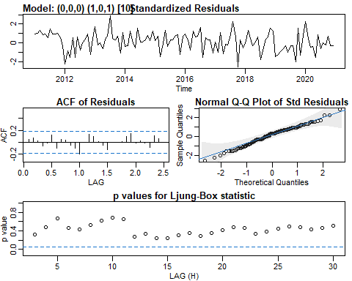

round(ARMAtoAR(ar = c(0,0,0,0,0,0,0,0,0,.9916), ma = c(0,0,0,0,0,0,0,0,0,0, -.5250),   
 lag.max = 50))

## [1] 0 0 0 0 0 0 0 0 0 -1 1 0 0 0 0 0 0 0 0 0 -1 0 0 0 0  
## [26] 0 0 0 0 0 0 0 0 0 0 0 0 0 0 0 0 0 0 0 0 0 0 0 0 0

round(ARMAtoMA(ar = c(0,0,0,0,0,0,0,0,0,.9916), ma = c(0,0,0,0,0,0,0,0,0,0, -.5250),   
 lag.max = 1000))

## [1] 0 0 0 0 0 0 0 0 0 1 -1 0 0 0 0 0 0 0 0 1 -1 0 0 0  
## [25] 0 0 0 0 0 1 -1 0 0 0 0 0 0 0 0 1 -1 0 0 0 0 0 0 0  
## [49] 0 1 -1 0 0 0 0 0 0 0 0 1 -1 0 0 0 0 0 0 0 0 1 0 0  
## [73] 0 0 0 0 0 0 0 1 0 0 0 0 0 0 0 0 0 1 0 0 0 0 0 0  
## [97] 0 0 0 1 0 0 0 0 0 0 0 0 0 1 0 0 0 0 0 0 0 0 0 1  
## [121] 0 0 0 0 0 0 0 0 0 1 0 0 0 0 0 0 0 0 0 1 0 0 0 0  
## [145] 0 0 0 0 0 1 0 0 0 0 0 0 0 0 0 1 0 0 0 0 0 0 0 0  
## [169] 0 1 0 0 0 0 0 0 0 0 0 1 0 0 0 0 0 0 0 0 0 1 0 0  
## [193] 0 0 0 0 0 0 0 1 0 0 0 0 0 0 0 0 0 1 0 0 0 0 0 0  
## [217] 0 0 0 1 0 0 0 0 0 0 0 0 0 1 0 0 0 0 0 0 0 0 0 1  
## [241] 0 0 0 0 0 0 0 0 0 1 0 0 0 0 0 0 0 0 0 1 0 0 0 0  
## [265] 0 0 0 0 0 1 0 0 0 0 0 0 0 0 0 1 0 0 0 0 0 0 0 0  
## [289] 0 1 0 0 0 0 0 0 0 0 0 1 0 0 0 0 0 0 0 0 0 1 0 0  
## [313] 0 0 0 0 0 0 0 1 0 0 0 0 0 0 0 0 0 1 0 0 0 0 0 0  
## [337] 0 0 0 1 0 0 0 0 0 0 0 0 0 1 0 0 0 0 0 0 0 0 0 1  
## [361] 0 0 0 0 0 0 0 0 0 1 0 0 0 0 0 0 0 0 0 1 0 0 0 0  
## [385] 0 0 0 0 0 1 0 0 0 0 0 0 0 0 0 1 0 0 0 0 0 0 0 0  
## [409] 0 1 0 0 0 0 0 0 0 0 0 1 0 0 0 0 0 0 0 0 0 1 0 0  
## [433] 0 0 0 0 0 0 0 1 0 0 0 0 0 0 0 0 0 1 0 0 0 0 0 0  
## [457] 0 0 0 1 0 0 0 0 0 0 0 0 0 1 0 0 0 0 0 0 0 0 0 1  
## [481] 0 0 0 0 0 0 0 0 0 1 0 0 0 0 0 0 0 0 0 1 0 0 0 0  
## [505] 0 0 0 0 0 1 0 0 0 0 0 0 0 0 0 1 0 0 0 0 0 0 0 0  
## [529] 0 1 0 0 0 0 0 0 0 0 0 1 0 0 0 0 0 0 0 0 0 1 0 0  
## [553] 0 0 0 0 0 0 0 1 0 0 0 0 0 0 0 0 0 1 0 0 0 0 0 0  
## [577] 0 0 0 1 0 0 0 0 0 0 0 0 0 1 0 0 0 0 0 0 0 0 0 1  
## [601] 0 0 0 0 0 0 0 0 0 1 0 0 0 0 0 0 0 0 0 1 0 0 0 0  
## [625] 0 0 0 0 0 1 0 0 0 0 0 0 0 0 0 1 0 0 0 0 0 0 0 0  
## [649] 0 1 0 0 0 0 0 0 0 0 0 1 0 0 0 0 0 0 0 0 0 1 0 0  
## [673] 0 0 0 0 0 0 0 1 0 0 0 0 0 0 0 0 0 1 0 0 0 0 0 0  
## [697] 0 0 0 1 0 0 0 0 0 0 0 0 0 1 0 0 0 0 0 0 0 0 0 1  
## [721] 0 0 0 0 0 0 0 0 0 1 0 0 0 0 0 0 0 0 0 1 0 0 0 0  
## [745] 0 0 0 0 0 1 0 0 0 0 0 0 0 0 0 1 0 0 0 0 0 0 0 0  
## [769] 0 1 0 0 0 0 0 0 0 0 0 1 0 0 0 0 0 0 0 0 0 1 0 0  
## [793] 0 0 0 0 0 0 0 1 0 0 0 0 0 0 0 0 0 1 0 0 0 0 0 0  
## [817] 0 0 0 1 0 0 0 0 0 0 0 0 0 0 0 0 0 0 0 0 0 0 0 0  
## [841] 0 0 0 0 0 0 0 0 0 0 0 0 0 0 0 0 0 0 0 0 0 0 0 0  
## [865] 0 0 0 0 0 0 0 0 0 0 0 0 0 0 0 0 0 0 0 0 0 0 0 0  
## [889] 0 0 0 0 0 0 0 0 0 0 0 0 0 0 0 0 0 0 0 0 0 0 0 0  
## [913] 0 0 0 0 0 0 0 0 0 0 0 0 0 0 0 0 0 0 0 0 0 0 0 0  
## [937] 0 0 0 0 0 0 0 0 0 0 0 0 0 0 0 0 0 0 0 0 0 0 0 0  
## [961] 0 0 0 0 0 0 0 0 0 0 0 0 0 0 0 0 0 0 0 0 0 0 0 0  
## [985] 0 0 0 0 0 0 0 0 0 0 0 0 0 0 0 0

polyroot(0.9916)

## complex(0)

polyroot(-.5250)

## complex(0)

homicide_forecast <- sarima.for(homicide_ts,24,0,0,0,1,0,1,10, no.constant = TRUE)

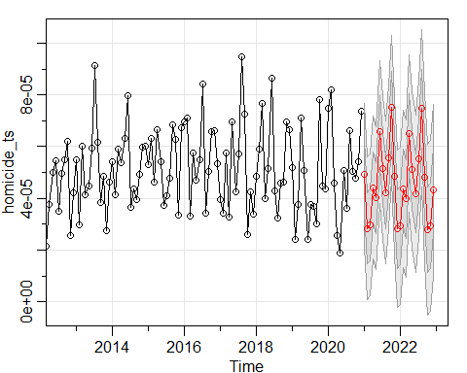

auto.arima(sexual_assault_ts)

## Series: sexual_assault_ts   
## ARIMA(1,1,1)   
##   
## Coefficients:  
## ar1 ma1  
## 0.3378 -0.9716  
## s.e. 0.0907 0.0259  
##   
## sigma^2 estimated as 1.004e-10: log likelihood=1200.87  
## AIC=-2395.75 AICc=-2395.54 BIC=-2387.41

sex_assault_model1 <- sarima(sexual_assault_ts,1,1,1, no.constant = TRUE)

## initial value -11.328211   
## iter 2 value -11.378067  
## iter 3 value -11.405921  
## iter 4 value -11.409323  
## iter 5 value -11.435754  
## iter 6 value -11.474319  
## iter 7 value -11.480533  
## iter 8 value -11.492280  
## iter 9 value -11.503517  
## iter 10 value -11.509919  
## iter 11 value -11.513864  
## iter 12 value -11.514604  
## iter 13 value -11.514661  
## iter 14 value -11.514662  
## iter 14 value -11.514662  
## iter 14 value -11.514662  
## final value -11.514662   
## converged  
## initial value -11.510254   
## iter 2 value -11.510280  
## iter 3 value -11.510305  
## iter 4 value -11.510306  
## iter 4 value -11.510306  
## iter 4 value -11.510306  
## final value -11.510306   
## converged

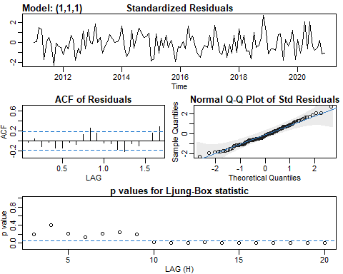

round(ARMAtoAR(ar = .3378, ma = -.9716,   
 lag.max = 50))

## [1] 1 1 1 1 1 1 1 1 1 0 0 0 0 0 0 0 0 0 0 0 0 0 0 0 0 0 0 0 0 0 0 0 0 0 0 0 0 0  
## [39] 0 0 0 0 0 0 0 0 0 0 0 0

round(ARMAtoMA(ar = .3378, ma = -.9716,   
 lag.max = 50))

## [1] -1 0 0 0 0 0 0 0 0 0 0 0 0 0 0 0 0 0 0 0 0 0 0 0 0  
## [26] 0 0 0 0 0 0 0 0 0 0 0 0 0 0 0 0 0 0 0 0 0 0 0 0 0

polyroot(.3378)

## complex(0)

polyroot(-.9716)

## complex(0)

sex_assault_model2 <- sarima(sexual_assault_ts,1,1,1,1,0,0,10, no.constant = TRUE)

## initial value -11.342277   
## iter 2 value -11.462051  
## iter 3 value -11.498510  
## iter 4 value -11.506782  
## iter 5 value -11.521380  
## iter 6 value -11.533843  
## iter 7 value -11.549605  
## iter 8 value -11.564060  
## iter 9 value -11.565579  
## iter 10 value -11.574005  
## iter 11 value -11.578221  
## iter 12 value -11.578848  
## iter 13 value -11.579542  
## iter 14 value -11.579570  
## iter 15 value -11.579586  
## iter 16 value -11.579589  
## iter 16 value -11.579589  
## iter 16 value -11.579589  
## final value -11.579589   
## converged  
## initial value -11.558841   
## iter 2 value -11.559232  
## iter 3 value -11.559674  
## iter 4 value -11.559689  
## iter 5 value -11.559691  
## iter 5 value -11.559691  
## iter 5 value -11.559691  
## final value -11.559691   
## converged

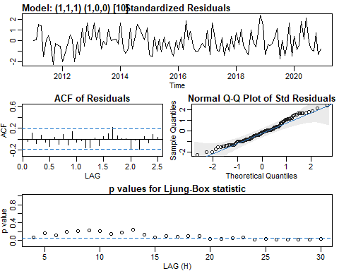

round(ARMAtoAR(ar = c(.2543,0,0,0,0,0,0,0,0,.344,0.0875), ma = -.9775,   
 lag.max = 50))

## [1] 1 1 1 1 1 1 1 1 1 0 0 0 0 0 0 0 0 0 0 0 0 0 0 0 0 0 0 0 0 0 0 0 0 0 0 0 0 0  
## [39] 0 0 0 0 0 0 0 0 0 0 0 0

round(ARMAtoMA(ar = c(.2543,0,0,0,0,0,0,0,0,.344,0.0875), ma = -.9775,   
 lag.max = 50))

## [1] -1 0 0 0 0 0 0 0 0 0 0 0 0 0 0 0 0 0 0 0 0 0 0 0 0  
## [26] 0 0 0 0 0 0 0 0 0 0 0 0 0 0 0 0 0 0 0 0 0 0 0 0 0

polyroot(c(.2543, .344, .0875))

## [1] -0.9870688-0i -2.9443597+0i

polyroot(-.9775)

## complex(0)

sex_assault_model3 <- sarima(sexual_assault_ts,1,1,1,1,0,1,10, no.constant = TRUE)

## initial value -11.342277   
## iter 2 value -11.473992  
## iter 3 value -11.489283  
## iter 4 value -11.499871  
## iter 5 value -11.531015  
## iter 6 value -11.554754  
## iter 7 value -11.566523  
## iter 8 value -11.578458  
## iter 9 value -11.579762  
## iter 10 value -11.580583  
## iter 11 value -11.580823  
## iter 12 value -11.580987  
## iter 13 value -11.581104  
## iter 14 value -11.581443  
## iter 15 value -11.581520  
## iter 16 value -11.581666  
## iter 17 value -11.582076  
## iter 18 value -11.582305  
## iter 19 value -11.582549  
## iter 20 value -11.582664  
## iter 21 value -11.582878  
## iter 22 value -11.582901  
## iter 23 value -11.582904  
## iter 23 value -11.582904  
## final value -11.582904   
## converged  
## initial value -11.587163   
## iter 2 value -11.597220  
## iter 3 value -11.599157  
## iter 4 value -11.602045  
## iter 5 value -11.603265  
## iter 6 value -11.604753  
## iter 7 value -11.607407  
## iter 8 value -11.609311  
## iter 9 value -11.609881  
## iter 10 value -11.609940  
## iter 11 value -11.609942  
## iter 12 value -11.609945  
## iter 13 value -11.609946  
## iter 13 value -11.609946  
## iter 13 value -11.609946  
## final value -11.609946   
## converged

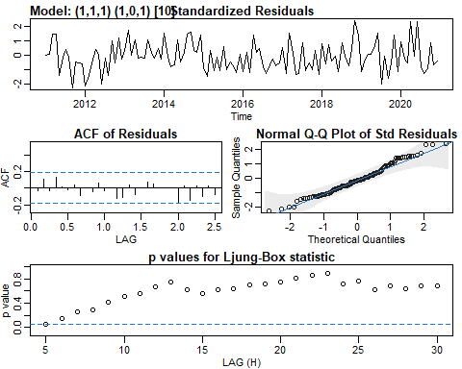

sex_assault_model4 <- sarima(sexual_assault_ts,0,1,1,1,0,1,10, no.constant = TRUE)

## initial value -11.346875   
## iter 2 value -11.466314  
## iter 3 value -11.542258  
## iter 4 value -11.553688  
## iter 5 value -11.554823  
## iter 6 value -11.555736  
## iter 7 value -11.557530  
## iter 8 value -11.557596  
## iter 9 value -11.558411  
## iter 10 value -11.561074  
## iter 11 value -11.565054  
## iter 12 value -11.568586  
## iter 13 value -11.572474  
## iter 14 value -11.581462  
## iter 15 value -11.584123  
## iter 16 value -11.584817  
## iter 17 value -11.585627  
## iter 18 value -11.585819  
## iter 19 value -11.585944  
## iter 20 value -11.585965  
## iter 21 value -11.585965  
## iter 21 value -11.585965  
## iter 21 value -11.585965  
## final value -11.585965   
## converged  
## initial value -11.584480   
## iter 2 value -11.585992  
## iter 3 value -11.589977  
## iter 4 value -11.593378  
## iter 5 value -11.594951  
## iter 6 value -11.595591  
## iter 7 value -11.595956  
## iter 8 value -11.596180  
## iter 9 value -11.596237  
## iter 10 value -11.596343  
## iter 11 value -11.596442  
## iter 12 value -11.596607  
## iter 13 value -11.596623  
## iter 14 value -11.596649  
## iter 15 value -11.596656  
## iter 16 value -11.596760  
## iter 17 value -11.596766  
## iter 18 value -11.596766  
## iter 18 value -11.596766  
## iter 18 value -11.596766  
## final value -11.596766   
## converged

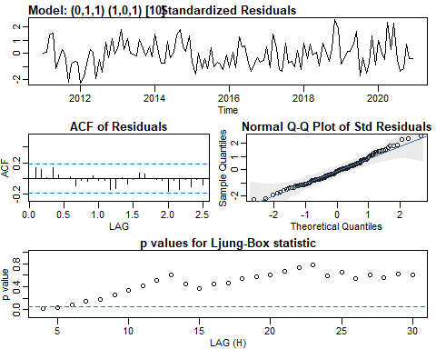

round(ARMAtoAR(ar = c(0,0,0,0,0,0,0,0,0, .9568), ma = c(-.9609,0,0,0,0,0,0,0,0,-.7754,.7451),   
 lag.max = 50))

## [1] 1 1 1 1 1 1 1 1 1 0 0 0 0 0 0 0 0 0 0 0 0 0 0 0 0 0 0 0 0 0 0 0 0 0 0 0 0 0  
## [39] 0 0 0 0 0 0 0 0 0 0 0 0

round(ARMAtoMA(ar = c(0,0,0,0,0,0,0,0,0, .9568), ma = c(-.9609,0,0,0,0,0,0,0,0,-.7754,.7451),   
 lag.max = 50))

## [1] -1 0 0 0 0 0 0 0 0 0 0 0 0 0 0 0 0 0 0 0 0 0 0 0 0  
## [26] 0 0 0 0 0 0 0 0 0 0 0 0 0 0 0 0 0 0 0 0 0 0 0 0 0

polyroot(.9568)

## complex(0)

polyroot(c(-.9609, -.7754, .7451))

## [1] -0.7288156-0i 1.7694813+0i

sex_assault_forecast <- sarima.for(sexual_assault_ts,24,0,1,1,1,0,1,10, no.constant = TRUE)

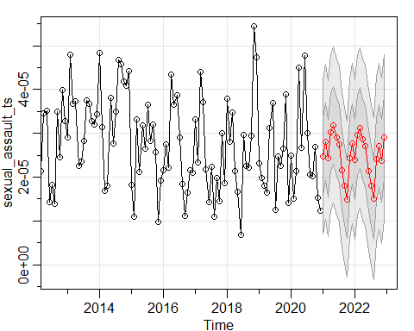

auto.arima(assault_battery_ts)

## Series: assault_battery_ts   
## ARIMA(1,0,0) with non-zero mean   
##   
## Coefficients:  
## ar1 mean  
## 0.3940 8e-04  
## s.e. 0.0847 1e-04  
##   
## sigma^2 estimated as 1.905e-08: log likelihood=897.23  
## AIC=-1788.46 AICc=-1788.26 BIC=-1780.1

abatt_model1 <- sarima(assault_battery_ts,1,0,0)

## initial value -8.816912   
## iter 2 value -8.900272  
## iter 3 value -8.900306  
## iter 4 value -8.900328  
## iter 4 value -8.900328  
## iter 4 value -8.900328  
## final value -8.900328   
## converged  
## initial value -8.895718   
## iter 2 value -8.895815  
## iter 3 value -8.895874  
## iter 4 value -8.895874  
## iter 4 value -8.895874  
## iter 4 value -8.895874  
## final value -8.895874   
## converged

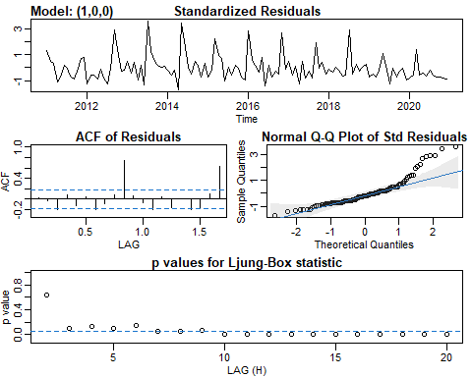

abatt_model2 <- sarima(assault_battery_ts,1,0,0,0,0,1,10)

## initial value -8.816912   
## iter 2 value -9.149080  
## iter 3 value -9.159863  
## iter 4 value -9.166128  
## iter 5 value -9.166380  
## iter 6 value -9.166392  
## iter 7 value -9.166399  
## iter 8 value -9.166400  
## iter 8 value -9.166400  
## final value -9.166400   
## converged  
## initial value -9.139177   
## iter 2 value -9.139608  
## iter 3 value -9.139857  
## iter 4 value -9.139899  
## iter 5 value -9.139925  
## iter 6 value -9.139926  
## iter 6 value -9.139926  
## iter 6 value -9.139926  
## final value -9.139926   
## converged

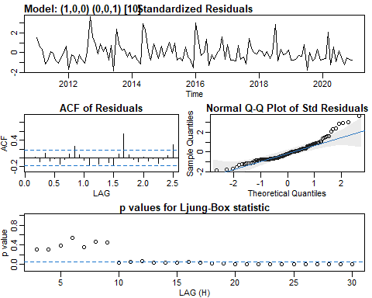

abatt_model3 <- sarima(assault_battery_ts,1,0,1,1,0,0,10)

## initial value -8.794908   
## iter 2 value -9.173433  
## iter 3 value -9.350350  
## iter 4 value -9.356883  
## iter 5 value -9.361855  
## iter 6 value -9.364418  
## iter 7 value -9.374772  
## iter 8 value -9.381134  
## iter 9 value -9.389290  
## iter 10 value -9.398794  
## iter 11 value -9.402125  
## iter 12 value -9.402371  
## iter 13 value -9.402644  
## iter 14 value -9.402711  
## iter 15 value -9.402721  
## iter 16 value -9.402728  
## iter 17 value -9.402736  
## iter 18 value -9.402760  
## iter 19 value -9.402790  
## iter 19 value -9.402790  
## final value -9.402790   
## converged  
## initial value -9.364933   
## iter 2 value -9.366082  
## iter 3 value -9.367104  
## iter 4 value -9.367255  
## iter 5 value -9.367284  
## iter 6 value -9.367424  
## iter 7 value -9.367427  
## iter 8 value -9.367429  
## iter 9 value -9.367434  
## iter 10 value -9.367438  
## iter 11 value -9.367438  
## iter 12 value -9.367440  
## iter 12 value -9.367440  
## iter 12 value -9.367440  
## final value -9.367440   
## converged

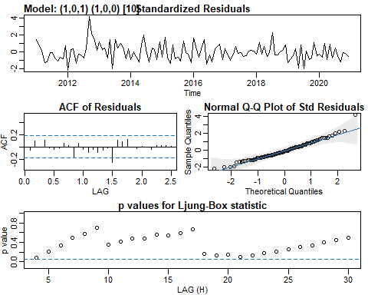

round(ARMAtoAR(ar = c(.8051,0,0,0,0,0,0,0,0, .8009, .6448), ma = -.5807,   
 lag.max = 50))

## [1] 0 0 0 0 0 0 0 0 0 -1 -1 -1 0 0 0 0 0 0 0 0 0 0 0 0 0  
## [26] 0 0 0 0 0 0 0 0 0 0 0 0 0 0 0 0 0 0 0 0 0 0 0 0 0

round(ARMAtoMA(ar = c(.8051,0,0,0,0,0,0,0,0, .8009, .6448), ma = -.5807,   
 lag.max = 50))

## [1] 0 0 0 0 0 0 0 0 0 1 1 1 1 1 1 1 1 1 1  
## [20] 1 3 4 6 7 7 7 7 7 7 7 9 13 17 23 28 33 38 41  
## [39] 44 46 49 55 66 83 104 129 156 183 208 232

abatt_model4 <- sarima(assault_battery_ts,1,1,1,1,0,0,10)

## initial value -8.686658   
## iter 2 value -9.313896  
## iter 3 value -9.343836  
## iter 4 value -9.345029  
## iter 5 value -9.360564  
## iter 6 value -9.363573  
## iter 7 value -9.365915  
## iter 8 value -9.366051  
## iter 9 value -9.366061  
## iter 10 value -9.366062  
## iter 10 value -9.366062  
## final value -9.366062   
## converged  
## initial value -9.332358   
## iter 2 value -9.334059  
## iter 3 value -9.335257  
## iter 4 value -9.335923  
## iter 5 value -9.336138  
## iter 6 value -9.336216  
## iter 7 value -9.336238  
## iter 7 value -9.336238  
## iter 7 value -9.336238  
## final value -9.336238   
## converged

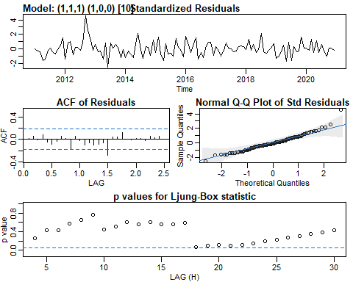

abatt_model5 <- sarima(assault_battery_ts,0,1,1,1,0,0,10, no.constant = TRUE)

## initial value -8.690329   
## iter 2 value -9.243293  
## iter 3 value -9.291367  
## iter 4 value -9.335485  
## iter 5 value -9.352009  
## iter 6 value -9.359946  
## iter 7 value -9.364323  
## iter 8 value -9.364602  
## iter 9 value -9.365327  
## iter 10 value -9.365347  
## iter 10 value -9.365347  
## iter 10 value -9.365347  
## final value -9.365347   
## converged  
## initial value -9.333947   
## iter 2 value -9.334237  
## iter 3 value -9.334360  
## iter 4 value -9.334360  
## iter 4 value -9.334360  
## iter 4 value -9.334360  
## final value -9.334360   
## converged

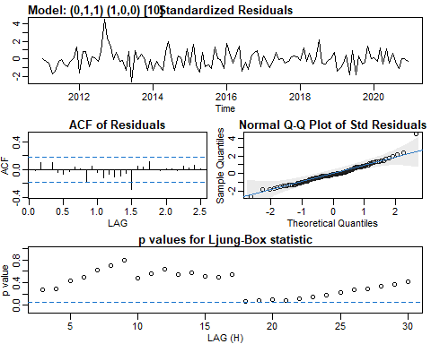

round(ARMAtoAR(ar = c(0,0,0,0,0,0,0,0,0, .8046), ma = -.7375,   
 lag.max = 50))

## [1] 1 1 0 0 0 0 0 0 0 -1 -1 0 0 0 0 0 0 0 0 0 0 0 0 0 0  
## [26] 0 0 0 0 0 0 0 0 0 0 0 0 0 0 0 0 0 0 0 0 0 0 0 0 0

round(ARMAtoMA(ar = c(0,0,0,0,0,0,0,0,0, .8046), ma = -.7375,   
 lag.max = 50))

## [1] -1 0 0 0 0 0 0 0 0 1 -1 0 0 0 0 0 0 0 0 1 0 0 0 0 0  
## [26] 0 0 0 0 1 0 0 0 0 0 0 0 0 0 0 0 0 0 0 0 0 0 0 0 0

polyroot(-.7375)

## complex(0)

polyroot(.8046)

## complex(0)

abatt_forecast <- sarima.for(assault_battery_ts,24,0,1,1,1,0,0,10)

