**Hands-On#4**

Use the following information to complete Yoko’s Kitchen website.

<home> page

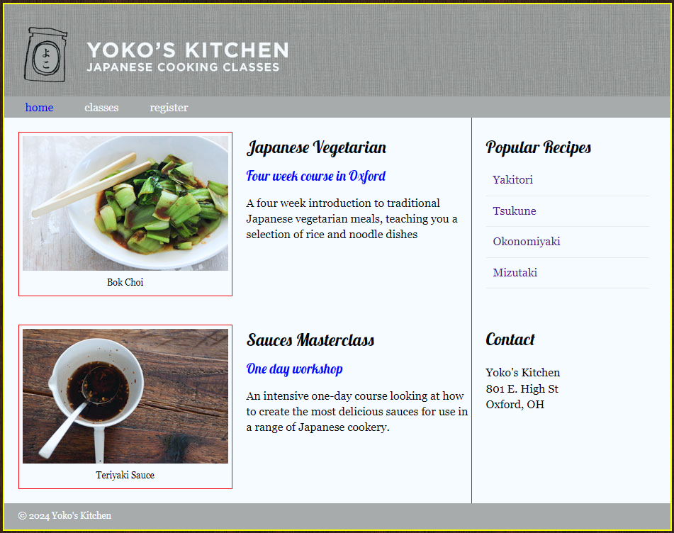

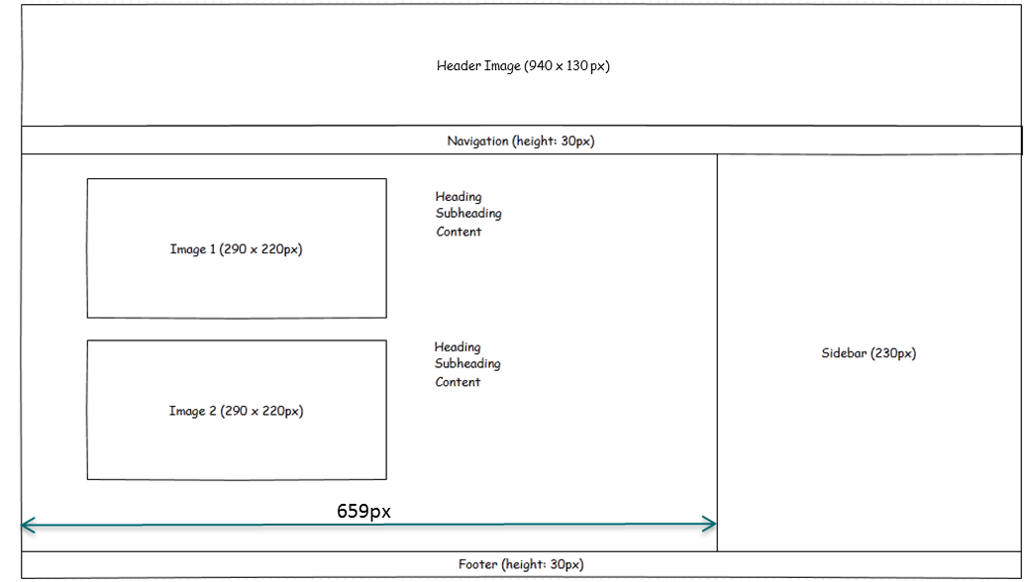

figcaption

figcaption

<classes> page  
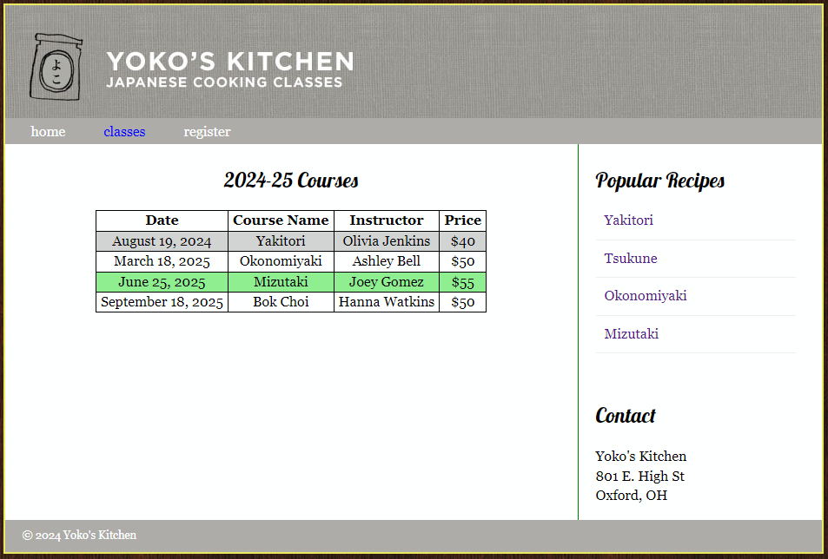

<register> page  
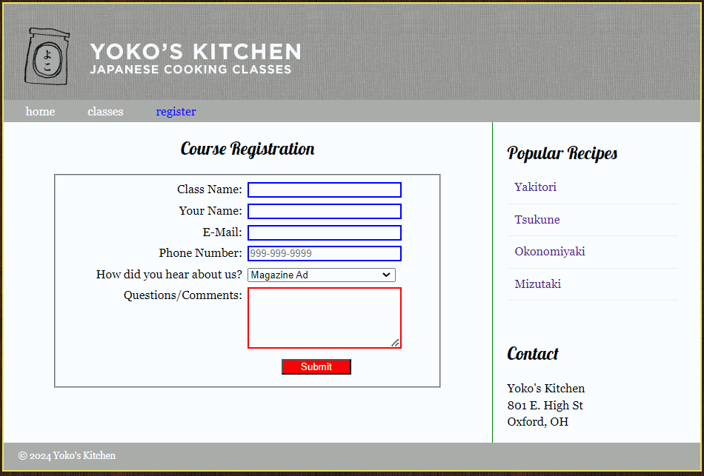



* [home](http://127.0.0.1:51968/index.html)
* [classes](http://127.0.0.1:51968/index.html)
* [register](http://127.0.0.1:51968/index.html)

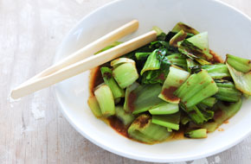Bok Choi

**Japanese Vegetarian**

**Four week course in Oxford**

A four week introduction to traditional Japanese vegetarian meals, teaching you a selection of rice and noodle dishes.

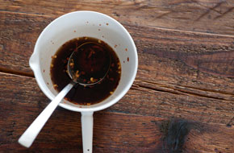Teriyaki Sauce

**Sauces Masterclass**

**One day workshop**

An intensive one-day course looking at how to create the most delicious sauces for use in a range of Japanese cookery.

**Popular Recipes**

[Yakitori](http://127.0.0.1:51968/index.html) [Tsukune](http://127.0.0.1:51968/index.html) [Okonomiyaki](http://127.0.0.1:51968/index.html) [Mizutaki](http://127.0.0.1:51968/index.html)

**Contact**

Yoko's Kitchen  
801 E. High St  
Oxford, OH

© 2024 Yoko's Kitchen

**index.html for homepage**

**<!DOCTYPE html>**

**<html>**

<!-- head part-->

**<head>**

**<title>IMS222 HTML/CSS Exercise</title>**

**<link rel="stylesheet" href="home.css">**

**<link href="https://fonts.googleapis.com/css2?family=Lobster&display=swap"**

**rel="stylesheet">**

**</head>**

<!-- body part-->

**<body>**

<!-- <div>tag is used for defining the overall width of Yoko’s Kitchen webpages -->

**<div class="wrapper">**

<!-- header-->

**<header>**

**<img src="images/header.jpg" alt=”header image”>**

**<nav>** <!-- try nav>ul>li>a*3 and tab -->

**<ul>**

**<li><a href="index.html" class="current">home</a></li>**

**<li><a href="classes.html">classes</a></li>**

**<li><a href="register.html">register</a></li>**

**</ul>**

**</nav>**

**</header>**

<!-- main content area -->

**<section class="courses">**

**<article>**

**<figure>**

**<img src="images/bok-choi.jpg" alt="bok-choi image" />**

**<figcaption>Bok Choi</figcaption>**

**</figure>**

**<h2>Japanese Vegetarian</h2>**

**<h3>Four week course in Oxford</h3>**

**<p>A four week introduction to traditional Japanese vegetarian meals,teaching you a selection of rice and noodle dishes</p>**

**</article>**

**<article>**

**<figure>**

**<img src="images/teriyaki.jpg" alt=”teriyaki image”/>**

**<figcaption>Teriyaki Sauce</figcaption>**

**</figure>**

**<h2>Sauces Masterclass</h2>**

**<h3>One day workshop</h3>**

**<p>An intensive one-day course looking at how to create the most delicious sauces for use in a range of Japanese cookery.</p>**

**</article>**

**</section>**

<!-- sidebar -->

**<aside>**

**<article class="popular-recipes">**

**<h2>Popular Recipes</h2>**

**<a href="">Yakitori</a>**

**<a href="">Tsukune</a>**

**<a href="">Okonomiyaki</a>**

**<a href="">Mizutaki</a>**

**</article>**

**<article class="contact">**

**<h2>Contact</h2>**

**<p>Yoko's Kitchen<br />**

**801 E. High St<br />**

**Oxford, OH<br />**

**</p>**

**</article>**

**</aside>**

**<!-- footer -->**

**<footer>**

**&copy; 2024 Yoko's Kitchen**

**</footer>**

**</div>**

**</body>**

**</html>**

**<home.css>**

header, section, footer, aside, nav, article, figure, figcaption {

display: block;} /* display these tags as [block](https://www.w3schools.com/html/html_blocks.asp) elements */

body {

font-family: Georgia, Times, serif;

line-height: 1.4em;

margin: 0px;

background: url("images/dark-wood.jpg");

}

.wrapper {

width: 940px;

margin: 20px auto; /* 20px on top/bottom and equal margin for left/right */

background-color: #fff;

border: 2px solid yellow;

}

/* header */

nav li {

display: inline;

margin-right: 40px;

}

nav, footer {

clear:both;

background-color: #aca8a8;

color: white;

height: 30px;

}

nav ul {

margin-top: -6px;

}

nav li a {color: white}

nav li a:hover, .current {

color: blue;

}

a { text-decoration: none; }

/* main section */

.courses {

float: left;

width: 659px;

border-right: 1px solid green;

}

figure {

float:left;

padding: 5px;

margin: 20px;

border: 1px solid red;

}

.courses article {

[overflow](https://www.w3schools.com/cssref/pr_pos_overflow.asp): auto;

width: 100%;

}

figcaption {

text-align: center;

font-size: 80%;

}

h2, h3 {

font-weight: normal;

font-family: 'Lobster', cursive;

}

h3 {

color: blue;

}

/* sidebar */

aside {

width: 230px;

float: left;

padding-left: 20px;

}

aside article a {

display: block; /*change <a> tag(inline element) to a block element */

padding: 10px;

border-bottom: 1px solid #eee;

}

aside article a:hover { color: yellow; }

.contact { padding-top: 30px; }

/* footer */

footer {

font-size: 80%;

padding: 7px 0px 0px 20px;

}

**classes.html**

**<section class="courses">**

**<article>**

**<h1>2024-25 Courses</h1>**

**<table>**

**<tr>**

**<th>Date</th>**

**<th>Course Name</th>**

**<th>Instructor</th>**

**<th>Price</th>**

**</tr>**

**<tr id="passed">**

**<td>August 19, 2024</td>**

**<td>Yakitori</td>**

**<td>Olivia Jenkins</td>**

**<td>$40</td>**

**</tr>**

**<tr>**

**<td>March 18, 2025</td>**

**<td>Okonomiyaki</td>**

**<td>Ashley Bell</td>**

**<td>$50</td>**

**</tr>**

**<tr>**

**<td>June 25, 2025</td>**

**<td>Mizutaki</td>**

**<td>Joey Gomez</td>**

**<td>$55</td>**

**</tr>**

**<tr>**

**<td>September 18, 2025</td>**

**<td>Bok Choi</td>**

**<td>Hanna Watkins</td>**

**<td>$50</td>**

**</tr>**

**</table>**

**</article>**

**</section>**

**Classes.html CSS code**: Go to classes.html and add **<link rel="stylesheet" href="class.css">** to the <head> section – line 6. Then, create a new file named "class.css" and insert the following code into it.

**table {**

**margin: 0 auto**

**}**

**table,td,th {**

**border: 1px solid black;**

**text-align: center;**

**padding: 0 5px;**

**border-collapse: collapse;**

**}**

**table tr:**[**nth-child**](https://www.w3schools.com/cssref/css_selectors.asp)**(even) {**

**background-color: lightgreen;**

**}**

**table tr:hover {**

**background-color: #2554ad;**

**transition: 0.5s**

**}**

**/* try to use id for h2 below to avoid the conflict with h2 in index.html**

**h2 {**

**text-align: center;**

**font-family: 'Lobster', cursive;**

**}**

**#passed {**

**background-color: lightgray**

**}**

**/* try to add a class for <section> to avoid the conflict with courses in index.html related to border line**

**.courses {**

**border: none;**

**}**

**aside {**

**border-left: 1px solid green**

**}**

**Register.html**

<section class="courses">

<article>

<h2>Course Registration </h2>

<form action=" " method="POST" name="registration_form" id="registration_form">

<fieldset>

<label for="classname">Class Name:</label>

<input type="text" name="classname" id="classname" required><br>

<label for="name">Your Name:</label>

<input type="text" name="name" id="name" required><br>

<label for="email">E-Mail:</label>

<input type="email" name="email" id="email" required><br>

<label for="phone">Phone Number:</label>

<input type="tel" name="phone" id="phone" placeholder="999-999-9999" required><br>

<label for="hearaboutus">How did you hear about us?</label>

<select name="hearaboutus" id="hearaboutus" required>

<option value="magazine">Magazine Ad</option>

<option value="radio">Radio Ad</option>

<option value="tv">TV Ad</option>

<option value="word">Social Media</option>

</select>

<label for="questions">Questions/Comments:</label>

<textarea name="questions" id="questions" rows="5"></textarea>

<label>&nbsp;</label>

<input type="submit" id="submit" value="Submit">

</fieldset>

</form>

</article>

</section>

**register.html CSS code**: Go to classes.html and add **<link rel="stylesheet" href="register.css">** to the <head> section – line 6. Then, create a new file named "register.css" and insert the following code into it.

**fieldset {**

**width: 75%;**

**margin: auto**

**}**

**label {**

**float: left;**

**width: 15em;**

**text-align: right;**

**}**

**input, select, textarea {**

**width: 15em;**

**margin-left: 0.5em;**

**margin-bottom: 0.5em;**

**}**

**input:required {**

**border: 2px solid blue;**

**}**

**.optional {**

**border: 2px solid red; /* to make it work, add class = “optional” to the**

**target html elements */**

**}**

**input**[**[type="submit"]**](https://www.w3schools.com/cssref/css_selectors.asp) **{**

**width: 7em;**

**background-color: red;**

**color: white;**

**margin-left: 4em**

**}**

**h2 {**

**text-align: center;**

**font-family: 'Lobster', cursive;**

**}**

**.register {**

**border: none;**

**}**

**aside {**

**border-left: 1px solid green**

**}**