First off, the “Growth of $10,000 chart” seems to be doing something wrong. There’s no way there’s \*that\* much difference between the S&P 500 index fund admiral shares and the ETF

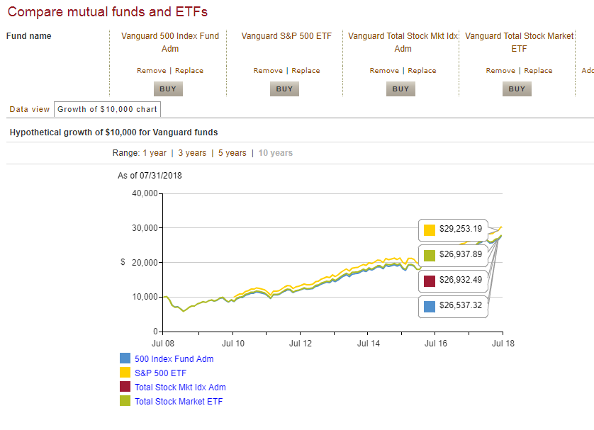

Just to show the expense ratios aren’t off…

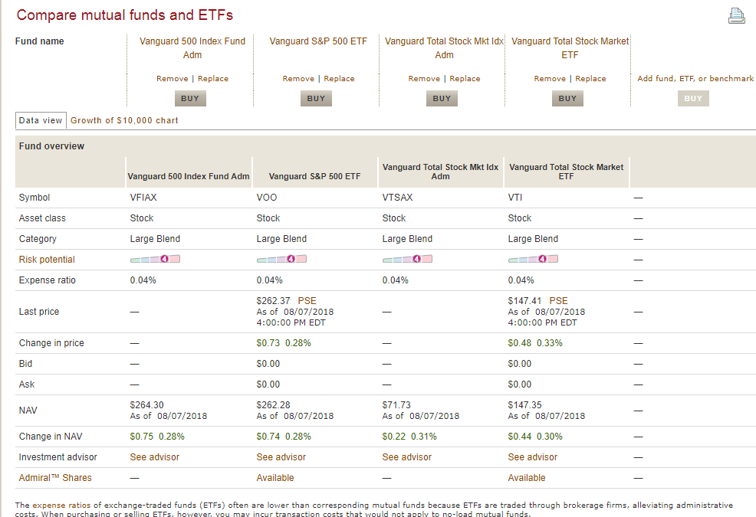

And the returns line up correctly too (at least the 5-year). Not sure what’s up!

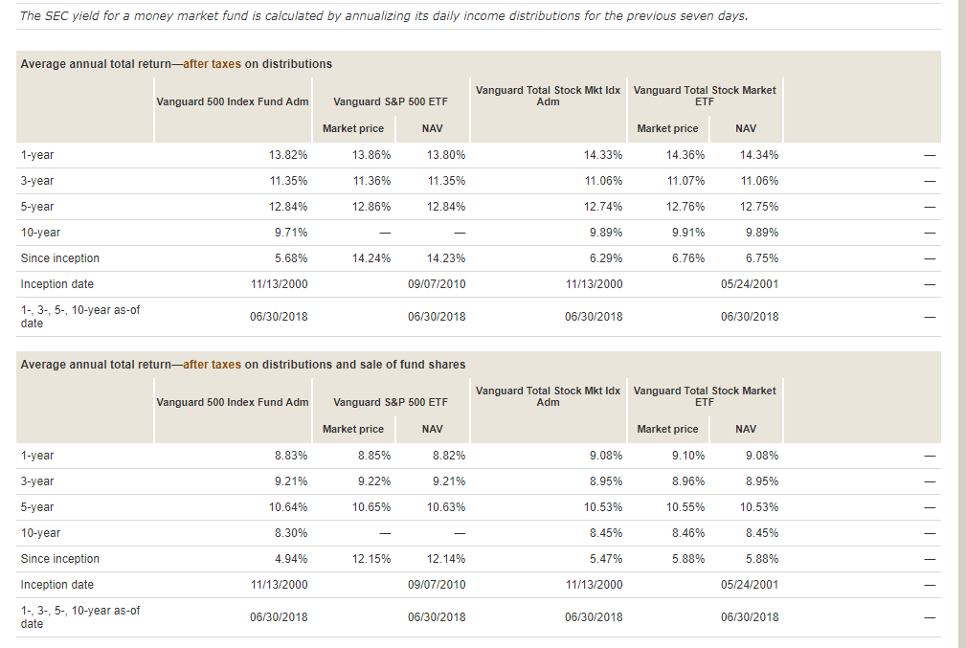

Here also is the corresponding chart from Morningstar.

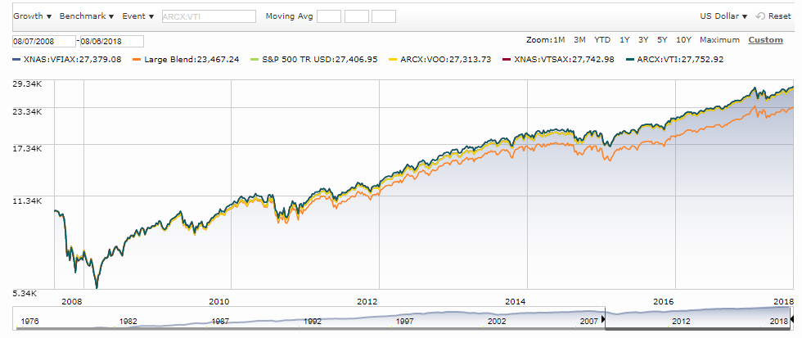

My main question is, why fundamentally is there a discrepancy between the ETF price and the index fund price?

* Also, assuming there is a difference, in trying to decide which to pick there is still disagreement!
  + Your website says the Vanguard ETF’s are a smidge better
  + Morningstar says VOO (S&P 500 ETF) slightly worse than VFIAX (S&P 500 index fund), whereas VTI (total stock market etf) is slightly better than VTSAX!
  + Jack Bogle hints that the traditional index funds (“Tifs”) are universally better:  
    *Over the past months, Tif investor returns were a few basis points higher than fund returns in each of the five largest Vanguard broad-market index funds. In contrast, returns earned by the firm’s ETF investors — owning the identical underlying portfolios — trailed the returns of the funds by an average of 1.6 per cent during the same period. This anecdotal evidence seems to confirm the consensus that higher trading activity takes its toll on investor wealth.*