**Phase Coherence as a Measure of Perceptual Synchrony in Large-Scale Coupled Oscillator Systems.**

*Nolan Lem*

**Abstract**

The means through which we perceive of temporal regularity play a critical role in our ability to listen, process, and construct meaning out of musical events. This experiment looks at synchrony as a subjective auditory percept in the context of several auditory scenes. I outline a model of temporal synchrony that arises in the context of periodically sounding events that converge and diverge over time using a system of event-triggered coupled oscillators. Similarly, I suggest that perceived synchrony, as well as other auditory percepts dealing with rhythm, is a processual percept that is integrated over time in response to the rhythmic coherence of independently-sounding auditory patterns. This aspect differentiates perceived synchrony from other processes involved in rhythmic beat perception in so far as it concerns the coherence of rhythm from a plethora of competing rhythmic information that are coupled to one another but are not initially related in terms of hierarchical rhythmic structures. This study examined how accurately participants were able to detect the phase coherence within different groups of coupled oscillators systems providing sound-event stimuli.

**Introduction**

Coupled oscillator systems are useful in describing a broad array of synchronistic behaviors among a wide array of biological and chemical systems including the mechanisms involved in firefly synchronization, pacemaker cell interactivity, and circadian rhythm (Strogatz & Stewart, 1993). Previous research has drawn on a dynamical system approach to coupled oscillators to describe the auditory and cognitive processing involved in subjects’ detection of rhythmic periodicity with respect to both musical and psychophysical parameters (Large & Jones, 1999; Large and Synder, 2009; Large & Palmer, 2002; Large & Kolen, 1994; Large et al., 2010). Other connectionist theories have drawn from research in temporal structure via beat-based coding to describe how listeners encode timing intervals to demarcate isochronous and non-isochronous rhythmic structures (Povel & Essens, 1985). As such, this study focuses on the model outlined by Dynamic Attending Theory (DAT) in so far as it postulates that temporally regular patterns direct attending rhythms in a goal-oriented way, one that is derived from the modulation of expectancy over time (Jones 1976).

This study uses a coupled oscillator model as a sound synthesis mechanism to examine how well one subjective measure of synchrony, phase coherence, correlates with the participants’ real-time detection of such a parameter. As such, participants were asked to move a slider in tandem with audio tracks that exhibit time-varying changes in phase coherence over time. The participants’ responses generated a *synchrony contour* that was compared with the actual phase coherence of each trial. The responses of the synchrony contours were analyzed in terms of similarity distance measures and cross- correlation with respect to the phase coherence event structure as it evolved over time.

Previous research in rhythmic perception has highlighted the importance of expectancy in the detection of temporal periodicity. Using a statistical model that accounts for subject expectancy over time as a function of state variables (namely, phase and frequency), studies have demonstrated the role of temporal regularity in engendering a more acute detection of time changes in simple rhythmic identification tasks (Large & Jones 2009). Listeners who were entrained by isochronous rhythms were better able to identify timing discrepancies when confronted with such tasks. Furthermore, other research has asserted that rhythmic detection is modulated by both experience and event structure (Large & Jones 2009). Ultimately, the listeners’ “referent period”, the period by which other cognitive rhythmic structures are gauged, and “attentional focus” adapt over time. These effects of session context were shown to be highly influential in affecting the way in which the participants could infer tempo changes within pre-defined beat markers.

This study makes use of the notion in DAT that “self-sustaining oscillations are an engine for generating goal-oriented expectancies” (Large 2009). From this perspective, each oscillator in the model conveys periodic behavior (e.g. an attending rhythm) that directs attention in a hierarchical fashion. That is, attention proceeds from the interplay of micro-macro level interactions between competing oscillatory units that ultimately composite high-level, perceptual ‘attractors’ that seek to coordinate expectancy with respect to the external sounding events. The DAT model suggests that there is an actual transduction between external sound events and an internal, cognitive representation of those events as comprised of coupled oscillators. Neural resonance theory (Large et. al 2015) has corroborated this claim from a physiological perspective by examining how neural populations in neocortical and thalamic regions of the brain can become entrained by external rhythmic sound events (Large & Synder 2009). Similarly, fMRI studies have looked at the role of the basal ganglia in detecting periodic stimuli (Grahn & Rowe 2012). This type of research prefigures temporal regularity as a cognitive process comprised of alternating periods of temporal searching with periods of temporal expectancy. More specifically, putamen activity has been shown to be associated with beat continuation, the extension of a demarcated periodic beat structure (Haruno & Kawato, 2006; Schiffer and Schubotz 2011). Conversely, non-periodic beat rhythms, those lacking temporal regularity, were shown to be associated with activity in the cerebellum (Grube et al. 2010; Teki et al. 2011).

This experiment looks at the way in which we intuit rhythm from a plethora of competing rhythmic information in the form of periodic sound stimuli. In the auditory scene presented, the listener must first identify emergent rhythmic structure from different densities of time-varying sound events generated from the behavior of a coupled oscillator system. More specifically, as the coupling coefficient of the system is varied in real-time, the oscillators begin to phase align to reflect quasi-periodic behavior.

This experiment uses the Kuramoto Model to derive the dynamic system of coupled oscillators (Kuramoto, 1984). Equation 1 shows the governing phase equation for a single oscillator in a system of N limit-cycle oscillators, with coupling coefficient K, and initial frequency ωi .

 [1]

The initial frequencies (ωi ) are drawn from a Gaussian probability density function g(ω) that is included in the following methodology section. Note that this coupled-oscillator system is phase-coupled but not frequency-coupled—the initialized frequency of the oscillators are fixed and therefore do not affect one another.

Kuramoto was able to reconfigure the phase equation in terms of mean-field quantities called the complex order parameters, phase coherence, *r*, and the mean phase, *ψ* as shown in Equation 3.

 [2]

Referring to [3], the oscillators in the system interact solely through the complex order parameters: the individual oscillator’s phase interacts with the group’s mean phase and the oscillators’ coupling strength are proportionally coupled to the group’s mean phase coherence, r. In effect, when *r* is zero, the collective phase state of the oscillators is ‘incoherent’, that is there is effectively no phase coupling and each oscillator simply moves with their respective initial frequencies. Conversely when *r* = 1, the oscillators are in complete phase alignment, moving together at some mean frequency (ωmean). There exists some coupling threshold, Kc, that mutually synchronizes the oscillators such that *r(t)* grows exponentially until it reaches a steady state, r∞ (English 2008). Figure 1 shows a plot of the phase coherence for different coupling coefficients over time.

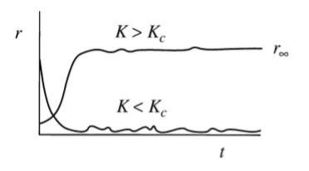

Figure 1: Evolution of r(t) in numerical simulation by Strogatz (2000) of Kuramoto Model

This study looks at the phase coherence as a perceptual parameter that indicates some measure of perceptual synchrony. Because the time evolution of r changes in response to varying the coupling coefficient (*K*), I hypothesize that this parameter may provide some insight into the nature of synchrony as a subjective auditory percept.

I examine this auditory percept in a multi-trial study that asks participants to move a digital slider in response to prepared audio tracks that vary phase coherence of a sonified coupled oscillator system (as described in the next section). More specifically, six of the trials looked at how the subjects responded to different phase coherence trajectories over time and the other three trials looked at how the subjects inferred synchrony given different oscillator populations sounding in the system. The latter trials were concerned with how the density of the coupled oscillator system affects the subjects’ perceived synchrony. I predict that the participants’ ‘average perceived synchrony contour’ (APSC) would approximate the actual phase coherence contour inherent in the system dynamics. This would be reflected in the time-series data collected and by comparing the phase coherence with the APSC. I also predicted that the subjects’ APSC would better correlate with the actual phase coherence contour when was the system was more densely populated with oscillators.

**Methods**

*Participants*

Twelve students from the Music Department at Stanford University took part in this experiment. Their ages ranged from 18 – 33 years old. Prior musical training was not taken into account in the gathering of the subjects.

*Stimulus*

*Coupled-Oscillator Sonification System*

This study used the ChucK audio programming language to implement a system of sound-event triggered coupled oscillators. In this program, each oscillator in the system triggers an audio sample of a struck woodblock upon each cycle of its respective period (e.g. limit cycle). This sound was chosen because it was percussive (impulse-oriented, containing a short transient) and was capable of suggesting pulse. Referring to **[3]**, θi = 0 was set to be the sample triggering point for each oscillator for convenience sake. This woodblock sample contains a natural pitch of approximately 420 Hz. However the sounds assigned to each oscillator were upsampled from 6 to 20 times its initial rate resulting in a random distribution of woodblock fundamentals ranging from 2500 to 8400 Hz. This was done so that the individual oscillators were of a similar timbre but with slight variations in pitch so that individual oscillators could be slightly discerned from one another. Similarly, when the samples sound in this higher frequency range, listeners may be less likely to be latch onto any one event-triggered oscillator. I found that sounds in a more realistic woodblock range may woodblock_stftencourage the listener to better discern individual oscillators from the audible mix of the group. Figure 2 shows the waveform and power spectrogram of the woodblock audio sample used in this study.

woodblock_waveformThe individual audio files for each trial were prepared by modulating the phase coherence (via changing the coupling coefficient over time) in the ChucK program and recording the output audio to the local disk. The actual phase coherence data was output to a text file where it was then analyzed using custom python scripts and the matplotlib graphical library. The phase coherence data was passed through a 4th order Butterworth low pass filter with a 3-dB cutoff point Wn = 0.005 (0.25, 0.83, 3.57 Hz for ωl, ωm, and ωh respectively). This was performed to smooth the phase coherence contour that was sampled at the three different clock periods depending on ωl, ωm, or ωh .

The one hundred initialized frequencies of the oscillator populations were drawn from a Gaussian distribution (µ=0.0425, σ = 0.0125). Each of the trials in the first experiment contained three different clock periods such that the mean frequency of the system in a fully synchronous state (*r* > 0.99) was ωL ≈ 0.67 Hz, ωM ≈ 2.28 Hz, ωH ≈ 9.5 Hz. To ward off the potential for session context effects (via entrainment of perceived pulses) in the more synchronous states, I chose mean frequencies that were not integer multiples of one another

For ωL , the probability density function (PDF) places ±3σ being 0.08 Hz and 1.27 Hz. For ωm: ±3σ = 0.26 Hz and 4.23 Hz. For ωh: 1.11 Hz and 18.1 Hz. These parameters were chosen so as to fall within a reasonably perceptual rhythmic range to establish continuity between individual oscillators’ triggered sample sounds. This was done in response to research that suggests we are most sensitive to musical rhythms that fall within the range of 30-240 bpm or 0.5-4 Hz. (London, 2004).

The sampled audio contained a sampling rate of 44.1 kHz. The participants listened to the audio tracks from the custom MAX/MSP interface using headphones at desks at the Center for Computer Research in Music and Acoustics (CCRMA). The data was collected using a custom designed user interface in the Max/MSP programming environment. Within this GUI, participants moved a virtual slider that indicated different levels of perceived synchrony as the prepared audio files for each trial were played over headphones. A polling dialog box showed the participants’ slider value over time providing them with the slider’s feedback. The data was collected at a sampling rate of 10 Hz. The participant’s slider data was output to a text file that was formatted for the custom python plotting scripts.

*Procedures*

This study involved two experiments that asked participant to move a digital slider (using the computer’s trackpad) in concert with nine prepared audio tracks that were generated using the coupled-oscillator ChucK program. The digital slider contained text that marked points on the slider from ‘very synchronous’ and ‘somewhat synchronous’ to ‘not synchronous at all’. These nine listening tasks made up the course of the study which was divided into two experiments.

The first experiment looked at participants’ ability to perceive of synchrony using three different mean frequencies within a one-hundred oscillator population and two phase coherence trajectories (called pattern contexts, see below). Each mean frequency (ωl, ωm, ωh) in Experiment 1 contained two distinct pattern contexts whereby the phase coherence followed different trajectories: a *ramp* from non-synchronous to full synchrony to non-synchronous state (over a two minute period) and *intervallic* (stepped) transitions in phase coherence (over a one minute period). Each step in the intervallic phase coherence trial lasted approximately ten seconds and each trial consisted of six steps. The phase coherence steps followed the sequence: r ≈ 0.35, 0.10, 0. 60, 0.9, 0.21, and 0.70. Experiment 1 consisted of these six auditory tasks: trials 1-3 for the ramp context and trials 4-6 for the interval context.

These phase coherence contours were chosen to reflect basic time-based events that might induce “pattern context effects”. In this study, I use the definition taken from Large and Jones (1999) where they define them to be contextual effects of parameter modulation over time within the course of a single trial. Similarly, “session context effects” are effects that are transported over from trial to trial.

The ramp context in Experiment 1 (trials 1-3) were chosen because they span a significant range of the phase coherence (0-0.9) and are represent a goal-oriented procedure in so far as they induce a synchronous phase state and then devolve back down to non-synchrony over the same interval of time. Because of the symmetry of this trajectory, this might allow pattern context effects to be observed such as the listener becoming entrained to the pulse percept inherent in the synchronous state. Similarly, the intervallic context in trials 4-6 represent piece-meal “jumps” in phase coherence that allow for steady-state responses. The shape of this contour may highlight how long it takes for the participants to settle on a perceived synchrony after each intervallic step (this is examined in the results section). Lastly, the density context uses the same ramp context in Experiment 1 to examine how the number of oscillators in the system affect the subjects’ perceived synchrony.

Figure 3 and Figure 4 shows the phase coherence, r(t), for the ramped and intervallic mid-frequency range audio track, ωm.

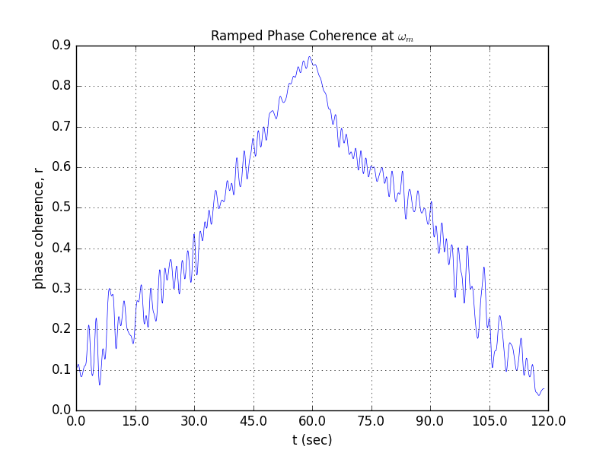

Figure 3: Ramp Context for ωml - Phase Coherence, r(t)

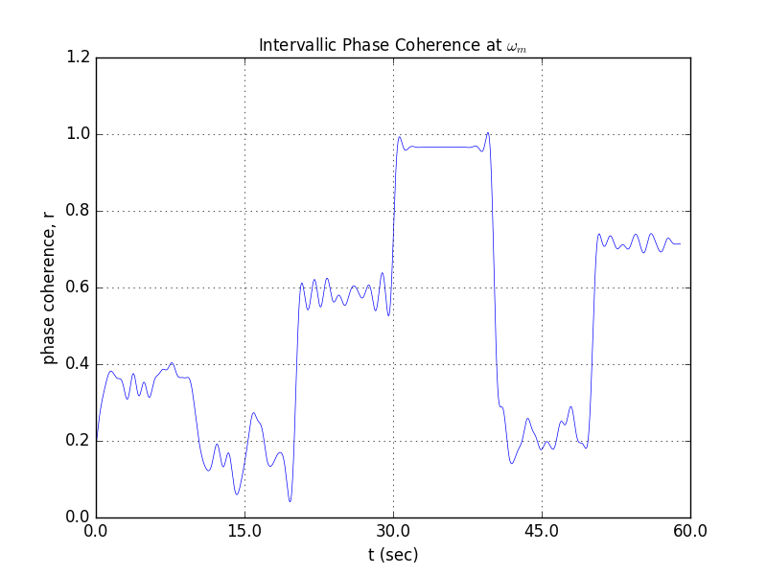

Figure 4: Interval Context at ωm- Phase Coherence, r(t)

The participants were familiarized with the Max/MSP interface and given instructions on how to move the slider. They were played two short audio examples that corresponded with the labels on the slider: one provided an example of how ‘extremely synchronous’ system sounded and the other demonstrated the ‘not synchronous at all’ case. The participant then proceeded to perform the tasks in each trial at their own pace.

Experiment 2 looked at how the relative density of the coupled-oscillator systems influenced the participants’ ratings of synchrony. This experiment consisted of three trials with 20, 40, and 150 oscillator systems with ωm as the mean frequency. The phase coherence was ramped up and down over a period of one minute. Figure 5 shows the phase coherence plot of the 150 oscillator system.

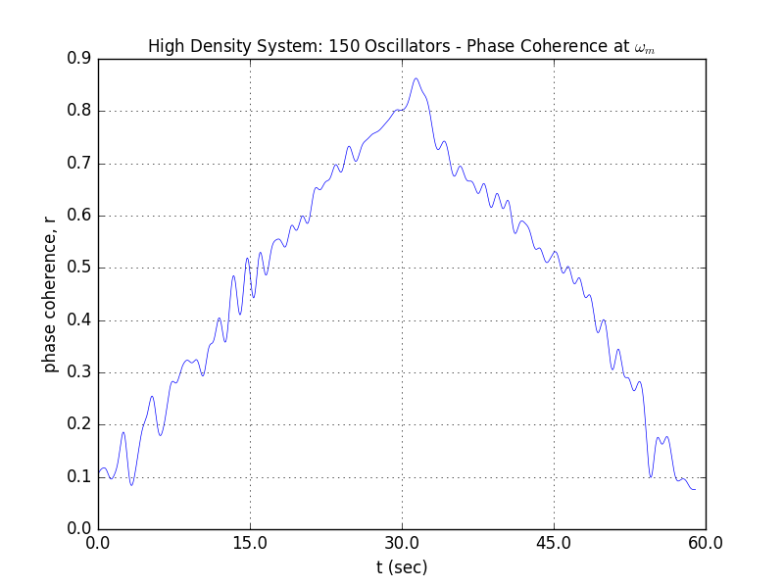

Figure 5: Density Context ωm- Phase Coherence, r(t)

The participants did the first three trials (ramped trajectories) of Experiment 1 first, followed by the three trials (oscillator density ramps) of Experiment 2, and finally the last three trials of experiment 1 (intervallic trajectories).

*Data collection and Analysis*

The participants’ slider data was output to text files at a rate of 10 Hz. For each trial in each experiment, the participants’ data was averaged and plotted against the actual phase coherence as a function of time. The results of this *average synchrony contour* were correlated with the actual phase coherence over time. Additionally, the first change in slider data at the onset of each trial were noted. This reaction time gives some indication on how long it took the participants to discern any level of synchrony in the system when the audio tracks began. This same approach was used in trials 4-6 of the intervallic contexts to examine when the participants settled on a synchrony rating at each phase coherence step (every 10 seconds).

I looked at Euclidean distance between data points in the average synchrony contour and the phase coherence contour to provide a similarity distance measure. This differential error was plotted with respect to time for each of the trials. From this error plot, we can infer at what points in the trial context the participants tended to deviate from the phase coherence (treated as a ground truth) of the system. This is most likely to depend on the pattern contexts of the phase coherence as it is modulated over time. Similarly, I was able to look at how the average synchrony contour over or under estimated the phase synchrony trajectory as a percentage of the duration of each trial.

**Hypotheses and expected results**

My primary hypothesis is that the perceived synchrony as a subjective auditory percept will follow the phase coherence of the given system over time. Regarding experiment one, I anticipate that the participants perceived synchrony would align with the phase coherence of the system over time. More specifically, I hypothesize that the participants would more accurately gauge the phase coherence of the system of the ωl, ωm frequency ranges. The ωh frequency range contains a mean frequency that makes it difficult for participants to cohere rhythmic events and hence establish temporal regularity within the system. In Experiment 2, I expect that the participants would be better able to follow the phase coherence of the larger density system (150 oscillators) over the less dense (20 oscillator) system. Because individual oscillator’s sounds are more difficult to discern within the context of a larger population, rhythmic regularity may be more difficult to perceive of in a less densely sounding system. Regarding the intervallic context, I would predict that higher levels of phase coherence preceding lower levels of phase coherence would yield higher perceived levels of synchrony across the participants. Because higher levels of phase coherence are likely to entrain the listeners to the pulse, I would anticipate that this will increase their over-estimation of lower phase coherence levels via their synchrony ratings.

**Results**

The results of the ramp context (trials 1 -3) from Experiment 1 are shown in Figure 6 (A-C).

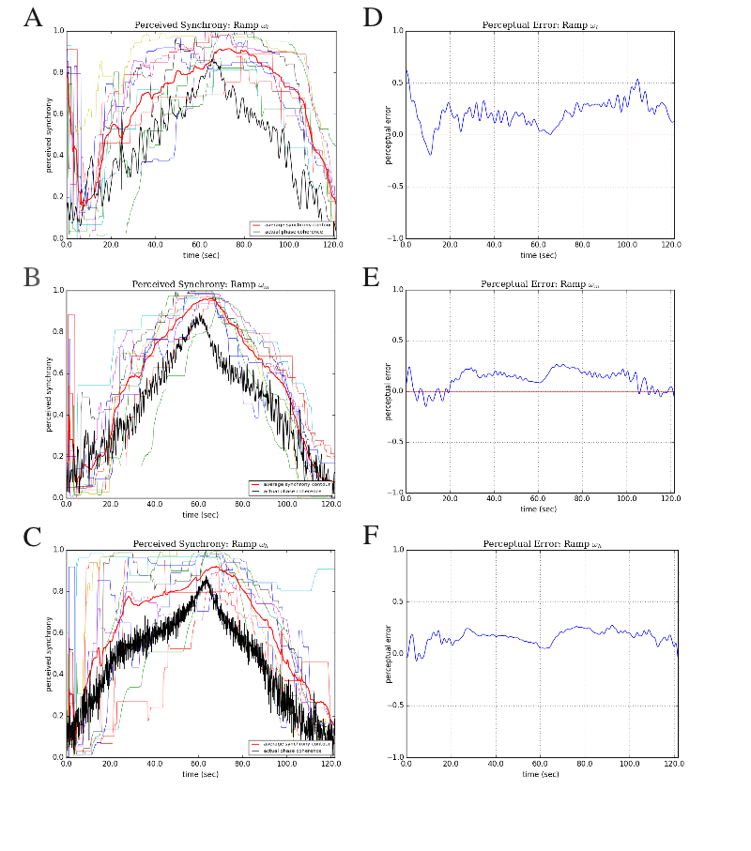

Figure 6. A-C: Ramp Contexts. Average Perceived Synchrony Contour vs. Phase Coherence, r(t). D-F: Perceptual Error, e(t)

The results of trials 4-6 of Experiment 1, the intervallic context, are shown in Figures 7 A-C.

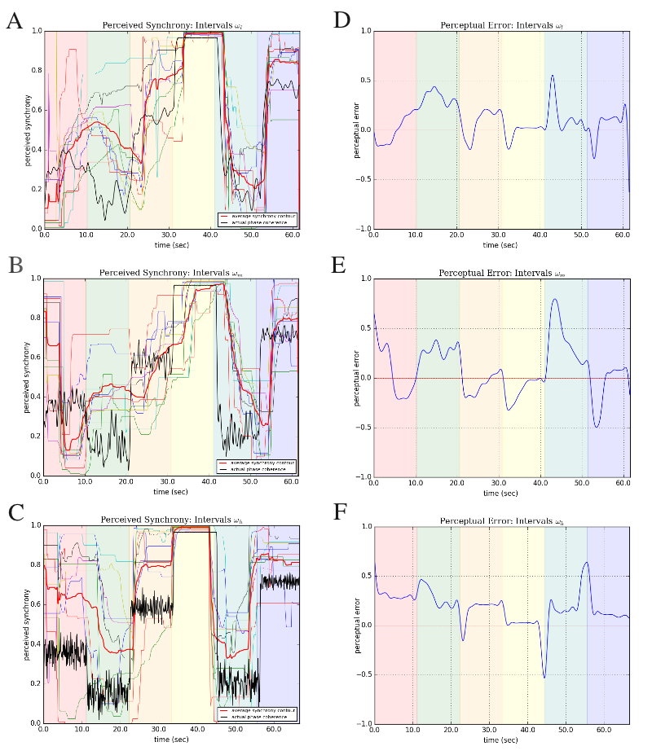

Figure 7. A-C: Interval Contexts. Average Perceived Synchrony Contour vs. Phase Coherence, r(t). D-F: Perceptual Error, e(t)

The results of Experiment 2, the density contexts, are shown in Figure 8 A-C.

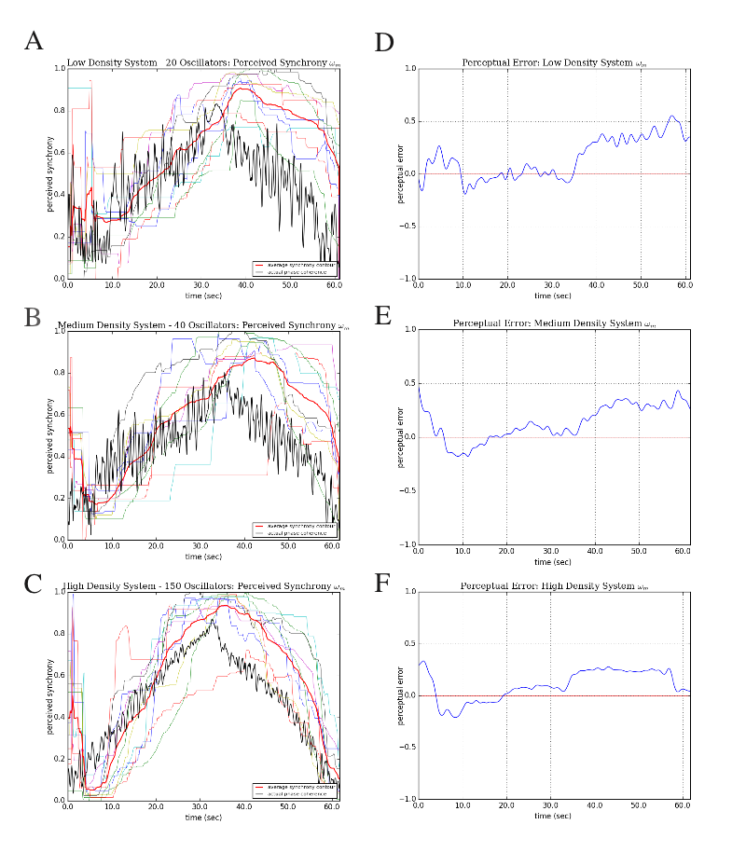

Figure 8. A-C: Density Contexts. Average Perceived Synchrony Contour vs. Phase Coherence, r(t). D-F: Perceptual Error, e(t)

The perceptual error contours, e(n), shown in the plots on the right hand columns of Figures 6, 7, and 8 (D-F) were calculated by subtracting the phase coherence, r(n), from the APSC. This is shown in Equation 3.

where si(n) are the individual participants’ rated synchrony contours, N is the number of oscillators, and r(n) is the time-series phase coherence contour. The perceptual error, e(n), is simply the phase coherence, r(n), subtracted from the APSC, the first term in [3].

Table 1 shows the total percent error relative to trial context.

**Table 1: Total Percent Error over Trial Window**

|  |  |  |  |
| --- | --- | --- | --- |
|  | **⍵l** | **⍵m** | **⍵h** |
| **Ramp** Percent Error | 0.208 | 0.118 | 0.16 |
|  | **⍵l** | **⍵m** | **⍵h** |
| **Interval** Percent Error | 0.0937 | 0.0767 | 0.182 |
|  | **low density** | **med density** | **high density** |
| **Density** Percent Error | 0.149 | 0.132 | 0.101 |

The percent error was calculated by using a normalized uniform-grid trapezoidal function to integrate the error function, e(n), over the duration of each trial context window. Table 2 shows how the percentage of time per trial that the APSC over or underestimated the phase coherence.

**Table 2: Average Perceptual Synchrony Contour: Percent Over-Under Estimation**

|  |  |  |  |  |  |  |  |  |  |
| --- | --- | --- | --- | --- | --- | --- | --- | --- | --- |
|  | **Ramp** Context | |  | **Interval** Context | |  | **Density** Context | |  |
|  | **⍵l** | **⍵m** | **⍵h** | **⍵l** | **⍵m** | **⍵h** | **⍵m** | **⍵m** | **⍵m** |
| *negative* | 0.041 | 0.161 | 0.039 | 0.237 | 0.430 | 0.060 | 0.319 | 0.174 | 0.248 |
| *positive* | 0.959 | 0.839 | 0.961 | 0.763 | 0.570 | 0.940 | 0.681 | 0.826 | 0.752 |

**Discussion**

Overall the participants rated synchrony followed the contours of the phase coherence over time. More specifically, in each of the trials and pattern contexts, the participants’ APSC followed the trajectory of the phase coherence with better than 21% accuracy over the entire temporal window. This is shown in Table 1 which illustrates the total percent error across the trials. By averaging the percent error across each pattern context, we can obtain the following percent errors for the ramp, interval, and density contexts respectively: 16.2%, 11.7%, and 12.7 %. Averaging all the percent error values of all the trials, the participants showed a total average percent error of 13.6% with respect to the phase coherence. The participants rated the ramp contexts with the least accuracy. Similarly, referring to Table 2, this is also the pattern context in which they significantly over-estimated the synchrony of the system (all three trials showed > 83% overestimation). This is surprisingly insofar as the phase coherence contour was continuous and symmetric.

These ramp contexts also illustrated the participants’ asymmetrical APSC starting at the midpoint (t≈60 s for trials 1-3 and t≈30 s for trials 7-9) on the downward ramp. Referring to Figure 6 and Figure 8 (A-F), there is a notable lag in the APSC associated with the downward ramp that are most likely a result having just become entrained to the mean frequency at a nearly synchronous system state. In effect, listeners are more likely to rate the stimuli as synchronous once a pulse percept has been established despite the rhythmic content is becoming devolved. As Large et. al have pointed out, the ‘induced imaginary pulse’ is most likely a result of emergent neuronal populations that are induced via entrainment (Large et. al 2015). In this case however the pulse itself is explicitly expressed, albeit for a relatively short time, before it is procedurally un-synchronized. This is evident in the error plots shown in Figures 6-8 (D-F) where there is a sizable increase in the average error estimation relative to the ascending ramp. Overall, this result seems to reflect the hypothesis that pattern context effects are present and observable in this specific coupled-oscillator event-driven model.

The interval contexts shown in Figure 7 (A-C) were notable in that the participants rated them with the most accuracy over the entire duration of the trials. It’s interesting to note that the first two phase coherence intervals of the ωl and ωm case seem to be flipped—that is, the APSC shows an upward motion from interval one to interval two (red to green shaded regions) even though the phase coherence is moving downward from 0.35 to 0.1. At the onset of each trial, there is a time period where the participants, lacking any prior stimuli, must react to the sounds to set the synchrony slider. Because they lack a context from which to gauge their perceived synchrony, there is a reaction time associated with establishing a baseline synchrony rating. Inspecting the plots for the ramp and density contexts (Figures 6-8. A-C), the APSC seems to settle into an area of ‘not-synchronous at all’ around the 5 second mark. Similarly, the jumps between different steady-state phase coherence values in the intervallic contexts also seems to show around a 5 second reaction time to settle into a perceived synchrony slider value. This is perhaps best illustrated by inspecting the error plots on Figures 7-E where the error is reduced (directed toward zero) around the midpoint of each stepped interval duration, each one being ten seconds. I would expect that the lower the mean frequency (e.g. ωl), the longer the reaction time to settle on some synchrony rating. Similarly a higher mean frequency (e.g. ωh) would yield quicker synchrony responses. From inspection, this characteristic seems to be somewhat reflected in the ωl, ωm, and ωh plots by comparing the perceptual error’s transition times from one interval to the next—namely, the last four transitions (orange 🡪 yellow 🡪 blue 🡪 purple).

Further analysis (such as taking an FFT or MFCC) of the perceptual error time series might demonstrate a quantifiable measure of the frequency content associated with the data. Nevertheless, more data would be needed to develop this type of reaction time metric.

Relative to the data obtained from the other trials, the density contexts, shown in Figure 8 (A-F) were notable for the significant perceptual error after the midway convergence point in the trials. Again, this is most likely a result of the rhythmic entrainment that is induced from the high level of phase coherence at this halfway point. The less dense systems (Figure 8 D,E) show a larger perceptual error than the most dense system. This was expected given that I predicted that the participants would rate the high density system more accurately. Less densely populated systems facilitate the listener in latching onto individual or clusters of oscillator rhythms. This might encourage the listener to hear the system as a polyrhythm at times and thereby indicative of hierarchical temporal structures. Once the phase coherence is significantly high—midway through the ramp context for instance—the listener may be more likely to perceptually latch onto the oscillators that stay in sync with the prefigured pulse as the phase coherence is ramped back down again.

**Significance**

Because coupled oscillator models can account for the behavior found in a variety of natural systems, it may be useful to unpack the cognitive and auditory mechanisms through which we attend to meaningful patterns within our complex acoustic world. Namely, our ability to discern and cohere temporally periodic events within competing auditory stimuli is significant in so far as it involves a complicated interplay between attention, temporal expectancy, and sensory-motor coordination. By examining this high-level percept (or even defining it as such), we may be better equipped to understand how other processes involved in music cognition function. From the perspective of music, the convergence of rhythmic patterns is a compositional device used in a variety of musical genres. Much process-based music—such as minimalism, house, techno—evoke synchronistic sonic behavior to generate a variety of complex rhythmic materials. Likewise, many experimental music genres, such as contemporary orchestral music, create dense constructions of sonic mass that converge and diverge over time (see the work of I. Xenakis, K. Penderecki, K. Stockhausen). Synchronistic behavior is probably most interesting to us in so far as it is reflected in the sounds of the natural world. Swarms of crickets, lightning bugs, cicadas, and locust all contain biological mechanisms to enable them to self-synchronize and oftentimes their sonic language reflects this exigency.

If we can define synchrony as a subjective auditory percept, one that is distinct from other rhythmic percepts, then we might better understand how we inhabit and derive meaning from the rich acoustic ecologies encapsulated by the natural world.

**References**

English, L. Q. 2008. Synchronization of oscillators: an ideal introduction to phase transitions. *European Journal of Physics*, 29. 143 – 153. doi: 10.1088/0143-0807/29/1/015

Grahn, J. A., & Rowe, J. B. 2012. Finding and Feeling the Musical Beat: Striatal Dissociations between Detection and Prediction of Regularity. *Cerebral Cortex*. doi:10.1093/cercor/bhs083

Grube M, Cooper FE, Chinnery PF, Griffiths TD. Dissociation of duration-based and beat-based auditory timing in cerebellar degeneration. *Proc Natl Acad Sci* U S A. 2010;107:11597–11601.

Haruno, M., & Kawato, M. (2006) Different neural correlates of reward expectation and reward expectation error in the putamen and caudate nucleus during stimulus-action-reward association learning. *Journal of* *Neurophysiology,*95. 948–959.

Schiffer AM, Schubotz RI. (2011). Caudate nucleus signals for breaches of expectation in a movement observation paradigm. *Frontiers in Human Neuroscience*. 5-38.

Jones, M. R. (1976). Time, Our Lost Dimension: Toward a New Theory of Perception, Attention, and Memory. *Psychological Review*, 83. 323-355.

Kuramoto, Y. (1984). *Chemical Oscillations, Waves, and Turbulence*, Springer, Berlin.

Large, E. W., and Snyder, J. S. (2009). Pulse and meter as neural resonance. *Ann. N.Y. Academy Science.* 1169, 46–57. doi: 10.1111/j.1749-6632.2009.04550.x

Large, E. W., & Jones, M. R. 1999. The Dynamics of Attending: How People Track Time-Varying Events. *Psychological Review*, 106, 119-159.

Large, E. W., & Palmer, C. 2002. Perceiving temporal regularity in music. *Cognitive Science*, 26. 1-37.

Large, E. W., & Kolen, J. F. 1994. Resonance and the Perception of Musical Meter. *Connection Science*, 6. 177-208. doi: 10.3389/fnsys.2015.00159

Large, E. W, Herrera, J. A, & Velasco, M. J. 2015. Neural Networks for Beat Perception in Musical Rhythm. *Frontiers in Systems Neuroscience*, 9. 1-14.

Large, E.W, Almonte, F. V, & Velasco, M. J. 2010. A canonical model for gradient frequency neural networks. *Physica D*, 239. 905-911.

Povel, D. J., & Essens, P. (1985). Perception of temporal patterns. *Music Perception, 2,* 411-440.

Strogatz, S.H. 2000. From Kuramoto to Crawford: exploring the onset of synchronization in populations of coupled oscillators. *Physical D*, 143. 1 – 20.

Strogatz, S. H., & Stewart, I. 1993. Coupled Oscillators and Biological Synchronization. *Scientific American*, December 1993. 102- 109.

Teki S, Grube M, Kumar S, Griffiths TD. Distinct neural substrates of duration-based and beat-based auditory timing. *Journal of Neuroscience*. 2011;31:3805–3812.

(you just made a nice proposal. Go back and read again to check whether the whole story makes sense and nothing in your actual design stands out as abrupt or unexplained. Any scientific research or scholarship proposal will follow more or less this format/its variations. You can write this way, and go grab some money or interesting opportunities! Also you just made the half of the final report. You have to add the results and discussions later to make the complete report. Final report template will be released shortly, but not much different from this until the results section)