Open-X-Tactile Data Submission Guide

Data Processing and Submission Specifications for Uploaders
Version: v0.2 Draft
Audience: Data Uploaders
Scope: How to export zarr according to the FTP-1 data processing documentation, run the Open X-Tactile check scripts, and submit the required materials.

1. Objective and Workflow
All Contributors are asked to complete 4 tasks:
- Process the raw data according to the FTP-1 specification and export .zarr
- Run the three OXT-QC check scripts
- Prepare manual review materials (annotated images, visualization videos, and supplementary notes)
- Package and submit
The workflow is as follows:
Raw tactile manipulation data
→ Process according to FTP-1 data_processing and export FTP-1-compatible zarr
→ Run Open-X-Tactile Quality Check (metadata / 4dvis / vlm)
→ Submit zarr + check outputs + manual materials

2. Export zarr According to the FTP-1 Documentation
The Open X-Tactile data format follows the FTP-1 data processing format.
Please first read and follow the FTP-1 data processing documentation below to process your data into FTP-1-compatible zarr:
https://github.com/michaelyuancb/ftp1-policy/blob/main/data_processing/README.md
This document defines the zarr format, directory structure, key naming, pose convention, camera fields, tactile fields, and action/state fields. Uploaders need to submit the processed .zarr files.
Regarding sensor_name naming, please first visit https://open-x-tactile.github.io/, click Contribute Data, and use the search bar below to check whether the sensor already exists (the search bar supports keyword suggestions). If it already exists, please directly use the sensor name listed on the official website. Otherwise, you may choose your own name; make sure not to include spaces or special characters.
Recommended zarr directory structure:
zarr/
episode_batch_0000.zarr
episode_batch_0001.zarr
...
Alternatively, it can be split by task:
zarr/
grasp.zarr
lift.zarr
...

For egocentric data (robot data containing an egocentric perspective) and UMI data, OXT has more detailed requirements for coordinate-frame direction definitions. The FTP-1 data processing documentation briefly mentions the coordinate definition standard of z-forward / x-right / y-down; for more detailed coordinate-frame definitions, please refer to:
- docs_Illustration about Ego Data Frame.pptx
- docs_Illustration about UMI Data Frame.pptx

Notes on supplementary_joints and supplementary_tactile:

FTP-1 mainly focuses on head-arm-hand joints and tactile information. However, some robot embodiments may include other parts, such as joints for mobility/waist/legs, or full-body tactile signals. For additional joints (action) signals, please refer to:

https://github.com/michaelyuancb/ftp1-policy/blob/main/data_processing/README.md

Following the description there, fill in the key supplementary_joints, with shape (T, D), where D is the number of additional joints. Please submit supplementary_joints_note.json to explain the meaning of each dimension (required). We recommend additionally submitting supplementary_joints_note.png and annotating which robot joint each dimension corresponds to.

For robot embodiments whose tactile signals include tactile information beyond the current MTTS definition, the tactile package only needs to include the three keys `data`, `sensor`, and `type`; please submit supplementary_tactile_note.json to explain the meaning of each dimension (required). We recommend additionally submitting supplementary_tactile_note.png and annotating which tactile sensor each dimension corresponds to.

For the format of supplementary_joints_note.json and supplementary_tactile_note.json, please refer to the template files we provide.

3. Run Open-X-Tactile Quality Check
OXT-QC repository:
https://github.com/nolann030628/OXT-QC.git
The checks include three parts:
- metadata and zarr structure precheck: precheck_metadata.py
- Coordinate-frame/trajectory-related 4D visualization check: precheck_4dvis.py
- RGB+tactile semantic review: precheck_vlm.py
Please run them according to the repository README and save the output directory for later submission. Below is a brief introduction to the general functions of the OXT-QC toolkit. For the specific workflow, output meanings, and checking methods, please refer to the documentation inside the OXT-QC toolkit.

3.1 metadata and Structure Precheck
python precheck_metadata.py /path/to/zarr_or_parent_dir
Main outputs:
- oxt_check_output/precheck_report.json
- oxt_check_output/precheck_report_result.json
- oxt_check_output/metadata.json
- oxt_check_output/dict.json
3.2 4D Visualization Check
python precheck_4dvis.py -d --data_path /path/to/one_dataset.zarr
Purpose: verify ego/UMI/wrist/end-effector related coordinate frames and trajectory behavior.
Refer to the FTP-1 pose convention and the coordinate-frame explanation PPTs in the repository.
3.3 VLM Review
python precheck_vlm.py /path/to/zarr_or_parent_dir
Main outputs:
- oxt_check_output/vlm_review.json
- oxt_check_output/vlm_review_result.json
Note: VLM is used for preliminary screening; warning/fail results require manual review.

4. Submit to the Open-X-Tactile Dataset
The final submission contains two parts. First, please package and upload the zarr data to Hugging Face or ModelScope. Then, submit a dataset-conclusion (metadata) package to the OXT organizer team for data checking, dataset release, and data analysis.

4.1 Upload Data to Hugging Face / ModelScope
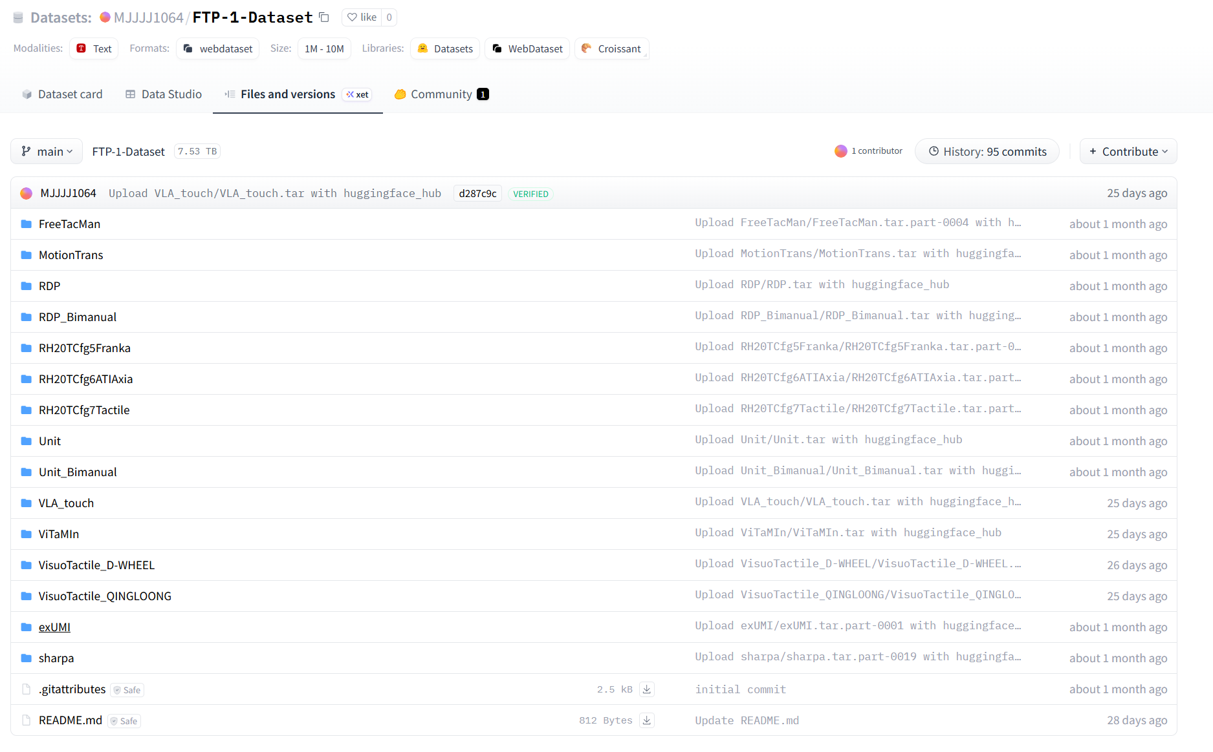
Please upload to Hugging Face or ModelScope according to the file layout shown above; specifically:
<user_id>/<dataset_name>
- <sub_dataset_name-1>/
- <sub_dataset_name-2>/
- <sub_dataset_name-3>/
- <zip-1>
- <zip-2>
....
- README.md
- supplementary_joints_note.json / supplementary_tactile_note.json (if applicable, optional)

Here, <dataset_name> is the name of the entire dataset (also the dataset name listed on the OXT website), and is used as the dataset name on HF or MS; <sub_dataset_name> is the name of a sub-dataset within the dataset. If there is only one sub-dataset, a single folder is sufficient. The folder contains the zip files; if split archives are used, there can be multiple files. README.md is a description of the dataset. There is no unified format requirement; it only needs to cite the OXT website so that users can visit the OXT website to find the data format instructions.
For reference, see:
https://huggingface.co/datasets/MJJJJ1064/FTP-1-Dataset/tree/main/RH20TCfg7Tactile

4.2 Submit metadata & data example to OXT Organizers
In addition to uploading to the HF/MS website, each Contributor also needs to submit a metadata&example folder to the OXT organizing team for data checking, publishing the data to the OXT website, and subsequent data statistics.
The final submission package structure is as follows:
OXT_Submission_<dataset_name>/
oxt_check_output/
dict.json
precheck_report.json
precheck_report_result.json
vlm_review.json
vlm_review_result.json
hand_joints_idx.png
institution_<institution_log>.png
metadata.json
sensor_<sensor_name_1>.png
sensor_<sensor_name_2>.png
...
tactile_func_area_idx.png
video.mp4
supplementary_joints_note.json etc. (if applicable, optional)

The meanings of these items are described below:

4.2.1 Basic Information
metadata.json: A metadata annotation file. Please refer to the template and contents in the example. This is the most important file among all submitted materials. Please carefully check it repeatedly to ensure that the submitted metadata information is correct. Thank you.
video.mp4: A short example video showing dataset samples. It must be cropped to a square resolution; the recommended resolution is 224x224. Submitters should manually resize and crop it.
oxt_check_output/: Keep the complete output results obtained from the OXT-QC toolkit quality checks in this folder.
institution_<institution_log>.png: Logo image of the submitting institution or organization. It should be a white-background, high-resolution image without watermark. The institution name should not contain spaces.
sensor_<sensor_name_1>.png: For each sensor used, provide an image and name the image file using the sensor name used in the zarr and dataset. Sensor naming requirements are given in Chapter 2 of this document.
supplementary_joints_note.json etc.: If supplementary joint or tactile information is included, the corresponding note files must be provided. The JSON is required, and the PNG is recommended. See Chapter 2 of this document for details.

4.2.2 End-effector Annotation Images (hand_joints_idx.png and tactile_func_area_idx.png)
Please upload a clear end-effector photo or diagram and mark the corresponding slot index on the image.
These two images are submitted to the Open X-Tactile team for manual review and are used to check whether the UAS and MTTS definitions are correct (see https://ftp1-policy.github.io/).
Two files need to be submitted: hand_joints_idx.png and tactile_func_area_idx.png

4.2.2.1 hand_joints_idx Annotation Image
File name: hand_joints_idx.png. The example image is as follows:
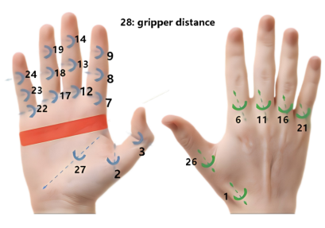
Please mark the following in the image:
1. Each exported hand / gripper joint
2. The hand_joints_idx number corresponding to each joint

4.2.2.2 tactile_func_area_idx Annotation Image
File name: tactile_func_area_idx.png. The example image is as follows
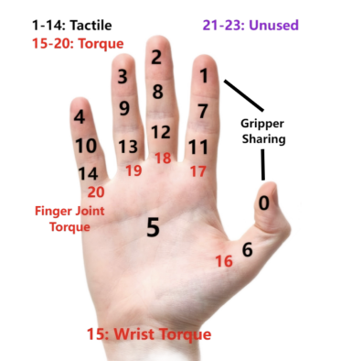
Please mark the following in the image:
1. The position of each tactile sensor or tactile channel
2. The tactile_func_area_idx number corresponding to each tactile sensor / channel

