Nolan DeSchryver and Matthew Frey

Scene Object Documentation and Rendering Analysis
This document describes each object present in the 3D scene and explains:
- Mathematical characteristics
- Primitives used to render
- Transformations applied
- Shader behavior and reasoning
- Virtual camera configuration
The scene is implemented using OpenGL’s fixed-function pipeline and hierarchical modeling with matrix stacks.

Virtual Camera
Position
(-1.0, 3.25, 15.95)
Orientation
Controlled using yaw and pitch angles.
Look direction:
lookX = cameraX + cos(pitch) * sin(yaw)
lookY = cameraY + sin(pitch)
lookZ = cameraZ - cos(pitch) * cos(yaw)
Projection
Perspective projection using:
gluPerspective(45, aspectRatio, 0.1, 100)
- Field of View: 45
- Near plane: 0.1
- Far plane: 100
View Matrix
Created with:
gluLookAt(eye, center, up = (0,1,0))
This produces a right-handed viewing frustum.
Camera Geometry Diagram (conceptual)
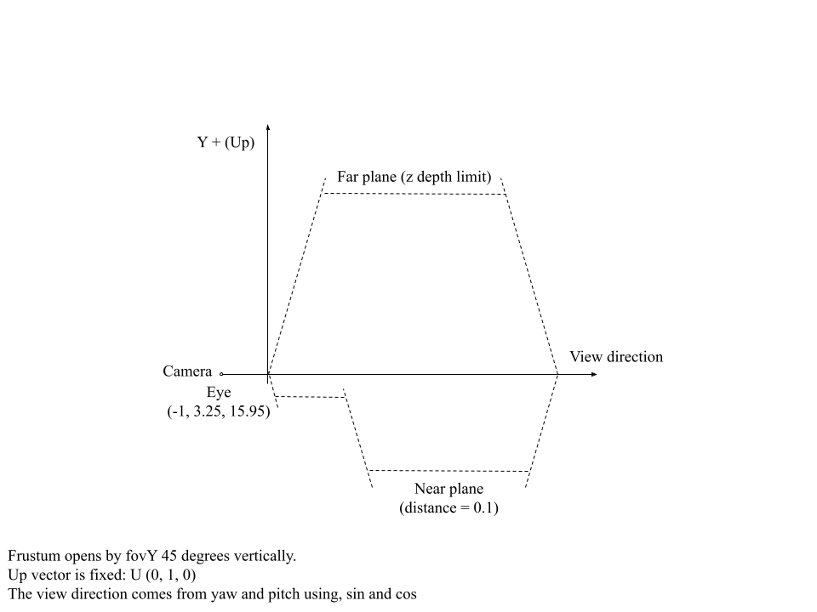
Global Rendering Pipeline
Lighting
Fixed-function OpenGL lighting enabled with:
glEnable(GL_LIGHTING)
Materials supplied using:
glMaterial*
Provides:
- Ambient
- Diffuse
- Specular
- Shininess
Texturing
Textures applied using:
GL_TEXTURE_2D with GL_MODULATE
Allows texture colors to combine with material lighting.
Transparency
Blending:
glBlendFunc(GL_SRC_ALPHA, GL_ONE_MINUS_SRC_ALPHA)
Used for glass and curtain overlays.

Scene Objects:

Ground Plane
Mathematical Characteristics:
- Flat plane at Y = shellBottomY + shellThickness (≈ −6.13), flush with the top surface of the room floor
- X extents: wallSectionLeftX + shellThickness to wallSectionRightX − shellThickness (interior between the side walls)
- Z extents: wallSectionCenterZ to wallSectionCenterZ + sideWallSpan − shellThickness (interior up to the back wall)
- Divided into 200 × 200 tiles
Primitives Used:
- Quads (checkerboard grid)
Transformations:
- None; drawn directly in world space using the room's computed interior bounds
Shader Behavior
- Alternating materials create a checkerboard appearance
- Lighting gives soft shading across the plane
Notes:
- The plane is no longer a fixed-size world-space element; its bounds are derived from the surrounding shell walls so it exactly fills the room interior
- It is drawn after the shell geometry is computed in drawScene() so the required bound variables are in scope
Main Building Body
Mathematical Characteristics:
- Base cube scaled to rectangular prism
- Center passed as parameter (posX, posY, posZ); first instance at (0, 3.25, −10), second at (16, 3.25, −10)
- Scale: sx = 12, sy = 6.5, sz = 1 with cubeSize = 2 → half-extents (12, 6.5, 1) in world space
Primitives Used:
- Cube (6 quads)
Transformations:
- Translate: positions building at the supplied world-space origin
- Scale: stretches cube into facade proportions
Shader Behavior:
- Warm facade material
- Lighting produces realistic shading and highlights
Notes:
- The building rendering now happens in a drawBuilding() function that is called twice to draw two building at a given position
Window Grid
Mathematical Characteristics:
- Rectangular quads positioned on the building's front face - Arranged in rows and columns
- Building position supplied as (posX, posY, posZ) from drawBuilding()
Primitives Used:
- Textured quads
Transformations:
- Matrix reset to camera view inside drawWindows()
- Vertices placed directly in world coordinates
- Prevents inherited scaling from the building

Shader Behavior:
- Texture + GL_MODULATE
- Allows tinting while preserving lighting
- Creates realistic window appearance
Window Frame
Mathematical Characteristics:
- Borders and dividers forming a rectangular frame
- Fixed world-space position; part of the interior room, not drawBuilding()
Primitives Used:
- Multiple scaled cubes
Transformations:
- Each part: push matrix → translate → scale → draw cube → pop matrix
- Hierarchical modeling builds complex structure
Shader Behavior:
- Metallic gray material
- Moderate shininess for specular reflections
Texture Overlay
Mathematical Characteristics
- Single quad slightly in front of frame
- Small Z offset prevents z-fighting
Primitives Used
- Textured quad
Transformations
- Direct vertex placement
Shader Behavior
- Lighting disabled
- Blending enabled
- Alpha transparency
- Creates glass/projection effect
Curtain Panels
Mathematical Characteristics
- Thin vertical and horizontal slabs beside the frame
Primitives Used
- Scaled cubes
Transformations
- Translate to position
- Scale to thin sheet
Shader Behavior
- Gray material with lighting
- Produces soft shadowed fabric look
Wall Section Under Frame
Mathematical Characteristics
- Large rectangular slab beneath window
Primitives Used
- Scaled cube
Transformations
- Translate to center
- Scale to width/height/depth
Shader Behavior
- Warm wall material
- Lit for depth perception
Electrical Outlet
Mathematical Characteristics
- Multiple small components: plate, inset, screws, socket slots
Primitives Used
- Several scaled cubes
Transformations
- Each component individually translated, scaled, and drawn
- Layered depth offsets avoid z-fighting and create realism
Shader Behavior
- Different materials: off-white plate, darker screws, dark slots
- Improves visual detail under lighting
Roof Sections
Mathematical Characteristics
- Two thin slabs per building instance: main roof and darker trim band
- Both positioned relative to buildingTopY = posY + buildingH
- Roof 1 center: (posX, buildingTopY + 0.15, posZ) — half-extents (12, 0.15, 4)
- Roof 2 center: (posX, buildingTopY + 0.40, posZ) — half-extents (12, 0.15, 4)
Primitives Used
- Scaled cubes
Transformations
- Translate relative to posY + buildingH so roofs always sit on top of whatever building position is passed
- Scale to wide, thin slab proportions
Shader Behavior
- Roof 1: warm facade material matching building body
- Roof 2: dark gray trim material
- Lighting produces edge shading that separates the two layers visuallyTranslate upward
Scale to thin rectangles
Surrounding Shell (Side Walls, Back Wall, Floor, Ceiling)

Mathematical Characteristics
- Encloses the interior room; all five surfaces share the same thickness: shellThickness = frameDepth = 0.12 - Height spans shellBottomY (≈ −6.25) to shellTopY = wallSectionTopY + frameHeight
- Width and depth both equal sideWallSpan = wallSectionWidth (the full frame-row span)
- Left side wall center: (wallSectionLeftX + shellThickness × 0.5, shellCenterY, wallSectionCenterZ + sideWallSpan × 0.5)
- Right side wall center: (wallSectionRightX − shellThickness × 0.5, shellCenterY, wallSectionCenterZ + sideWallSpan × 0.5)
- Back wall center: (wallSectionCenterX, shellCenterY, wallSectionCenterZ + sideWallSpan)
- Floor center: (wallSectionCenterX, shellBottomY + shellThickness × 0.5, wallSectionCenterZ + sideWallSpan × 0.5)
- Ceiling center: (wallSectionCenterX, shellTopY − shellThickness × 0.5, wallSectionCenterZ + sideWallSpan × 0.5)
- Carpet quad rendered 0.002 units above the floor slab top, tiled at a world-unit size of 1.2; UV coordinates computed as backWallWidth / 1.2 and
sideWallSpan / 1.2
Primitives Used
- Five scaled cubes (side walls, back wall, floor slab, ceiling)
- One textured quad (carpet overlay on floor surface)
Transformations
- Each surface: translate to computed center → scale to full extent × shellThickness → draw cube
- Carpet: direct vertex placement at floorTopY; no matrix push needed
Shader Behavior
- Walls and ceiling: warm beige material (225, 184, 142) lit for depth and corner shading
- Floor slab: same warm beige material
- Carpet: procedural gray texture via GL_MODULATE with a neutral mid-gray material; GL_REPEAT wrapping tiles the pattern across the full floor area

