Project 6: Specular Lighting, Objects, Illumination and Shaders
Nolan DeSchryver and Matthew Frey
CST-310
Project Documentation

Theoretical Background
- Phong Lighting Model
This is a technique in computer graphics that computes surface color based on three components: ambient light, diffuse light, and specular light.
- Shininess (Specular) Exponent
This controls how concentrated the specular highlight is. Low shininess values like 2, 4, and 8 mean the concentration is large making the object appear soft. High values like 128 and 256 make the concentration tight making the object appear metallic.
Mathematical Concepts
- Vector mathematics
Vector math is foundational for lighting in computer graphics. This includes things like vector normalization and dot products.
- Tranformations
The shader must compute lighting in eye space. Additionally, the cubes themselves must be moved in 3 dimensions to appear side-by-side and in view of the camera.
Programming Concepts
- Vertex and Fragment Shaders
The vertex shaders transform vertices from world space to clip space while preserving the geometry:
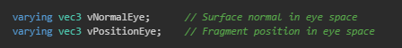
The Fragment shaders compute per-pixel Phong lighting to output a final color:
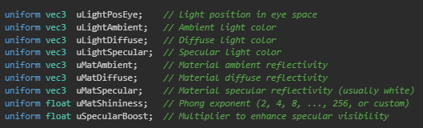
- Threading for Interactivity
There is a separate input thread that avoids blocking the rendering loop so that way another cube can be generated when the user gives an input shininess values:
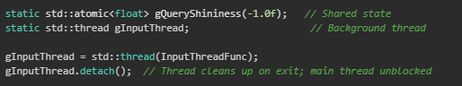
Shininess Values
There are 8 shininess values displayed on cubes rendered from left to right then top to bottom. In this order, the greater the shininess value, the more metallic an object appears to be. The shininess values are 2, 4, 8, 16, 32, 64, 128, and 256.
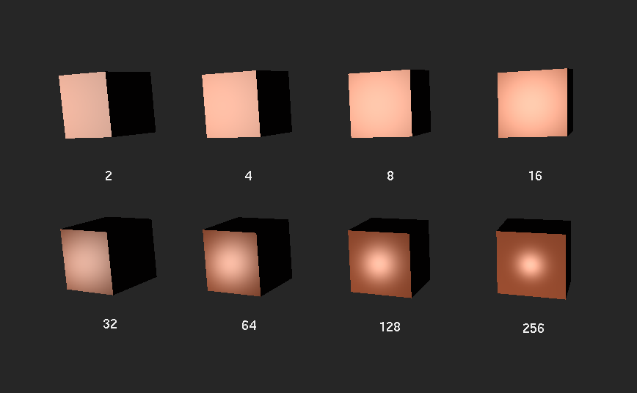
There is also a way to interact with the render. The user can input a shininess value ranging from 1-1000 in the console to produce a new cube with that value:
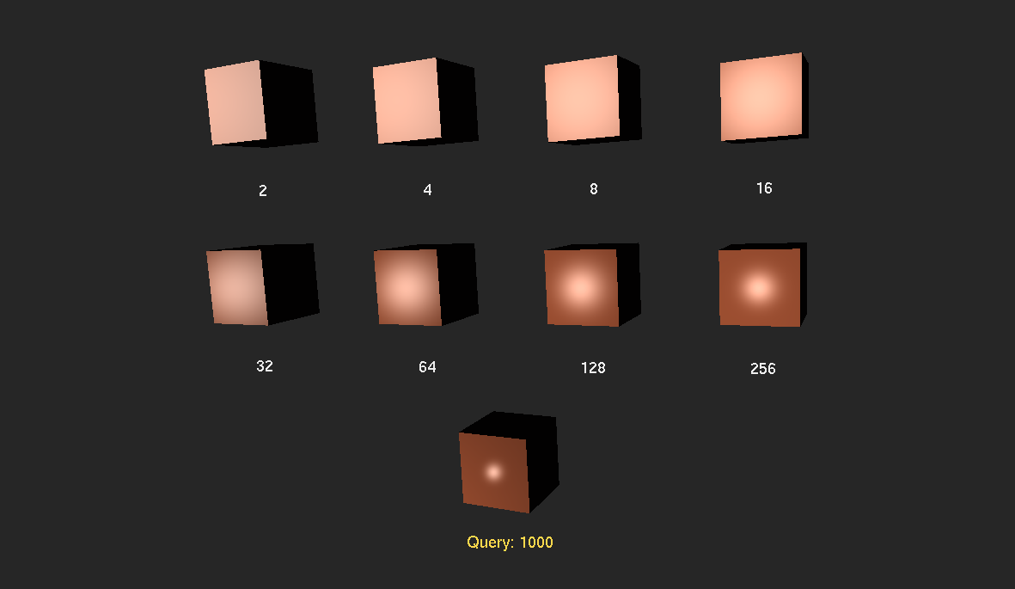

Flow Chart
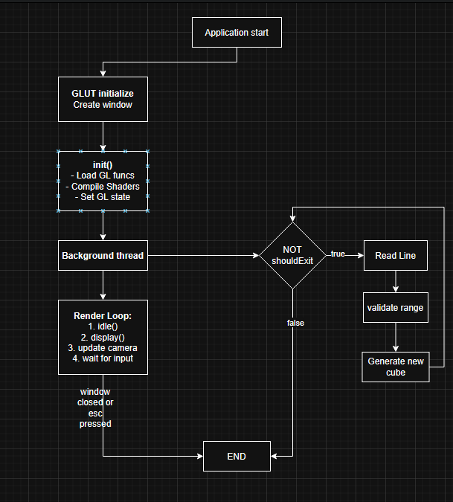
Illumination Algorithm

Compute Specular-Aligned Light Direction:
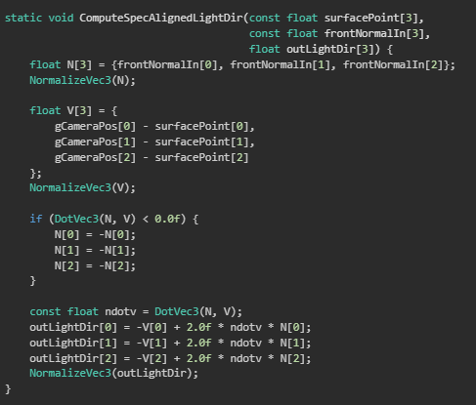
Vertex Shader:
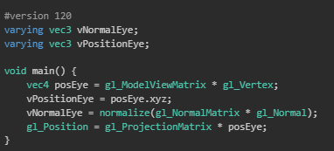
Fragment Shader (specular lighting):
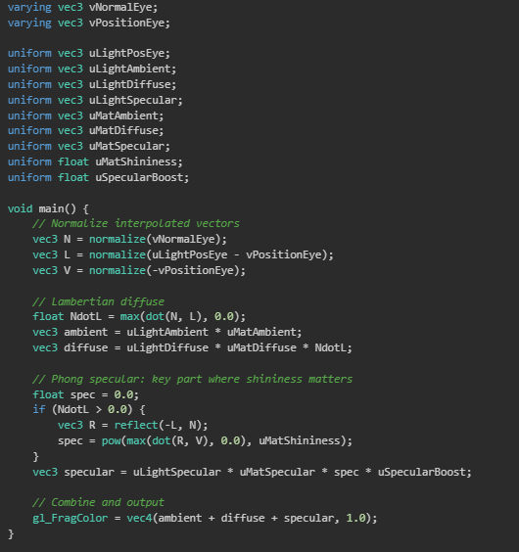
Mesh and Geometry
Draw Cube (called 8 times + when the user inputs a value):
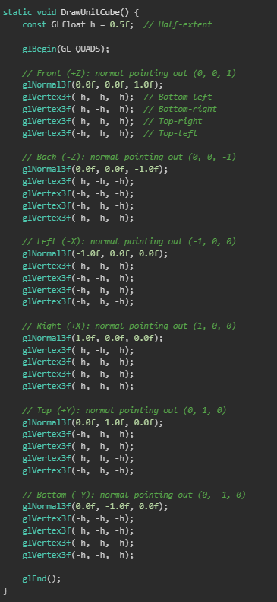

Drawing cubes in world space:
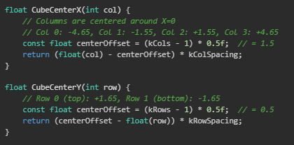
Compiling
