Project 10 Documentation
Nolan DeSchryver & Matthew Frey

This project demonstrates advanced texture mapping techniques in OpenGL, featuring parallax mapping and bump mapping applied to various 3D objects. The scene includes a checkerboard floor and two 3D models (cylinder and sphere) with bump mapping.
Theoretical Background
Bump Mapping: This changes the way light interacts with surface textures to simulate depth. This can be used to create rough or smooth surfaces.
Tangent Space
Bump mapping relies on tangent space calculations. The Tangent-Bitangent-Normal transforms vectors from world space to tangent space, allowing normal maps to be correctly applied regardless of the surface's orientation.
Phong Lighting
This project uses the basic lighting system with ambient, diffuse, and specular lighting

Mathematical Concepts
Camera Angles:
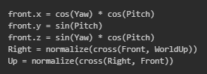
Tangent and Bitangent Calculations:
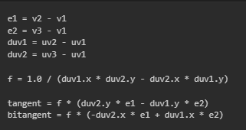

Phong Lighting:
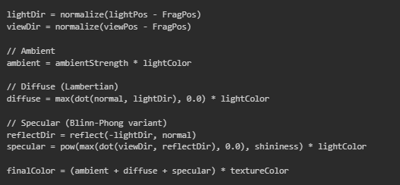

Aesthetic Decisions:
We had to adjust some of the lighting settings for the different shapes because the lighting bounced off the textures different:
