Nolan DeSchryver
CST-310 Project 2

Description
In this project we will be using OpenGL to render a scene from real life. My teammate and I both took two pictures to submit and one will be selected. We will eventually have to replicate that picture in OpenGL. This first project is simply the photo selection.
Methodology
In OpenGL, certain objects are more difficult to draw than others. This can be because of factors like lighting, texture, color, number of vertices, and more. That means when taking our pictures, we had to be strategic on what objects we were capturing so it is not too difficult to replicate in OpenGL.
Pictures
- 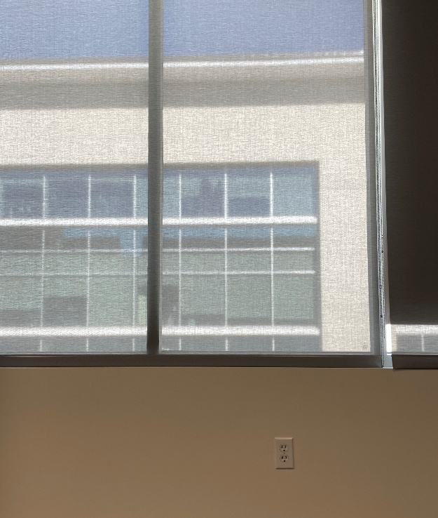
- 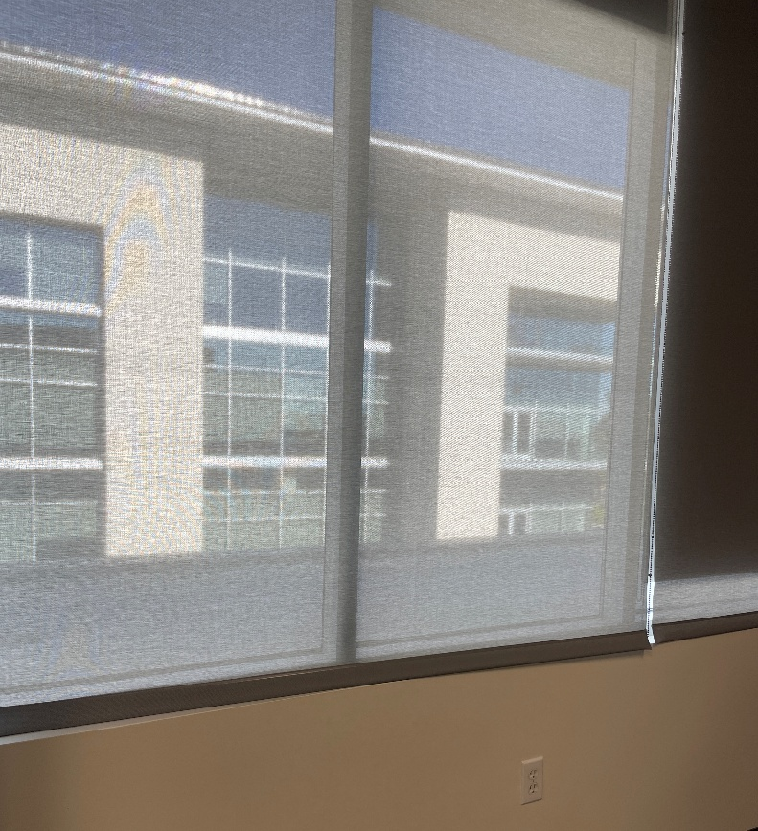
- 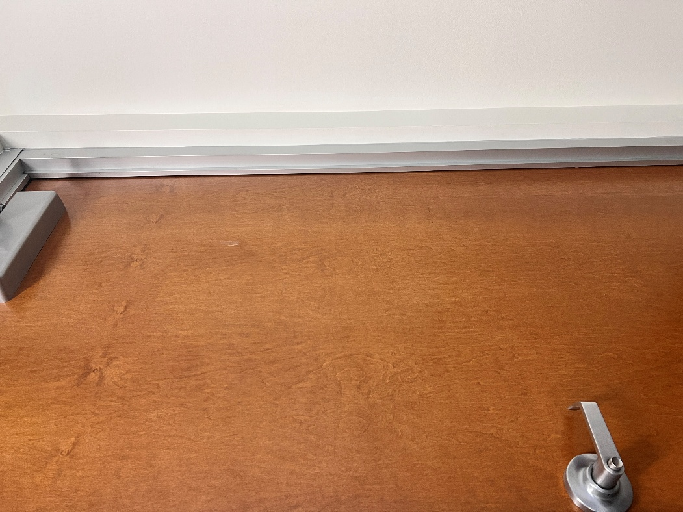
- 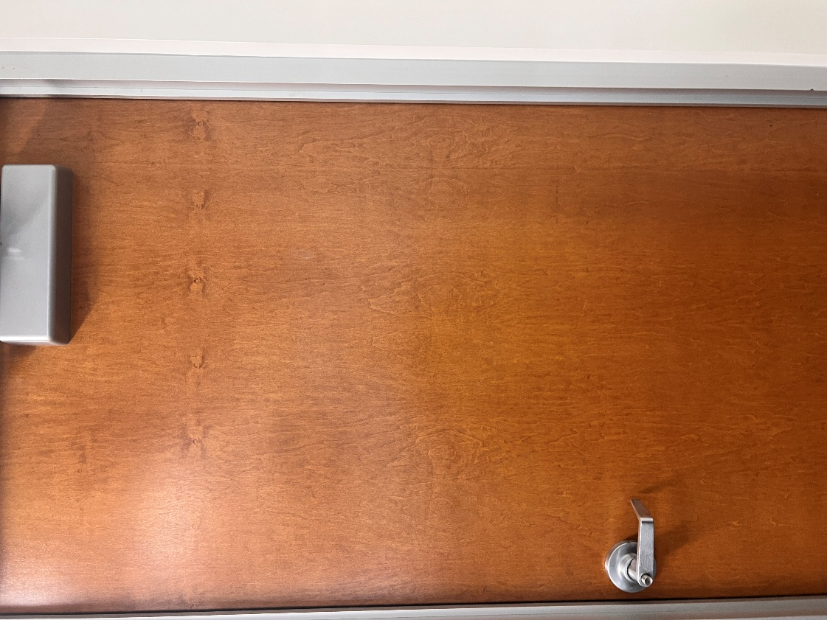

Certification
Nolan took the first two pictures with his phone in class and Matthew took the next two pictures with his phones in class.

