
DE10 Audio Game
SWE-350
11/9/2025

Nolan Tuttle
Grand Canyon University
College of Engineering and Technology
Software Engineering Program
Embedded Systems 1

Table of Contents
Project Demonstration Link……………………………………………………………………………………2
Github Repo Link………………………………………………………………………………………………………2
System Design……………………………………………………………………………………………………………3
Application Logic Design………………………………………………………………………………………….7
Risk Matrix…………………………………………………………………………………………………………………11
Test Plan………………………………………………………………………………………………………………………12
Known Issues………………………………………………………………………………………………………………13
Misc Documentation…………………………………………………………………………………………………14

Project Demonstration Link

https://www.youtube.com/watch?v=SPP4C422jtY

GitHub Repo Link
https://github.com/nolantuttle/DE10AudioGame

System Design
General Technical Approach:
This project is an audio-based memory game running on Intel’s SoC FPGA platform. Running on the DE10 Standard embedded board, it maps the four buttons to four unique audio samples and generates a sequence of these audio samples to play from the WM8731 audio codec through the line out port on the board. The goal of the player is to press the buttons which are mapped to the four audio samples to generate the same sequence of audio samples output by the board, with each round the sequence will increment by 1, increasing difficulty of the game. By utilizing both the Hard Processing System (HPS) and FPGA fabric, the application delivers a responsive interaction that combines audio, button input, and hex display feedback.

The HPS is responsible for executing the game logic features of this application. For example, the audio sample sequence generation/randomization as well as keeping track of sequence length. The HPS will check to see if the user’s button input is correct and matches the sequence, if not it is also responsible for resetting the game upon failure. The HPS communicates the audio samples to play over the lightweight AXI bridge into the FPGA’s memory mapped I/O.

Audio output is configured using an I2C line connected to the FPGA and HPS, although the HPS only is responsible for the actual configuration. The output is set to operate in 16-bit I2S mode at 48 kHz so that it is prepared for audio input from the FPGA over I2S. The audio codec functions in slave mode, allowing the clock cycles to be set by the FPGA through its VLSI logic. Game progress and feedback such as current sequence length is displayed on the hex display. Currently the I2C configuration sets the audio into DSP mode, accepting on-chip memory storage as the audio sample.

Development of HPS logic such as C files was performed using Visual Studio Code, while compilation, linking, and running occurs through a Makefile-based build system. The structure of the project is modular and separated into sections in the filesystem as shown in Figure 10.

System Design

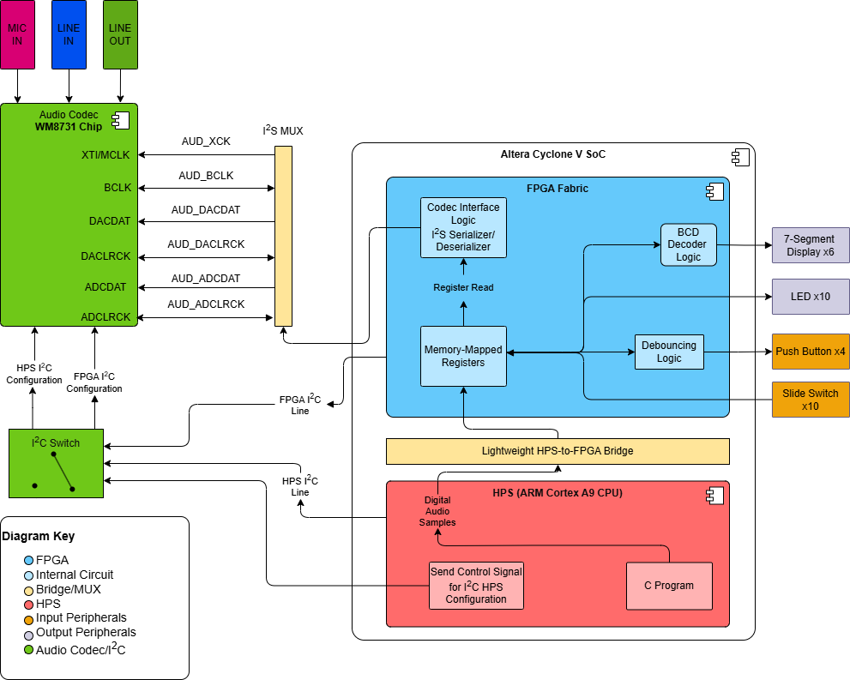

Figure 1: System Design Component Diagram for audio output

Application Logic Design

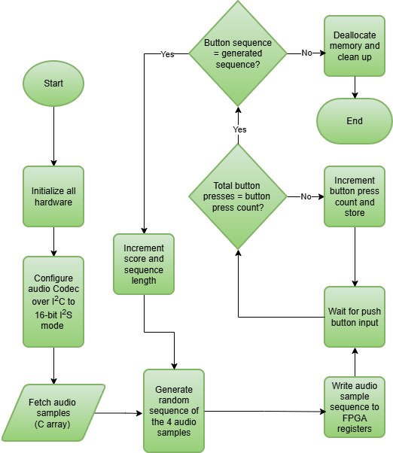
Figure 2: Application Logic Design for HPS
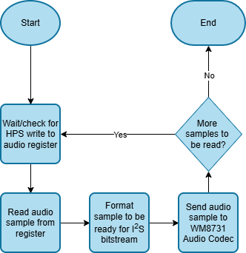
Figure 3: Application Logic Design for FPGA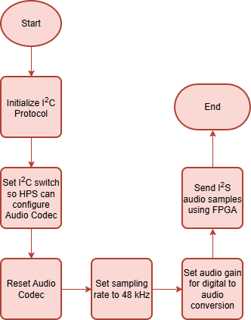
Figure 4: Application Logic Design for Audio Codec
Figure 5: Main Application Pseudocode Logic
START
// Initialize all hardware
Init_hardware()
Configure_codec(bit_depth, sampling_rate, gain)

// Game tracking variables
Sequence = []
Pattern_length = 1
Game_over = FALSE

WHILE !(Game_over)

New_sample = generate_sample()
Sequence.append(new_sample)

FOR sample IN Sequence
Sample_to_FPGA(sample)
Wait_for_playback()
END FOR
// User input
FOR num IN pattern_length
Input = read_button()
If(Input != sequence[num])
Game_over = TRUE
BREAK
END IF
END FOR

IF NOT Game_over
Pattern_length+=1
END IF
END WHILE

Game_complete_display()
END

VLSI Design
library ieee;
use ieee.std_logic_1164.all;
use ieee.numeric_std.all;

entity audio_codec is
port (

----------WM8731 pins-----
AUD_BCLK: out std_logic;
AUD_XCK: out std_logic;
AUD_ADCLRCK: out std_logic;
AUD_ADCDAT: in std_logic;
AUD_DACLRCK: out std_logic;
AUD_DACDAT: out std_logic;

---------FPGA pins-----

clock_50: in std_logic;
key: in std_logic_vector(3 downto 0);
ledr: out std_logic_vector(9 downto 0);
sw: in std_logic_vector(9 downto 0);
FPGA_I2C_SCLK: out std_logic;
FPGA_I2C_SDAT: inout std_logic

);

end audio_codec;

architecture main of audio_codec is

signal bitprsc: integer range 0 to 4:=0;
signal aud_mono: std_logic_vector(31 downto 0):=(others=>'0');
signal read_addr: integer range 0 to 240254:=0;
signal ROM_ADDR: std_logic_vector(17 downto 0);
signal ROM_OUT: std_logic_vector(15 downto 0);
signal clock_12pll: std_logic;
signal WM_i2c_busy: std_logic;
signal WM_i2c_done: std_logic;
signal WM_i2c_send_flag: std_logic;
signal WM_i2c_data: std_logic_vector(15 downto 0);
signal DA_CLR: std_logic:='0';

component pll is
port (
clk_clk : in std_logic := 'X'; -- clk
clock_12_clk : out std_logic; -- clk
reset_reset_n : in std_logic := 'X'; -- reset_n
onchip_memory2_0_s1_address : in std_logic_vector(17 downto 0) := (others => 'X'); -- address
onchip_memory2_0_s1_debugaccess : in std_logic := 'X'; -- debugaccess
onchip_memory2_0_s1_clken : in std_logic := 'X'; -- clken
onchip_memory2_0_s1_chipselect : in std_logic := 'X'; -- chipselect
onchip_memory2_0_s1_write : in std_logic := 'X'; -- write
onchip_memory2_0_s1_readdata : out std_logic_vector(15 downto 0); -- readdata
onchip_memory2_0_s1_writedata : in std_logic_vector(15 downto 0) := (others => 'X'); -- writedata
onchip_memory2_0_s1_byteenable : in std_logic_vector(1 downto 0) := (others => 'X'); -- byteenable
onchip_memory2_0_reset1_reset : in std_logic := 'X' -- reset
);
end component pll;

component aud_gen is
port (
aud_clock_12: in std_logic;
aud_bk: out std_logic;
aud_dalr: out std_logic;
aud_dadat: out std_logic;
aud_data_in: in std_logic_vector(31 downto 0)
);
end component aud_gen;

component i2c is
port(
i2c_busy: out std_logic;
i2c_scl: out std_logic;
i2c_send_flag: in std_logic;
i2c_sda: inout std_logic;
i2c_addr: in std_logic_vector(7 downto 0);
i2c_done: out std_logic;
i2c_data: in std_logic_vector(15 downto 0);
i2c_clock_50: in std_logic
);

end component i2c;

begin

u0 : component pll
port map (
clk_clk => clock_50, -- clk.clk
reset_reset_n => '1', -- reset.reset_n
clock_12_clk => clock_12pll, -- clock_12.clk
onchip_memory2_0_s1_address => ROM_ADDR,
onchip_memory2_0_s1_debugaccess =>'0', -- debugaccess
onchip_memory2_0_s1_clken =>'1', -- clken
onchip_memory2_0_s1_chipselect =>'1', -- chipselect
onchip_memory2_0_s1_write =>'0', -- write
onchip_memory2_0_s1_readdata =>ROM_OUT, -- readdata
onchip_memory2_0_s1_writedata =>(others=>'0'),
onchip_memory2_0_s1_byteenable =>"11",
onchip_memory2_0_reset1_reset=>'0'
);

sound: component aud_gen
port map(
aud_clock_12=>clock_12pll,
aud_bk=>AUD_BCLK,
aud_dalr=>DA_CLR,
aud_dadat=>AUD_DACDAT,
aud_data_in=>aud_mono

);

WM8731: component i2c
port map(
i2c_busy=>WM_i2c_busy,
i2c_scl=>FPGA_I2C_SCLK,
i2c_send_flag=>WM_i2c_send_flag,
i2c_sda=>FPGA_I2C_SDAT,
i2c_addr=>"00110100",
i2c_done=>WM_i2c_done,
i2c_data=>WM_i2c_data,
i2c_clock_50=>clock_50
);

AUD_XCK<=clock_12pll;
AUD_DACLRCK<=DA_CLR;

ROM_ADDR<=std_logic_vector(to_unsigned(read_addr,18));

process (clock_12pll)
begin

if rising_edge(clock_12pll)then

if(SW(8)='1')then--------reset
read_addr<=0;
bitprsc<=0;
aud_mono<=(others=>'0');
else
LEDR(1)<=SW(7);
aud_mono(15 downto 0)<=ROM_OUT;----mono sound
aud_mono(31 downto 16)<=ROM_OUT;
if(DA_CLR='1')then
if(bitprsc<5)then----8ksps
bitprsc<=bitprsc+1;
else
bitprsc<=0;
if(read_addr<240254)then
read_addr<=read_addr+1;
else
read_addr<=0;
end if;
end if;
end if;
end if;

end if;

end process;

process (clock_50)
begin

if rising_edge (clock_50)then
if(KEY="1111")then
WM_i2c_send_flag<='0';
end if;
end if;
if rising_edge(clock_50) and WM_i2c_busy='0' then

if (KEY(0)='0') then ----Digital Interface: DSP, 16 bit, slave mode
WM_i2c_data(15 downto 9)<="0000111";
WM_i2c_data(8 downto 0)<="000010011";
WM_i2c_send_flag<='1';

elsif (KEY(0)='0'AND SW(0)='1' ) then---HEADPHONE VOLUME
WM_i2c_data(15 downto 9)<="0000010";
WM_i2c_data(8 downto 0)<="101111001";
WM_i2c_send_flag<='1';

elsif (KEY(1)='0'AND SW(0)='0' ) then---ADC of, DAC on, Linout ON, Power ON
WM_i2c_data(15 downto 9)<="0000110";
WM_i2c_data(8 downto 0)<="000000111";

WM_i2c_send_flag<='1';
elsif (KEY(1)='0'AND SW(0)='1' ) then---USB mode
WM_i2c_data(15 downto 9)<="0001000";
WM_i2c_data(8 downto 0)<="000000001";

WM_i2c_send_flag<='1';
elsif (KEY(2)='0'AND SW(0)='0') then---activ interface
WM_i2c_data(15 downto 9)<="0001001";
WM_i2c_data(8 downto 0)<="111111111";

WM_i2c_send_flag<='1';
elsif (KEY(2)='0'AND SW(0)='1') then---Enable DAC to LINOUT
WM_i2c_data(15 downto 9)<="0000100";
WM_i2c_data(8 downto 0)<="000010010";

WM_i2c_send_flag<='1';
elsif (KEY(3)='0' AND SW(0)='0') then---remove mute DAC
WM_i2c_data(15 downto 9)<="0000101";
WM_i2c_data(8 downto 0)<="000000000";

WM_i2c_send_flag<='1';
elsif (KEY(3)='0' AND SW(0)='1') then---reset
WM_i2c_data(15 downto 9)<="0001111";
WM_i2c_data(8 downto 0)<="000000000";

WM_i2c_send_flag<='1';
end if;

end if;
end process;
end main;
Figure 6: Audio Codec VHDL Example (Toni, 2017)

begin

aud_bk<=aud_clock_12;

process(aud_clock_12)
begin

if falling_edge(aud_clock_12) then

aud_dalr<=clk_en;

if(aud_prscl<250)then------48k sample rate
aud_prscl<=aud_prscl+1;
clk_en<='0';
else
aud_prscl<=0;
da_data_out<=aud_data_in;--get sample
clk_en<='1';
end if;

if(clk_en='1')then-------send new sample
sample_flag<='1';
data_index<=31;
end if;

if(sample_flag='1')then

if(data_index>0)then
aud_dadat<=da_data_out(data_index);
data_index<=data_index-1;
else
aud_dadat<=da_data_out(data_index);
sample_flag<='0';
end if;

end if;
end if;
Figure 7: Audio Generation Example VHDL (Toni, 2017)

Risk Matrix
ID | Category | Description | Severity | Mitigation
1 | Scope | The audio I2S pipeline from the C program on the HPS to the audio codec is highly complex, so there is a risk of faulty system design resulting in functional issues or system failure. | H | Reduction - Mirror existing official documentation from Terasic, conduct extensive research on communication protocols like I2S and I2C, as well as the WM8731 audio codec.
2 | Technical | Because setting the clock rate for the codec is done using the clock division method (shown in Figure 7), the FPGA clock division might not match the sample rate needed for the codec. | M | Reduction - Adjust the FPGA clock division in the FPGA Verilog logic.
3 | Technical | When configuring the audio codec over I2C using the HPS, an incorrect configuration (wrong sampling rate, gain, etc.) (see Figure 4), can cause prevented audio output. | M | Reduction - Validate the correct register writes happen over I2C, test with a known audio codec configuration.
4 | Technical | The FPGA must be configured in such a way that the HPS only sends data when it is ready to receive data in its registers. There is a risk that these are not in sync with each other and data is sent when FPGA is not ready. | H | Avoidance - Use a handshaking method between HPS and FPGA, something like the flag hps_data_ready in the Verilog logic (Figure 6).
5 | Operational | Latency in audio playback or peripheral responsiveness may hinder UX when running the game. | L | Acceptance -Replace more HPS logical operations with FPGA programming to improve latency.

Test Plan
# | Title | Summary | Steps | Data | Expected  Result | Status
1 | FPGA Button IRQ interaction | Verify that the interrupt request module for the pushbutton works properly | - Power on board  - Load the kernel module (irq_pushbutton.ko)  - Push any button  - Verify LED feedback | The analog data from the button press being passed to the HPS. | The LEDs should increment their binary count representation with each consecutive button press. | Pass

Known Issues
ID | Description | Plan of Address
1 | N/A | N/A

Misc Documentation
One important aspect to understand about the I2S communication between the FPGA and the audio codec chip in this project is that, unlike a system where the codec chip works as a master, determining the necessary clock cycles for itself, it is better in this application for the audio codec chip to be in slave configuration, letting the FPGA generate the necessary clocks. The two clocks here are the serial clock (sck) and word select (ws) pictured below in Figure 8 and as used in the Verilog logic in Figure 7. Figure 8 shows a block diagram for what the shift register that receives the audio data might look like with a master codec design. Note that the below diagram is a master configuration, not slave configuration.
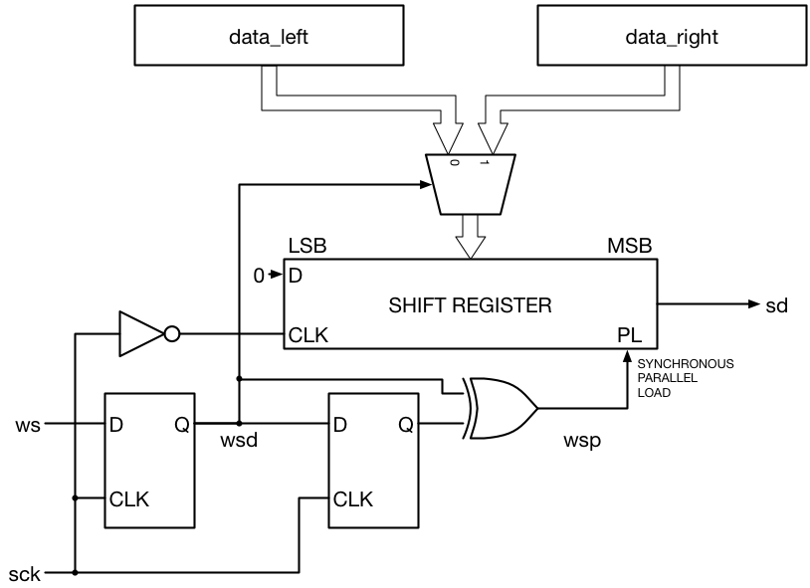
Figure 8: Traditional I2S transmitter block diagram. Reprinted from Beyond Circuits, "Tutorial 19: I2S Transmitter," https://www.beyond-circuits.com/wordpress/tutorial/tutorial19/.

Using a master configuration as shown above in this embedded application could result in inaccurate audio samples because there is a risk of generating inaccurate frequencies since it is handled by the codec. The bigger risk here, however, is synchronizing the FPGA clock with the WM8731 Codec clock. If the FPGA handles the clock generation, such as in a slave design, the FPGA has full control over timing, shown by the FPGA clock S_AXIS_ACLK shown in Figure 9. This makes it far easier to synchronize HPS audio sample writes to FPGA registers that will output audio; however, the FPGA must generate accurate clocks. This is an important distinction because it affects the Verilog significantly; the FPGA must generate clocks and thus, requires modules that can help the system function in slave mode.
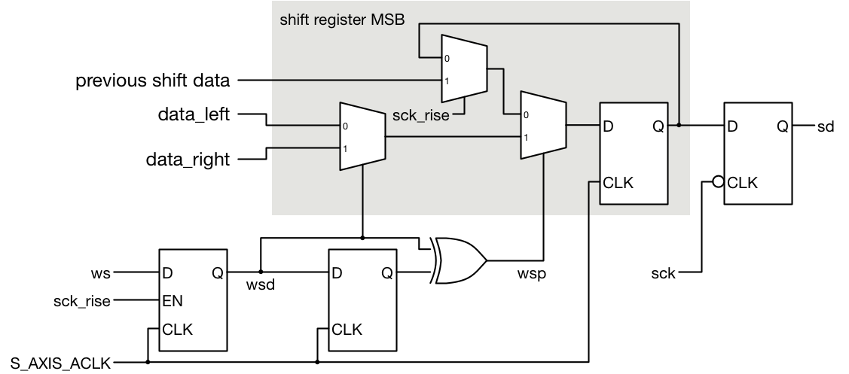
Figure 9: FPGA Clock I2S transmitter block diagram. Reprinted from Beyond Circuits, "Tutorial 19: I2S Transmitter," https://www.beyond-circuits.com/wordpress/tutorial/tutorial19/.
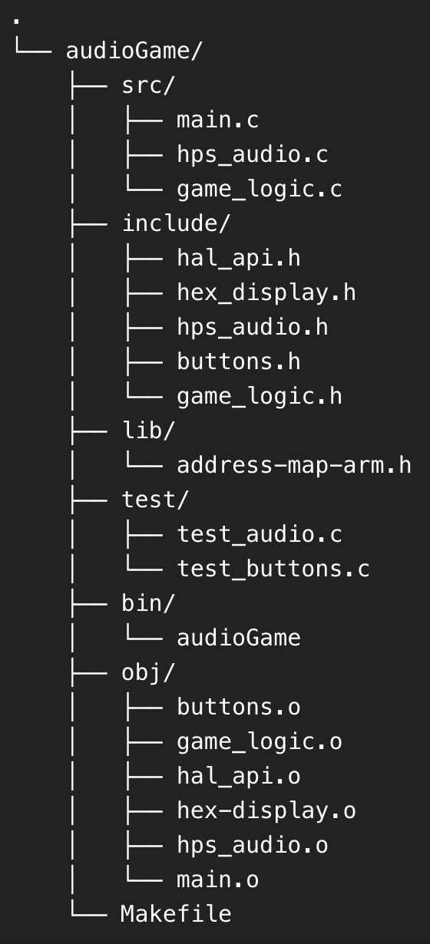
Figure 10: File Tree Structure for Audio Game project

Reference
Beyond Circuits. (n.d.). Tutorial 19: I2S Transmitter. Retrieved October 18, 2025, from https://www.beyond-circuits.com/wordpress/tutorial/tutorial19/
Toni. (2017, May 16). Tutorial: Playing audio through WM8731 using Terasic DE10-Standard FPGA development board [Video]. YouTube. https://www.youtube.com/watch?v=zzIi7ErWhAA

