
Project Proposal
SWE450
2/8/26

Nolan Tuttle
Grand Canyon University
College of Engineering and Technology
Software Engineering Program
Embedded Systems 2

Table of Contents
Project Demonstration Link……………………………………………………………………………………x
Github Repo Link………………………………………………………………………………………………………x
System Design……………………………………………………………………………………………………………x
Application Logic Design………………………………………………………………………………………….x
Risk Matrix…………………………………………………………………………………………………………………x
Test Plan………………………………………………………………………………………………………………………x
Known Issues………………………………………………………………………………………………………………x
Misc Documentation…………………………………………………………………………………………………x

Project Demonstration Link

https://youtu.be/YtjKAwD07TA

GitHub Repo Link
https://github.com/nolantuttle/DE10AudioGame2

Introduction
This project extends prior audio output work on Intel's SoC FPGA platform by implementing a distributed interactive control system between an Adafruit ItsyBitsy 5V 32u4 microcontroller and the DE10-Standard board. In this design, user input is captured via push buttons connected to the ItsyBitsy and transmitted over a UART interface to the DE10-Standard, where button press commands trigger audio playback sequences through the onboard WM8731 audio codec. The system demonstrates reliable, real-time command communication across heterogeneous platforms and emphasizes hardware–software co-design.
The Adafruit ItsyBitsy 5V 32u4 microcontroller is responsible for monitoring push button inputs, debouncing signals, and acting as the UART transmitter during communication. Button press events are encoded and transmitted as serial data packets to ensure deterministic delivery and proper command recognition. On the DE10-Standard, the FPGA fabric implements a UART receiver interface and command decoding logic to interpret incoming button signals, while coordinating timing and triggering appropriate audio responses for interactive gameplay.
Audio output is produced through the WM8731 codec using a 16-bit I²S interface at 48 kHz. Codec configuration is performed via I²C, while the FPGA supplies the necessary clocks and manages the audio data path. By separating user input handling and control on the ItsyBitsy from real-time audio generation and game logic on the FPGA, the project highlights effective partitioning of responsibilities across embedded microcontrollers and programmable logic.

System Design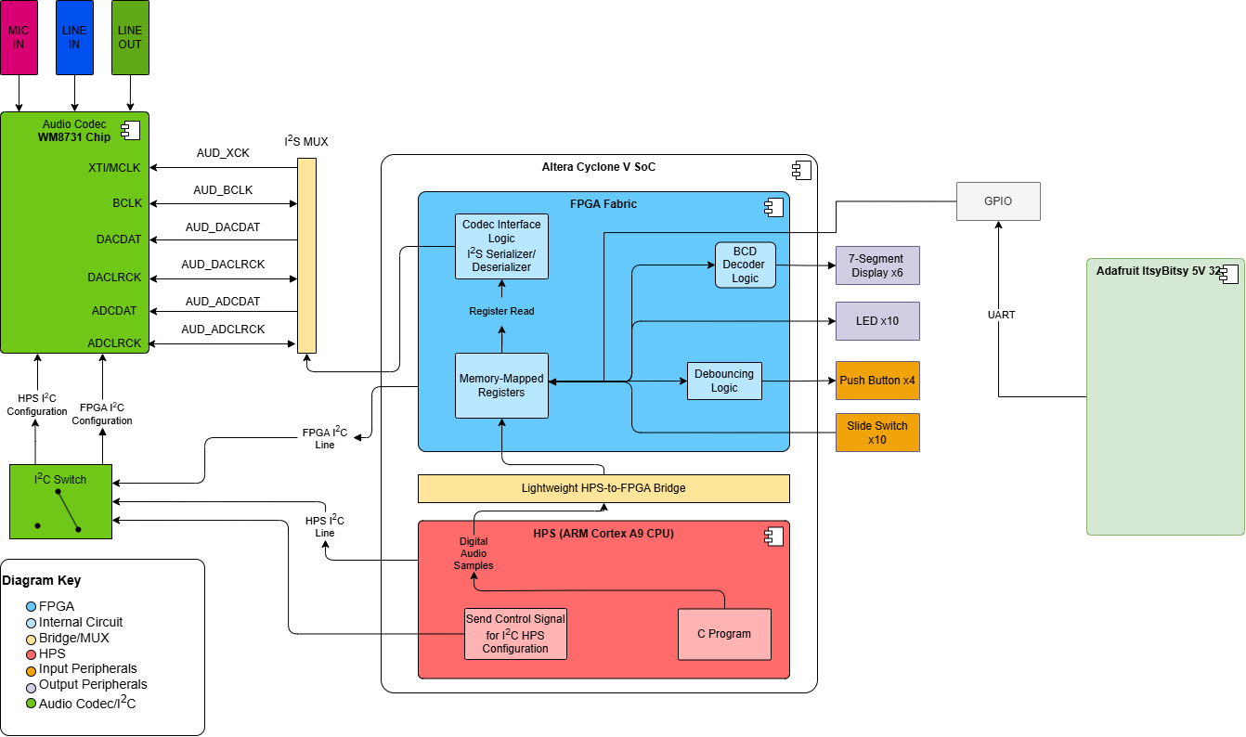

Figure 1: System Design for Raspberry Pi Communication with DE10-Standard

Application Logic Design

Risk Matrix
ID | Category | Description | Severity | Mitigation
1 | Technical | SPI data streaming not fast enough for real-time audio streaming | H | Reduction – Buffer audio with FIFO, test SPI transfer rates under load
2 | Technical | SPI protocol mismatch between Raspberry Pi and FPGA | H | Reduction – Define a protocol to ‘frame’ SPI data so there is no clock timing mismatch and incorrect data reads of garbage values.
3 | Operational | Latency from Raspberry Pi SPI transfer path | L | Acceptance – Some latency is acceptable, as long as continuous playback is achieved
4 | Technical | Codec configuration failure, incorrect I2S settings | L | Avoidance – Use previously tested config from last semester, mimic FPGA design

Test Plan
# | Title | Summary | Steps | Data | Expected  Result | Status
1 | SPI Frame Transmission | Verify the Raspberry Pi can transmit audio frames over SPI to DE10 | - Power on DE10 and Pi  - Run Pi SPI script  - Capture received frames on FPGA, verify bytes are received | Test audio frame with known payload size | FPGA receives complete frame with correctly synced frame | Pending
2 | SPI Framing Validation | Confirm SPI framing protocol is working correctly | - Connect MOSI pin to MISO  - Send test frames from Pi  - Read and echo frames received | Same as above | Echoed frames match transmitted frames exactly | Pending
3 | Audio Buffer | Verify FPGA FIFO buffer can handle continuous audio stream without underrun | - Stream multi-frame audio sequence from Pi  - Monitor FIFO queue on FPGA | 1-2 seconds of 16-bit audio samples | No buffer under/overflow | Pending
4 | Audio Output | Check proper playback through audio codec | - Power on DE10 and Pi  - Stream audio sample to FPGA  - Enable I2S config and audio output | Small test audio clip, stored song clip | Audio outputs correctly with no distortion or disruption of continuity | Pending

Known Issues
ID | Description | Plan of Address
1 | N/A | N/A
2 | N/A | N/A

Misc Documentation

