
Milestone 4
SWE450
3/9/26

Nolan Tuttle
Grand Canyon University
College of Engineering and Technology
Software Engineering Program
Embedded Systems 2
Table of Contents
Table of Contents 1
Project Demonstration Link 2
GitHub Repo Link 2
Introduction 2
System Design 3
Application Logic Design 4
Risk Matrix 4
Test Plan 5
Known Issues 7
Misc Documentation 7

Project Demonstration Link

https://youtube.com/shorts/7x4BIMBo_v4?feature=share

GitHub Repo Link
https://github.com/nolantuttle/DE10AudioGame2

Introduction
This project extends prior audio output work on Intel's SoC FPGA platform by implementing a distributed interactive control system between an Adafruit ItsyBitsy 5V 32u4 microcontroller and the DE10-Standard board. In this design, user input is captured via push buttons connected to the ItsyBitsy and transmitted over a UART interface to the DE10-Standard, where button press commands trigger audio playback sequences through the onboard WM8731 audio codec. The system demonstrates reliable, real-time command communication across heterogeneous platforms and emphasizes hardware–software co-design.
The Adafruit ItsyBitsy 5V 32u4 microcontroller is responsible for monitoring push button inputs, debouncing signals, and acting as the UART transmitter during communication. Button press events are encoded and transmitted as serial data packets to ensure deterministic delivery and proper command recognition. On the DE10-Standard, the FPGA fabric implements a UART receiver interface and command decoding logic to interpret incoming button signals, while coordinating timing and triggering appropriate audio responses for interactive gameplay.
Audio output is produced through the WM8731 codec using a 16-bit I²S interface at 48 kHz. Codec configuration is performed via I²C, while the FPGA supplies the necessary clocks and manages the audio data path. By separating user input handling and control on the ItsyBitsy from real-time audio generation and game logic on the FPGA, the project highlights effective partitioning of responsibilities across embedded microcontrollers and programmable logic.

System Design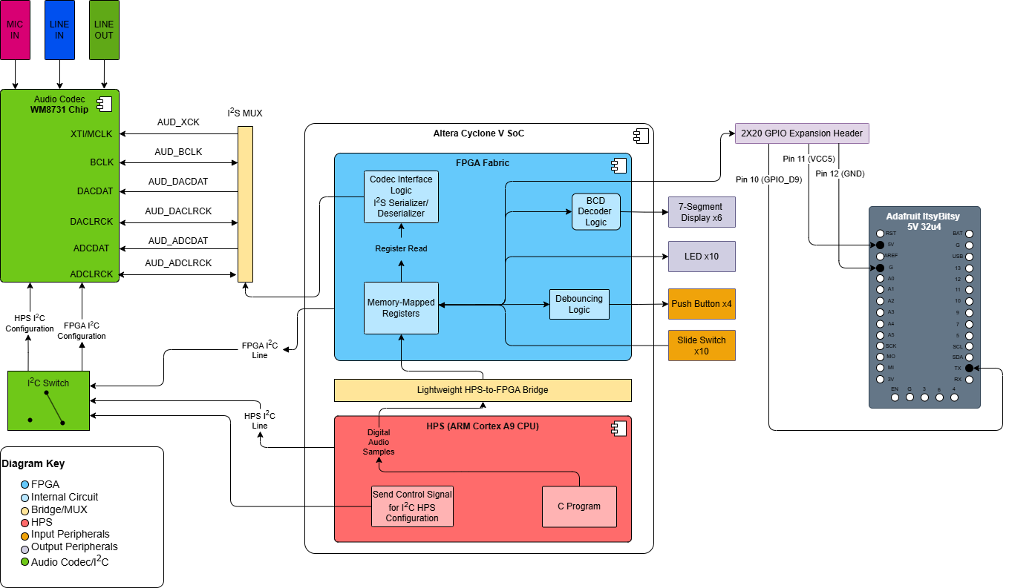

Figure 1: System Design for ItsyBitsy Communication with DE10-Standard

Application Logic Design

Risk Matrix
ID | Category | Description | Severity | Mitigation
1 | Technical | UART data reception not synchronized with game logic clock domain | H | Reduction – Run UART RX on same clock domain as game logic (clock_12) to avoid clock domain crossing issues
2 | Technical | Button presses dropped or misread due to UART timing | H | Reduction – Implement robust UART receiver with start bit detection and proper baud rate configuration (115200 baud at 12 MHz)
3 | Operational | Physical connection issues between ItsyBitsy and FPGA GPIO | L | Reduction – Use secure header pin connections, verify continuity with multimeter before testing
4 | Technical | Codec configuration failure, incorrect I2S settings | L | Avoidance – Use previously tested config from last semester, mimic FPGA design

Test Plan
# | Title | Summary | Steps | Data | Expected  Result | Status
1 | UART Byte Transmission | Verify the ItsyBitsy can transmit button press commands over UART to DE10 | - Power on DE10 and ItsyBitsy  - Run ItsyBitsy button test code  - Monitor FPGA LEDs for received bytes | Test bytes: 0x01, 0x02, 0x04, 0x08 | FPGA LEDs display received byte values correctly | Pass
2 | Button Press Integration | Confirm button presses trigger correct audio tones | - Connect ItsyBitsy UART to FPGA  - Press each button sequentially  - Verify corresponding tone plays | Four button presses mapped to four tones | Each button press triggers unique tone (440Hz, 523Hz, 659Hz, 784Hz) | Pending
3 | Game State Logic | Verify Simon game logic works with UART input | - Start game on FPGA  - Use ItsyBitsy buttons to play sequence  - Monitor game state LEDs | Complete game sequence (3-4 rounds) | Game progresses through states correctly: GENERATE_SEQ → PLAY_SEQ → WAIT_USER → WIN/LOSE | Pending
4 | Full Gameplay | Check complete game flow from start to multiple rounds | - Power on DE10 and ItsyBitsy  - Play through multiple rounds  - Verify correct/incorrect inputs handled properly | 5+ game rounds with intentional errors | Game advances on correct sequences, enters LOSE state on incorrect input, resets properly | Pending

Known Issues
ID | Description | Plan of Address
1 | Physical KEY buttons on FPGA still active alongside UART input | Acceptable – Both input methods can coexist for testing/debugging flexibility
2 | No bidirectional communication (FPGA → ItsyBitsy) implemented yet | Future work – Add UART TX module to send game state to ItsyBitsy OLED display

Misc Documentation

