Environmental Analysis & Technical Writing Portfolio
Administrative and Operations Coordinator
Department of Biology
Stanford | Remote

Contents
Cover Letter 2
Introduction 5
Background 8
Data 14
3.1 Measuring Infiltration Rates in the City of Los Angeles 14
3.2 Finding Potential Area to Install PICP 15
3.3 Rain per Year that can Fall on 29.3 miles² of PICP 16
3.4 Gallons of Water PICP Produced Converted to Acre Feet 17
4.1 PICP Installation and Maintenance Costs 19
4.2 Purchasing Water and Maintenance Costs 20

Administrative and Operations Coordinator

The Department of Biology
School of Humanities and Sciences
Stanford
Remote | August 3, 2026

Dear Hiring Committee,
As Rachel Carson wrote in Silent Spring, salmon have followed threads of fresh water back to the rivers- a reminder that ecological systems carry memory across watersheds. Aldo Leopold’s land ethic expands that responsibility to the broader community, while Lissa K. Wadewitz’s work on the history of the Salish Sea shows how ecological, cultural, and jurisdictional boundaries overlap. These perspectives have shaped how I approach administrative work- a vantage point I have learned to operate from with clarity, patience, and a steady commitment to supporting complex work. I tend workflows the way ecologists tend landscapes: by watching patterns, listening for signals, and creating the conditions for systems to function smoothly. These values will help me support teams, communicate clearly across stakeholders, and contribute to efficiencies that advance both community and environmental outcomes for the Administrative and Operations Coordinator position within the Department of Biology.
My professional experience reflects this system-minded approach. I bring experience maintaining large data sets, supporting cross-functional teams, and organizing technical and operational information with accuracy and consistency. At McKinstry, I supported facilities, IT, security, HR, and accounts payable by triaging requests, logging and routing mailed checks with accuracy, and maintaining sensitive workflow documentation. At Texas Tech University, I coordinated scheduling, communications, and resource allocation across academic teams while managing an independent Excel tracking system to keep track of information accessible and organized. Communication style emphasizes clarity, respect, and relationship-building, which supports collaboration with faculty, staff, and students, and partners across locations. Comfortable coordinating planning, preparing agendas and summaries, supporting meeting facilitation, and producing clear documents that help teams make informed decisions.
Eager to grow within an academic environment, and the Department of Biology’s commitment to discovery, interdisciplinary collaboration, and inclusive learning aligns strongly with my long-term goals. Thank you for your time. I welcome the opportunity to meet and go over how my skills align in supporting the Administrative and Operations Coordinator position.
Sincerely,
Kimberly Nolasco

Master of Art in Sustainable Management
Cost-effective analysis between interlocking concrete pavers and purchasing water for the city of Los Angeles
By Kimberly Nolasco
Contributors: Claire Todd, and Priscilla St Clair

Abstract

This study will analyze the cost of installation and how much it would take to maintain permeable interlocking concrete pavement (PICP), if they were to be installed in the city of Los Angeles. In comparison to the purchasing and maintenance cost of imported water. The investigation will use Hydrogeology to explain the ground and surface water movement, to understand fully what permeable interlocking concrete pavement is, how it works, and how its permeability is of importance to the city of Los Angeles. While economics will be used to estimate the costs of PICP and purchasing water. The data collected from PICP will be its maintenance and installation costs total within 25 years (Smith, 2006). Then the PICP costs will be compared to the amount of purchasing water and maintenance costs when invested within 25 years. The cost-effectiveness is determined by which method of providing water would be the cheapest between both, PICP installation or purchasing water.

Introduction

For Los Angeles, would permeable interlocking concrete pavement (PICP) be a cost-effective way to increase local water supply compared to purchasing water? The question will explore a sustainable urban planning solution for the city of Los Angeles (LA) in order to increase its local water supply. Los Angeles is infamously known for its lack of rain and harsh droughts; it has forced the city residents to desperately conserve water. Although Los Angeles is conserving water, there is still an environmental issue at hand because of the way the city has developed due to population increase, which leads to more demand for resources, water being one of them. Development is important for the growing city, but developing with old-fashioned paving methods such as concrete and asphalt does not allow the city to retain enough groundwater. 57 % of water is imported water from outside of Los Angeles; 48% comes from San Francisco (bay delta) and 9% is from the Colorado River (Briefing Book, 2016). 29 % of locally sourced water is brought through aqueducts from the Sierra Nevada mountain range, and only 12 % Los Angeles groundwater is used (Briefing Book, 2016).
The Los Angeles Department of Water and Power, on their website, also claims that the city of Los Angeles “is committed to a sustainable water future that relies more on local water supplies than costly and unreliable imported water. The plan to increase local water resources includes groundwater replenishment using purified recycled water (purified water)” (2015 Urban Management Plan, 2015). Thus, groundwater is important for LA because it can be more efficient in terms of being a direct source rather than an excess of water being lost due to evaporation or leakage of aqueducts. This report will use hydrogeology and the estimate costs of permeable interlocking concrete pavement, to determine if the permeable interlocking concrete pavement, which will be called PICP for the remainder of the investigation, is cost-effective in comparison to purchasing exports of water.
Conceptual Framework

Hydrogeological concepts will be used to obtain certain information to make a cost-effective analysis, due to the fact that hydrogeology terminology will be extensively used in order to get the potential area of PICP installation. Such terminology will be explained in depth further in the study. A preview of some of the terminology is rain intensity, rain gages, groundwater, total rainfall annually in the city of Los Angeles, and many other conversions and calculations derived from hydrogeology will be used in the study. Without geologic knowledge, finding the area needed to install would be impossible to make a cost-effective analysis.
Cost-effective analysis will allow us to add more information on comparing installing interlocking cement and comparing it to Los Angeles water purchasing costs. The comparative analysis of prices will allow more validity to see if in the results interlocking pavement installation is a lower cost effective and makes it a viable solution for Los Angeles drought issues. It will also be explained in depth further in the investigation. Such terminology that will be needed to make the cost-effective analysis is Present Value formula; the formula will determine which is cost-effective once all the data is plugged into the equation to obtain the final results of the investigation.
Both Geology and Economics are needed to make the investigation function and aid in analyzing the question asked in the investigation.

Background
2.1 Hydrogeology
Hydrogeology is the specific section of the water cycle that focuses on how water is collected on the surface and infiltrates as groundwater (Perlman, 2017). The water cycle explains how the water moves from the atmosphere, which includes evaporation, condensation, and precipitation. The water cycle also explains how water travels on the surface, which can be released back into the ocean or into the ground, also known as groundwater. Surface water consists of how much rain can collect in snowpack’s, rivers, lakes, and reservoirs, along with understanding how cities use the water around them (Perlman, 2017).
Cities, where there is little precipitation and are located farther away from water reservoirs, use aqueducts. Aqueduct, a term used for an engineered process to bring water through tubes or a synthetic channel (Perlman, 2017). Surface water in urban areas also becomes storm water runoff, which is when rainwater does not percolate into asphalted streets and ends up in storm drains that lead directly to the ocean (Perlman, 2017). That storm water runoff can sometimes carry pollutants from streets and other unknown toxins from agriculture and urban areas into the other bodies of water. As for groundwater, it is rainwater that collects underground by infiltrating into different types of rocks. There are two important characteristics that allow for a certain amount of groundwater water to be present and move underground (Waller, 1982). Those two characteristics are porosity, the size of the space in between rocks, and permeability, which is how easily the water can move through the rocks (Waller, 1982). Therefore, when it rains water enters the permeable surface and pools past the water table, called the saturated area, it is considered an aquifer (Perlman, 2017). Eventually, people who live near a shallow aquifer(s) make wells to extract the water out (Perlman, 2016). Groundwater is important because it is where the freshest water can be found that why understands where groundwater forms an aquifer it will be the one (Waller, 1982).

2.3 Los Angeles Groundwater
Understanding the surface water and groundwater movement is essential for this paper because Los Angeles has most of its water supply through aqueducts, and only 12 % is groundwater. The aqueducts are reliable in the sense of bringing water constantly to Los Angeles but, since some aqueducts are not covered water eventually evaporates, so there is a loss of water (Perlman, 2017). That is why Los Angeles is moving towards groundwater remediation, to recharge their water table (Briefing Book, 2016). One way for Los Angeles to increase its groundwater supply is through changing some of the impermeable surfaces such as the daily concrete, and asphalt roads that do not allow water to permeate into the ground (“University of Southern California, 2016).

2.4 What is Permeable Interlocking Concrete Pavement (PICP)?
There are three different types of permeable surfaces “consist of a variety of pavement types, pavers, and other devices that provide storm water infiltration while serving as a structural surface” (“Florida Field Guide to Low Impact Development”, 2008). Such artificial devices that allow water to infiltrate are pervious asphalt, pervious cement, and pervious pavers. In this research, the focus will be on pervious pavers, known as Permeable Interlocking Concrete Pavement, for short they called be called pavers. Permeable interlocking concrete pavement will be used in a condensed name known as PICP, or pavers interchangeably. PICP has composed a series of sediment layers. The first layer consists of small concrete blocks 3 ⅛ inch thick with joints that are filled with smaller aggregate, the same size of sediment used to fill the joints makes the first layer of graded bedding that is 1 ½ to 2 inches thick, followed by a stone open graded base with a thickness of 4 inches, with lastly a stone sub-base with a thickness of 6 to 8 inches but it ultimately depends on the amount of water storage is needed for the specific area it will be installed in, see Figure 1, (Interlocking Concrete Pavement Institute, 2016). PICP components allow it to be 100 % permeable, meaning that it allows for water to flow through as the aggregate base and sub-base act as a reservoir (“Design Professional Fact Sheet”, 2008).
PICP also filters the water that passes through eventually leading its way through the aquifer, it filters our zinc, copper, small particulates, and phosphorus (“Design Professional Fact Sheet”, 2008). PICP functions also include reducing runoff by 100 % and has an infiltration rate of 300 to 600 in./hr (“Design Professional Fact Sheet”, 2008).
How PICP works is by allowing water to flow through the gaps between the cement pavement block, into the base and sub-base filtering the water as it runs through the systems (ICPI Tech Spec 18, 2013). It is important to understand that the concrete pavers are used to lock the aggregate base that fills the gap and holds them in place (“Design Professional Fact Sheet”, 2008). The bedding layer is important because it keeps the concrete pavers flat like a regular surface, as for the stone open-graded base and stone subbase layers’ filters and retains the water acting like a reservoir (ASCE 2010). Although the depth of the sub-base is critical because a full analysis of the soil is needed in order to know how deep the subbase layer needs to go in order to act as a reservoir for the specific area it will be installed in (ASCE, 2010).

2.5 Cost-Effective Analysis
The cost-effective analysis is comparing two or more projects that achieve the same outcome to see which one has the lowest cost (Berck and Hellfand, 2011). This report will make a cost-effective analysis between the investment cost of installing pervious cement versus the current cost of purchasing water in Los Angeles. To find the cost-effective analysis of permeable interlocking concrete pavement (Berck and Hellfand, 2011). To make the cost-effective analysis, the usage of present value will be used in its algorithmic forms shown in equations 1 and 2 (Berck and Hellfand, 2011). Present Value in definition is “the amount that, if invested at rate r will produce the future value after the defined length of time”, this means in the example of this investigation the cost of installing PICP is a specific quantity “x”, invested at a rate of 7% within a 25-year span will produce a certain amount in the future. For more clarification, looking at equation 1, present value formula is equal to the “Installation Cost” plus the “Maintenance Cost” divided by (1+ r)^{year} until you reach the maximum year for the project. In equation 1 it shows up in the 25th year due to how long the PICP can live until it needs to be replaced (Smith, 2017). As to understanding why 7% rate was used, is since the U.S. Office of Management and Budget recommend using a 7 % discount rate as “the approximate as the rate of return for private investments” (Berck and Hellfand, 2011). Rates are used when conducting present value analysis for either the rate in which the money is being borrowed and the rate in which money could be invested (Berck and Hellfand, 2011).
Equation 1.
𝑃𝑉 = (𝑰𝒏𝒔𝒕𝒂𝒍𝒍𝒂𝒕𝒊𝒐𝒏 𝑪𝒐𝒔𝒕) + 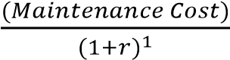 + 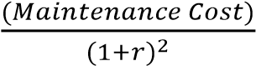 … + 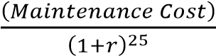 =
𝑇𝑜𝑡𝑎𝑙 𝐶𝑜𝑠𝑡 𝑖𝑛 25 𝑦𝑒𝑎𝑟𝑠

The present value formula will show how much it will cost to install and maintain PICP with maintenance cost for over 25 years. The Present Value formula for purchasing water is not the same. For the present value formula, the only difference is that the starting cost is the amount of water purchased plus the maintenance cost, and then for every year both of those are added. Unlike in the present value analysis for PICP, only maintenance cost is added every year, and only installation cost is the starting cost. See equation 2 below to see how it contrasts with equation 1.
Equation 2.
(𝑃𝑢𝑟𝑐ℎ𝑎𝑠𝑖𝑛𝑔 𝑊𝑎𝑡𝑒𝑟 + 𝑀𝑎𝑖𝑛𝑡𝑒𝑛𝑎𝑛𝑐𝑒 𝐶𝑜𝑠𝑡)
𝑃𝑉 = (𝑷𝒖𝒓𝒄𝒉𝒂𝒔𝒊𝒏𝒈 𝑾𝒂𝒕𝒆𝒓 + 𝑴𝒂𝒊𝒏𝒕𝒆𝒏𝒂𝒏𝒄𝒆 𝑪𝒐𝒔𝒕) +
(1 + 𝑟)
(𝑃𝑢𝑟𝑐ℎ𝑎𝑠𝑖𝑛𝑔 𝑊𝑎𝑡𝑒𝑟 + 𝑀𝑎𝑖𝑛𝑡𝑒𝑛𝑎𝑛𝑐𝑒 𝐶𝑜𝑠𝑡) (𝑃𝑢𝑟𝑐ℎ𝑎𝑠𝑖𝑛𝑔 𝑊𝑎𝑡𝑒𝑟 + 𝑀𝑎𝑖𝑛𝑡𝑒𝑛𝑎𝑛𝑐𝑒 𝐶𝑜𝑠𝑡)
+ … +
(1 + 𝑟) (1 + 𝑟)
= 𝑇𝑜𝑡𝑎𝑙 𝑐𝑜𝑠𝑡 𝑖𝑛 25 𝑦𝑒𝑎𝑟𝑠

Data
3.0 Hydrogeology Data
To find the area to install PICP many factors had to be taken into consideration. There are a series of steps that needed to be done when the data that was collected. Those are measuring infiltration rates in the city of Los Angeles, finding the “potential area” to install PICP, finding rain per year that can fall in the “potential area” to install PICP, and lastly finding the gallons of water and converting it to acre feet of water that PICP can provide. Below is the series of steps explained.

3.1 Measuring Infiltration Rates in the City of Los Angeles
Infiltration rate is the “speed at which water enters into the soil” (fao.org, 2017). To put the definition at practice, above, the PICP infiltration rate of 300 to 600 inch/hr, that means that the quantity of water between 300 to 600 inches will fill the soil in one hour (fao.org). The PICP infiltration rate shows that it can withhold the amount of water from a storm.
That known fact is critical in having confidence to install such pavers in the city of Los Angeles. What adds more to the reassurance that the PICP can be efficient in obtaining water, is that on average, when studying multiple rain gages listed in Table 1 shows three specific rain gages that were chosen to get an average of how much water it rains in inches/hr in the specific locations. Purposefully, Cogswell Dam was chosen to get a wider range of infiltration rates in the city of Los Angeles. Yet, Cogswell Dam rain gauge is farther from the potential location chosen to install PICP because it had one of the highest rain infiltration rates. Thus, on average in the locations chosen the water rate is approximately 0.18 inches/hr, comparing it to the 300 to 600 inches/hr infiltration rate of PICP the rate in which it rains in Los Angeles is a lot lower than that of the pavers. Thus, it concludes that the pavers in the chosen area of Los Angeles will be efficient in collecting water. Once upon determining the infiltration rates of Los Angeles and concluding that PICP is a permeable surface worthy to be installed, the next step is finding the total rainfall annually in Los Angeles, which is critical to finding the area of potential PICP installation.

3.2 Finding Potential Area to Install PICP

There are many ways in finding the area to install pavers in Los Angeles, but in this investigation the method was to find a partial area. What “partial area” entails to is, the idea of finding a certain percentage of impervious surface out of the entire area of the city of Los
Angeles. First, what needs to be known is the total area of Los Angeles, and according to the 2010 Census of Los Angeles the average came out to be 481.3 miles² (see Figure 2). 61% out of the 481.3 miles² is impervious. Once the number of impervious cements is retrieved, you must calculate how many are 61% percent of the 481.3 miles², the equation is shown below:
*= multiplication
Equation 3. 481.3 miles * .61 (convert the 61% to a decimal) = 293. 6 miles²
Once you retrieve 61% of the 481.3 miles² which is 293.6 miles², 10% out of the 61% percent of the impervious cement is chosen to be the “partial area”. Meaning that 10% of the
293.6 miles² will be the area chosen to install the PICP. Looking at the equation below:

Equation 4. 293.6 miles² * .10 (convert 10% to a decimal) = 29.3 miles²

Thus, the number of potential miles squared chosen to install the PICP is 29.3 miles². The next general step has to do with multiplying the total annual rainfall, 14.59 inches, with the number of the potential miles², 29.3 miles² in inches², in order to find the number of rains per year that can fall on the area of PICP chosen in Los Angeles (see section 3.3).

3.3 Rain per Year that can Fall on 29.3 miles² of PICP
The total rainfall of the city of Los Angeles annually, according to the National Oceanic and Atmospheric Administration between the years 1877 to 2016, states that it has rained 14.59 inches. The annual rainfall in inches will in finding out how much “potential area” could be rained on annually, will be represented as rain per year in the rest of the investigation. To find how much rain per year the “potential area” of PICP installed will be obtain, is through dimensional analyses in which the unit of measurement of miles² must be converted into inches², shown below:
29.3 miles² converted to inches² is, 1.178x10¹¹ inches²
Then, you calculate the converted number:

Equation 4. 1.178x10¹¹ inches squared * 14.59 inches (Annual Rainfall) = 1.719x10¹² inches³

1.719x10² inches³ is the number of rains per year that can fall in 29.3 miles². This number is important because it must be converted to gallons to understand how many gallons the number rain per year, 1.719x10² inches cubed, can produce in the 29.3 miles² (see equation 5).

3.4 Gallons of Water PICP Produced Converted to Acre Feet
The gallons produced in the rain per year number which is 1.719x10¹² inches³, in the 29.3 miles² was determined through dimensional analysis of converting the unit of measure inches cubed to gallons, shown below:

Equation 5. 1.719x10¹² inches³ * 1 gal / 231 inches³ = 7,437,229,437 gallons of water (7 billion gallons of water)
Dividing the number 1.719x10¹² inches² by the number of inches³ that go into 1 gallon,
231 inches³, is the result of the number of gallons that the potential number of PICP, 29.3 miles², can produce which is approximately 7 billion gallons of water. The next step to find the number of waters provided in acre feet is through another dimensional analysis in converting gallons to acre feet (AF), calculations shown below:

Equation 6. 7,437,229,437 gallons of water * 1 acre feet / 325,853 gallons = 22,824 acre feet

22, 824 AF is the number of waters in acre feet that PICP, if installed, can produce to Los Angeles. Which is important to know to compare the number of AF that purchasing water can provide to the city of Los Angeles.

4.0 Cost-Effective Analysis Data

The cost-effective data collected will include the amount it would cost to install and maintain the PICP. As for purchasing water, it will include the cost of purchasing the water and the maintenance costs. Although more costs were to be considered, such as water treatment costs, but it was left out for the remainder of the investigation due to lack of information on it. This is important to note because it can limit the results of the cost-effective analysis that will be described in section 6.1.

4.1 PICP Installation and Maintenance Costs

4. 1A Installation
Cost of mechanically, meaning not done by hand, installing PICP is $12 per ft² (R. Smith, personal communication, April 6, 2017). Through some more dimensional analysis the 29.3 miles² total to be $9.8 billion to install PICP.

4.1B Maintenance
Cost of maintenance of pervious cement is $1,000 acre to vacuum the surface with an air machine, and it should be done twice a year (R. Smith, personal communication, April 6, 2017). For the remainder of the investigation the maintenance cost chosen was that of $2,000 acre, the reason being was that the Technical Director of Interlocking Concrete Pavement Institute, David R. Smith, in an interview advised that cleaning the permeable interlocking concrete should be treated properly by cleaning it more than once throughout the year, thus it was added to our cost.

Thus, the total maintenance cost, through some more dimensional analysis totaled $37 million.
Both the installation and maintenance cost will be inserted in the present value formula, see equation 9 for immediate calculation. Once the data collected above was added to the formula in equation 9. Next, what needed to be done was finding the purchasing and maintenance cost for the city of Los Angeles when buying water.

To compare the data collected in this section, see Table 2.

4.2 Purchasing Water and Maintenance Costs

According to the Los Angeles Department of Water and Power (2015 Urban
Management Plan, 2015) the city spends $272 million in purchasing water and $462 million in maintenance and operations costs (Fact and figures, 2017).

4.2A Purchasing Water

The $272 millions for purchasing water costs is not the number that will be needed to add into the cost-effective analysis because in order to get a good comparison of the cost-effectiveness of both methods, retrieving water from purchasing or from PICP, the number needed to be found is how much it would cost the city to purchase the amount of water produced from PICP. The reason being that comparing how much it would cost the city to purchase the amount of water that PICP can produce would be an equal comparison to the cost of installing PICP and a more accurate number to compare. The cost of purchasing water is found through calculating the number of acre feet that the city of Los Angeles purchases, and then it is multiplied by the cost of acre feet of water PICP produces. The number of acre feet (AF) that LADWP purchases is 313, 574.1 AF (Briefing Book, 2016). The step by step to get the results needed in this section are below:

Frist, find how much the city purchases from the Colorado River and the Bay Delta in million/acre feet,

Equation 7. $272 million / 313,574.1 AF= 867 million/acre feet

867 million/acre feet number, again, is critical for the next step:

To find the amount it would cost the city to purchase the amount of water PICP can produce is found by:

Equation 8. 876 million/acre feet / 1 acre feet * 22,824 acre feet= $1,978,840.8 million/acre feet (1.9 million)

$1.9 million is the total amount of purchasing cost for the same amount water one can get from PICP. This becomes the cost number that will be used in the Present Value formula for purchasing water (see equation 10).

4.2 B Maintenance Cost

According to the Los Angeles Department of Water and Power the maintenance cost of water along with transport of other sources of water like the Los Angeles Aqueduct, groundwater, and recycled water the total comes out to be $462 million. This is important to know because this is a limitation within the investigation, that entire maintenance cost was applied to purchasing water, when that is not necessarily true, only a certain amount applies to it, but due to the lack of specific maintenance cost for purchasing water, it was only an estimate to apply the entire maintenance cost due to the validity of that number. Thus, understanding the limitation, the investigation still proceeded to use $462 million for just that purchasing water cost.
All the data collected in this section is put into the present value formula in equation 10.

5.0 Results: The Most Cost-Effective

Recalling the formulas mentioned in section 2.5, having all the data collected above, was plugged into equation 1, partially, such as shown below,

Equation 9.
𝑃𝑉 = ($9.8 𝑏𝑖𝑙𝑙𝑖𝑜𝑛) + ^{($} ⁾ + ^{($} ⁾ … + ^{($} ⁾ = $10 𝑏𝑖𝑙𝑙𝑖𝑜𝑛
( . ) ( . ) ( . )

Equation 10.
($1.9 𝑚𝑖𝑙𝑙𝑖𝑜𝑛 + $462 𝑚𝑖𝑙𝑙𝑖𝑜𝑛) ($1.9 𝑚𝑖𝑙𝑙𝑖𝑜𝑛 + $462 𝑚𝑖𝑙𝑙𝑖𝑜𝑛)
𝑃𝑉 = ($1.9 𝑏𝑖𝑙𝑙𝑖𝑜𝑛 + $462 𝑚𝑖𝑙𝑙𝑖𝑜𝑛) + + …
(1 + .07) (1 + .07)
($1.9 𝑚𝑖𝑙𝑙𝑖𝑜𝑛 + $462 𝑚𝑖𝑙𝑙𝑖𝑜𝑛)
+ = 𝑇𝑜𝑡𝑎𝑙 𝑐𝑜𝑠𝑡 𝑖𝑛 25 𝑦𝑒𝑎𝑟𝑠
(1 + .07)

The entire formulas are represented in table 3 and 4, the result turned out to be that the cost-effective method for the city of Los Angeles is purchasing water rather than installing PICP. The cost for purchasing water when inputted into the present value formula the total within the 25 years would turn out to be $5 billion while the total for PICP installation would have been 10 billion (see tables 3 and 4 for exact numbers). Lastly, purchasing water also offers 313,574.1 AF acre feet of water while PICP offers 22,824 acre feet, which is 29,000 acre feet in difference, for a big area for PICP to install and retrieve that amount of water is what can seem a pointless investment. Although, what should have been included was the cost of repairs in flooding zones in Los Angeles in the purchasing costs to alleviate or outweigh the water costs. Flooding costs could offset and could not potentially make PICP installation sound displeasing due to its other useful factors that should have been included. Which will be touched in section 6.2 and the 6.0 Discussion
Alternatively, the investigation results turned out to be that purchasing water is cost-efficient compared to installing ICPI. Yet, there are many things that need to be taken into consideration before purchasing waster is cost-effective, being the result. Due to the fact that there were uncertainties, and limitations.

6.1 Uncertainties

The uncertainties were calculations not being checked or backed up by sources and not based off from other materials. For example, the calculations in the equations 3 through 7 could have been wrong, due to wrong usage of dimensional analysis, and that there is no scholarly references that can support if the approach methods in all data sections 3.0 and 4.0 were the correct ways to approach the investigation. Even though the entire 3.0 and 4.0 sections were guided by two professors in the Geoscience and Economics departments in Pacific Lutheran University, Dr. Clair Todd, and Dr. Priscilla St. Clair, consecutively.

6.2 Limitations

There were many limitations in this investigation and that was partially due to not gathering all the data needed to make a viable cost-effective analysis or using other data to aid the investigation, such as:

  - The water treatment costs for both purchasing water and water produced from the PICP installations were not included in the cost-effective analysis due to being hard to obtain during research. Water treatment costs were important since water that comes imported, purchased, from the ground, and recycled being treated before reaching residents. The numbers would have been critical to include but instead were excluded.
  - Applying the $462 million to the purchasing water cost, due to the only maintenance cost that could have been found. What if the maintenance cost for purchasing water was much lower? Yet, due to the cost of purchasing water could have been lower.
  - Choosing a smaller area to install PICP could have changed the price of installation and could have made it cheaper, if gallons weren’t chosen to compare in the experiment.
  - Flooding costs were not included, since flooding occurs in Los Angeles during times of heavy rain, there is damage on property. What if flooding costs were put into the maintenance costs of purchasing water? Could it have increased the cost more? The reason for putting it in the purchasing cost would be for no other reason than to alleviate the costs of PICP.
The limitations listed above could have aided in making the investigation have more validity than what was being analyzed.
7.0 Conclusion
The investigation resulted that purchasing water for the city of Los Angeles to be cost-efficient in numbers, does not necessarily mean that Los Angeles should just keep purchasing water. Los Angeles does have plans to increase their local groundwater resources in the future (2015 Urban Management Plan, 2015). Los Angeles should consider PICP pavers for their future, even though it may not be the cheapest alternative, the permeable pavers are multifunctional. PICP can aid floods that occur in the city, allow water to filter as it infiltrates, and store water. Cleaning the pavers is the only maintenance needed to function at their full potential yearly. Los Angeles should not be intimidated by the idea of installing PICP’s because other cities are doing it such as, Atlanta, Georgia which has already begun to install the exact
PICP learned in this investigation (Atlanta Watershed, 2017). Atlanta, Georgia Department of Watershed Management, have approved and began installing PICP and have their own guide on how and where to install them in the city. If other places are doing so, Los Angeles could install in smaller areas rather than 29.3 miles² calculated in this investigation, and it could be a bigger step for the plans in increasing groundwater usage locally instead of just depending on imports and purchasing of water. What the investigation resulted in should not be taken as valid proof, there are certain uncertainties and limitations, but a study like this should be completed with more credibility than what is offered in this investigation.

Figures and Tables
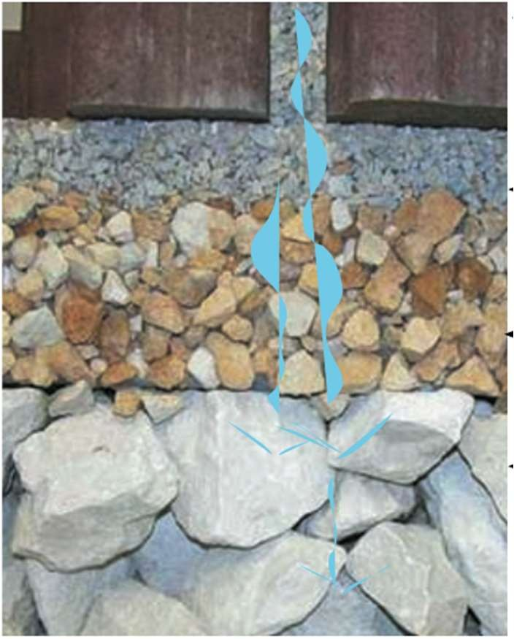 Figure 1. Source: (“Design Professional Fact Sheet, 2008) This figure is the basic representation of how the layer of sediments would look if installed, its layering allows storage and infiltration of rainwater.

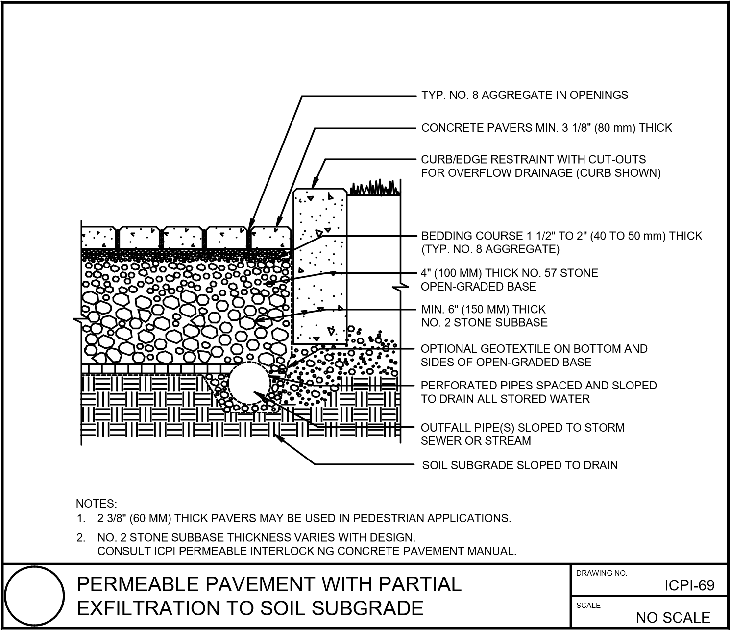

Figure 1A is another representation of how the PICP’s work and how it is engineered. (icpi.org)

Rain Gages | 99th Percentile per 24 hr |  | inches/hr
Cogswell Dam |  | 6.27 | 0.26125
Ducommons |  | 3.33 | 0.13875
Los Angeles-USC |  | 4.22 | 0.1583
Average |  | 14.59 | 0.1861

Table 1. The data on the table was provided by the Los Angeles Department of Water. This table shows three specific rain gages that were chosen to get an average of how much water it rains in inches/hr in the specific locations. Purposefully, Cogswell Dam was chosen that was out of the general chosen are to potentially install PICP, because it had one of the highest rain infiltration rates in the city of Los Angeles, so it was important to add it to the average in order to get a wider range of rain infiltration. Thus, on average in the locations chosen the water rate was 0.1861inches/hr, which compared to the PICP was a lot less.

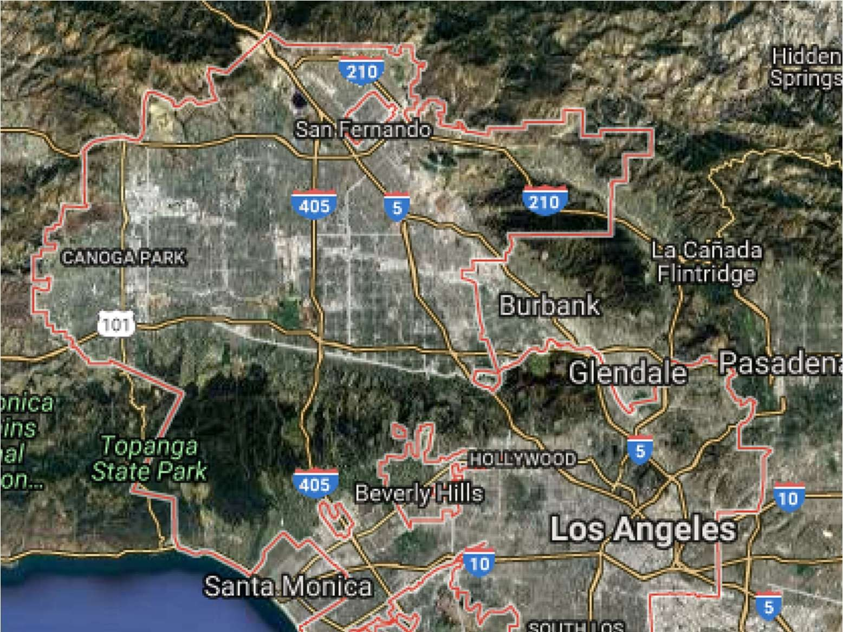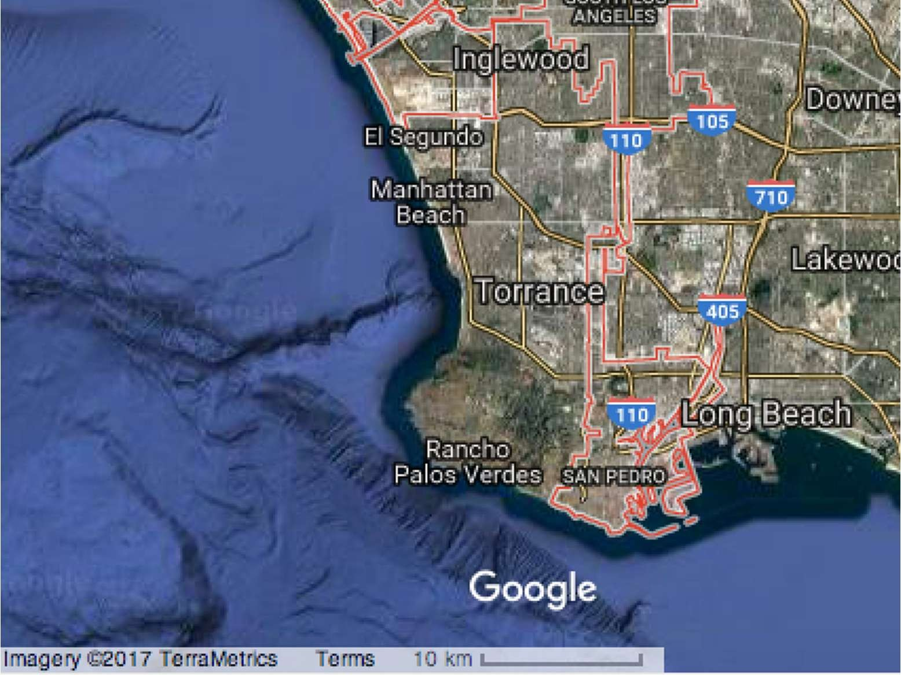
Figure 2. Source: Google Maps Los Angeles City Limit; all the area in within the red line, representing the boundary, is considered the city of Los Angeles. The entire city of Los Angeles is outlined by the red line, and it is estimated to be 481.3 miles squared.

Cost for Purchasing Water | Cost for PICP
Purchasing Cost: $19 million | Installation Cost $9.8 billion
Maintenance Cost: $462 million | Maintenance Cost: $37 million
Water Treatment Cost: N/A | Water Treatment Cost: N/A

Table 2. This table represents the data collected and what will be compared once put into the Present Value formula to find the total cost within 25 years for both purchasing water and cost of PICP to see which one is cost-effective.

PICP | Interest (7%) | Interest (3%)
yr0 | 9817164000 | 1247311828
yr1 | 35099065.42 | 36462135.92
yr2 | 32802864.88 | 35400131.96
yr3 | 30656883.06 | 34369060.16
yr4 | 28651292.58 | 33368019.57
yr5 | 26776908.96 | 32396135.51
yr6 | 25025148.56 | 31452558.74
yr7 | 23387989.31 | 30536464.8
yr8 | 21857933.93 | 29647053.2
yr9 | 20427975.64 | 28783546.8
yr10 | 19091566.02 | 27945191.07
yr11 | 17842585.06 | 27131253.46
yr12 | 16675313.14 | 26341022.78
yr13 | 15584404.8 | 25573808.52
yr14 | 14564864.3 | 24828940.32
yr15 | 13612022.71 | 24105767.3
yr16 | 12721516.55 | 23403657.57
yr17 | 11889267.81 | 22721997.64
yr18 | 11111465.24 | 22060191.88
yr19 | 10384546.95 | 21417662.02
yr20 | 9705184.07 | 20793846.62
yr21 | 9070265.486 | 20188200.61
yr22 | 8476883.631 | 19600194.76
yr23 | 7922321.151 | 19029315.3
yr24 | 7404038.459 | 18475063.4
yr25 | 6919662.111 | 17936954.76
Total | 10254825970 | 1901280003
Table 3. PICP Present Value formula within 25 years, the formula was done twice one showing 7% and 3% interest rate.
Purchasing Water | Interest (7%) | Interest (3%)
yr0 | 463978840.8 | 463978840.8
yr1 | 433625084.9 | 450464894
yr2 | 405257088.7 | 437344557.3
yr3 | 378744942.7 | 424606366.3
yr4 | 353967236.1 | 412239190.6
yr5 | 330810501.1 | 400232223.8
yr6 | 309168692.6 | 388574974.6
yr7 | 288942703.3 | 377257256.9
yr8 | 270039909.7 | 366269181.5
yr9 | 252373747.4 | 355601147
yr10 | 235863315.3 | 345243832.1
yr11 | 220433004.9 | 335188186.5
yr12 | 206012154.1 | 325425423.8
yr13 | 192534723.5 | 315947013.4
yr14 | 179938993.9 | 306744673.2
yr15 | 168167284 | 297810362.3
yr16 | 157165686 | 289136274.1
yr17 | 146883818.7 | 280714829.2
yr18 | 137274596.9 | 272538669.1
yr19 | 128294015.8 | 264600649.6
yr20 | 119900949.4 | 256893834.6
yr21 | 112056962 | 249411489.9
yr22 | 104726132.7 | 242147077.6
yr23 | 97874890.4 | 235094250.1
yr24 | 91471860.19 | 228246844.7
yr25 | 85487719.81 | 221598878.4
Total | 5870994855 | 8543310921
Table 4. Purchasing water Present Value formula, in which the equation was done twice with 7% and 3% interest rate to show variability.

References

ASCE 2010. Structural Design of Interlocking Concrete Pavement for Municipal Streets and Roadways, ASCE/T&DI/ ICPI Standard 58-10, American Society of Civil Engineers, Reston, Virginia.

Atlanta Watershed. Small commercial guide: City of Atlanta, Georgia Department of Watershed Management, Permeable Pavement. Accessed May 5, 2017. Retrieved from https://www.atlantawatershed.org/default/?linkServID=92F9E23F-F94B-4F78B4228B0FA9D89438&showMeta=2&ext=.pdf.

Bereck, Peter, & Helfand, E. Gloria. (2011). The time factor: discounting. In Sally Yagan Editor & Donna Battista Editor (Eds.), The Economics of the Environment (327-353). Boston: Addison Wesley.
Smith, R. David. (2006). “Permeable Interlocking Concrete Pavement”. Interlocking Concrete Pavement Institute. Washington D.C.: Interlocking Concrete Pavement Institute. Retrieved from http://www.idealconcreteblock.com/tl_files/pages/designers/knowgreen/PICP_Manual_3rd_edition.pdf

Fao.org. “Annex 2 infiltration rate and infiltration test”. FAO Corporate Document Repository. Accessed May 9, 2017. Retrieved from http://www.fao.org/docrep/s8684e/s8684e0a.htm.

Florida Field Guide to Low Impact Development. (2008) “Permeable surfaces”. University of Florida: Program for Resource Efficient Communities. Retrieved from http://buildgreen.ufl.edu/fact_sheet_permeable_surfaces.pdf.

Design professional’s fact sheet [PDF file]. Interlocking Concrete Pavement Institute. Accessed April 7, 2017.
https://www.icpi.org/sites/default/files/78801P_PICPFactSheetDesignProfessionals_LowRes_11 202015.pdf.

Interlocking Concrete Pavement Institute. (2016). Construction of permeable interlocking concrete systems. Retrieved from https://www.icpi.org/tech-specs-pdf/16992/26449.

Los Angeles Department of Water. (2014). “Analysis of 85th percentile 24-hour rainfall depth analysis within the county of Los Angeles”. Retrieved from http://ladpw.org/wrd/publication/engineering/Final_ReportProbability_Analysis_of_85th_Percentile_24-hr_Rainfall1.pdf.

Los Angeles Department of Water and Power. (2013). “Fact and figures.” Accessed April 6,
2017. https://www.ladwp.com/ladwp/faces/ladwp/aboutus/a-water/a-w-
factandfigures?_afrLoop=226028975362072&_afrWindowMode=0&_afrWindowId=s5ton4ys5_ 1#%40%3F_afrWindowId%3Ds5ton4ys5_1%26_afrLoop%3D226028975362072%26_afrWindo wMode%3D0%26_adf.ctrl-state%3D1219xnrabg_4.

Los Angeles Department of Water and Power. (2016). 2016 Briefing Book. Retrieved from http://webcache.googleusercontent.com/search?q=cache:2ElvRUWfGzIJ:www.ladwpnews.com/ go/doc/1475/2877378/+&cd=1&hl=en&ct=clnk&gl=us&client=safari.

Los Angeles Department of Water and Power. (2015). 2015 Urban Management Plan. Retrieved fromhttps://www.ladwp.com/cs/idcplg?IdcService=GET_FILE&dDocName=QOELLADWP005 416&RevisionSelectionMethod=LatestReleased.

MacDonald, Glen A. "Los Angeles water - myths, miracles, mayhem and William mulholland." Association of American Geographers. Last modified December 5, 2012. http://www.aag.org/cs/news_detail?pressrelease.id=1612.

McPherson, G., Simpson, J. R., Xiao, Q., & Wu, C. (2008). Los Angeles 1-million tree canopy cover assessment. In U.S. Forest Service. Accessed May 5, 2017.
https://www.fs.fed.us/psw/publications/documents/psw_gtr207/psw_gtr207.pdf

National Oceanic and Atmospheric Administration. Last modified December 18, 2014. “National weather service forecast office los angeles/Oxnard”.
https://www.census.gov/quickfacts/table/LND110210/0644000.

Perlman, U. H. (2017, January 4). The USGS Water Science School. Retrieved April 10, 2017, from https://water.usgs.gov/edu/.

University of Southern California. “Los Angeles water issue why is not just the drought”. USC Viterbi School of Engineering. Accessed December 10, 2016. Retrieved from https://viterbi.usc.edu/water/.

United States Census Bureau. “Quick facts Los Angeles city, California”. Accessed May 5, 2017. https://www.census.gov/quickfacts/table/LND110210/0644000.

Waller. (1982). “Ground water and the rural homeowner”. Retrieved from https://pubs.usgs.gov/gip/gw_ruralhomeowner/pdf/gw_ruralhomeowner.pdf.

