ResuME
Milestone 2: User Interface Implementation
Progress Report
Nolasco, Bonita, Masillones
November 4, 2026
Summary
The interface for ResuME is now built and can be navigated from the Welcome screen to every other screen in the Milestone 1 design. All 16 screens are implemented as an Apache Cordova app (HTML, CSS, and JavaScript), and the layout, colors, and spacing follow the approved mockups. Forms validate their input, buttons and tabs work, and the AI buttons switch off when the phone has no internet. Data is kept in the phone's local storage for now, so the screens can be tried out with real input before the database is connected.
What was completed
- All 16 screens. Welcome, Timeline, Add / Edit Entry (including Add Past Achievement), Description Suggestion, Entry Details, Scan Certificate, AI Notice, Resumes, Create Resume, Job Posting Suggestions, Resume Preview, Certificates, Settings, Profile, Reminders, and Backup and Restore.
- Navigation. Welcome shows once and is never shown again. The bottom bar (Timeline, Resumes, Certificates, Settings) appears on main screens only. Every other screen has a back arrow and the Android back button works the same way.
- Forms and input. Title, category, and date are required on Add / Edit Entry, with inline error messages. The semester is suggested from the date. Create Resume needs a version name and at least one ticked entry. Profile checks the email format.
- Interactive elements. Category chips, the OJT / Scholarship / Job selector, template picker, entry checklists, reminder toggles, confirmation dialogs for delete and restore, and short toast messages.
- Behavior from the plan. Entries are grouped by school year and semester with the newest first. Entries without proof are greyed out on the Certificates screen. The resume preview changes with the chosen template (Classic, Modern, Compact).
- Offline behavior. The AI buttons are turned off and a small notice appears when there is no connection. The AI Notice shows before the first AI use.
- Design consistency and responsiveness. One navy theme, the Inter typeface, Bootstrap 5 and Bootstrap Icons. All of them are bundled in the app so nothing loads from the internet. Layouts were checked at 390 px and 320 px wide with no sideways scrolling.
What remains to be developed
- Database. Replace local storage with the SQLite tables and the data layer (Week 2 to 3 plan).
- Proof storage. Real camera and file picker through the Cordova plugins, saving proof files in the app folder, and the proof viewer (Week 4).
- Reminders. Semester end-date notifications using Local Notification (Week 5).
- PDF, export, and backup. PDF resume generation, the combined certificate PDF, and the backup and restore file (Week 5 to 6). The PDF, Share, Export, Create Backup, and Restore buttons are in place but show a short message for now.
- AI features. Connecting the Gemini API for Certificate Scan, Description Improver, and Job Posting Suggestions (Week 7 to 8). The AI screens currently use sample results so the design can be reviewed.
- Testing. Testing on real phones with sample certificates, with internet off, and with a few students (Week 9).
Problems encountered and how they were addressed
Problem | How it was addressed
Text typed on Add / Edit Entry disappeared when the user went to Scan Certificate or Description Suggestion and came back. | The form keeps its values in a draft object that is passed to the next screen. Going back shows the same draft again.
The back arrow and the Android back button did not behave the same way between the bottom tabs and the screens opened from them. | The app keeps its own list of opened screens. Tapping a tab starts a new list, and the back arrow only shows on screens opened from another screen.
The AI buttons must not work without internet, but the internet check is different in a browser and in the Android app. | The check uses the Network Information plugin on the phone and the browser's online status when testing on a computer. The buttons update when the connection changes.
Error messages stayed visible after the user fixed the field. | Fields clear their error as soon as the user types or picks a value.
The APK could not be built in the place where the interface was first written because there was no Android SDK. | The project is a normal Cordova project. The APK is built on a computer with Android Studio using cordova build android. The steps are in the README.
Weekly check-in
The application can already be navigated and the major interfaces are implemented. This matches the Week 4 to 6 milestone for the interface. Features that need the database, PDF libraries, or the AI service are planned for the next weeks.

Screenshots of implemented screens
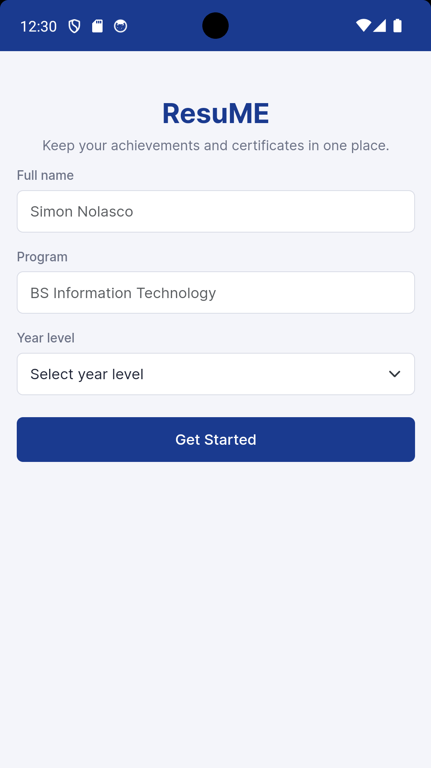 | 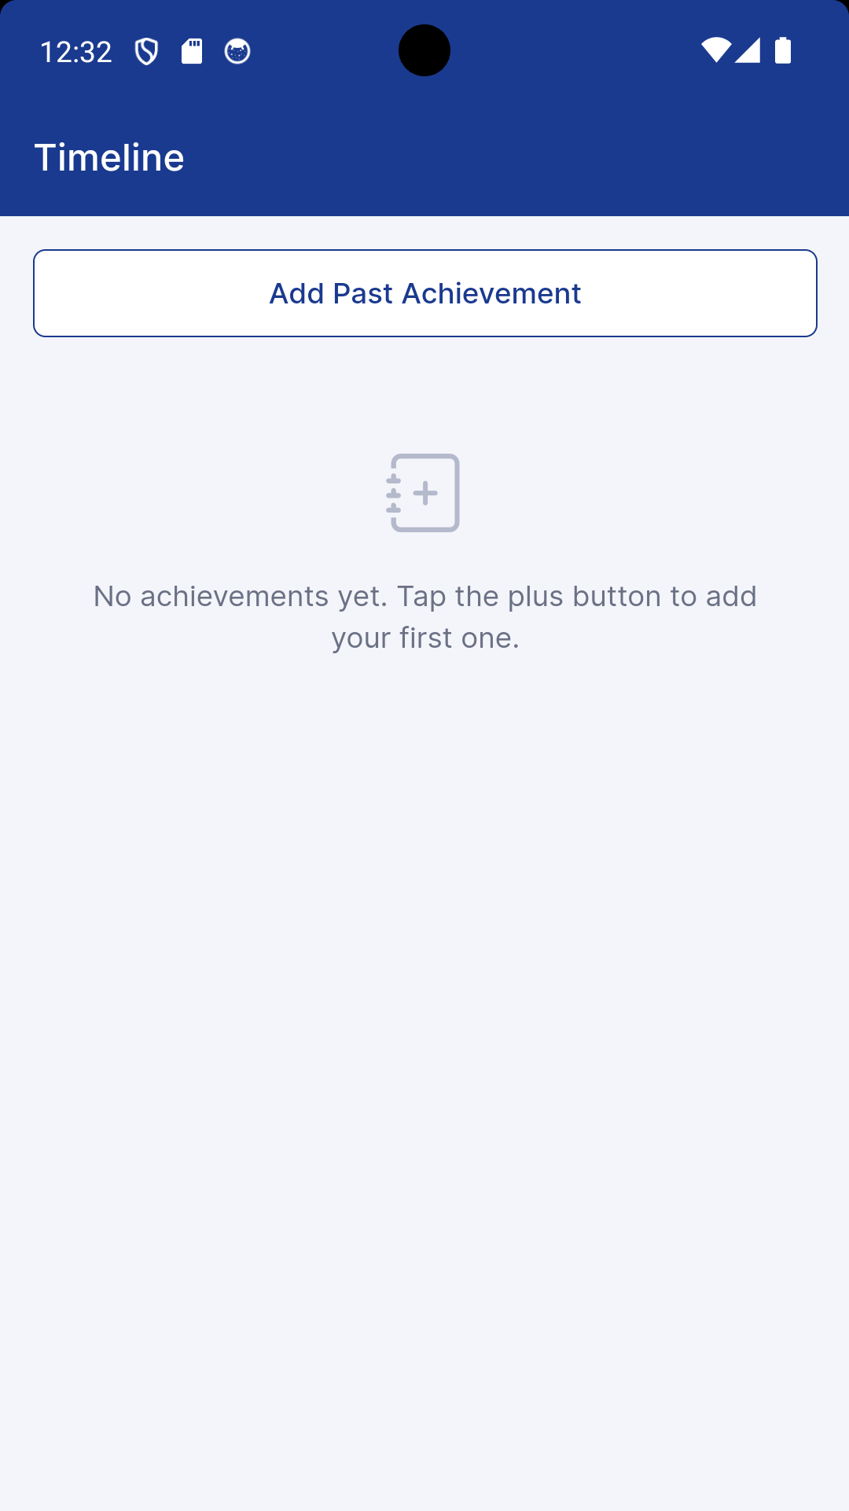 | 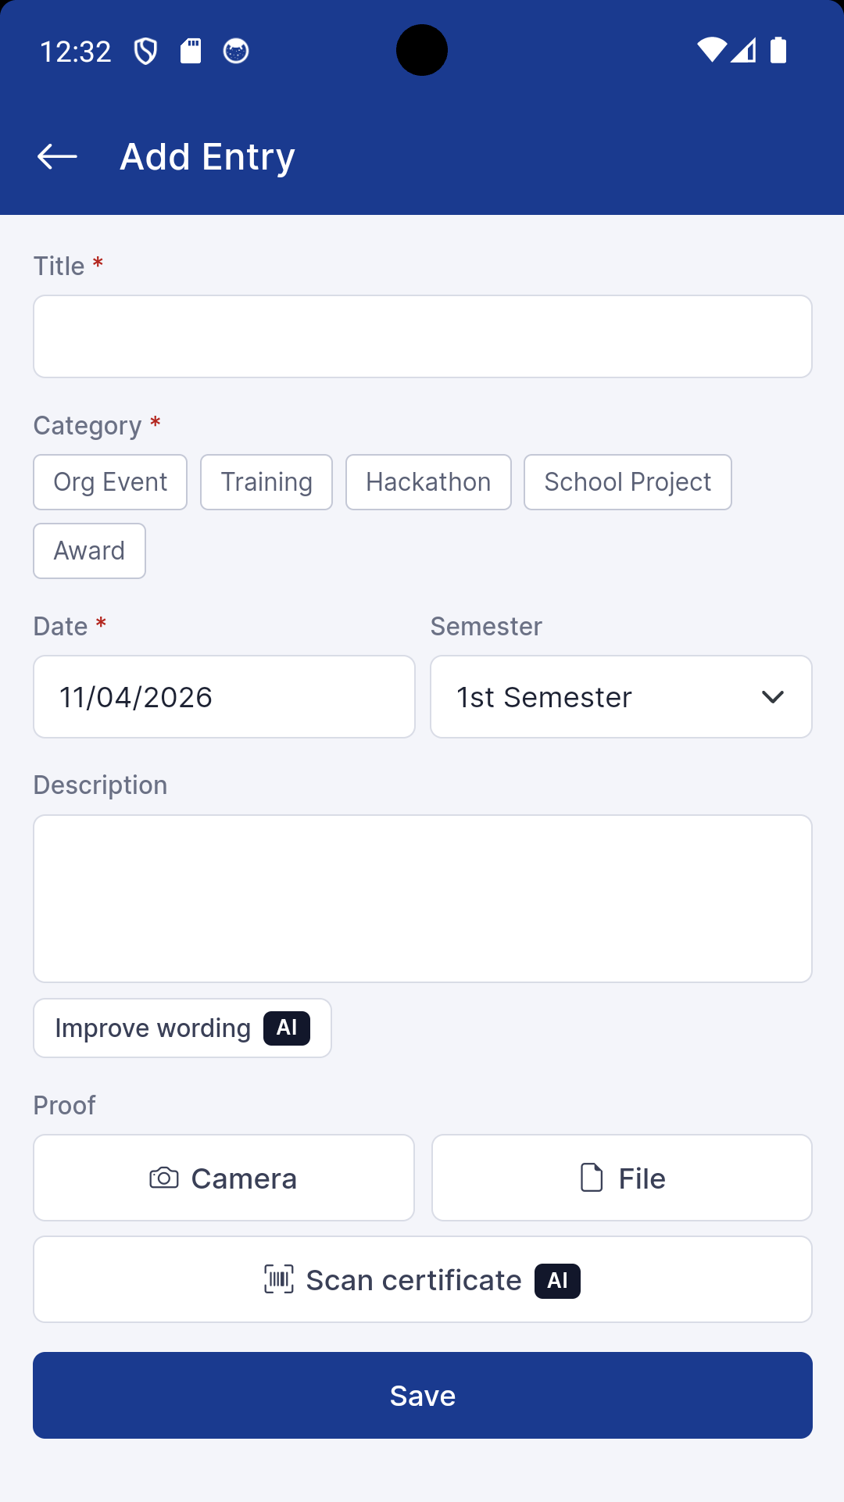
1. Welcome | 2. Timeline | 3. Add / Edit Entry

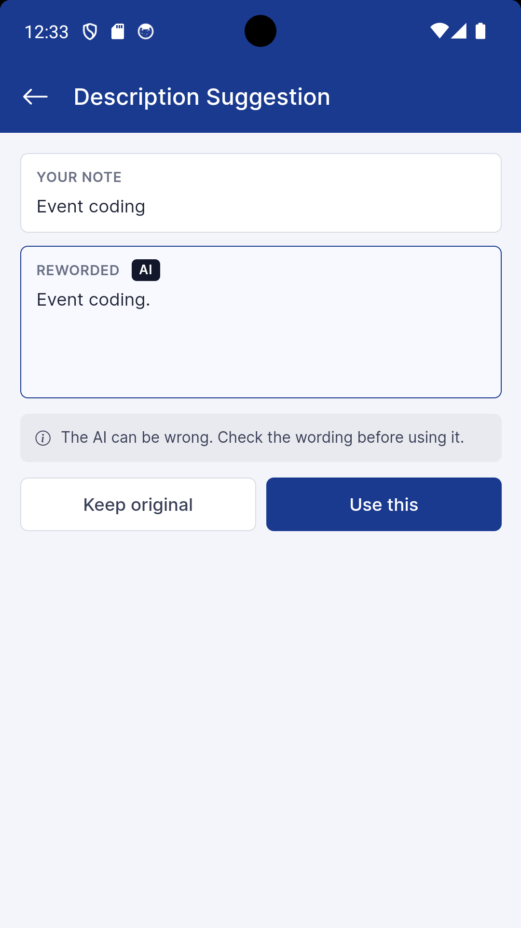 | 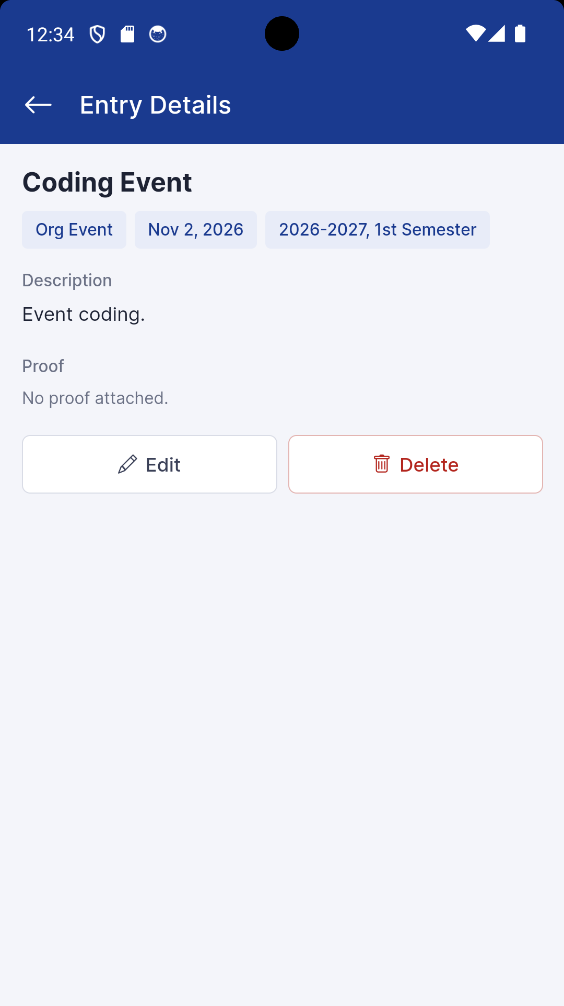 | 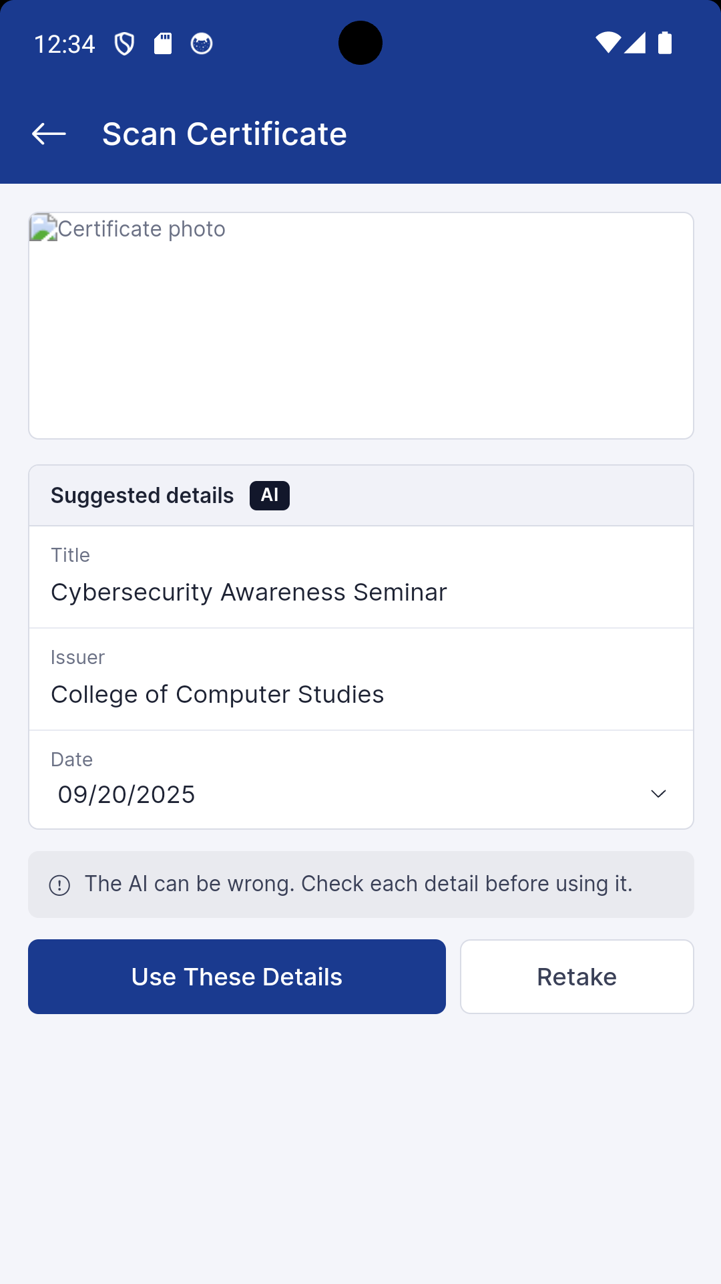
4. Description Suggestion | 5. Entry Details | 6. Scan Certificate

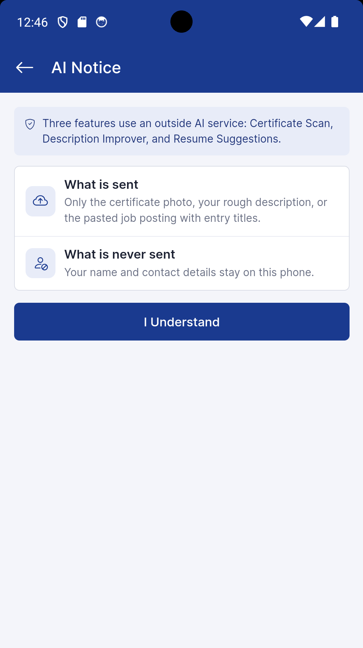 | 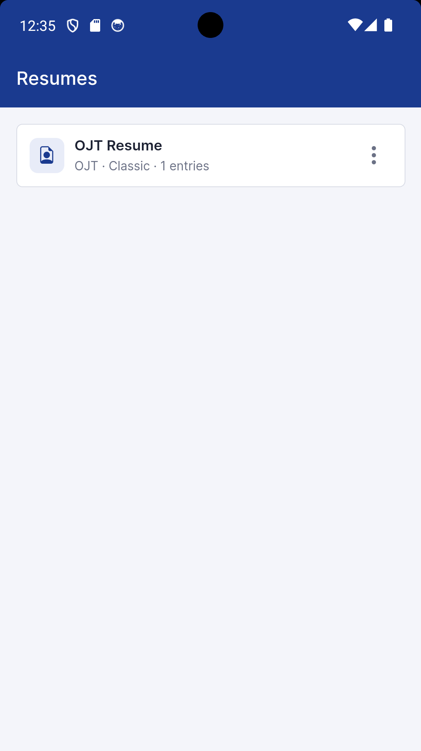 | 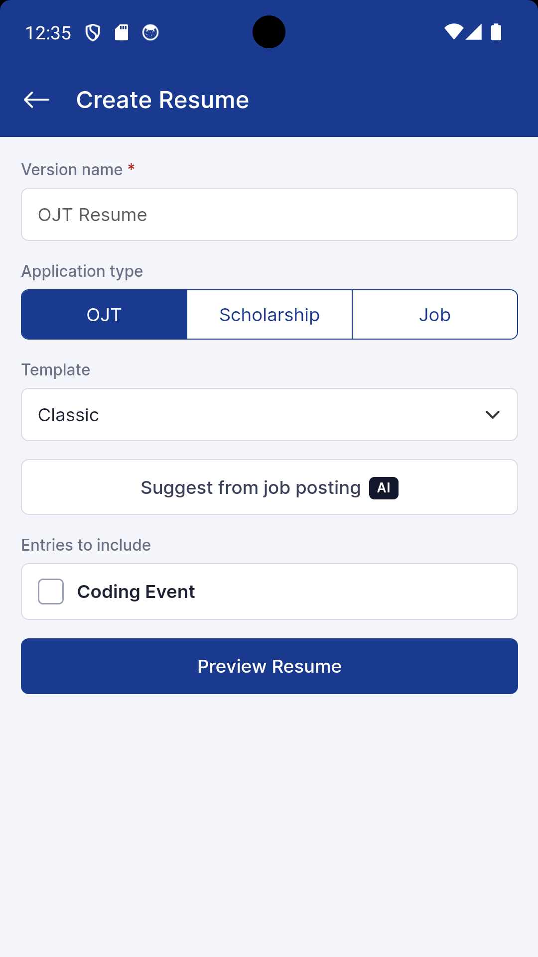
7. AI Notice | 8. Resumes | 9. Create Resume

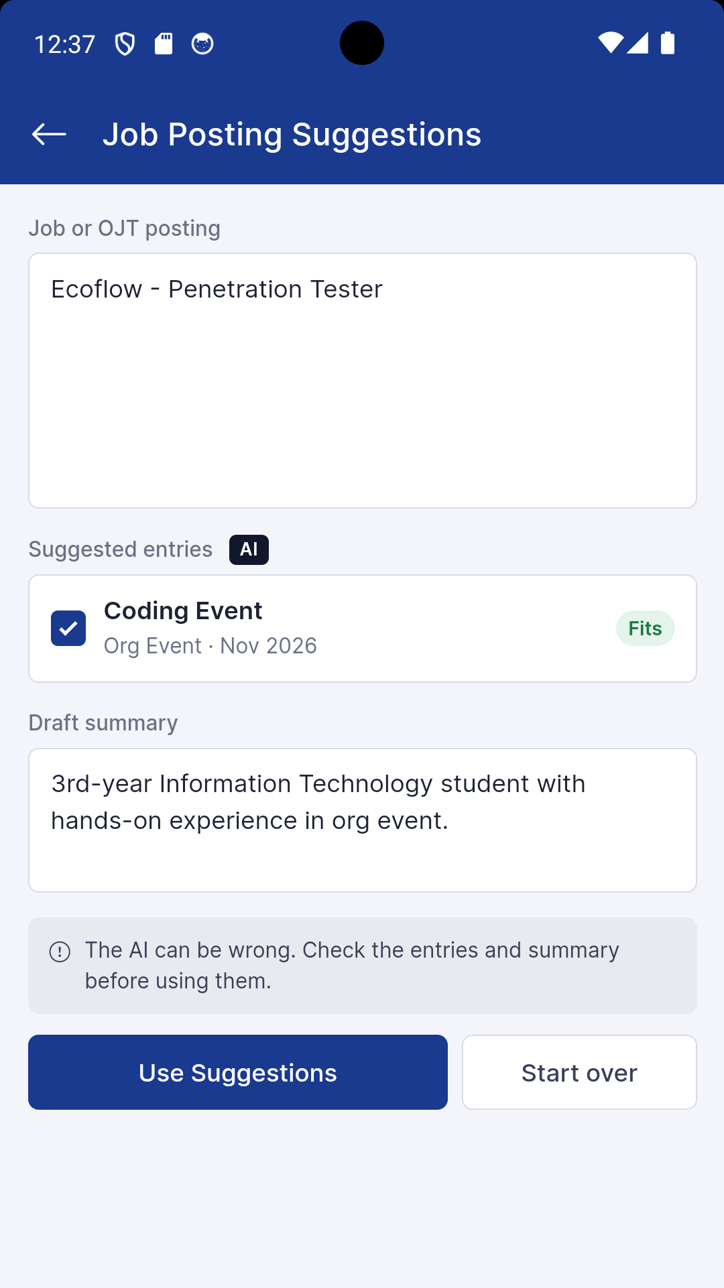 | 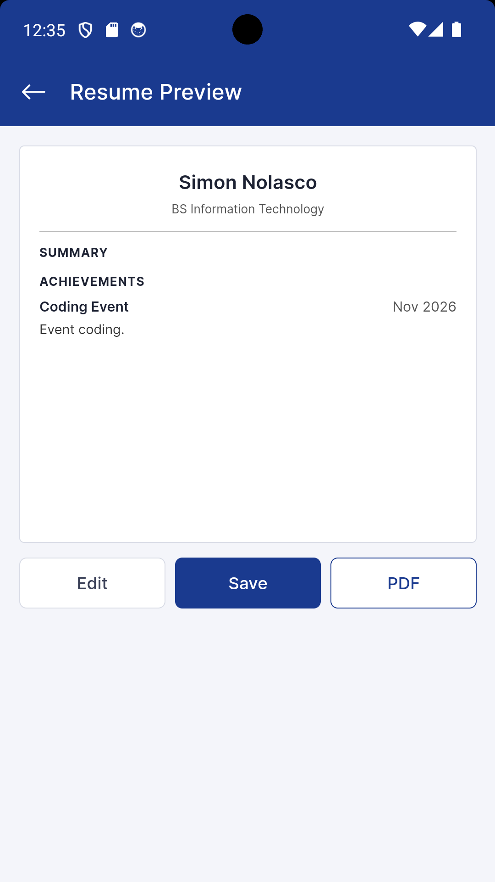 | 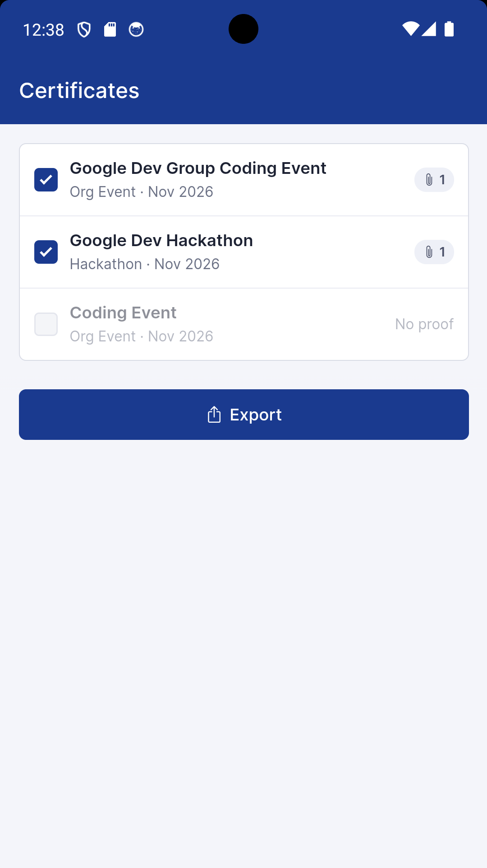
10. Job Posting Suggestions | 11. Resume Preview | 12. Certificates

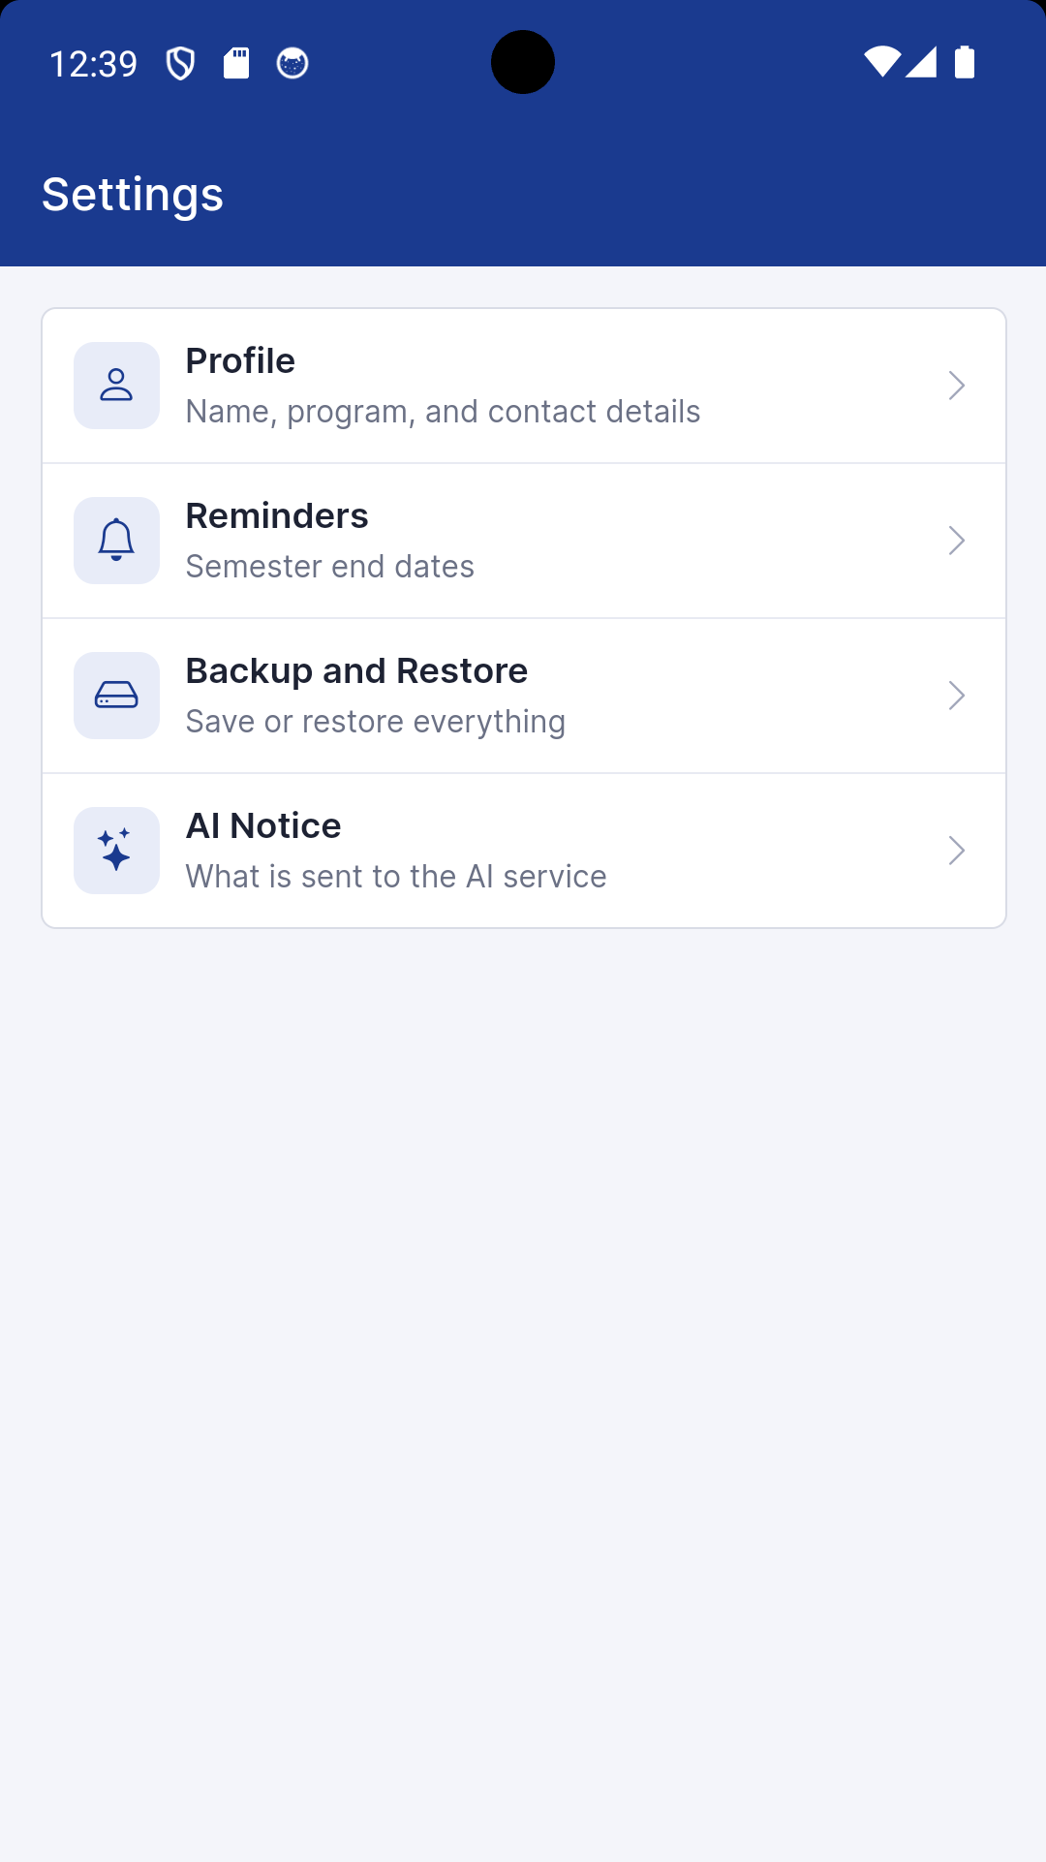 | 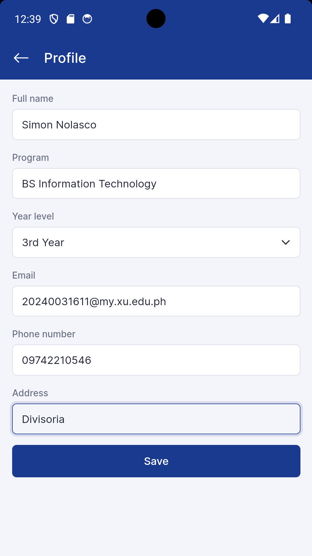 | 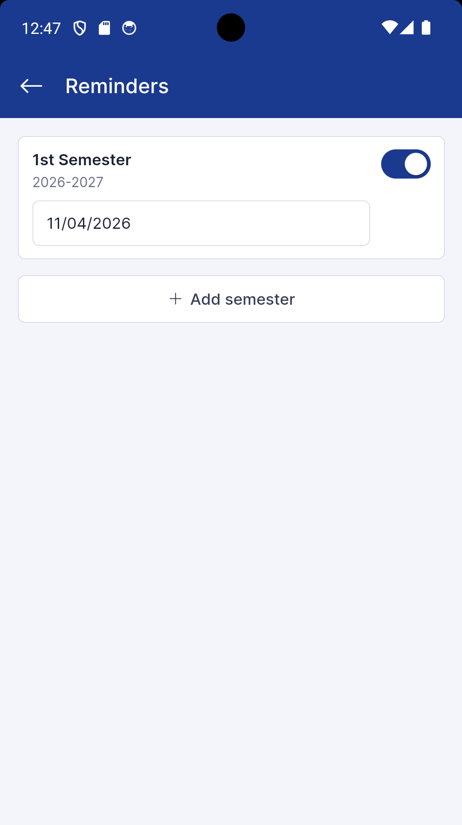
13. Settings | 14. Profile | 15. Reminders

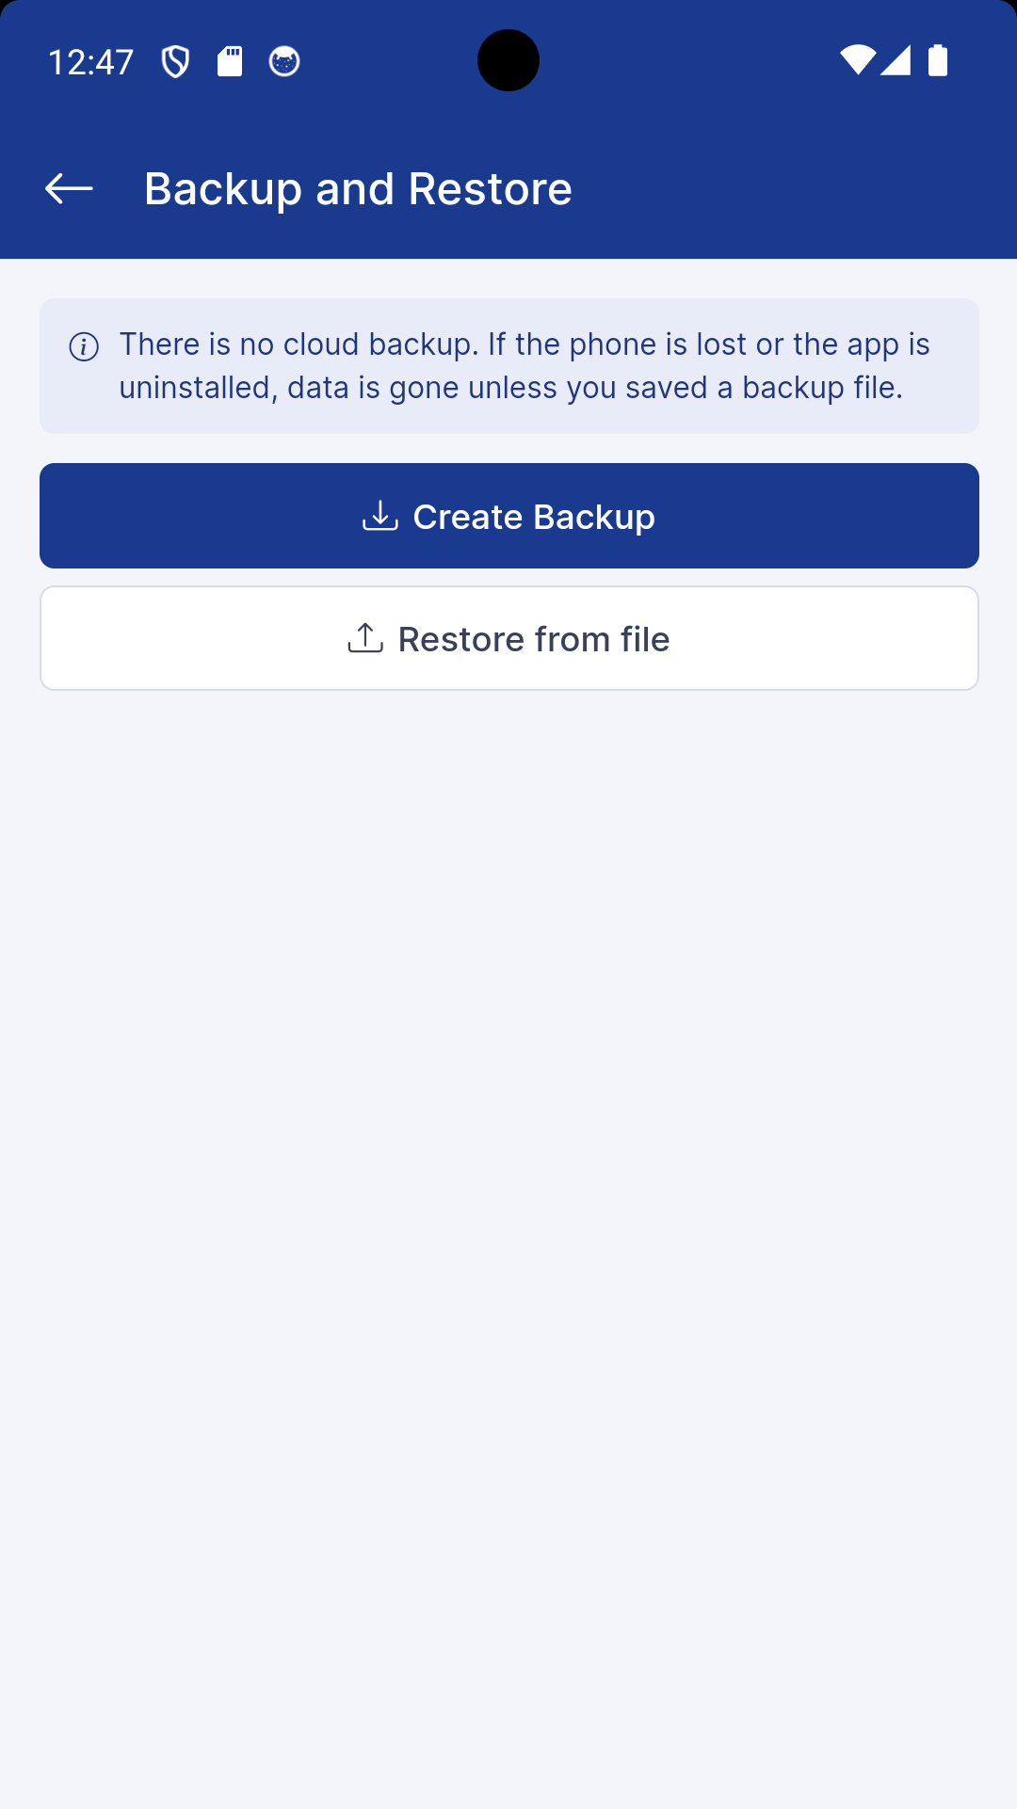
16. Backup and Restore

