Nate Olderman

Brandon Roberts

Eric Sculac

*Capstone Project Proposal*

Brief Summary of the Project:

For our capstone project, we have decided to work on a new social-media platform. A user of this platform wouldn’t have a profile, just their name and a picture. The focus would be on participating in groups that people are free to create and invite others to. These groups would allow for creating events, having discussions, posting photos, and more! In addition to this, there would be a messaging component so people that are not in groups with each other could still communicate through this platform. The academic focus of the project would be on networking, graph theory, databases, and cryptography (passwords).

Description of what will be difficult:

The core difficulty of this project lies in supporting the wide array of functionalities the platform will offer, such as: calendars and event scheduling, photo uploading to the database, discussion threads, group creation and visibility, user searching (through other users as well as past discussions), and account creation and deletion (considering graph theory). In addition to this, we will need to learn more about and be able to execute: the storage and efficiency of large data sets, communication over the internet, storing and accessing from a database, and ensuring passwords are properly encrypted.

Justification of the “independent exploration” angle:

Through this project we’ll learn how to create an independent web app using JavaScript, as well as practicing good design while doing so. We will be teaching ourselves how to use a new set of tools (a new programming framework, specifically), which is something we will likely be doing a lot when joining new jobs and starting new projects. Also, this project is highly expandable. If we choose (and if we have time to) we may stretch the same idea to handheld devices, giving us an opportunity to learn the tools necessary for phone app design.

Tools, packages, and frameworks to be used:

For this project we will use JavaScript as our programming language, with AngularJS as our MVC (Model-View-Controller) Framework. AngularJS has in experienced increased popularity in the past year by over 300%, and has very good accessibility in tutorials and documentation available. We will also be using GitHub as a collaboration tool.

List of features

* Create a group
* Create calendar for the group (schedule events)
* Post files, Text, and Pictures
* Make specific group topics/pages and people can post, subscribe and view comments. Levels of visibility:

Public -> everyone can see group and everything posted within group, Private -> see group’s existence

Invisible -> cannot see group.

* A setting for joining the group: Everyone can join, apply to join, invite only to join.
* Efficiently search for a post/topic within a group
* Allow for messaging between individuals outside of the group (individual messaging conversations)
* Overall group settings (people can change if everyone can see what groups they are in)
* Throwaway group and long term group choice (throwaway is meant to be short term and very simplistic and easy to set up)
* Group self destruct feature (date that it automatically deletes itself from the server)
* Upgrade a throwaway group to a long term group. A notification goes out to all of the group members and they can elect to join the new group or not. Anyone who doesn’t elect to join the new group will destroy everything they posted previously. Use a checkbox when the notification for upgrading to a new group: “Do you want to upgrade to the new group? y/n. Do you want to delete the things you posted previously to the group? y/n.”

Working Together:

We will be using github for version control and communicating through email. A github repository has been created that we all have access to. It is difficult to determine responsibilities for each member at this early stage. There are currently no tasks that will fall to one person. We plan to work together and will attempt to abstract the project into pieces that each member can be responsible for as we progress.

Diagram:

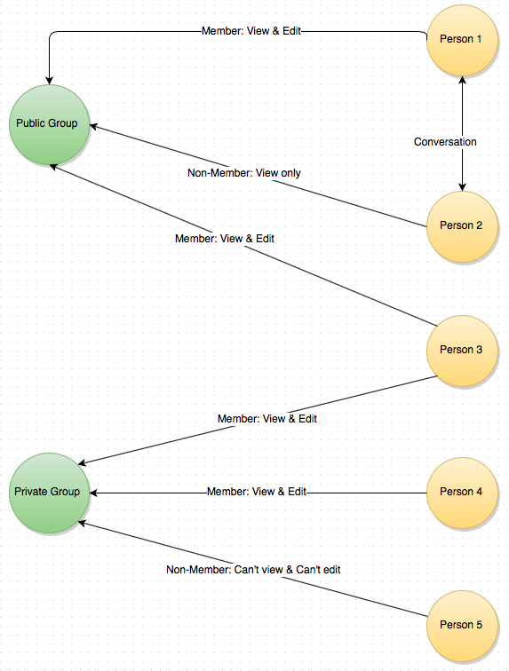

A tentative timeline for the project broken down by week:

The rough schedule for our project is defined below:

|  |  |
| --- | --- |
| **Week Beginning** | **Checkpoints** |
| January 20th | Planning: Functional requirements, project UMLs, use case diagram, and choose basic design |
| January 26th | Planning: Database tables, server setup, |
| February 2nd | Account creation/deletion (authentication), sign in and basic design |
| February 9th | Make structure of a group part 1 (discussion threads) |
| February 16th | Make structure of a group part 2(create events) |
| February 23rd | Make structure of a group part 3(post photos, visibility) |
| March 2nd | User Create/Delete groups |
| March 9th | Post/Delete from group |
| March 16th | **Spring Break** |
| March 23rd | Create invite/accept invite capability |
| March 30th | Search for groups (possibly by location) |
| April 6th | Extra use cases |
| April 13th | Extra use cases and design |
| April 20th | Communicate with people outside groups |
| April 27th | Test requirements |
| May 4th (short week) | Test requirements |

An emergency plan for what to do if you run out of time:

In the event that our capstone project becomes too involved for the time which we are allotted, we will pursue a core functionality. The necessary functionality in the project will be creating an account, creating a group, inviting others to the group, posting to the group (discussion thread), and creating events. The stretch goals that we are striving to reach include posting photos, allowing for account visibility, searching for groups, and communicating with individuals outside of groups. We will be following the schedule above and removing the stretch functionalities if we do not have time to complete them. If we advance in the project ahead of schedule we will begin the core functionalities for an android application.