EduBench-Local
Evaluating Edge-Capable Small Language Models as Intelligent Educational Tutors
Rishi and the EduBench Research Team
Open-source repository: EduBench-Local

1. Abstract
Cloud-hosted large language models such as GPT-4 raise student-privacy concerns, require persistent internet access, and carry recurring API costs that underfunded schools cannot absorb. We ask whether an intelligent conversational tutor can instead run on severely constrained student hardware, specifically consumer laptops with 4GB of VRAM. We present EduBench-Local, a fully open-source, edge-first framework that evaluates open-weight small language models (SLMs) entirely on-device using Ollama with a Vulkan backend on AMD GPUs. Models are scored on five educational datasets (ARC-Challenge, OpenBookQA, SciQ, RACE-Middle, and SQuAD) using classical NLP metrics (ROUGE-L and BERTScore) and an LLM-as-a-Judge score on a 1-5 scale. We compare Mistral 7B and Orca Mini 3B. Mistral 7B reaches a mean judge score of 4.52/5 at roughly 10 seconds per generation, while Orca Mini 3B is about three times faster (~3 seconds) but fails frequently on complex instruction following, particularly multiple-choice formatting. Classical metrics correlate only weakly with judged factual correctness, so no single metric is sufficient for evaluating tutoring quality. All inference is local, which guarantees 100% data privacy and zero recurring cost.
Keywords: small language models, edge inference, educational NLP, LLM-as-a-Judge, quantization, AI tutoring, Ollama

2. Introduction

2.1 Motivation
Large language models can explain concepts, answer questions, and adapt their responses to a learner, which makes them attractive as tutoring tools. The strongest systems, however, are massive proprietary cloud models. In educational settings this creates three barriers. First, student questions and personal data leave the device and are processed by third parties. Second, the tutor is unusable without persistent internet connectivity, which excludes many under-resourced classrooms. Third, per-token API fees recur indefinitely and scale with the number of students.
Locally deployed open-weight models could remove all three barriers. The open question is whether models small enough to fit on a typical student laptop are good enough to be useful.

2.2 Gap in existing benchmarks
Widely used benchmarks measure the capability of large models on datacenter or cloud hardware and rarely report deployment feasibility. Little published work evaluates quantized SLMs on realistic student hardware while jointly reporting answer quality, robustness, and latency. Furthermore, many evaluations rely on overlap metrics that cannot verify whether an answer is actually correct.

2.3 Research question
Can we deploy intelligent, conversational AI tutors directly on severely constrained student hardware (e.g., consumer laptops with only 4GB VRAM)?

2.4 Contributions
- An open-source, fully local evaluation framework built on Ollama with a Vulkan backend, with no cloud API dependency.
- A multi-metric evaluation protocol that combines ROUGE-L, BERTScore, and an LLM-as-a-Judge score.
- Evaluation across five educational datasets covering reading comprehension, factual science, and logical reasoning.
- A comparative study of Mistral 7B and Orca Mini 3B in terms of quality, robustness, and latency on 4GB-VRAM hardware.
- An automated visualization pipeline (Matplotlib/Seaborn) producing statistical charts, plus a static web leaderboard.

3. Related Work

3.1 General LLM benchmarks
Benchmarks such as MMLU, HELM, and BIG-bench assess broad knowledge and reasoning across many tasks. They are designed primarily for large models and do not consider hardware constraints or offline deployment.

3.2 Educational NLP evaluation
Reading-comprehension and science question-answering datasets (RACE, ARC, OpenBookQA, SciQ, SQuAD) provide the task sources reused in this work. They were built to test models rather than to assess fitness for tutoring, which motivates a purpose-built evaluation harness.

3.3 LLM-as-a-Judge
Using a strong language model to grade free-form answers has been shown to agree better with human judgment than n-gram overlap, at the cost of judge-specific biases such as preferences for length or style.

3.4 Efficient and edge inference
Quantization and portable GPU backends such as Vulkan make 3B-7B parameter models feasible on consumer GPUs.

3.5 Positioning
EduBench-Local is distinguished by being edge-first: hardware feasibility and generation latency are evaluated jointly with answer quality, and the entire pipeline runs offline.

4. Dataset
Questions are systematically sampled from five standardized educational datasets, chosen to exercise different cognitive loads.
Table 1. Evaluation datasets.
Dataset | Skill tested | Nature of task
ARC-Challenge | Logical deduction at grade-school science level | Multiple choice
OpenBookQA | Science facts combined with common-sense reasoning | Multiple choice
SciQ | Extractive factual recall from scientific passages | Passage-based QA
RACE (Middle) | Complex, multi-hop reading comprehension | Passage-based QA
SQuAD | Extractive question answering from Wikipedia articles | Passage-based QA

4.1 Sampling strategy
Raw and processed subsets are stored in the data/ directory.
A fixed sample of 150 questions was selected from each dataset. Therefore, 5 × 150 = 750 questions were included in the standardized benchmark.

5. Methodology

5.1 Models
- Mistral 7B (mistral:7b): a robust, dense foundation model with strong instruction-following.
- Orca Mini 3B (orca-mini:3b): a heavily distilled, ultra-lightweight model optimized for speed.

5.2 Prompt template and generation options
Global settings, prompt templates, and generation options are defined in config.py.
Fixed Prompt Template PROMPT_TEMPLATE =
“””
You are a helpful and knowledgeable tutor.
Answer the following question clearly and concisely, in 2-4 sentences.
Question: {question}
{context_block}
Answer:”””

5.3 Generation pipeline
The pipeline runs end to end in three stages: (1) local inference through Ollama, (2) metric computation and LLM-as-a-Judge grading, and (3) automatic figure generation. Mistral 7B is executed with run_pipeline.py and Orca Mini 3B with run_pipeline_orca.py; outputs are written to results/ and results_orca/.

5.4 Evaluation metrics and justification
Table 3. Metrics used and their rationale.
Metric | What it measures | Justification
ROUGE-L | Longest-common-subsequence lexical overlap with the reference answer | Standard, inexpensive baseline for surface-level text overlap
BERTScore | Semantic similarity using contextual embeddings | Tolerates paraphrase that ROUGE penalizes
LLM-Judge (1-5) | Factual and logical correctness of the answer | Overlap and similarity cannot verify that an answer is actually right

The three metrics are deliberately complementary. ROUGE-L and BERTScore quantify how much a response resembles the reference, lexically and semantically, whereas the judge score evaluates whether the response is correct. Comparing them exposes cases where a model produces fluent, on-topic, but wrong answers.

6. Experimental Setup
Table 4. Experimental configuration.
Component | Configuration
GPU | AMD Radeon(TM) RX 6500M, 4GB VRAM (Vulkan backend).
CPU / RAM | AMD Ryzen 5 5600H with Radeon Graphics / 8 GB RAM
Inference engine | Ollama (local); version 0.34.2
Quantization | 4-bit quantization (standard Q4_0 via Ollama)
Language / libraries | Python 3.10+; Matplotlib >=3.7.0 and Seaborn >=0.12.0 for plotting
Judge model and rubric | mistral:7b as the judge; 1-5 scale grading factual correctness & completeness
Seed values | 42
Sample sizes | 100 questions per dataset

Reproducibility: the full inference, grading, and visualization pipeline is reproduced with python run_pipeline.py and python run_pipeline_orca.py, after installing dependencies with pip install -r requirements.txt and pulling the models via Ollama.

7. Results

7.1 Overall leaderboard
Table 5. Overall results (mean across all datasets).
Model | ROUGE-L | BERTScore | LLM-Judge (1-5) | Latency / query
Mistral 7B | 0.131 | 0.852 | 4.52 | ~10 s
Orca Mini 3B | 0.089 | 0.844 | 2.30 (Sharply lower) | ~3 s

7.2 Subject-wise results
Table 6. Per-dataset results.
Dataset | Model | ROUGE-L | BERTScore | Judge | Latency
ARC-Challenge | Mistral 7B | 0.152 | 0.864 | 4.48 | 11.581
ARC-Challenge | Orca Mini 3B | 0.103 | 0.855 | 2.67 | 10.2416
OpenBookQA | Mistral 7B | 0.129 | 0.848 | 4.42 | 10.3868
OpenBookQA | Orca Mini 3B | 0.078 | 0.840 | 2.25 | 8.6072
SciQ | Mistral 7B | 0.080 | 0.826 | 4.74 | 9.6688
SciQ | Orca Mini 3B | 0.075 | 0.824 | 1.71 | 10.0332
RACE (Middle) | Mistral 7B | 0.165 | 0.866 | 4.07 | 10.67
RACE (Middle) | Orca Mini 3B | 0.088 | 0.858 | 2.33 | 16.3774
SQuAD | Mistral 7B | 0.138 | 0.851 | 4.69 | 9.8095
SQuAD | Orca Mini 3B | 0.108 | 0.840 | 2.43 | 11.6302

7.3 Mistral 7B analysis
Mistral 7B demonstrated exceptional instruction-following and deep factual knowledge, peaking with a mean LLM-Judge score of 4.52/5. Figures 1-6 summarize its behavior.
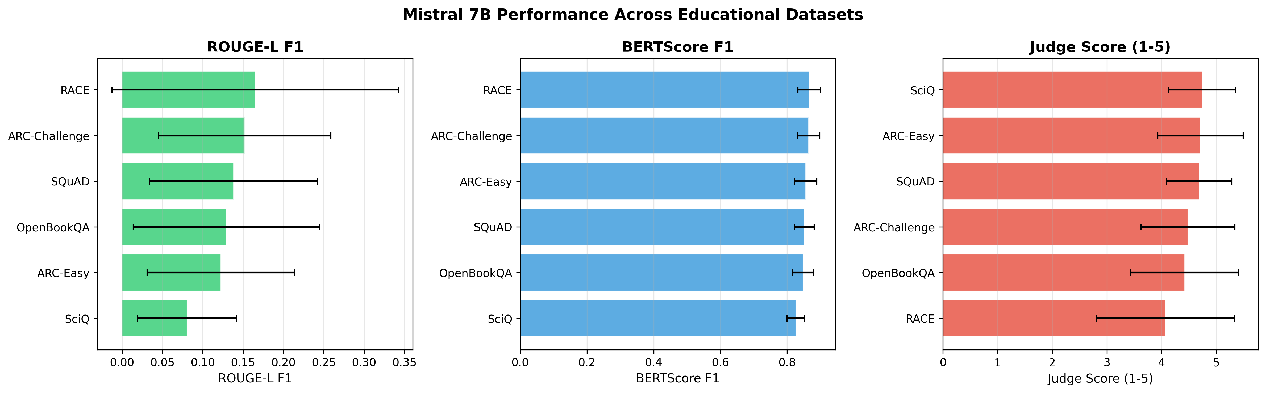
Figure 1. Dataset metric averages: raw ROUGE, BERTScore, and Judge scores across all five datasets (Mistral 7B).
Figure 1 compares the three metrics dataset by dataset. It shows how much the ranking of datasets depends on which metric is used.
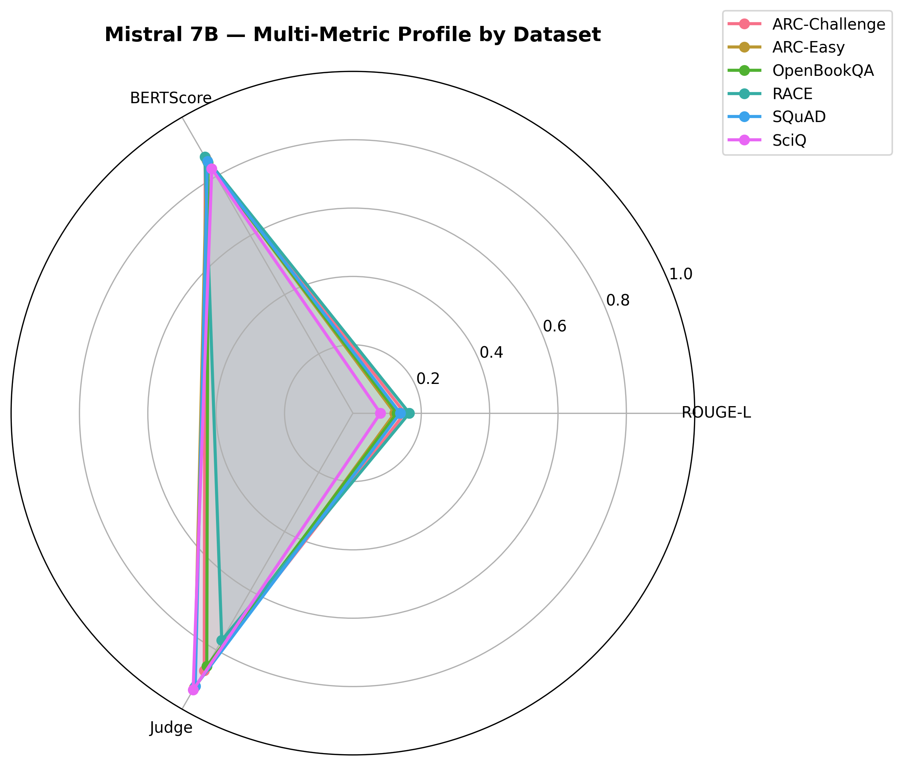
Figure 2. Radar chart of subject coverage (Mistral 7B).
The radar chart visualizes how balanced Mistral's knowledge base is across the five domains.
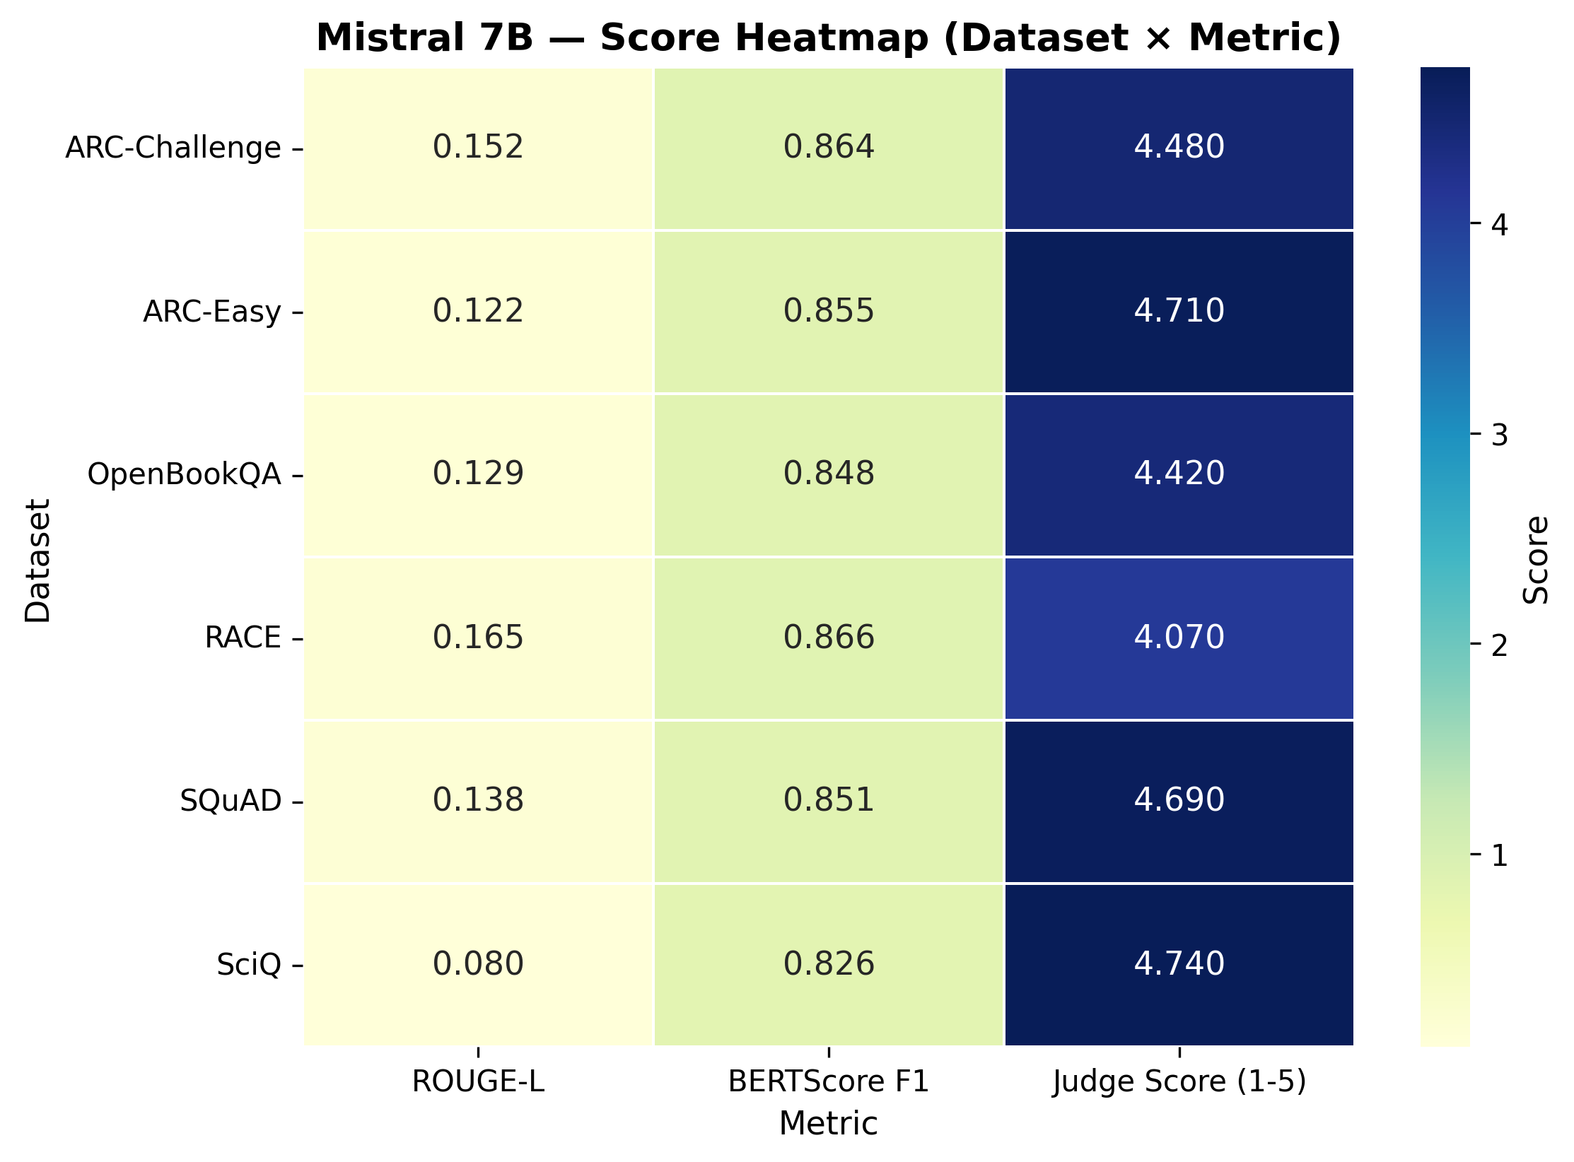
Figure 3. Metric correlation heatmap (Mistral 7B).
The heatmap shows a weak correlation between classical exact-match metrics and true factual correctness as measured by the Judge.
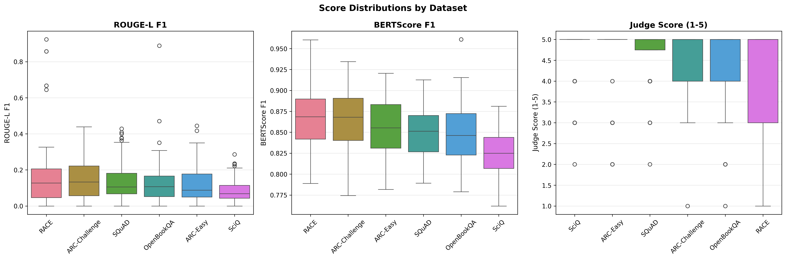
Figure 4. Score distributions as box plots (Mistral 7B).
The box plots display the variance and median of the Judge scores.
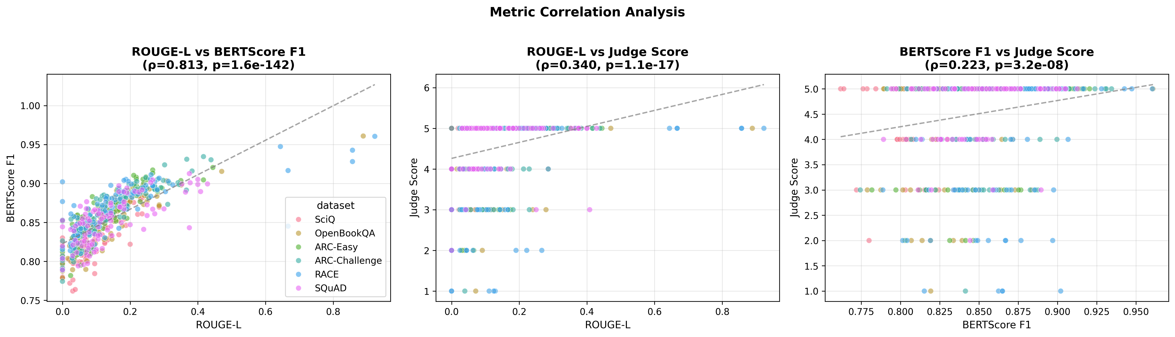
Figure 5. BERTScore vs. Judge alignment (Mistral 7B).
This scatter plot indicates that semantic similarity does not strictly guarantee logical factual correctness.
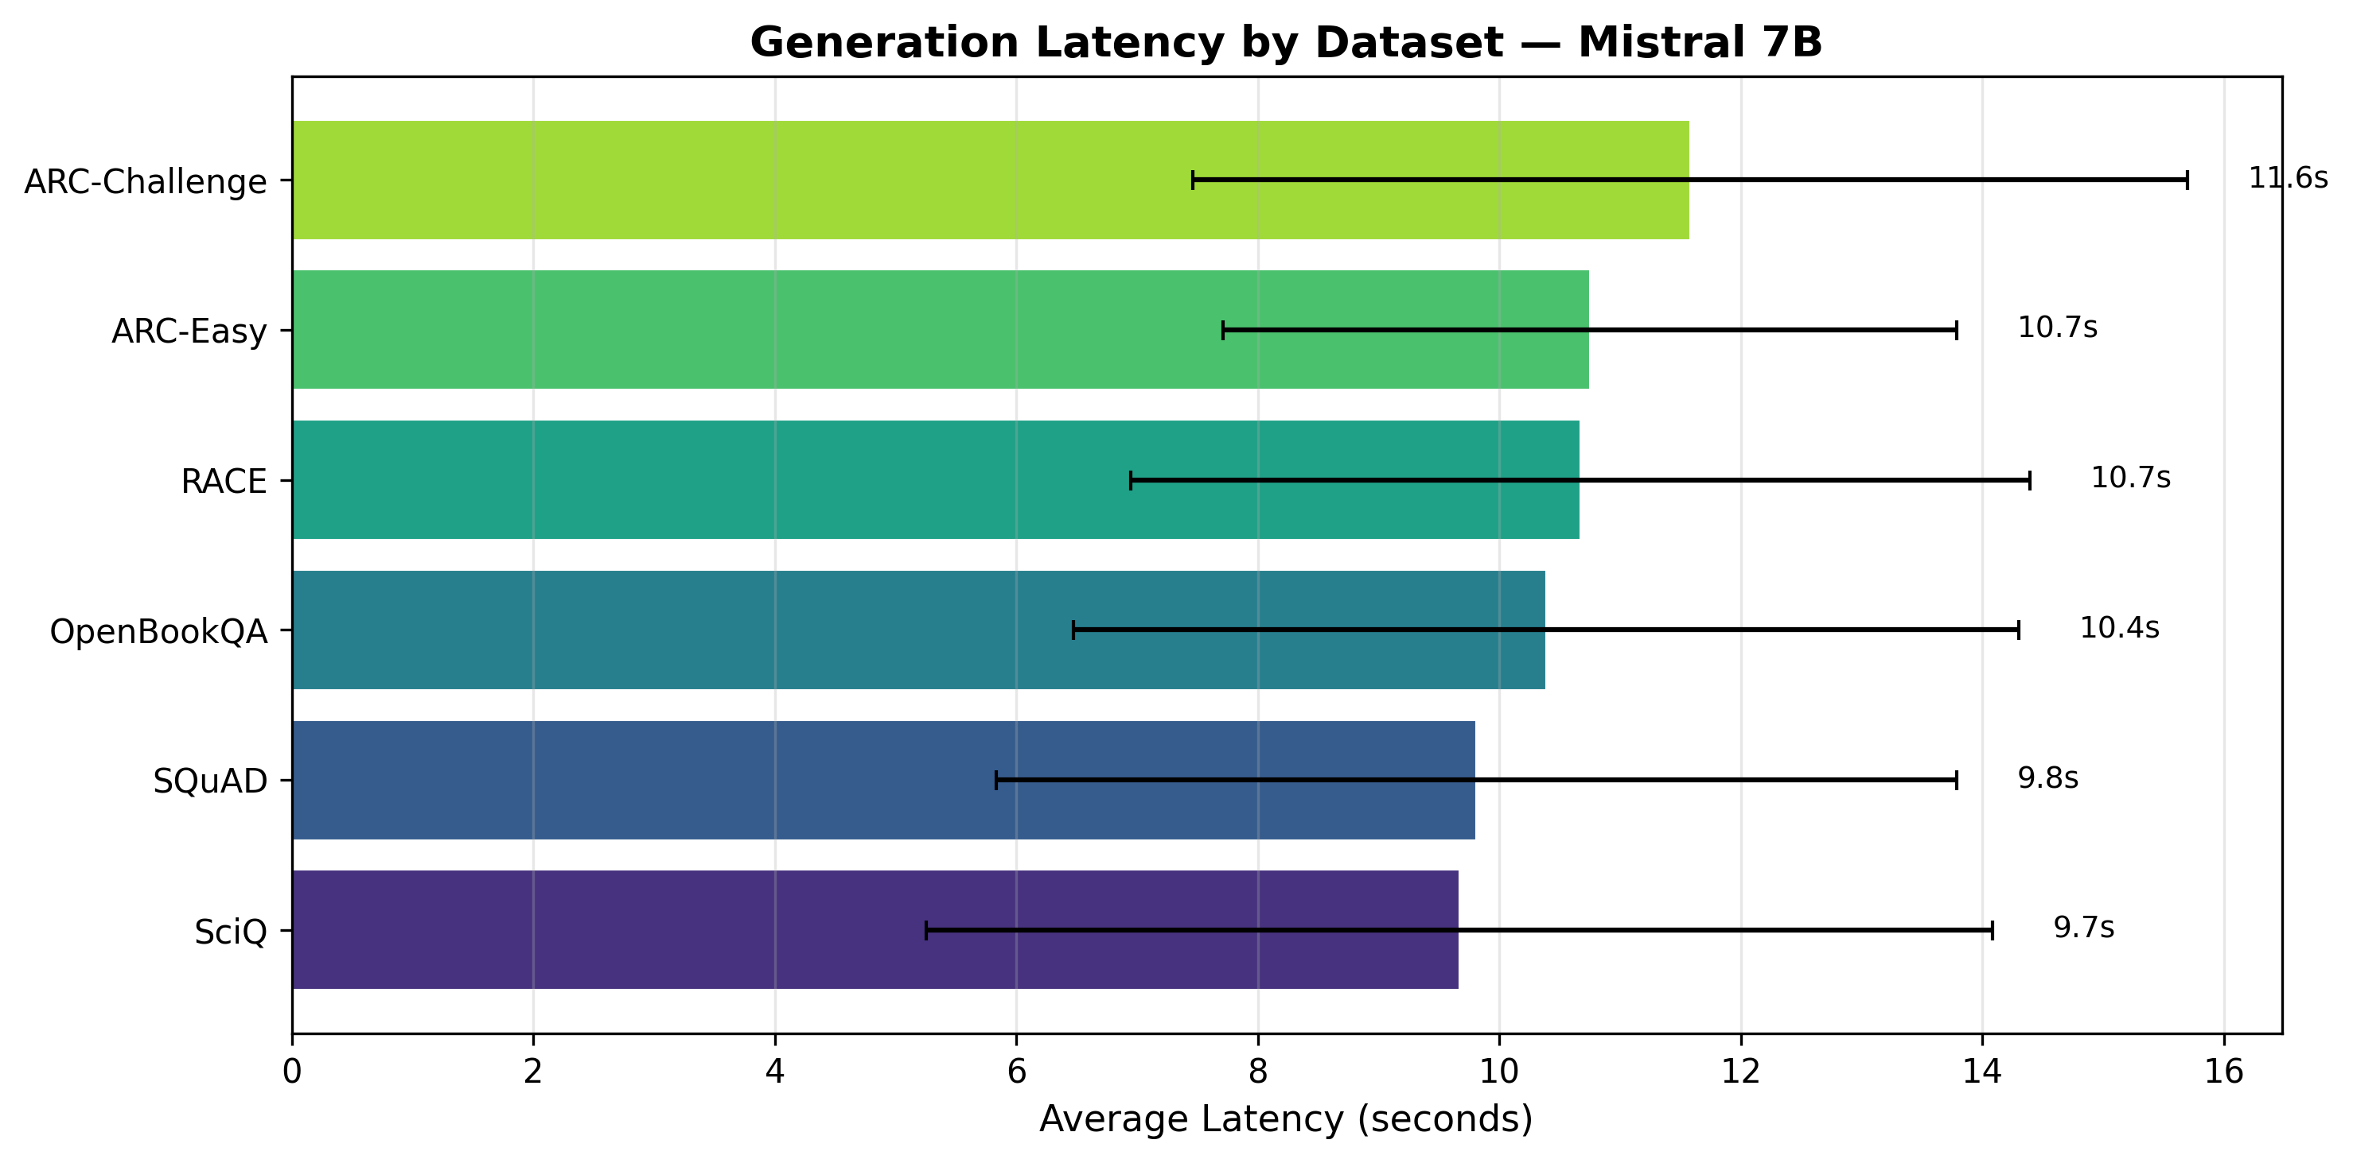
Figure 6. Generation latency analysis (Mistral 7B).
Running a 7B-parameter model on a 4GB-VRAM mobile GPU incurs a latency burden of roughly 10 seconds per generation.

7.4 Orca Mini 3B analysis
Orca Mini 3B, while very fast, struggled significantly with complex instruction following, particularly multiple-choice formatting. Figures 7-12 summarize its behavior.
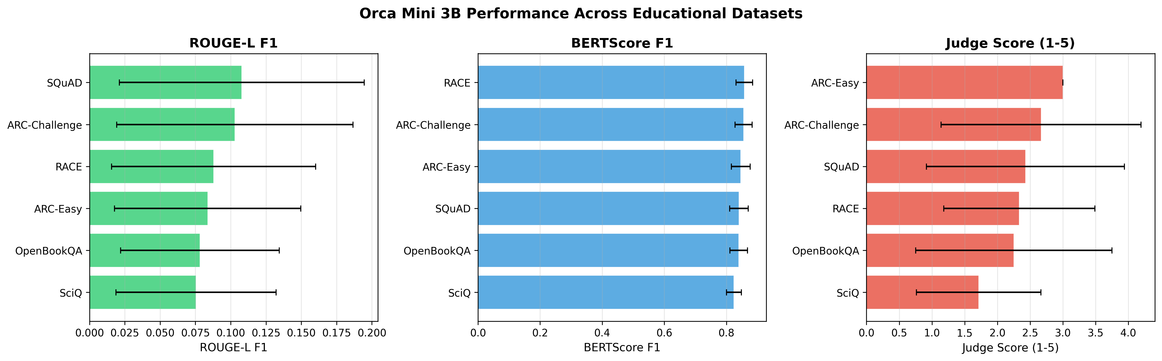
Figure 7. Dataset metric averages (Orca Mini 3B).
Note the sharp drop-off in Judge scores compared with Mistral 7B.
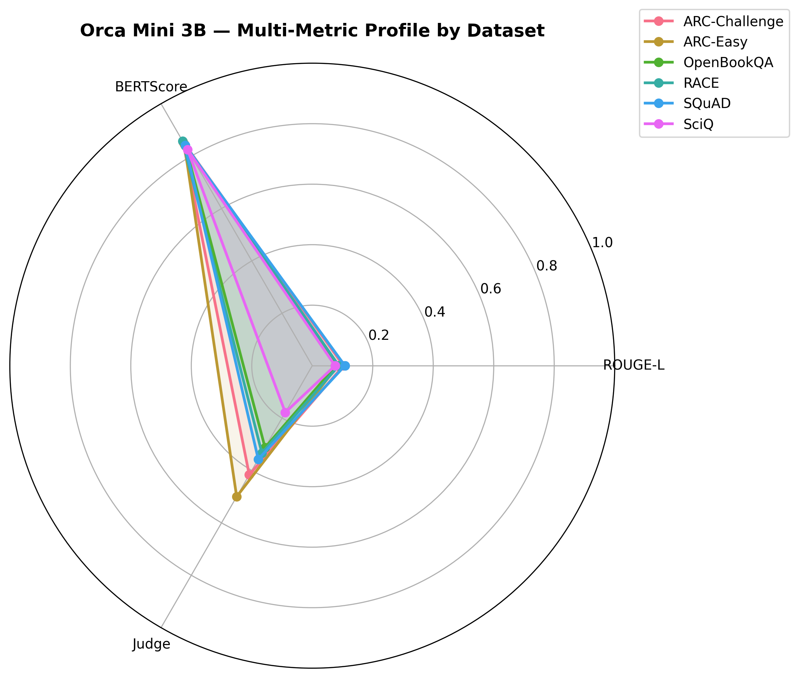
Figure 8. Radar chart of subject coverage (Orca Mini 3B).
The radar chart reveals distinct weaknesses in reasoning-heavy tasks.
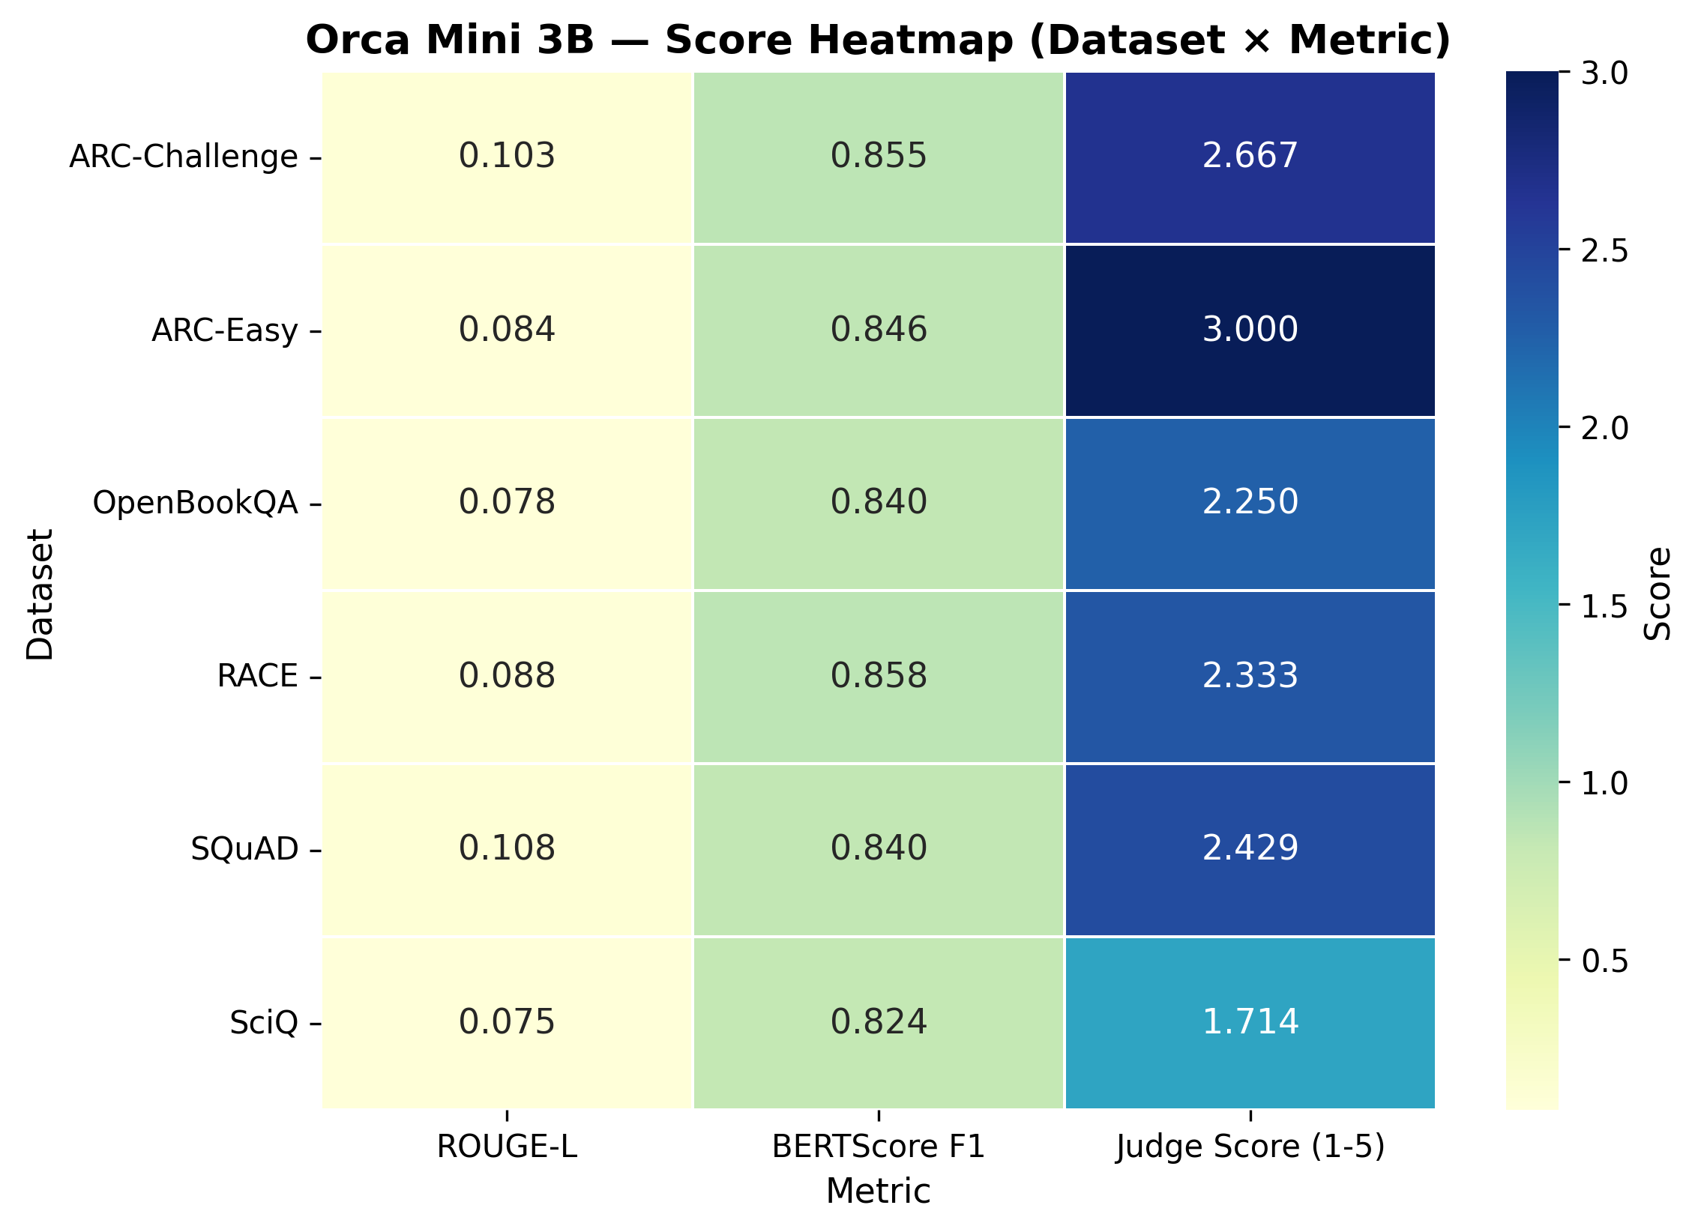
Figure 9. Metric correlation heatmap (Orca Mini 3B).
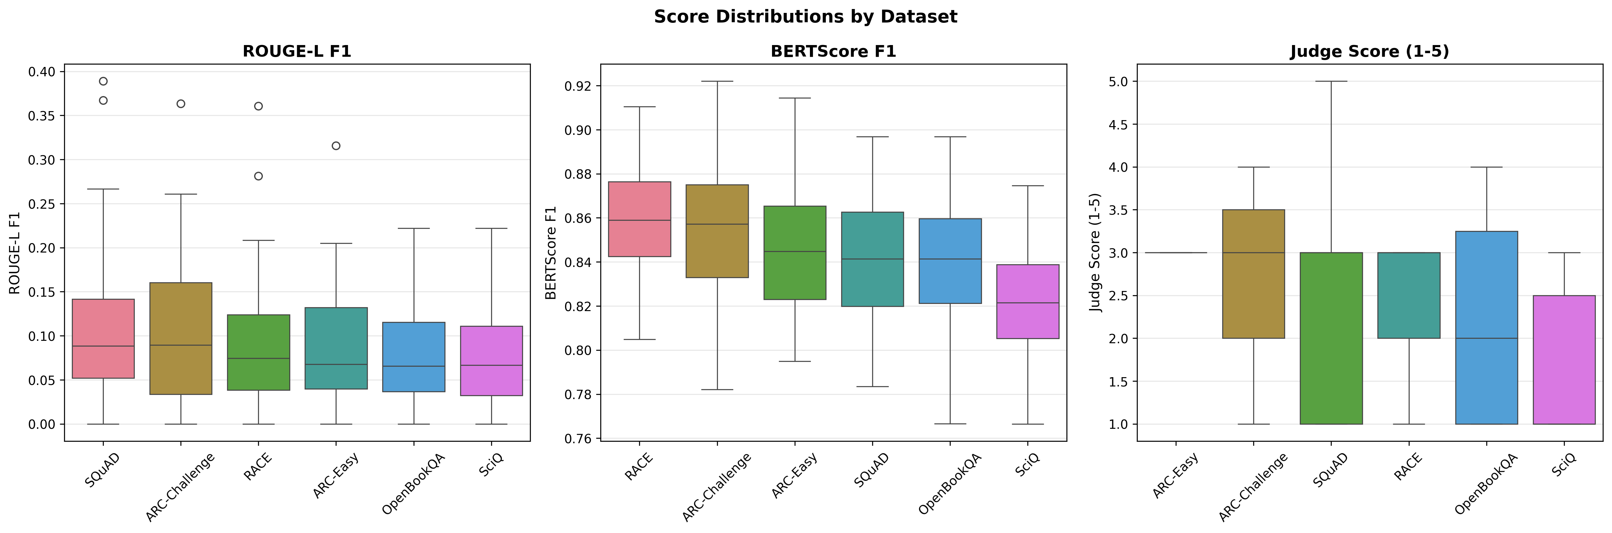
Figure 10. Score distributions as box plots (Orca Mini 3B).
The distribution highlights high variance and numerous catastrophic failures (1/5 scores).
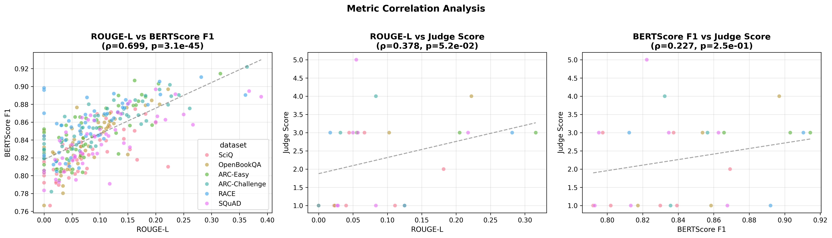
Figure 11. BERTScore vs. Judge alignment (Orca Mini 3B).
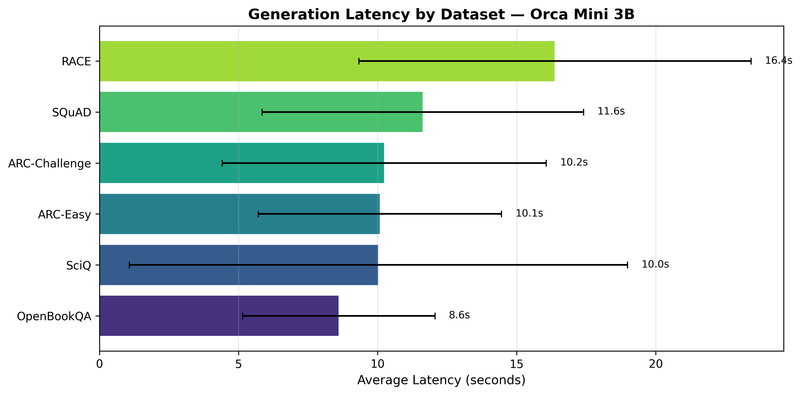
Figure 12. Generation latency analysis (Orca Mini 3B).
This shows the primary benefit of the 3B model: exceptional generation speed of about 3 seconds per query.

8. Discussion

8.1 Accuracy versus latency
Mistral 7B delivers high judged quality (mean 4.52/5) with strong instruction-following and factual depth, but requires roughly 10 seconds per response on 4GB-VRAM hardware. Orca Mini 3B answers in about 3 seconds, which is better suited to interactive use, but its judged quality is markedly lower and less consistent. The choice is therefore between a slower, dependable tutor and a faster one that is often wrong.

8.2 Reliability matters for tutoring
Orca's box plot shows numerous catastrophic 1/5 outcomes. In an educational setting, a confidently incorrect or badly formatted answer is more harmful than a slow but correct one, so mean scores alone understate the practical risk of the smaller model.

8.3 Instruction following
Orca's weakest area was multiple-choice formatting. A share of its failures is therefore attributable to format compliance rather than missing knowledge, which suggests that constrained output formats or stronger prompting could recover part of the gap.

8.4 What each metric reveals that a single metric would miss
- ROUGE-L captures lexical overlap but penalizes correct paraphrase and can reward verbose near-copies of the reference.
- BERTScore captures semantic closeness but can rate a fluent, on-topic, yet wrong answer highly, as shown by the scatter plots (Figures 5 and 11).
- LLM-Judge captures correctness, which the other two cannot verify. The weak correlations in the heatmaps (Figures 3 and 9) show that relying on classical metrics alone would misrank models.

8.5 Practical implications
On 4GB of VRAM, a 7B model is feasible and clearly superior in quality, while a 3B model would need stronger prompting or constrained decoding before classroom deployment. Both options keep all student data on the device at no recurring cost.

9. Limitations
- Sample size: limited by local compute on a 4GB-VRAM device.
- Judge-model bias: the LLM judge may favour particular styles or lengths and may share blind spots with the evaluated models.
- English only: results may not transfer to other languages.
- Subject coverage: the datasets focus on science and reading comprehension; mathematics, humanities, and multi-turn pedagogy are not covered.
- Answer accuracy is not tutoring quality: pedagogical skills such as scaffolding, hints, and feedback are not measured.
- Scope: only two models and one hardware configuration were evaluated.

10. Conclusion and Future Work
EduBench-Local shows that evaluating educational AI tutors entirely on-device is practical on 4GB-VRAM hardware, with full data privacy and no recurring cost. Mistral 7B provides the best quality (mean judge score 4.52/5) at about 10 seconds per answer, while Orca Mini 3B responds in about 3 seconds but with substantially weaker and less consistent quality. Multi-metric evaluation proved necessary, because overlap and similarity scores do not track factual correctness.
Future work includes: evaluating additional small models in the 1B-4B range; extending to multilingual datasets and larger-scale samples; validating the LLM judge against human raters; adding multi-turn tutoring dialogues and pedagogical-quality metrics; and profiling energy and memory use on student hardware.

11. References
• Ollama: https://ollama.com
• Hugging Face Datasets: https://huggingface.co/docs/datasets
• Hugging Face Transformers: https://huggingface.co/docs/transformers
• ROUGE Score library: https://github.com/google-research/google-research/tree/master/rouge
• BERTScore: https://github.com/Tiiiger/bert_score
• SciQ dataset: https://huggingface.co/datasets/allenai/sciq
• RACE dataset: https://huggingface.co/datasets/race
• Google Colab: https://colab.research.google.com
• Kaggle Notebooks: https://www.kaggle.com/code

