

SCHOOL OF SCIENCE AND TECHNOLOGY
COURSE: APT 2050-C: COMPUTER NETWORKS AND TELECOMMUNICATIONS
END SEMESTER EXAMINATION
SECTION B: PRACTICAL ASSESSMENT (50 MARKS)
INSTRUCTOR: DR. PAULA MUSUVA
TIME ALLOWED: 90 MINUTES

Student ID: 674585
Student Name: Stephane Nigaba

Instructions
- As you answer the questions, take screenshots of each step of your work to support your findings.
- Ensure to write your answers in this Word document as a template for your report.
- Answer ALL questions

Grading:
- Written report (20mks)
- Packet Tracer file (60mks)

Scenario
You have been hired as a network administrator at a small campus. Following good network design principles, you have been asked to create a segmented network with a router, two switches and two VLANs, one for teaching and the other for administrators as shown in the diagram below. Using Packet Tracer, simulate the deployment and test the configurations you will implement before you do them physically. Demonstrate to the IT manager that you understand networking and you will get the networks running properly and securely.

Topology
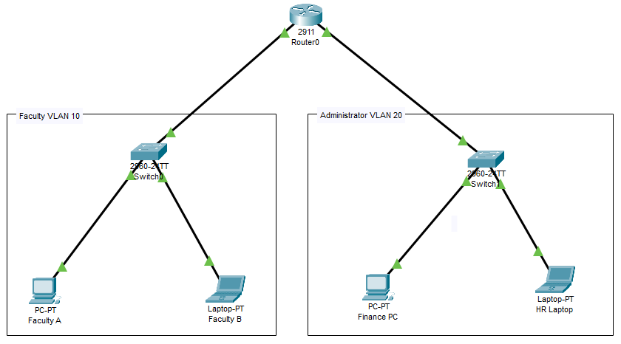

Addressing Table
Device | Interface Description | IP Address / Prefix
CoreRouter  2911 Router | G0/0/0  Connecting to Faculty LAN | First Address in Class C Network 192.168.10.x
CoreRouter  2911 Router | G0/0/0  Connecting to Faculty LAN | 2001:db8:acad::1/64
 | G0/0/0  Connecting to Faculty LAN | fe80::1
CoreRouter  2911 Router | G0/0/1  Connecting to Admin LAN | First Address in Class C Network 192.168.20.x
CoreRouter  2911 Router | G0/0/1  Connecting to Admin LAN | 2001:db8:acad:1::1/64
 | G0/0/1  Connecting to Admin LAN | fe80::1
Faculty LAN  2960 Switch | VLAN 10 | Second IP Address
Admin LAN  2960 Switch | VLAN 20 | Second IP Address
Faculty A PC | Fa0 to Fa0/3 on Switch | Third IP Address
 | Fa0 to Fa0/3 on Switch | 2001:db8:acad::3/64
Faculty B Laptop | Fa0 to Fa0/4 on Switch | Fourth IP Address
 | Fa0 to Fa0/4 on Switch | 2001:db8:acad::4/64
Finance PC | Fa0 to Fa0/3 on Switch | Third IP Address
 | Fa0 to Fa0/3 on Switch | 2001:db8:acad:1::3/64
HR Laptop | Fa0 to Fa0/4 on Switch | Fourth IP Address
 | Fa0 to Fa0/4 on Switch | 2001:db8:acad:1::4/64

Part 1: Set Up the Topology (5 marks)
Cable the equipment as shown in the topology diagram.
- Connect R1 G0/0/0 to Faculty LAN Switch port FastEthernet 0/24
- Connect R1 G0/0/1 to Admin LAN Switch port FastEthernet 0/24
- Connect Prof X PC Fa0 to Fa0/3 on Faculty LAN Switch
- Connect Prof Y Laptop Fa0 to Fa0/4 on Faculty LAN Switch
- Connect Finance PC Fa0 to Fa0/3 on Admin LAN Switch
- Connect HR Laptop Fa0 to Fa0/4 on Admin LAN Switch
Take screenshots to show your final connectivity and network layout. Ensure you enable device and port labels to be shown on the Packet Tracer diagram.

TOPOLOGY
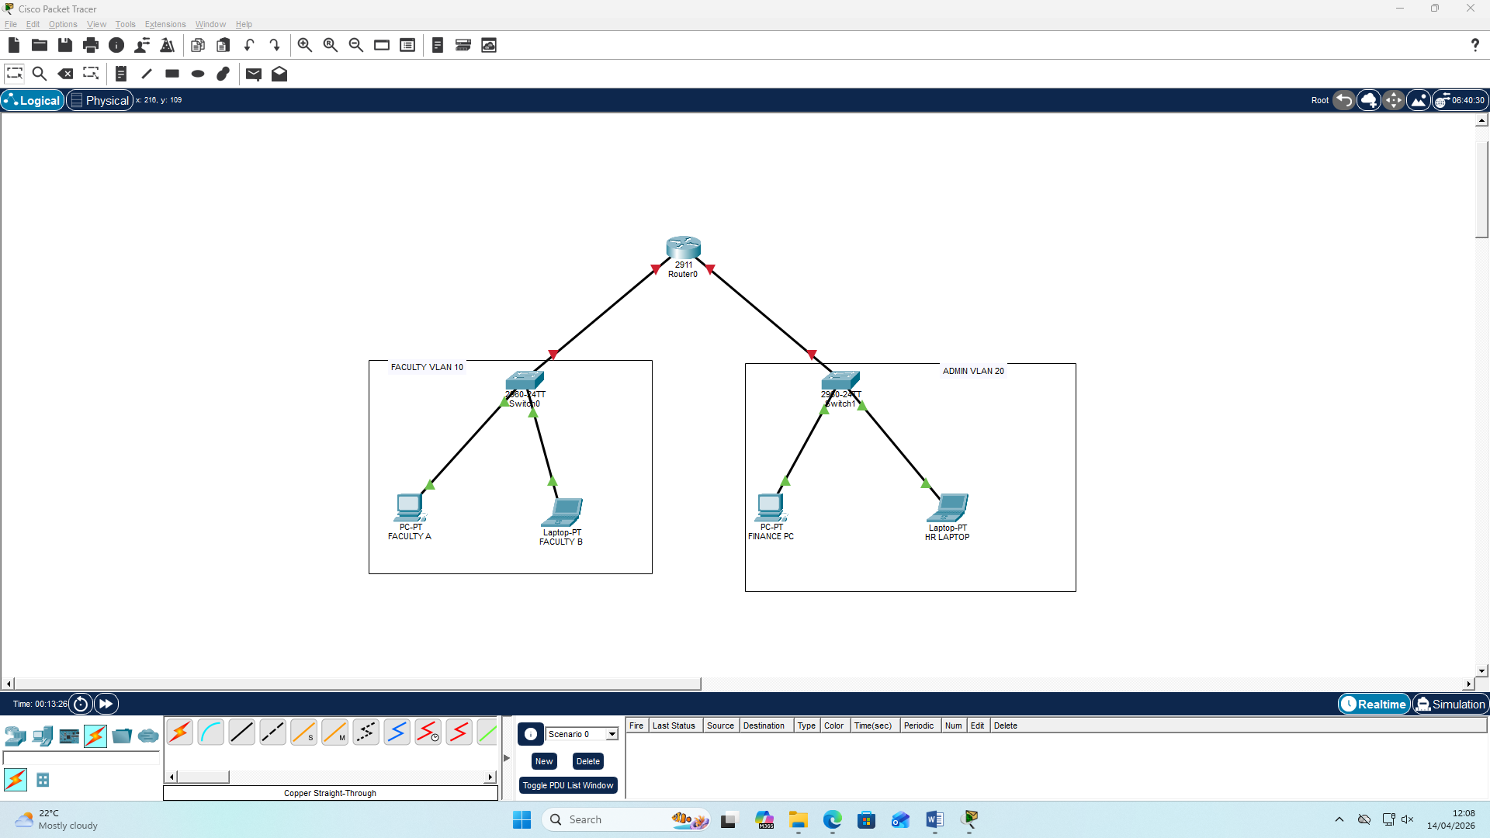

Part 2: IP Address Configuration (10 marks)
You will design and assign static IPv4 addressing information to the device interfaces.
Using guiding information in the Addressing Table:
- Design a Class C 192.168.10.x Network addressing scheme for the Faculty LAN. To avoid wastefulness, ensure this subnet can support no more than 64 devices. Populate the table below
Outline your subnetting calculations below here first and then populate the table
FOR NO MORE THAN 64 ADDRESSES 19.168.10.X WILL HAVE
- I WILL BORROW 2 BITS FROM THE NETWORK PORTION, REMAINING 6 BITS; SO HOSTS TOTAL HOSTS 2^6 = 64 HOSTS, BUT 2 Ips ARE RESERVED FOR THE NETWORK ADDRESS AND BROADCAST. SUBNET MASK WILL BE
255.255.255.192; THE “192” COMES FROM THE BORROWED BITS. 1ST =128,2ND = 64 AND SUM = 192

Interface | IP Address | Subnet Mask | Default Gateway
Faculty LAN VLAN99 | 192.168.10.2 | 255.255.255.192 | 192.168.10.1
Prof X PC | 192.168.10.3 | 255.255.255.192 | 192.168.10.1
Prof Y Laptop | 192.168.10.4 | 255.255.255.192 | 192.168.10.1

- Design a Class C 192.168.20.x Network addressing scheme for the Admin LAN. To avoid wastefulness, ensure this network can support no more than 32 devices. Populate the table below
Outline your subnetting calculations below here first and then populate the table
- I WILL BORROW 3 BITS FROM THE NETWORK PORTION, REMAINING 5 BITS; SO HOSTS TOTAL HOSTS 2^5 = 32 HOSTS, BUT 2 Ips ARE RESERVED FOR THE NETWORK ADDRESS AND BROADCAST. SUBNET MASK WILL BE
255.255.255.224; THE “224”COMES FROM THE BORROWED BITS. 1ST =128,2ND = 64, 3RD = 32 AND SUM = 224

Interface | IP Address | Subnet Mask | Default Gateway
Admin LAN VLAN99 | 192.168.20.2 | 255.255.255.224 | 192.168.20.1
Finance PC | 192.168.20.3 | 255.255.255.224 | 192.168.20.1
HR Laptop | 192.168.20.4 | 255.255.255.224 | 192.168.20.1

Configure the IPv4 and IPv6 addresses, subnet mask, and default gateway settings on ALL end user devices. NOTE: The IPv6 addresses are given to you in the addressing table
Take a screenshot to show each PC /Laptop configuration.

FACULTY A
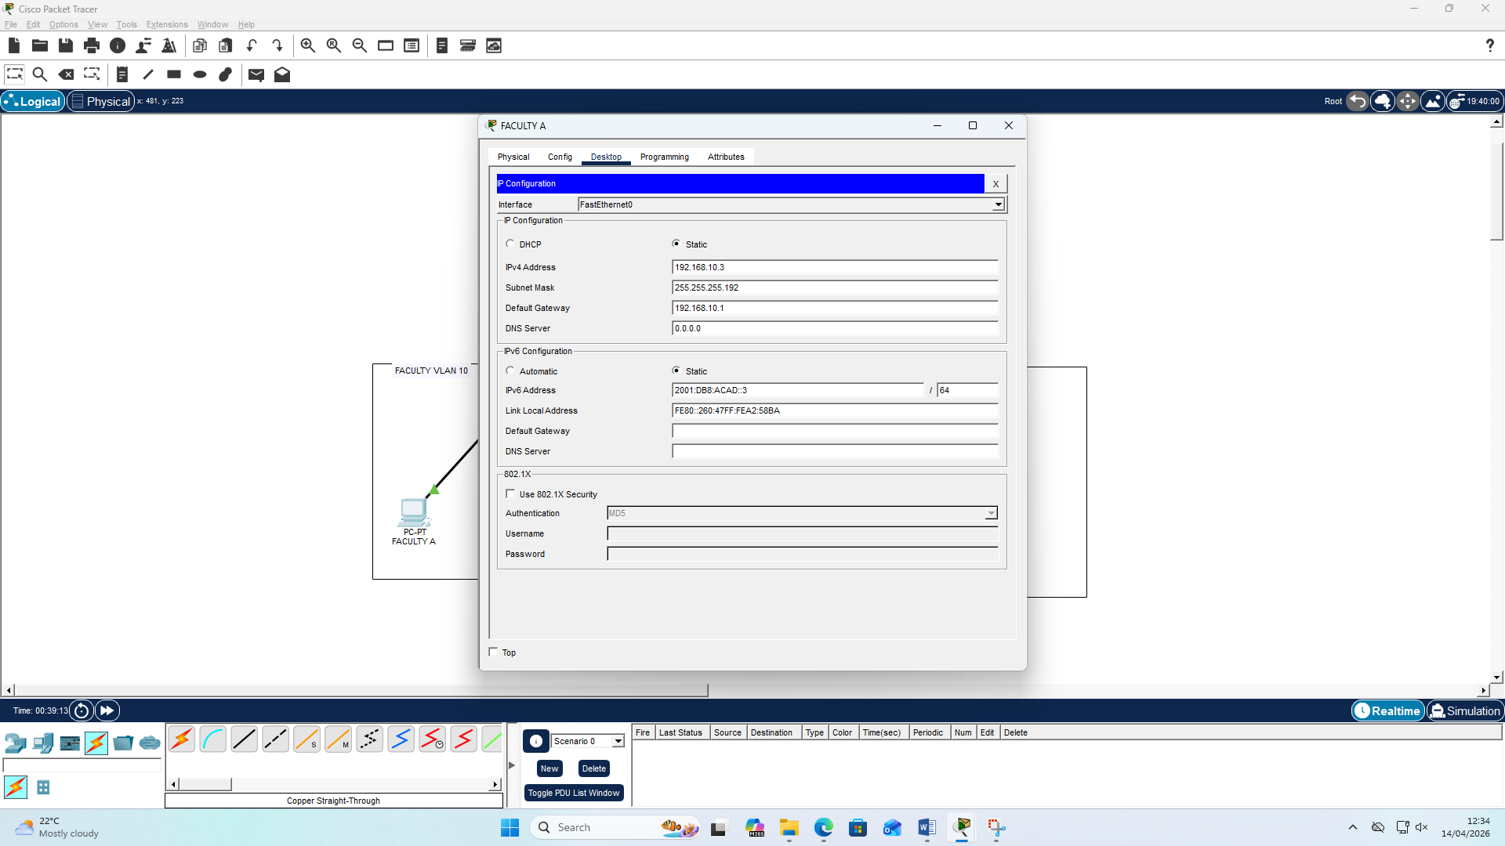

FACULTY B
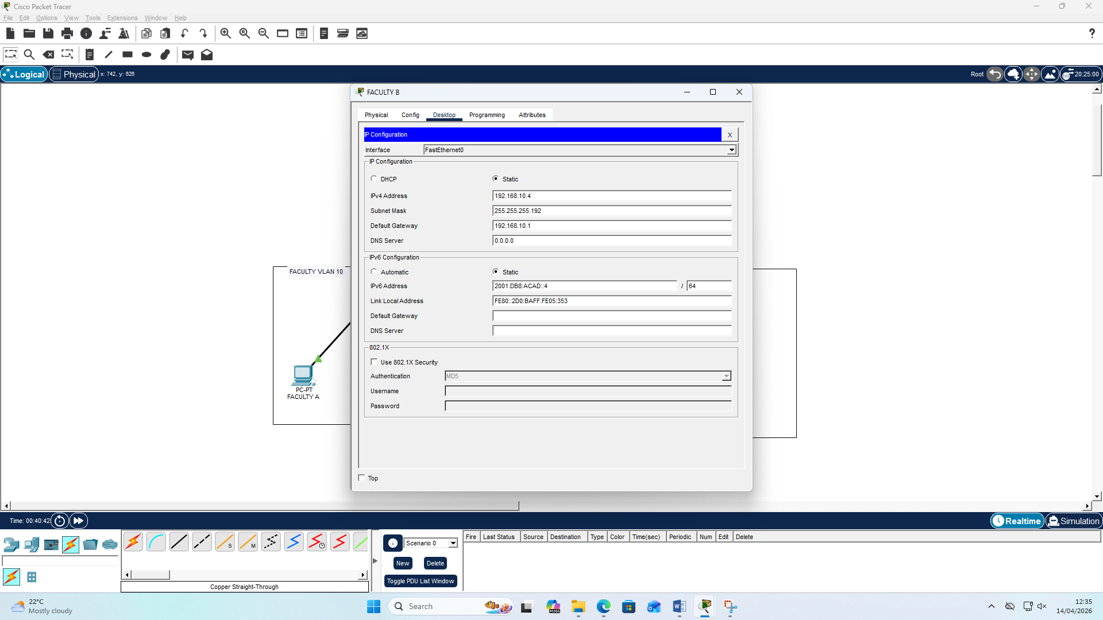

FINANCE PC
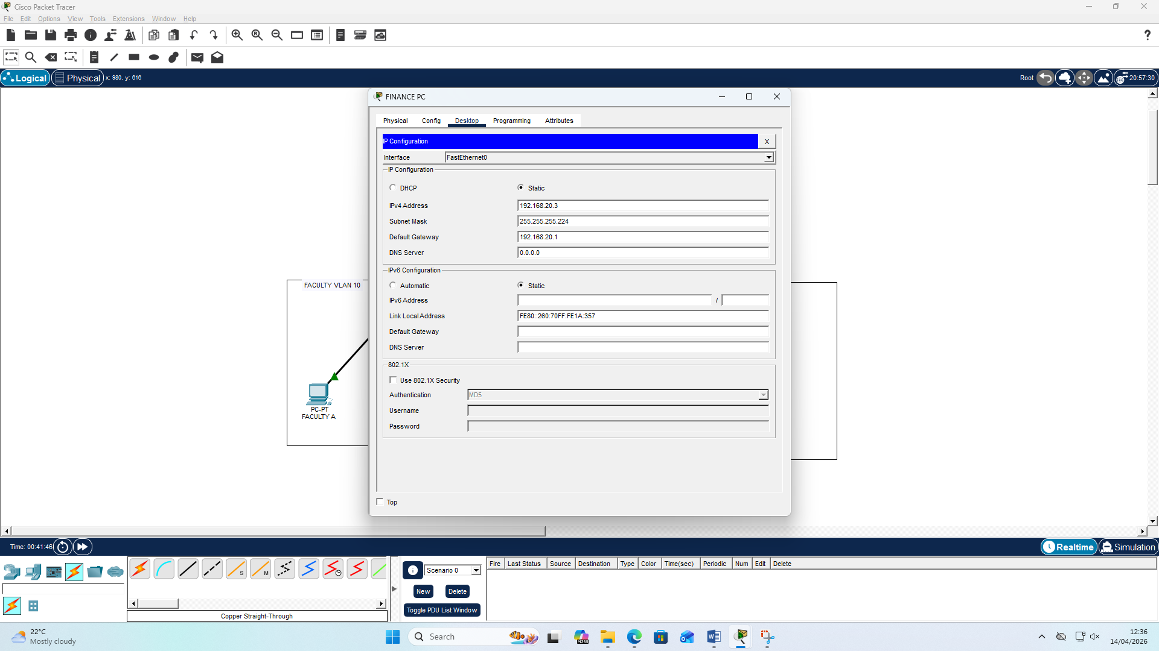

HR LAPTOP
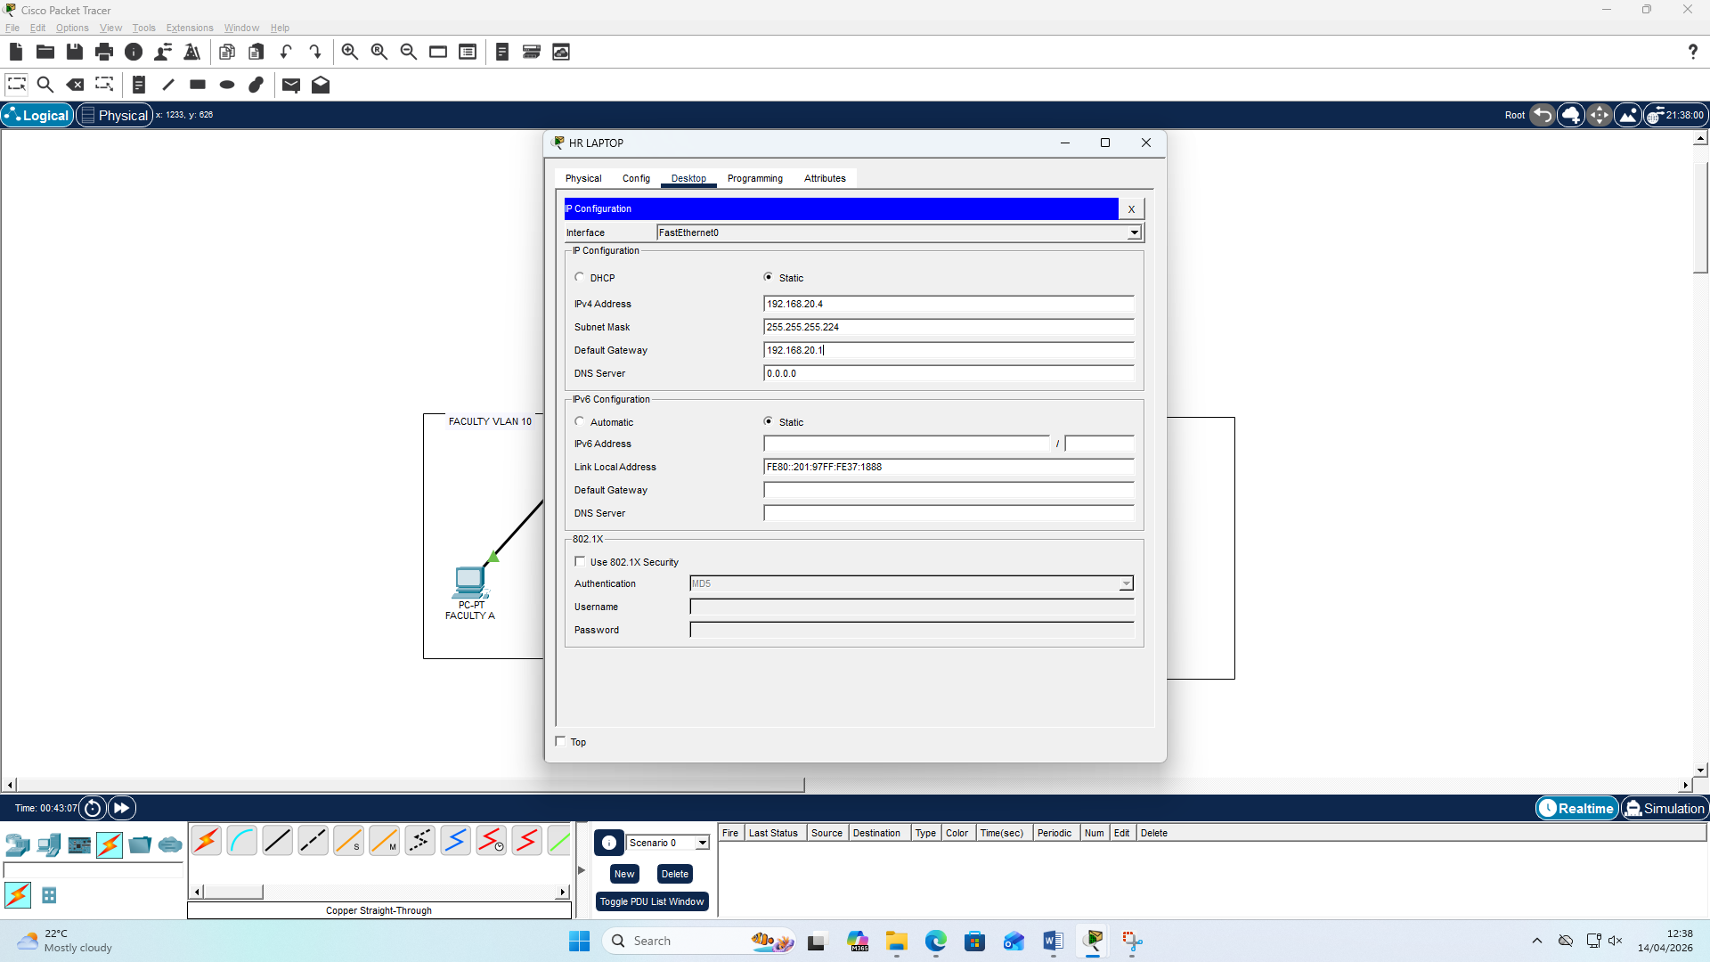

Part 3: Test Connectivity (2 mks)
Test connectivity between Prof X and Finance PC using ping.
Was the connection successful?
Take a screenshot to show test of connectivity.
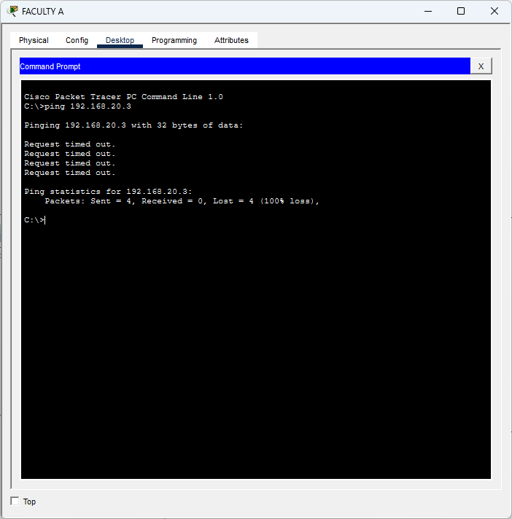
Explain Why.
Write your explanation here

The connection wasn’t successful because THE ROUTER is NOT yet CONFIGURED

Part 4: Configure the Router (10 mks)
Access the CLI interface of the router to configure it.
- Assign a hostname CoreRouter.
- Assign APT2050 as the privileged EXEC encrypted password using enable secret
- Encrypt the plaintext passwords using service password-encryption
- Create a banner that warns anyone accessing the device that unauthorized access is prohibited.
banner motd $ Unauthorized access is prohibited! $
- For G0/0/0, configure IP addressing according to the Addressing Table.
interface g0/0/0
description Connected to Faculty LAN
ip address [add IPv4 addressing details]
ipv6 address 2001:db8:acad::1/64
ipv6 address FE80::1 link-local
- Activate the interface G0/0/0
Take a screenshot to show all the configuration steps for G0/0/0
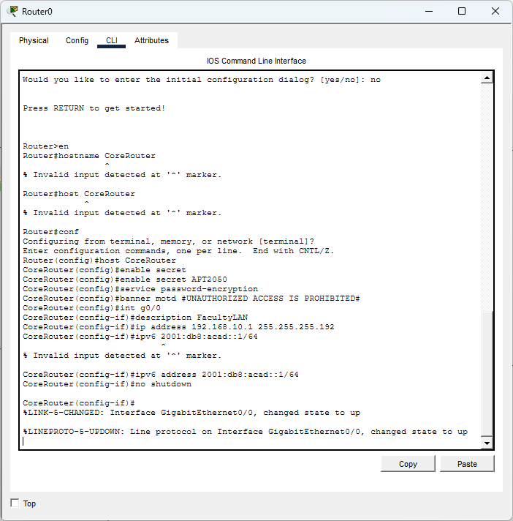
FORGOT TO ADD LINK-LOCAL; ADDED IN THE NEXT SCREENSHOT
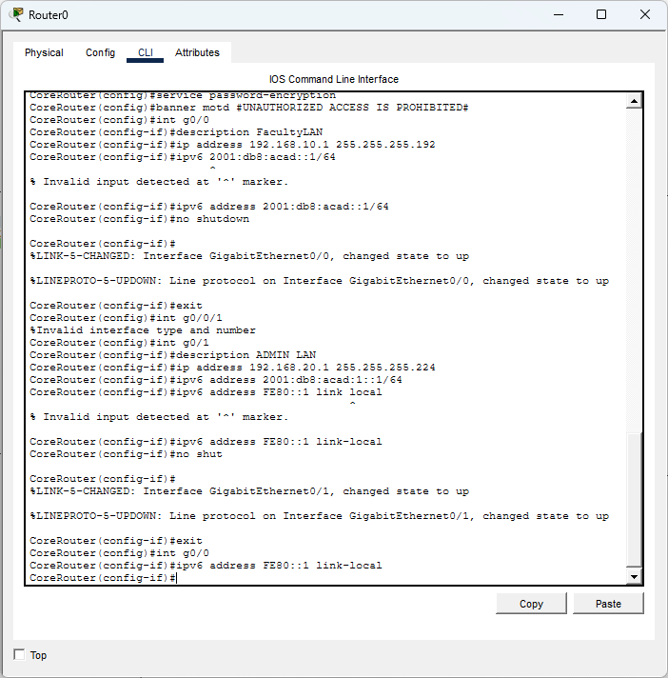
- For G0/0/1, configure IP addressing according to the Addressing Table and activate the interface.
interface g0/0/1
description Connected to Admin LAN
ip address [add IPv4 addressing details]
ipv6 address 2001:db8:acad:1::1/64
ipv6 address FE80::1 link-local
- Activate the interface G0/0/1
Take a screenshot to show all the configuration steps for G0/0/1
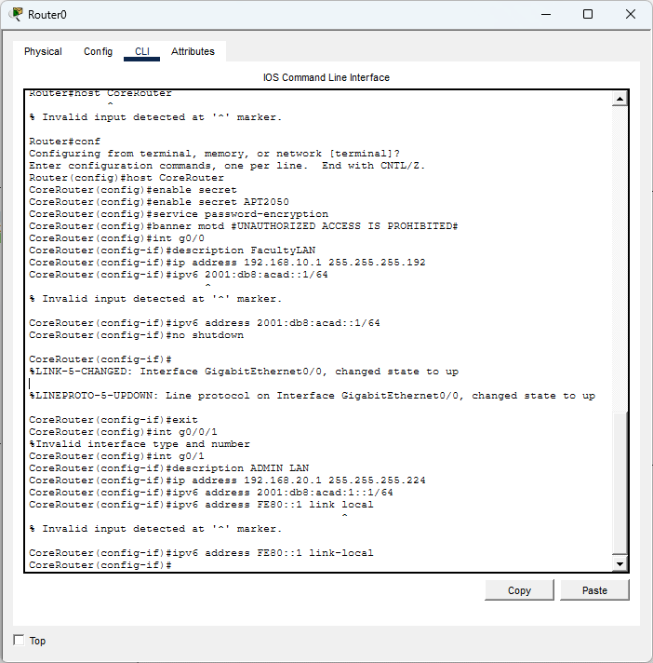

Additional Configurations
- Disable DNS lookup using no ip domain lookup
- Enable IPv6 routing, using the command ipv6 unicast-routing
- Set the clock on the router e.g. clock set 11:50:00 8 Dec 2025
- Save the running configuration to the startup configuration file.
Take a screenshot to show these configuration steps
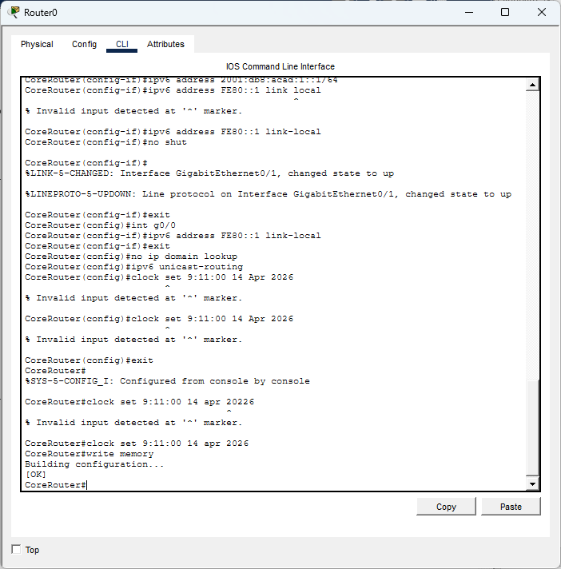

Part 5: Test Connectivity Again (2 mks)
Test connectivity between PCA and PCB again using ping.
Was the connection successful?
Explain Why.
Take a screenshot to show test of connectivity.
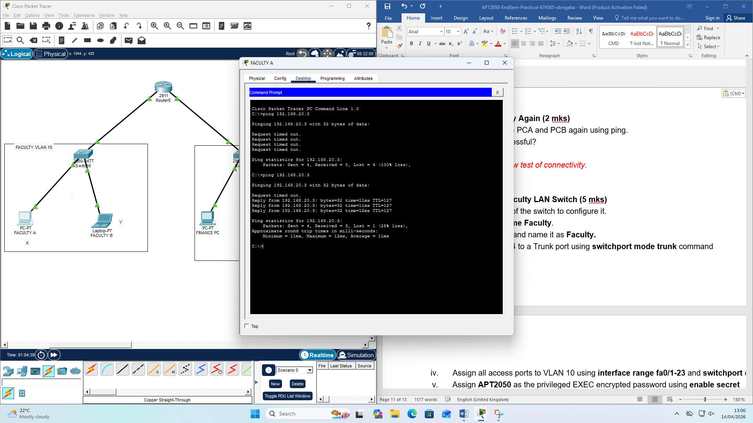
The ping command worked because the router was now configured

Part 6: Configure the Faculty LAN Switch (5 mks)
Access the CLI interface of the switch to configure it.
- Assign a hostname Faculty.
- Create VLAN 10 and name it as Faculty.
- Assign port fa0/24 to a Trunk port using switchport mode trunk command
- Assign all access ports to VLAN 10 using interface range fa0/1-23 and switchport commands
- Assign APT2050 as the privileged EXEC encrypted password using enable secret
- Encrypt the plaintext passwords using service password-encryption
- Create a banner that warns anyone accessing the device that unauthorized access is prohibited.
banner motd $ Unauthorized access is prohibited! $
- Configure the management interface of the switch which is VLAN99 with the Second IP address in the Faculty subnet addressing and activate the interface.
interface vlan 99
ip address [add Second IPv4 addressing details]
- Activate the interface vlan 99
- Configure the default gateway according to the Addressing Table
ip default-gateway [enter IP address]
- Save the running configuration to the startup configuration file.
Take a screenshot to show all the configuration steps.
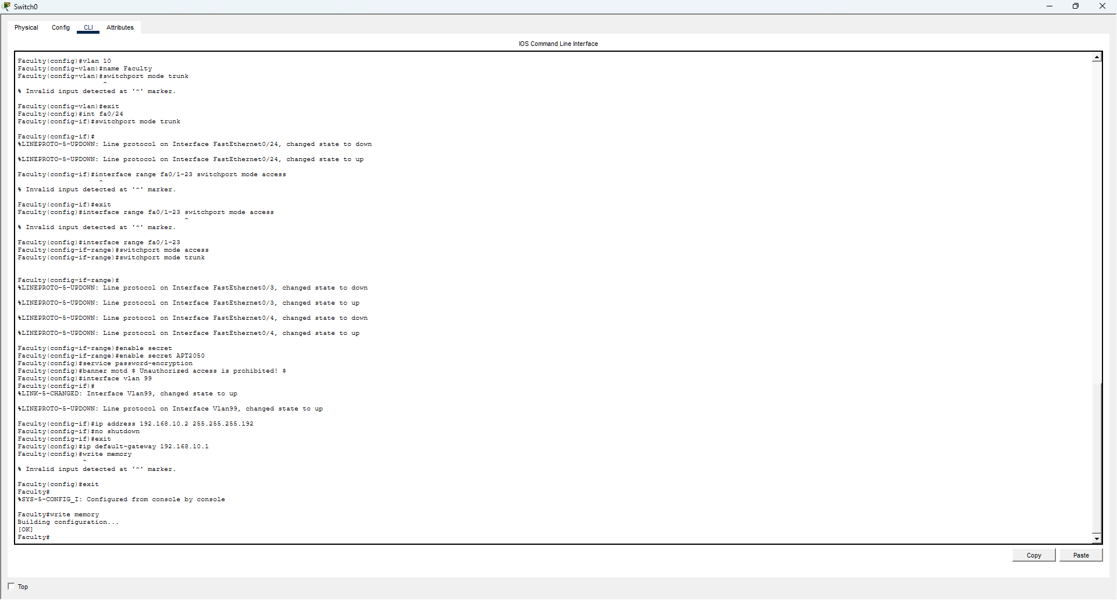
Correction on switchport on faculty
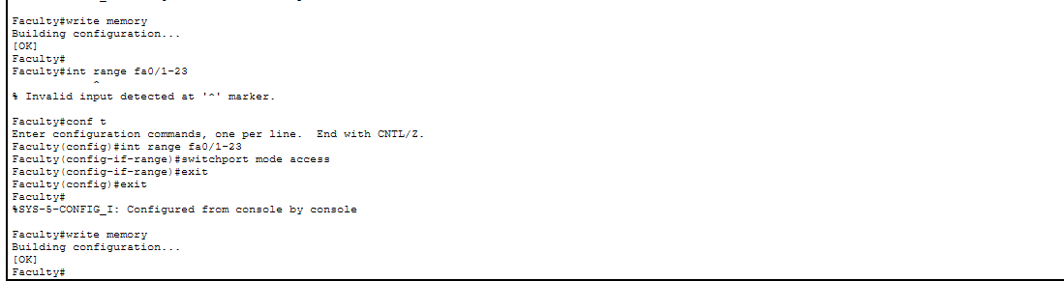
Part 6: Configure the Administration LAN Switch (5 mks)
Access the CLI interface of the switch to configure it.
- Assign a hostname Admin.
- Create VLAN 20 and name it as Admin.
- Assign port fa0/24 to a Trunk port using switchport mode trunk command
- Assign all access ports to VLAN 20 using interface range fa0/1-23 and switchport commands
- Assign APT2050 as the privileged EXEC encrypted password using enable secret
- Encrypt the plaintext passwords using service password-encryption
- Create a banner that warns anyone accessing the device that unauthorized access is prohibited.
banner motd $ Unauthorized access is prohibited! $
- Configure the management interface of the switch which is VLAN99 with the Second IP address in the Admin subnet addressing and activate the interface.
interface vlan 99
ip address [add Second IPv4 addressing details]
- Activate the interface vlan 99
- Configure the default gateway according to the Addressing Table
ip default-gateway [enter IP address]
- Save the running configuration to the startup configuration file.
Take a screenshot to show all the configuration steps.

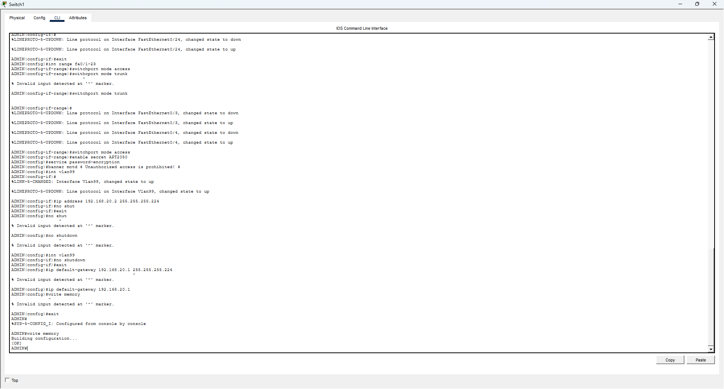

Part 6: Display Device Information (4 mks)
Use show commands to retrieve interface and routing information from the router.
- show ip route command on CoreRouter. What routes has the router learnt? Explain how it did this
Take a screenshot to show each of the show command outputs.
Explain your answer
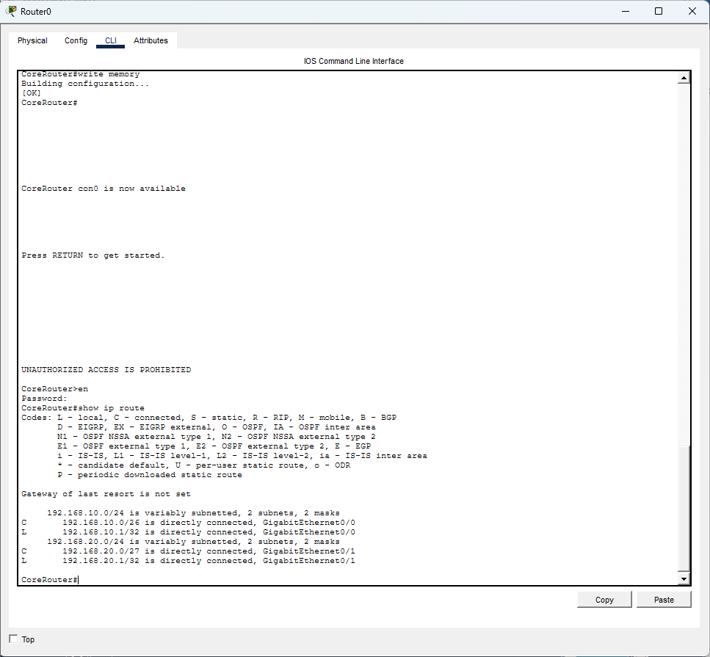
THE ROUTER LEARNT
C 192.168.10.0/26 is directly connected, GigabitEthernet0/0
L 192.168.10.1/32 is directly connected, GigabitEthernet0/0
192.168.20.0/24 is variably subnetted, 2 subnets, 2 masks
C 192.168.20.0/27 is directly connected, GigabitEthernet0/1
L 192.168.20.1/32 is directly connected, GigabitEthernet0/1

L 192.168.20.1/32
L 192.168.20.1/32 They are directly connected

- show ip interface brief command on CoreRouter. What is the status of the interfaces?
Take a screenshot to show each of the show command outputs.
Explain your answer
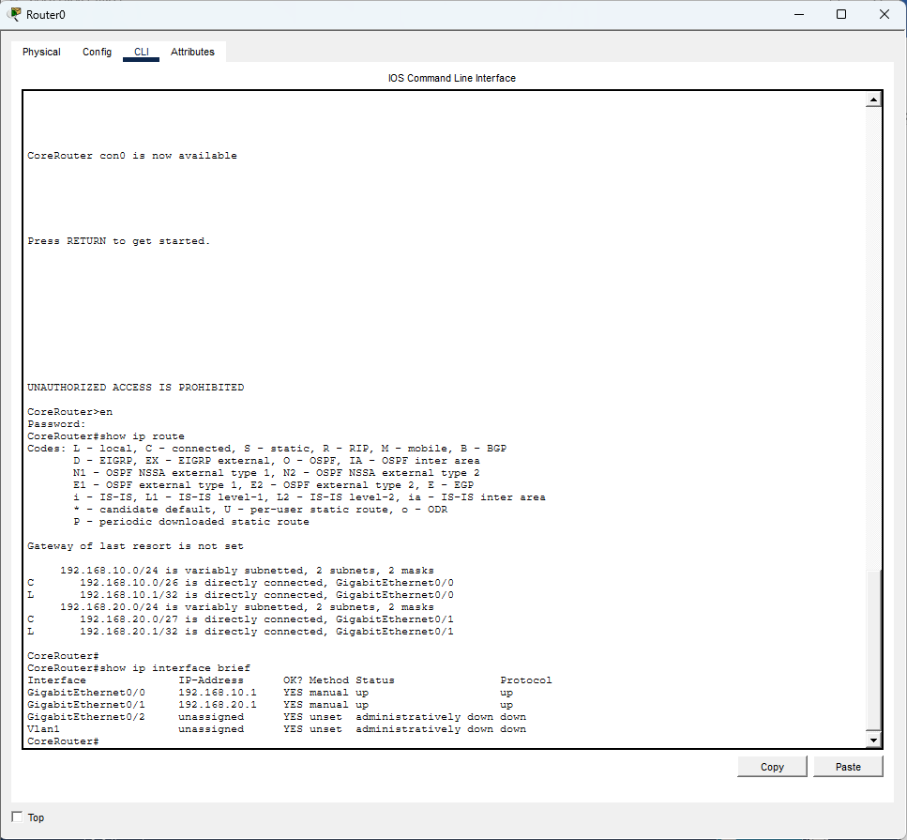

- show ip interface brief command on Faculty switch. What is the status of the interfaces?
Take a screenshot to show each of the show command outputs.
Explain your answer
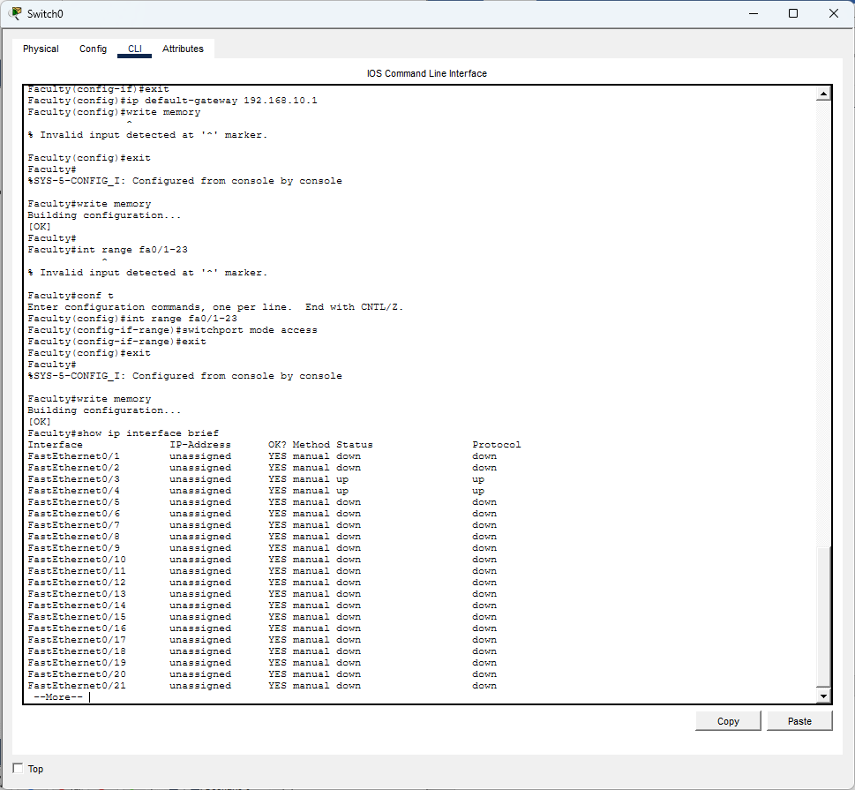
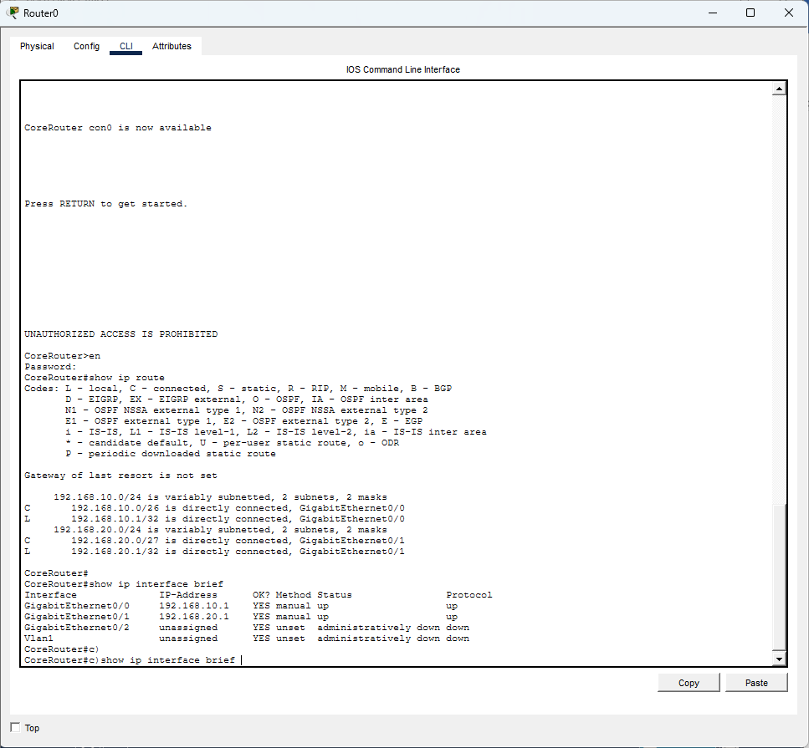

- show ip interface brief command on Admin switch. What is the status of the interfaces?
Take a screenshot to show each of the show command outputs.
Explain your answer
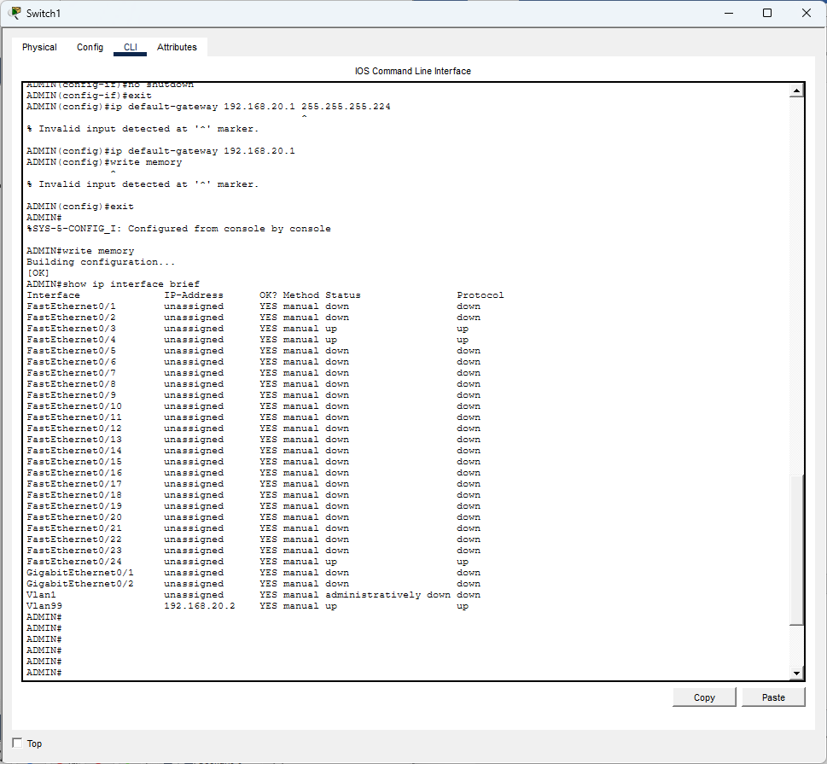
3 interfaces up
Part 5: Reflection Question (6 marks)
Explain three (3) security controls that you can setup for the network and how they work in protecting the campus network from attacks

PUT STATIC ROUTES instead of ospf

Type your answer here.

Submission Guidelines
- Save both your files with your names
- written report (this Word document) e.g. APT2050-EndSem-Practical-pmusuva.docx
- packet tracer file (.pkt) e.g. PacketTracer-endsem-pmusuva.pkt
- Upload both files for marking and marks are awarded as follows:
- Written report (20mks)
- Packet Tracer file (60mks)

