
TECHNICAL UNIVERSITY OF KENYA
FACULTY OF APPLIED SCIENCES AND TECHNOLOGY
SCHOOL OF COMPUTING AND INFORMATION TECHNOLOGY
DEPARTMENT OF COMPUTER SCIENCE AND INFORMATICS
PROJECT TITLE:
DEVELOPMENT OF A WEB-BASED LABORATORY INFORMATION MANAGEMENT SYSTEM (LIMS): A CASE OF YALA SUB-COUNTY HOSPITAL
PRESENTED BY:
OWUOR COLLINS SCCI/01227/2022
SUPERVISED BY:

Dr. Edwin Ngwawe & Mr. Peter Maina Kariuki
PROPOSAL SUBMITTED TO THE SCHOOL OF COMPUTING AND INFORMATION TECHNOLOGY IN PARTIAL FULFILMENT FOR THE DEGREE OF BACHELOR OF TECHNOLOGY IN INFORMATION TECHNOLOGY OF THE TECHNICAL UNIVERSITY OF KENYA
SUBMISSION DATE: FEBRUARY 2026

DECLARATION
I hereby declare that this is my original work and has not been presented previously in another institution for any academic certificate, diploma or degree.

OWUOR COLLINS
SCCI/01227/2022
Signature: ............................................................. Date: .............................................................

SUPERVISORS
Dr. Edwin Ngwawe
The Technical University of Kenya
Signature: ............................................................. Date: .............................................................

Mr. Peter Maina Kariuki
The Technical University of Kenya
Signature: ............................................................. Date: .............................................................

DEDICATION
I dedicate this work to my family for their unwavering financial, moral, and motivational support throughout every stage of this project. To my supervisors, Dr. Edwin Ngwawe and Mr. Peter Maina Kariuki, whose guidance shaped this work. To the staff of Yala Sub-County Hospital for their cooperation. And to the Almighty God for His divine protection and provision of good health and knowledge throughout this journey.

ACKNOWLEDGEMENT
First and foremost, I would like to thank the Almighty God for great health, wisdom, and knowledge throughout the duration of this project.
I sincerely thank my supervisors, Dr. Edwin Ngwawe and Mr. Peter Maina Kariuki, for their continuous support, constructive critique, and guidance during the development and documentation of this project.
My gratitude goes to the management and staff of Yala Sub-County Hospital — particularly the Laboratory In-Charge and Medical Superintendent — for granting access to the facility and cooperating during data collection, system analysis, and User Acceptance Testing.
Lastly, I thank my family and classmates for their invaluable support throughout the research and development period.

ABSTRACT
Medical record management at sub-county level public health facilities in Kenya remains heavily paper-based, resulting in significant inefficiencies in laboratory service delivery. At Yala Sub-County Hospital, the existing manual workflow — characterised by handwritten MOH 204 request forms and MOH 240 laboratory registers — causes turnaround time delays, transcription errors, lost result slips, and poor data traceability, all of which directly impair patient care.
This project presents the design, development, and deployment of a web-based Laboratory Information Management System (LIMS) for Yala Sub-County Hospital. The system was built using PHP (procedural architecture), MySQL as the relational database engine, and Bootstrap 5 for a responsive frontend interface, deployed over the hospital's Local Area Network (LAN) via XAMPP.
The system implements comprehensive core operational modules: Patient Registration with unique OPD numbering and A5 printable routing slips featuring Code128 barcodes, Electronic Test Ordering (CPOE) with clinical allergy warnings, Laboratory Testing Workbench with automated reference range validation and critical panic value alerting, Inpatient Blood Bank crossmatching, Specimen Rejection QA (ISO 15189), Cashless Revenue Collection via Kenya Government eCitizen (Paybill 222222) with dual-emblem A5 receipting, and an Administrative Dashboard with automated MOH 706 statistical reporting. Security features include bcrypt password hashing, CSRF token protection, MySQLi prepared statements for SQL injection prevention, strict Role-Based Access Control (RBAC) across four user roles, and an immutable audit trail.
User Acceptance Testing (UAT) was conducted with 8 hospital staff members representing all user roles. The overall average satisfaction score was 4.6 out of 5.0, with all participants expressing a clear preference for the digital system over the existing manual process. The project demonstrates that a cost-effective open-source web system can successfully bridge the digital divide in resource-constrained public health facilities.
Keywords: Laboratory Information Management System, LIMS, PHP, MySQL, Role-Based Access Control, Yala Sub-County Hospital, Kenya, M-Pesa, Health Informatics.

TABLE OF CONTENTS
DECLARATION 2
DEDICATION 3
ACKNOWLEDGEMENT 4
ABSTRACT 5
TABLE OF CONTENTS 6
LIST OF FIGURES 8
LIST OF TABLES 9
CHAPTER 1: INTRODUCTION 10
1.1 Introduction 10
1.2 Background of the Study 10
1.3 Problem Statement 10
1.4 Objectives 10
1.4.1 General Objective 10
1.4.2 Specific Objectives 10
1.5 Justification 11
1.6 Scope of the Study 11
1.7 Limitations of the Proposed System 11
1.8 Project Risk and Mitigation 11
1.9 Project Schedule 11
1.10 Budget and Resources 12
CHAPTER 2: LITERATURE REVIEW 14
2.1 Reviewed Similar Systems 14
2.1.1 The Manual Paper-Based System (MOH Standard) 14
2.1.2 OpenMRS (Open Medical Record System) 14
2.1.3 Commercial LIMS (Proprietary Systems) 14
2.2 Tools and Methodologies Used in Reviewed Systems 14
2.3 Gaps in Existing Systems and Proposed Solution 14
CHAPTER 3: METHODOLOGY 15
3.1 Methodology and Tools 15
3.1.1 Methodology 15
3.1.1.1 Justification for Agile 15
3.1.1.2 Agile Sprints 15
3.1.2 System Design Tools 16
3.2 Source of Data 16
3.3 Data Collection Methods 16
3.3.1 Observation 16
3.3.2 Questionnaires 16
3.3.3 Interviews 16
3.4 Resources Required 16
REFERENCES 17
APPENDIX 18
Appendix A: User Requirements Questionnaire 18

LIST OF FIGURES
Figure 1: Project Gantt Chart 15
Figure 2: Budget and Resources — Proportional Breakdown 17
Figure 3: Agile Methodology Diagram 24

LIST OF TABLES
Table 1: Budget and Resources 17
Table 2: Hardware and Software Requirements 28

CHAPTER 1: INTRODUCTION

Introduction
The modernisation of healthcare infrastructure is a central pillar of Kenya's Vision 2030 and the National Digital Health Strategy. While investments have been made in digitising records at national referral hospitals, the digital divide between national and sub-county level facilities remains significant. Yala Sub-County Hospital operates its laboratory entirely on manual paper-based workflows, resulting in a cascade of inefficiencies that directly compromise the quality and timeliness of patient care. This project addresses this gap by developing a localised, cost-effective, web-based Laboratory Information Management System (LIMS) specifically tailored for the hospital's operational context.

Background of the Study
Yala Sub-County Hospital is a Level 4 public health facility in Gem Sub-County, Siaya County, Western Kenya. As a primary referral centre for the region, it handles a high volume of outpatients and inpatients daily, offering laboratory services from basic haematology to viral load testing. Despite its critical role, the laboratory department operates entirely manually — relying on handwritten MOH 204 request forms, MOH 240 laboratory registers, and physical result slips carried between departments by patients or messengers. This system is slow, error-prone, and impossible to audit effectively.

Problem Statement
The reliance on paper-based registers at Yala Sub-County Hospital results in significant laboratory turnaround time delays, as staff spend disproportionate time transcribing data rather than analysing samples. The manual system lacks a reliable audit trail, making it difficult to establish who authorised a result or when a sample was collected. Transcription errors from illegible handwriting on MOH forms are a frequent source of patient safety incidents. The loss of physical result slips affects approximately 12% of all requests per month. Monthly MOH report compilation takes an average of two full working days due to manual tallying. There is a critical need for a digital solution that automates these workflows while remaining affordable and sustainable for a public hospital.

Objectives

General Objective
Develop a web-based Laboratory Information Management System (LIMS) for Yala Sub-County Hospital to automate diagnostic workflows, reduce clinical turnaround times, and secure revenue collection.

Specific Objectives
      - 1. Analyze current manual laboratory and billing workflows to determine functional and non-functional system requirements.
      - 2. Design a 3-tier system architecture, normalized relational database schema, and Role-Based Access Control (RBAC) model for hospital user roles.
      - 3. Implement core web modules for outpatient triage, CPOE test ordering, laboratory bench testing with panic alerts, specimen rejection QA (ISO 15189), blood bank safety, and eCitizen cashless billing (Paybill 222222).
      - 4. Evaluate system performance, data security, and user acceptance through structured test cases and hospital staff feedback.

Justification
The successful implementation of this project will benefit all stakeholders: the hospital gains reduced stationery costs and improved billing accuracy; clinicians gain instant access to patient test history; patients benefit from reduced waiting times and no lost results; administrators receive automated MOH-compliant reports; and the Ministry of Health gains more accurate disease surveillance data from Yala Sub-County.

Scope of the Study
In Scope: Design and development of a 3-tier web architecture on PHP 8.2 and MySQL 8.0; responsive Bootstrap 5 user interfaces with strict Role-Based Access Control; MOH 204 outpatient routing slips with Code128 barcodes; CPOE diagnostic ordering; laboratory workbench with automated reference range checking and panic alerting; inpatient blood bank crossmatching; specimen rejection QA (ISO 15189); cashless eCitizen Paybill 222222 payment gateway integration; automated FPDF PDF certification; and deployment on the hospital's intranet Local Area Network (LAN) via Apache/XAMPP. Out of Scope: Direct bidirectional serial interfacing (RS-232/HL7) with physical laboratory machines, live national cloud synchronization with DHIS2/KHIS servers, and physical hospital network cabling.

Limitations of the Proposed System
- Infrastructure dependency on a stable LAN and power supply — mitigated by UPS recommendations.
- English-only interface — may present a barrier to staff with limited English literacy.
- Long-term maintenance requires local IT support after initial deployment.

Project Risk and Mitigation
- System failure: Automated daily database backups and manual backup trigger for the Administrator.
- Unauthorised access: RBAC, bcrypt passwords, and CSRF protection implemented throughout.
- Staff resistance: Interface designed to mirror familiar manual workflow; early UAT engagement.
- Data loss during development: All source code version-controlled using GitHub.

Project Schedule
The project was executed over six months using the Agile methodology, from conceptualisation through deployment. The schedule is shown in the Gantt chart below.

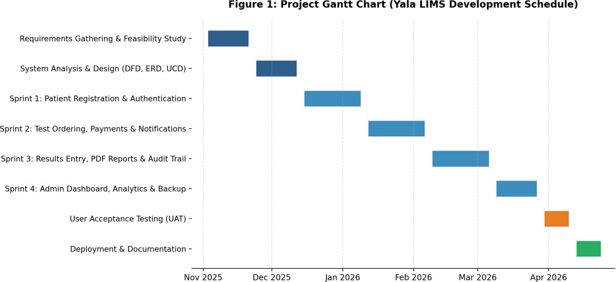
Figure 1: Project Gantt Chart

Budget and Resources

Item | Amount (KES) | Description
Laptop (Core i5, 8GB RAM) | 45,000 | Primary coding and deployment machine
Mobile Phone (Android) | 20,000 | For testing system responsiveness
Internet Access (6 months) | 12,000 | Research, GitHub, cloud backups
Cloud / Shared Hosting | 5,000 | Optional external hosting
Cloud Backup Storage | 3,000 | Minimum 15 GB
Antivirus Software | 2,000 | Kaspersky — 1-year licence
Transport & Logistics | 10,000 | Field visits to Yala Sub-County Hospital
Stationery & Printing | 6,000 | Binding of proposal and final report
Contingency | 7,800 | Unforeseen expenses
TOTAL | KES 110,800
Table 1: Budget and Resources

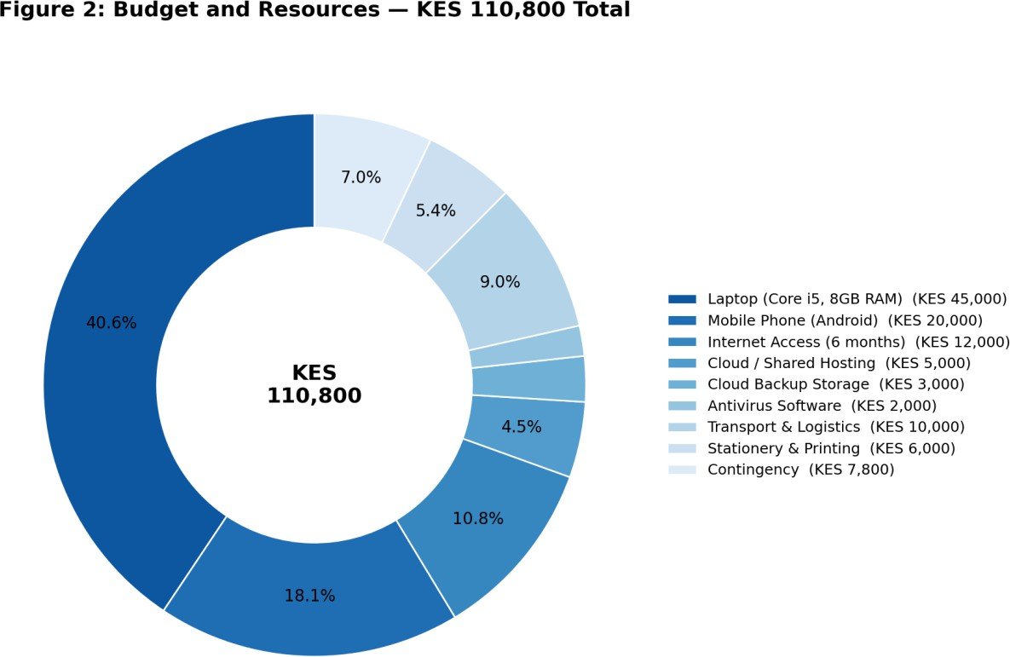

Figure 2: Budget and Resources — Proportional Breakdown

CHAPTER 2: LITERATURE REVIEW
The concept of digitising medical records to improve healthcare delivery is a subject of global interest. This chapter analyses existing systems — from the traditional manual methods at Yala Sub-County Hospital to advanced electronic platforms — to identify the gaps that the proposed system addresses.

Reviewed Similar Systems

The Manual Paper-Based System (MOH Standard)
This represents the current standard at the majority of Level 3 and 4 public facilities in Kenya (MOH, 2020). It relies on MOH 204 request forms and MOH 240 laboratory registers. Monthly reports are generated by manually tallying register entries. The system has been in place for decades due to its low barrier to entry and zero infrastructure requirement.

OpenMRS (Open Medical Record System)
An open-source EMR widely used in Kenya for HIV/AIDS programmes (AMPATH in Western Kenya). It supports longitudinal patient tracking and international data coding standards. However, its resource requirements and complexity make it unsuitable for Level 4 facilities with limited IT infrastructure.

Commercial LIMS (Proprietary Systems)
Systems such as LabWare LIMS, Thermo Fisher SampleManager, STARLIMS, and LabVantage provide comprehensive automation and direct analyser interfacing. Their licensing costs — often millions of shillings — make them unaffordable for county-funded public hospitals (Zahra & Patel, 2018).

Tools and Methodologies Used in Reviewed Systems
The manual system uses a transcription methodology with no logical validation. OpenMRS uses a Java/React enterprise architecture. Commercial LIMS use proprietary closed stacks. All three represent different points on the cost-complexity spectrum, leaving a gap specifically for lightweight, open-source, affordable solutions tailored to sub-county level facilities.

Gaps in Existing Systems and Proposed Solution
The manual system's gap is efficiency and accuracy. OpenMRS is too heavy and complex for Level 4 facilities. Commercial LIMS are unaffordable. The Yala LIMS addresses all three gaps: it is lightweight (runs on XAMPP over LAN), open-source (no licensing costs), and purpose-built for the specific workflows of Yala Sub-County Hospital's laboratory department.

CHAPTER 3: METHODOLOGY

Methodology and Tools

Methodology
The Agile Methodology was adopted for this project. Unlike the rigid Waterfall model, Agile offers an iterative and incremental approach that is well-suited to a context where requirements are discovered through close engagement with end users and where mid-development changes — such as the addition of insurance payment support — are necessary.
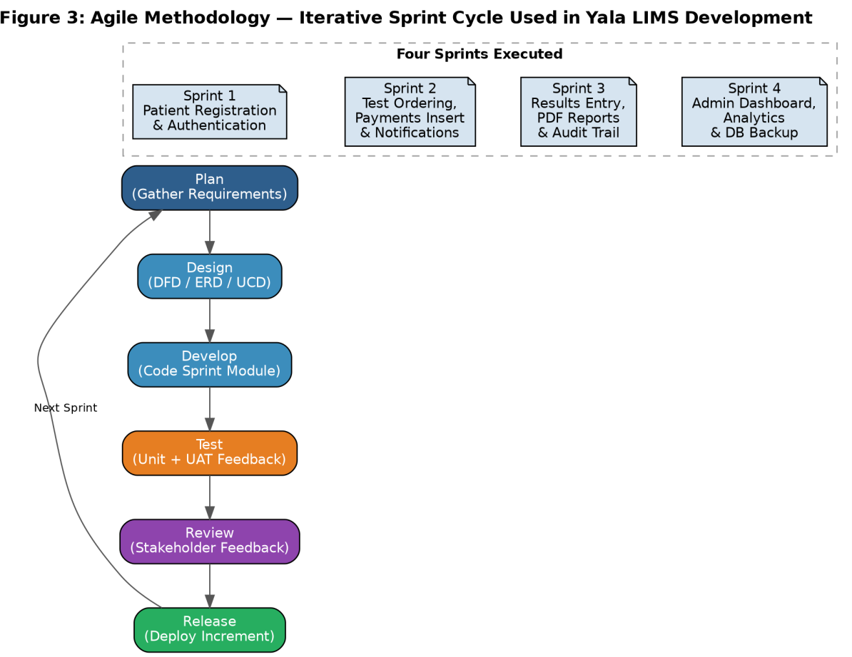
Figure 3: Agile Methodology

Justification for Agile
        - Accommodates changing requirements at any stage without derailing the project.
        - Delivers working modules early — each sprint produced a testable component for UAT feedback.
        - Risk is managed in small iterations — a failing module can be fixed without breaking completed ones.
        - Mirrors hospital staff workflows closely through continuous feedback integration.

Agile Sprints
        - Sprint 1: Patient Registration and Authentication Module
        - Sprint 2: Test Ordering, Payments Row Insert, and Notifications Module
        - Sprint 3: Results Entry, PDF Report Generation, and Audit Trail Module
        - Sprint 4: Administrative Dashboard, Reports Analytics, and Database Backup Module

System Design Tools
- Flowcharts: Sequential process flow for each module — drawn in Lucidchart.
- Use Case Diagrams: User-system interaction for all four roles — drawn in Visual Paradigm Online.
- Data Flow Diagrams (DFD): Level 0 and Level 1 — drawn in Lucidchart.
- Entity-Relationship Diagram (ERD): Relational database schema — drawn in dbdiagram.io.

Source of Data
Primary data was collected through field observation visits at Yala Sub-County Hospital, key informant interviews with the Lab In-Charge and Medical Superintendent, and structured questionnaires administered to 10 staff members. Secondary data was drawn from MOH standard operating procedures, open-source LIMS documentation, and academic literature on health informatics.

Data Collection Methods

Observation
A fly-on-the-wall approach was used during two field visits. Specific metrics recorded included average time per paper request, frequency of lost request forms, and daily test volume per technician.

Questionnaires
Structured questionnaires with closed and open-ended questions provided anonymity for honest staff feedback on the manual system's shortcomings.

Interviews
One-on-one interviews with the Lab In-Charge and Medical Superintendent provided detailed functional requirements that could not be captured by questionnaire alone.

Resources Required

Category | Resource | Spec | Unit KES | Total KES
Hardware | Development Laptop | Core i5, 8GB, 500GB SSD | 90,000 | 90,000
 | Android Mobile Device | Standard Android | 20,000 | 20,000
 | UPS / Power Backup | 650VA | 8,000 | 8,000
Software | Windows 10/11 | 64-bit | 18,000 | 18,000
 | VS Code, XAMPP, MySQL,  GitHub | Free / Open source | 0 | 0
 | Kaspersky Antivirus | 1-Year | 3,000 | 3,000
Internet | Internet Subscription | 4 Months | 4,000/mo | 16,000
TOTAL |  |  |  | 155,000
Table 2: Hardware and Software Requirements

REFERENCES
Beck, K., Beedle, M., & Bennekum, A. (2001). Manifesto for Agile Software Development. Agile Alliance. http://agilemanifesto.org/
Bootstrap. (2024). Bootstrap 5 Documentation. https://getbootstrap.com/docs/5.0/ Chart.js. (2024). Chart.js Documentation. https://www.chartjs.org/
FPDF Library. (2023). FPDF — Free PDF Class for PHP. http://www.fpdf.org/
Gibbon, G. A. (1996). A brief history of Laboratory Information Management Systems. Laboratory Automation and Information Management, 32(1), 1–5.
Mamlin, B. W., & Biondich, P. G. (2005). AMPATH Medical Record System. Transactions of the American Clinical and Climatological Association, 119, 169–174.
Ministry of Health Kenya. (2016). Kenya National eHealth Policy 2016–2030. http://www.health.go.ke/ Ministry of Health Kenya. (2020). Standard Operating Procedures for Laboratory Services in Public
Health Facilities. Nairobi.
MySQL AB. (2024). MySQL 8.0 Reference Manual. https://dev.mysql.com/doc/refman/8.0/en/
OWASP Foundation. (2023). OWASP Top Ten Web Application Security Risks. https://owasp.org/www-project-top-ten/
Oluoch, T., Santas, X., Kwaro, D., & Were, M. (2012). Electronic medical record-based clinical decision support on HIV care. International Journal of Medical Informatics, 81(10), 83–92.
OpenMRS Community. (2021). OpenMRS Developer Documentation. https://openmrs.org/ PHP Group. (2024). PHP 8.2 Manual. https://www.php.net/manual/en/
Pressman, R. S. (2014). Software Engineering: A Practitioner's Approach (8th ed.). McGraw-Hill Education.
Sepulveda, M. J., & Young, W. B. (2013). The Ideal Laboratory Information System. Archives of Pathology & Laboratory Medicine, 137(8), 1129–1140.
Sommerville, I. (2011). Software Engineering (9th ed.). Addison-Wesley.
Wager, K. A., Lee, F. W., & Glaser, J. P. (2017). Health Care Information Systems. John Wiley & Sons. Wakhure, P. (2019). Challenges affecting implementation of Health Information Systems in Public
Hospitals in Kenya. International Journal of Science and Research, 8(5), 120–125.
World Health Organization. (2020). Digital Implementation Investment Guide (DIIG). WHO Geneva. XAMPP Project. (2024). XAMPP Documentation. https://www.apachefriends.org/
Zahra, F., & Patel, S. (2018). Choosing the Right LIMS for small public laboratories. Journal of Laboratory Automation, 23(2), 145–152.

APPENDIX

Appendix A: User Requirements Questionnaire
Yala LIMS Requirements Questionnaire
I am an undergraduate student at the Technical University of Kenya developing a Laboratory Information Management System for Yala Sub-County Hospital. Your honest responses will be used solely for system requirements analysis.
- How long have you worked in your current department at this hospital?
- What is your main challenge with the current paper-based laboratory system?
- Do you currently use any digital tools to manage laboratory requests or results? (Yes / No)
- How frequently do result slips go missing before reaching the doctor? (Never / Rarely / Sometimes / Frequently)
- How long does it typically take to retrieve a patient's previous test result from the physical register?
- How many days does it typically take to compile the monthly MOH laboratory report?
- Do you think a digital laboratory system would improve your work efficiency? Please explain.
- What features would you consider most important in a digital system? (tick all that apply)
  - Electronic test ordering
  - Automated notifications when results are ready
  - Digital billing and payment recording
  - Automated monthly report generation
  - Patient history accessible from any workstation
- Any other suggestions?

