AERO1005 MATLAB Coursework 2

Author: Shenteng MA
Student ID: 20721362
Date of report: 18 April 2026

- Preliminary Task – Arduino and Git Installation
The local working folder is linked to a GitHub repository and contains the hidden .git folder. The main MATLAB script establishes communication with an Arduino Uno through the arduino() object. A preliminary LED blink loop was implemented using writeDigitalPin and pause commands to confirm MATLAB-Arduino communication
- Task 1 – Temperature Data, Plot, and Log File
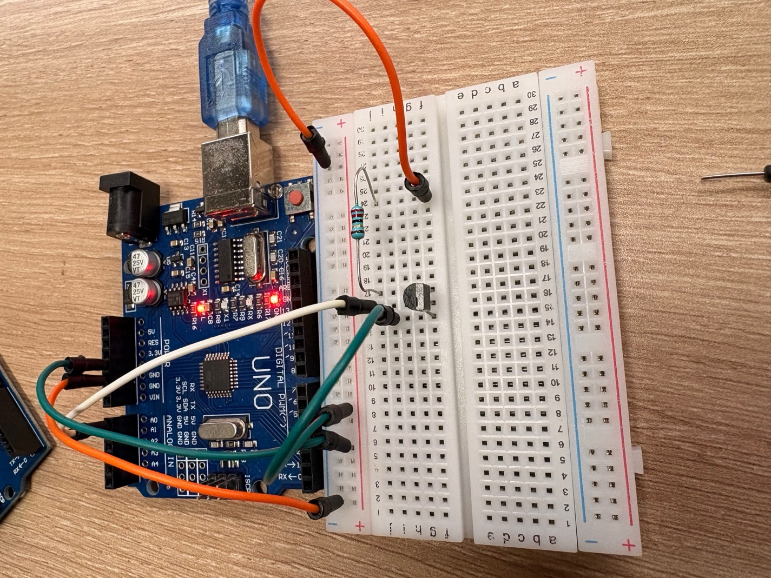
The temperature sensor is read from analogue pin A0. The script records approximately one reading per second for 600 seconds, converts voltage to temperature using the MCP9700A constants, calculates minimum, maximum, and average temperature, and writes the formatted output to capsule_temperature.txt.
Figure 1 Task 1 Breadboard Photograph
1
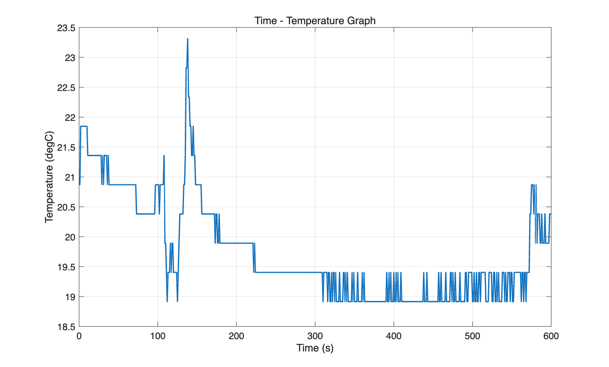
Figure 2Time-temperature Plot
Task 1 Log file Extract:
Data logging initiated - 17-Apr-2026 00:24:57
Location - Capsule
Minute 0
Temperature: 20.87 degC
Minute 1
Temperature: 20.87 degC
Minute 2
Temperature: 19.40 degC
Minute 3
Temperature: 19.89 degC
Minute 4
Temperature: 19.40 degC
Minute 5
Temperature: 19.40 degC
Minute 6
Temperature: 19.40 degC
Minute 7
Temperature: 18.91 degC
Minute 8
Temperature: 18.91 degC
Minute 9
Temperature: 19.40 degC
Minute 10
Temperature: 20.38 degC
Max temp 23.31 degC
Min temp 18.91 degC
Average temp 19.75 degC
Data logging terminated
- Task 2 – LED Temperature Monitoring Device
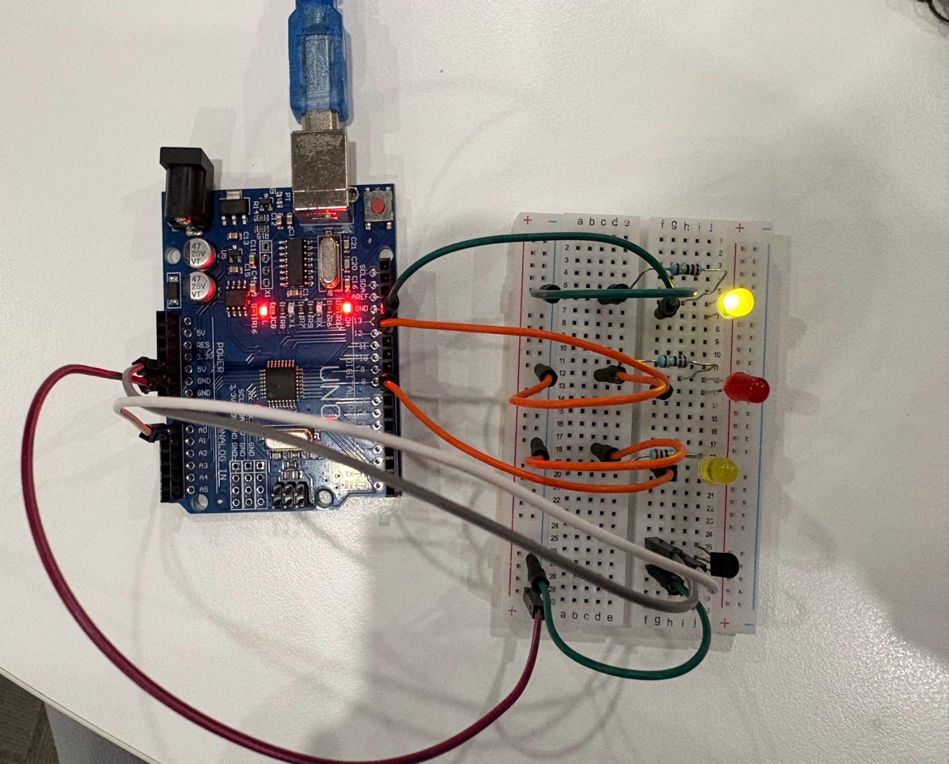
The function temp_monitor.m continuously reads the temperature, updates a live graph, and controls the LEDs according to the comfort range. Green remains on for 18-24 C, yellow blinks below 18 C, and red blinks above 24 C.
Figure 3 Task 2 Breadboard Photograph
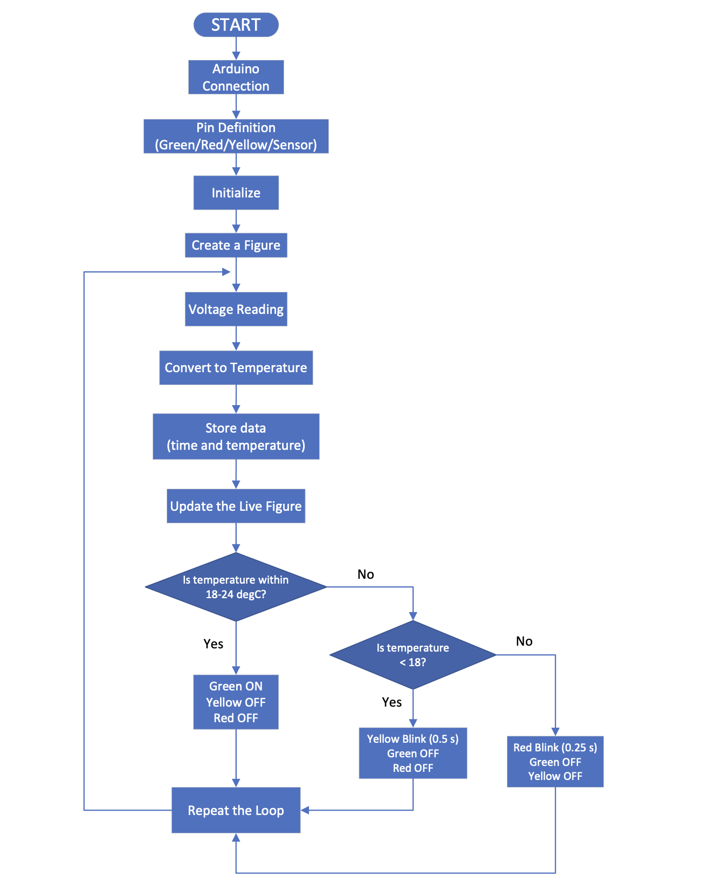
Figure 4 Task 2 Flowchart 1

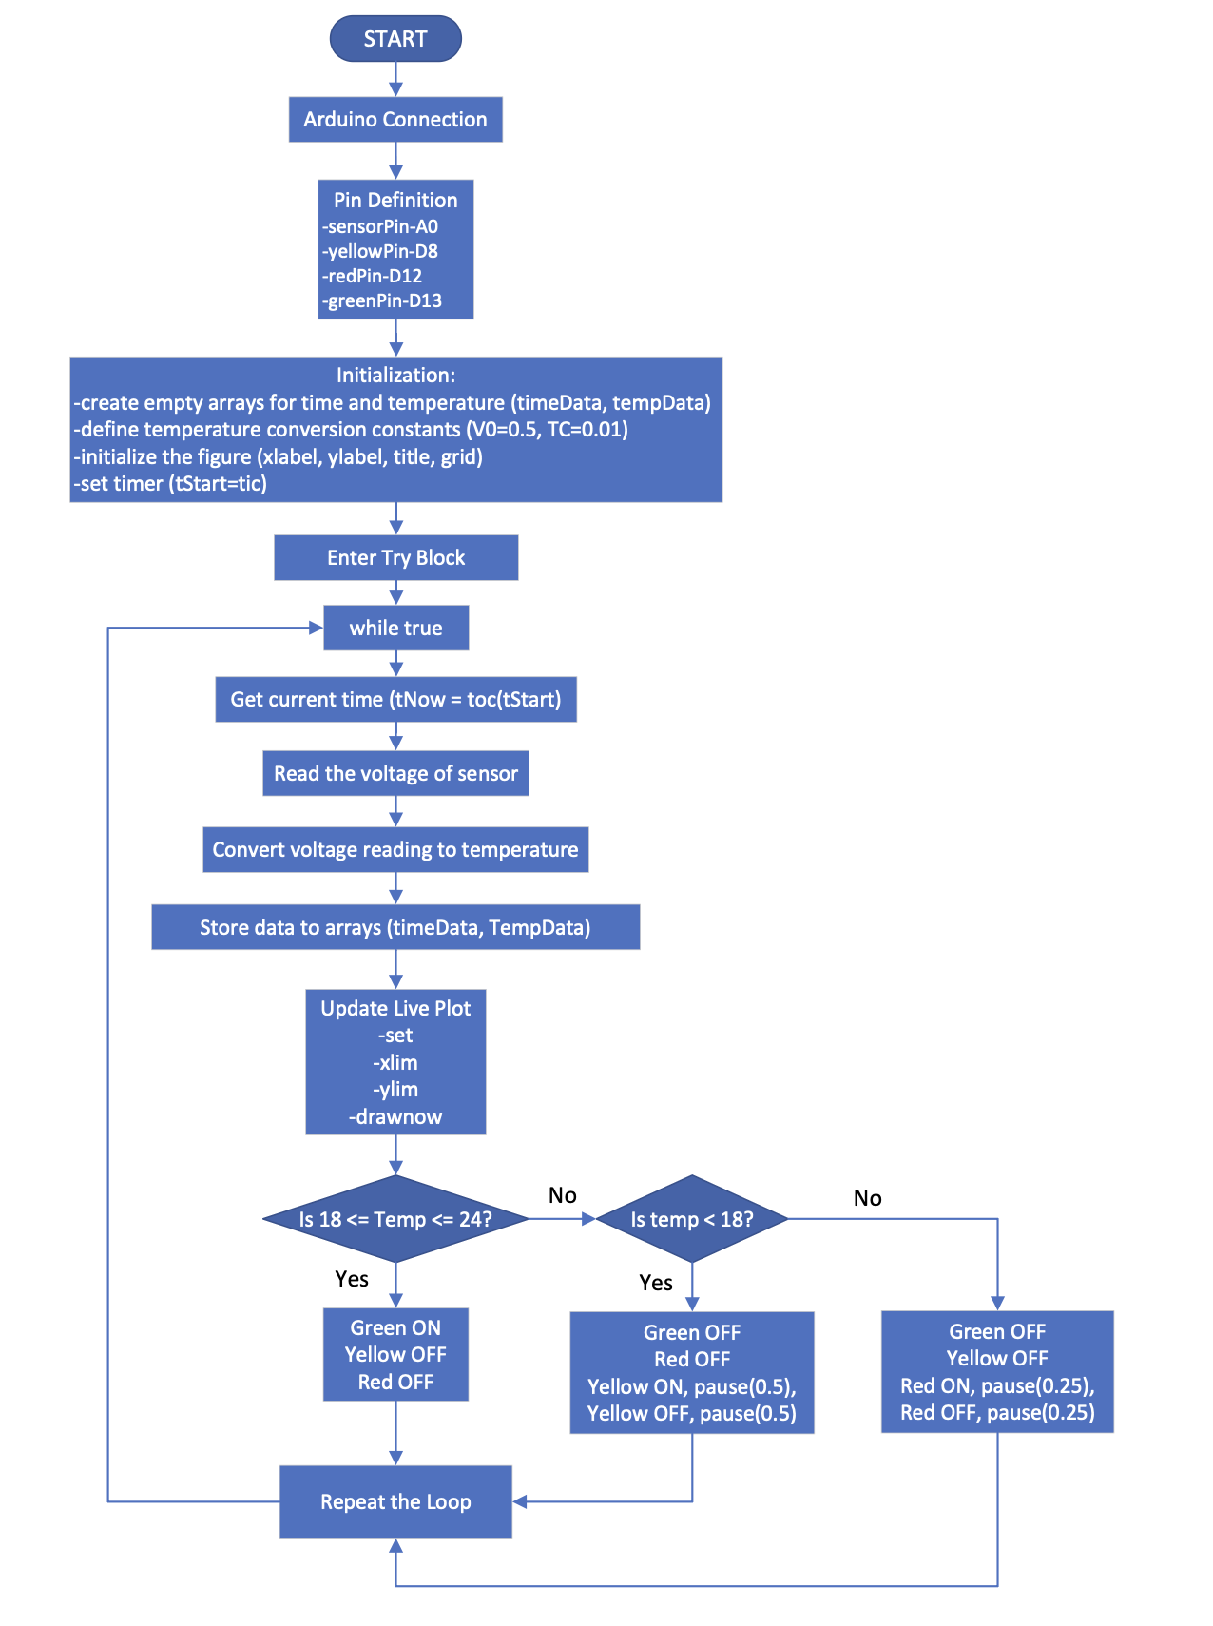
Figure 5 Task 2 Flowchart 2
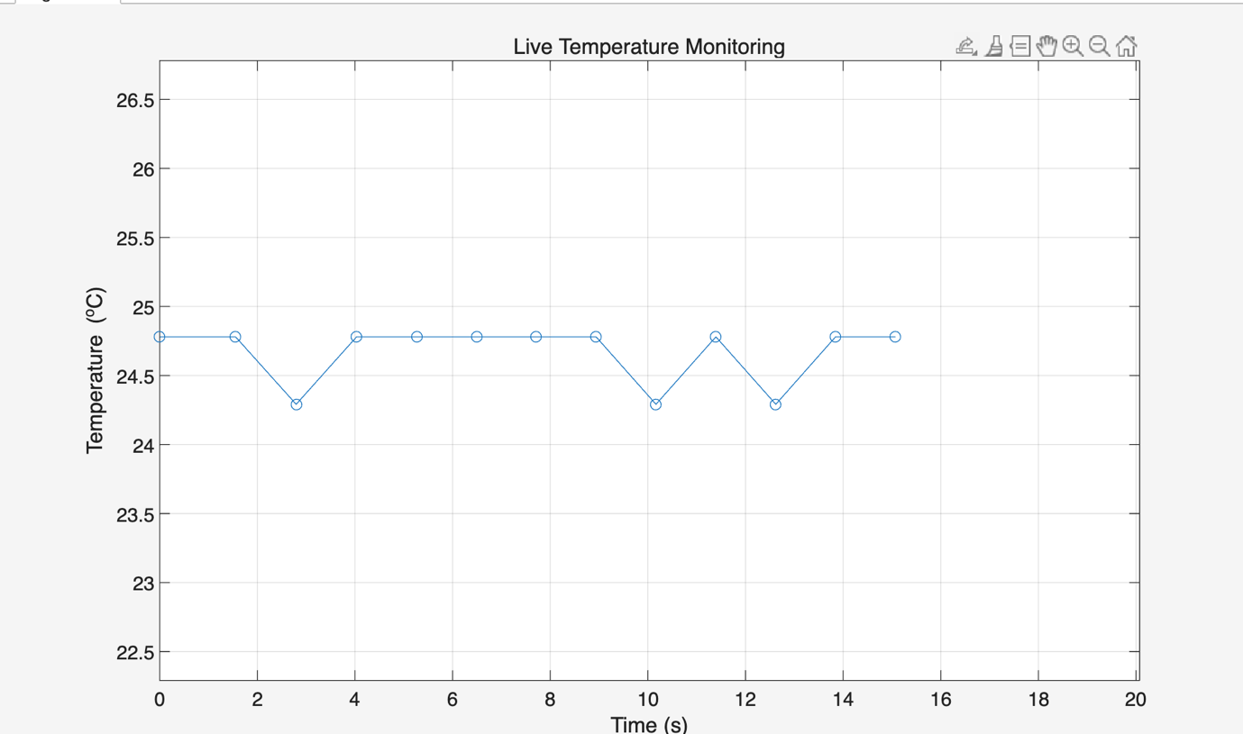
Figure 6 Task 2 Live Plot Graph
- Task 3 – Temperature Prediction Algorithm
The function temp_prediction.m continuously calculates the temperature rate of change in C/s using a rolling-window linear regression. It prints the current temperature, rate of change, and predicted temperature after five minutes. The LED logic provides a red warning for rapid heating above +4 C/min, a yellow warning for rapid cooling below -4 C/min, and a green light when the temperature remains stable within the comfort range.
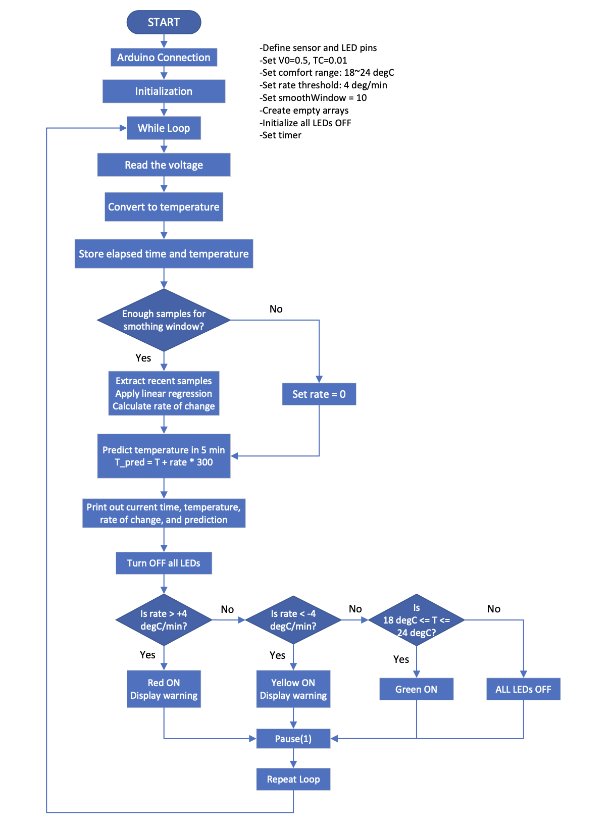
Figure 7 Task3 Flowchart

- Task 4 – Reflective Statement
This project strengthened my understanding of connecting MATLAB code to physical hardware through an Arduino interface. A key challenge was keeping the timing of sensor readings consistent while also making the LEDs blink at the required rates. The final Task 2 function addresses this by structuring the high-temperature red LED warning so that the blink interval is 0.25 s while the loop still remains close to a one-second acquisition cycle. Another challenge was reducing the effect of short-term sensor noise when predicting future temperature. In Task 3, a rolling-window linear regression was used to estimate the temperature gradient more reliably than using only two adjacent samples.
- AI Use Disclosure

