AERO1005 MATLAB Coursework 2
Solving Engineering Problems with a Programming Language
Author | Shenteng MA
Student ID | 20721362
Date of report | 18 April 2026
Main MATLAB script | Shenteng_MA_20721362.m

Submission Overview
This document supports the MATLAB coursework submission for AERO1005 Coursework 2. The project monitors capsule temperature using an Arduino interface, logs the measured data, controls LED indicators, and predicts future temperature behaviour from recent readings.
File | Purpose | Status
Shenteng_MA_20721362.m | Main coursework script for preliminary task, Task 1, and calls to Task 2/3 functions. | Implemented
temp_monitor.m | Continuous live temperature monitor with green/yellow/red LED behaviour. | Implemented
temp_prediction.m | Temperature rate estimation, five-minute prediction, and warning LEDs. | Implemented
capsule_temperature.txt | Task 1 formatted temperature log output. | Generated

Preliminary Task - Arduino and Git Installation
The local working folder is linked to a GitHub repository and contains the hidden .git folder. The main MATLAB script establishes communication with an Arduino Uno through the arduino() object. A preliminary LED blink loop was implemented using writeDigitalPin and pause commands to confirm MATLAB-Arduino communication.

Task 1 - Temperature Data, Plot, and Log File
The temperature sensor is read from analogue pin A0. The script records approximately one reading per second for 600 seconds, converts voltage to temperature using the MCP9700A constants, calculates minimum, maximum, and average temperature, and writes the formatted output to capsule_temperature.txt.
Photograph required
Insert the Task 1 breadboard photograph here before final submission. The local folder does not currently contain a hardware photograph.
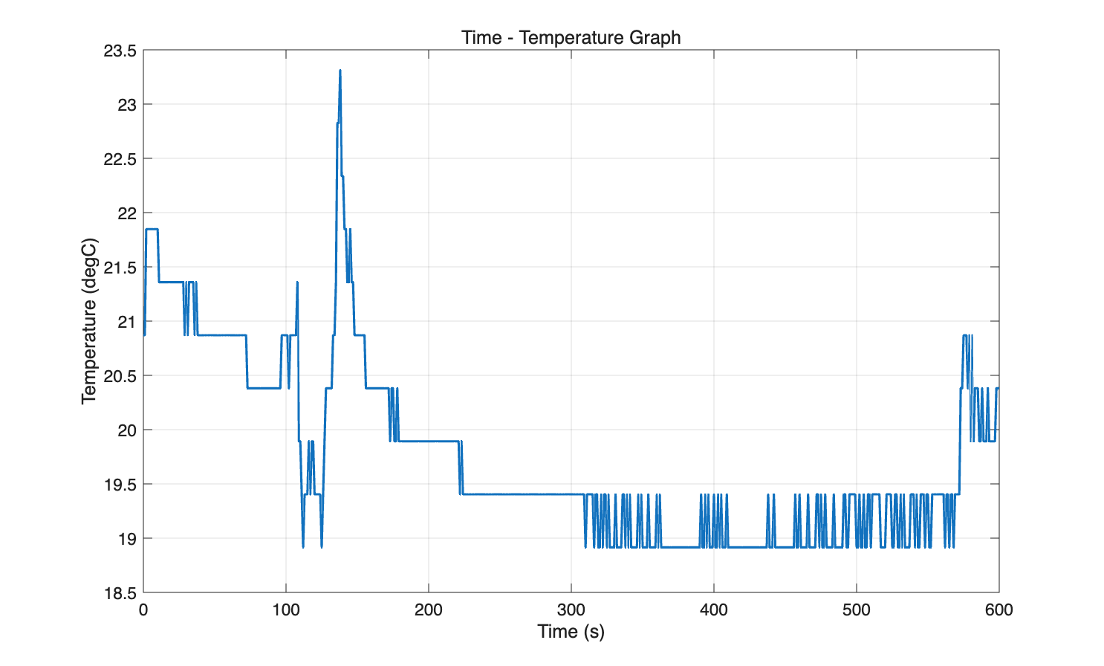
Figure 1. Time-temperature plot generated from the 10-minute temperature recording.

Task 1 Log File Extract
Data logging initiated - 17-Apr-2026 00:24:57
Location - Capsule
Minute 0
Temperature: 20.87 degC
Minute 1
Temperature: 20.87 degC
Minute 2
Temperature: 19.40 degC
Minute 3
Temperature: 19.89 degC
Minute 4
Temperature: 19.40 degC
Minute 5
Temperature: 19.40 degC
Minute 6
Temperature: 19.40 degC
Minute 7
Temperature: 18.91 degC
Minute 8
Temperature: 18.91 degC
Minute 9
Temperature: 19.40 degC
Minute 10
Temperature: 20.38 degC
Max temp 23.31 degC
Min temp 18.91 degC
Average temp 19.75 degC
Data logging terminated

Task 2 - LED Temperature Monitoring Device
The function temp_monitor.m continuously reads the temperature, updates a live graph, and controls the LEDs according to the comfort range. Green remains on for 18-24 C, yellow blinks below 18 C, and red blinks above 24 C. The red branch uses two 0.25 s ON/OFF blinks per loop so the data acquisition cycle remains close to one second.
Photograph required
Insert the Task 2 three-LED breadboard photograph here before final submission. The local folder does not currently contain a hardware photograph.
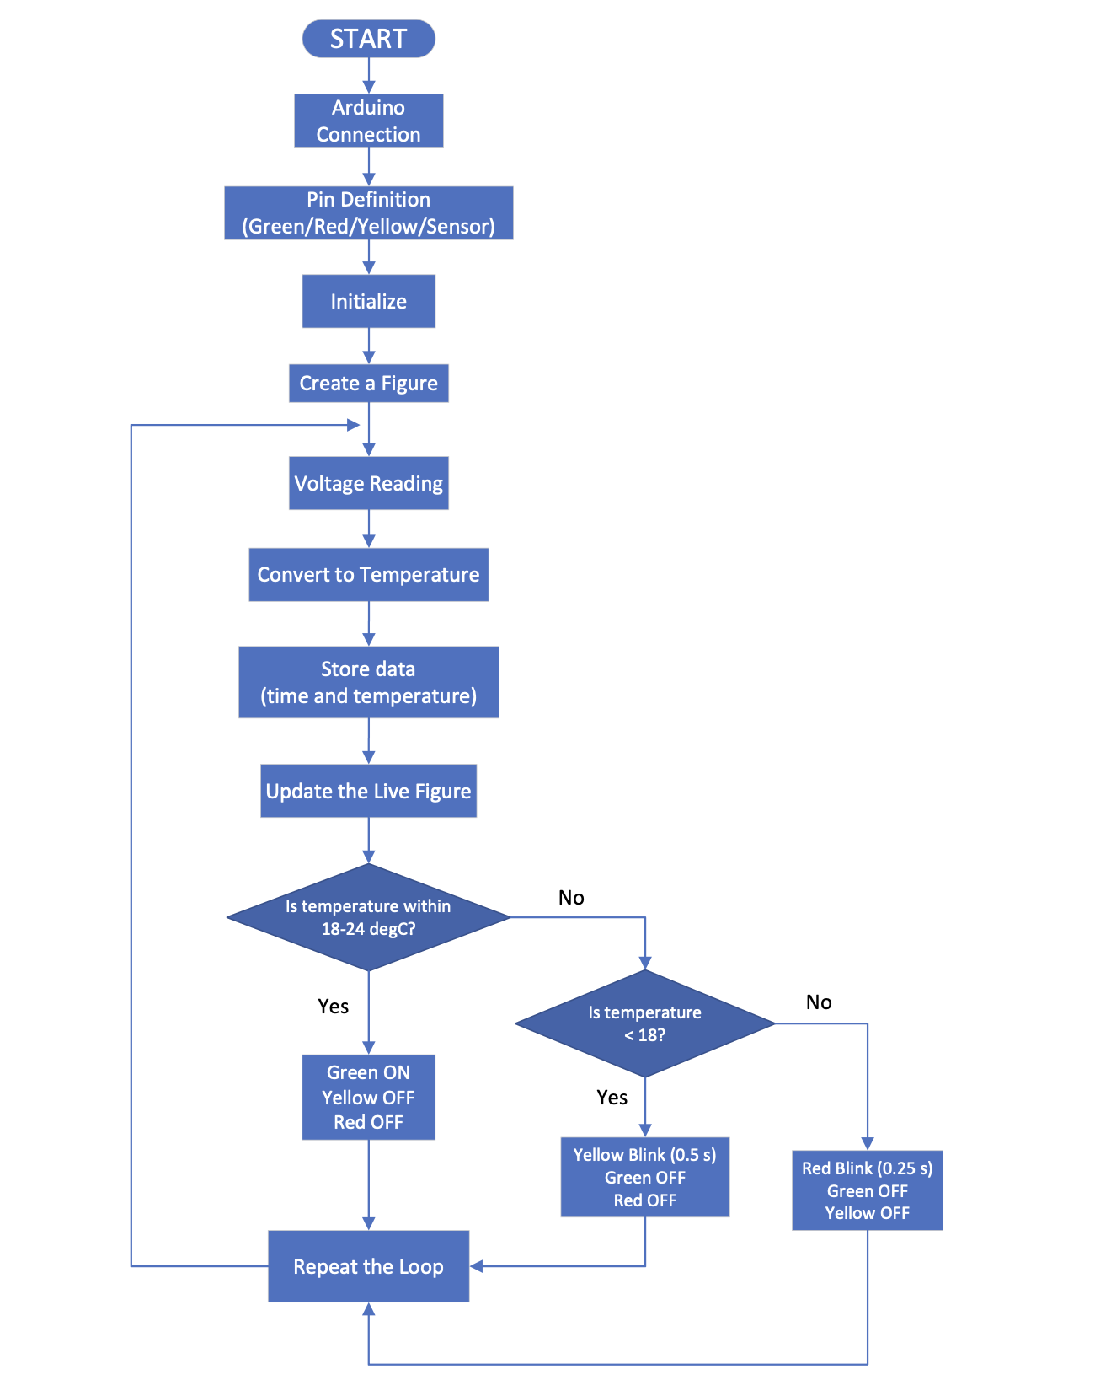
Figure 2. Task 2 initial implementation flowchart.

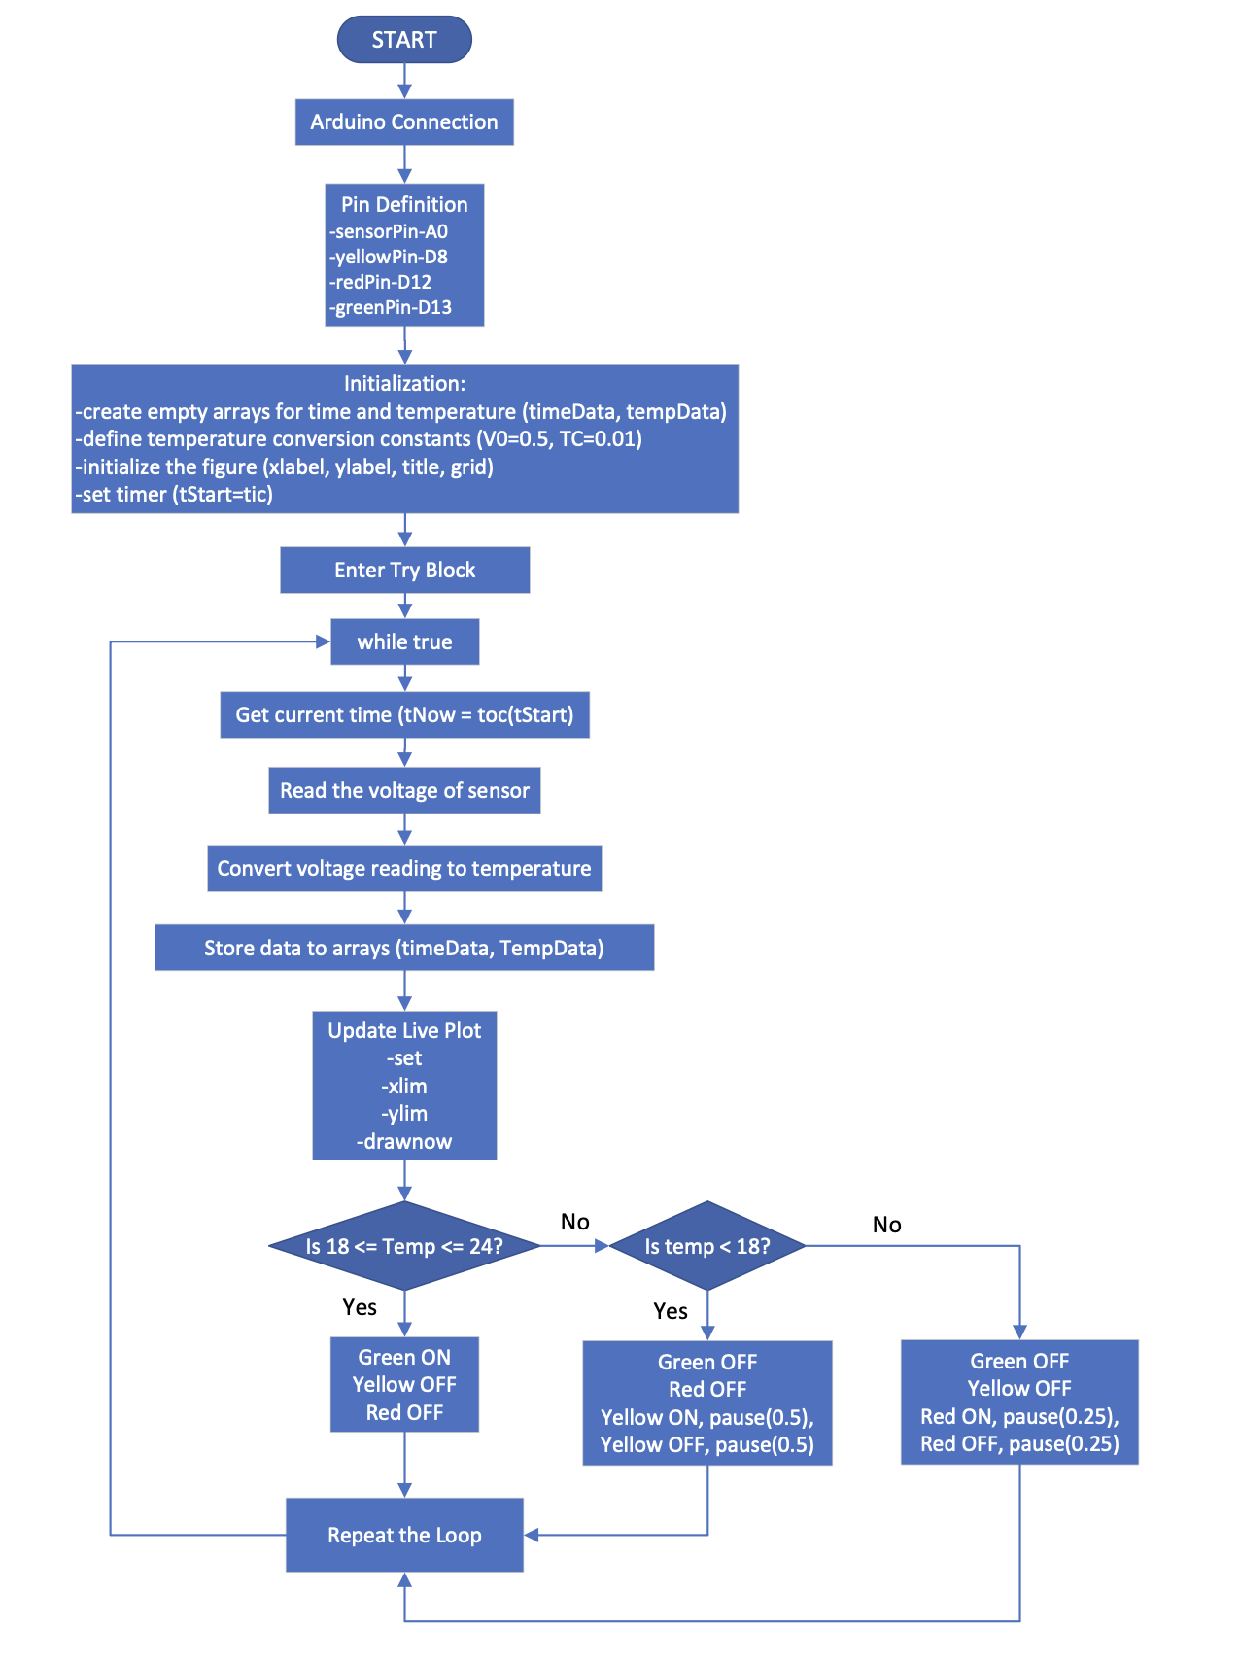
Figure 3. Task 2 updated flowchart reflecting temp_monitor.m implementation.
Live plot snapshot required
Insert a live Task 2 monitoring plot snapshot here after running temp_monitor.m, if available.

Task 3 - Temperature Prediction Algorithm
The function temp_prediction.m continuously calculates the temperature rate of change in C/s using a rolling-window linear regression. It prints the current temperature, rate of change, and predicted temperature after five minutes. The LED logic provides a red warning for rapid heating above +4 C/min, a yellow warning for rapid cooling below -4 C/min, and a green light when the temperature remains stable within the comfort range.
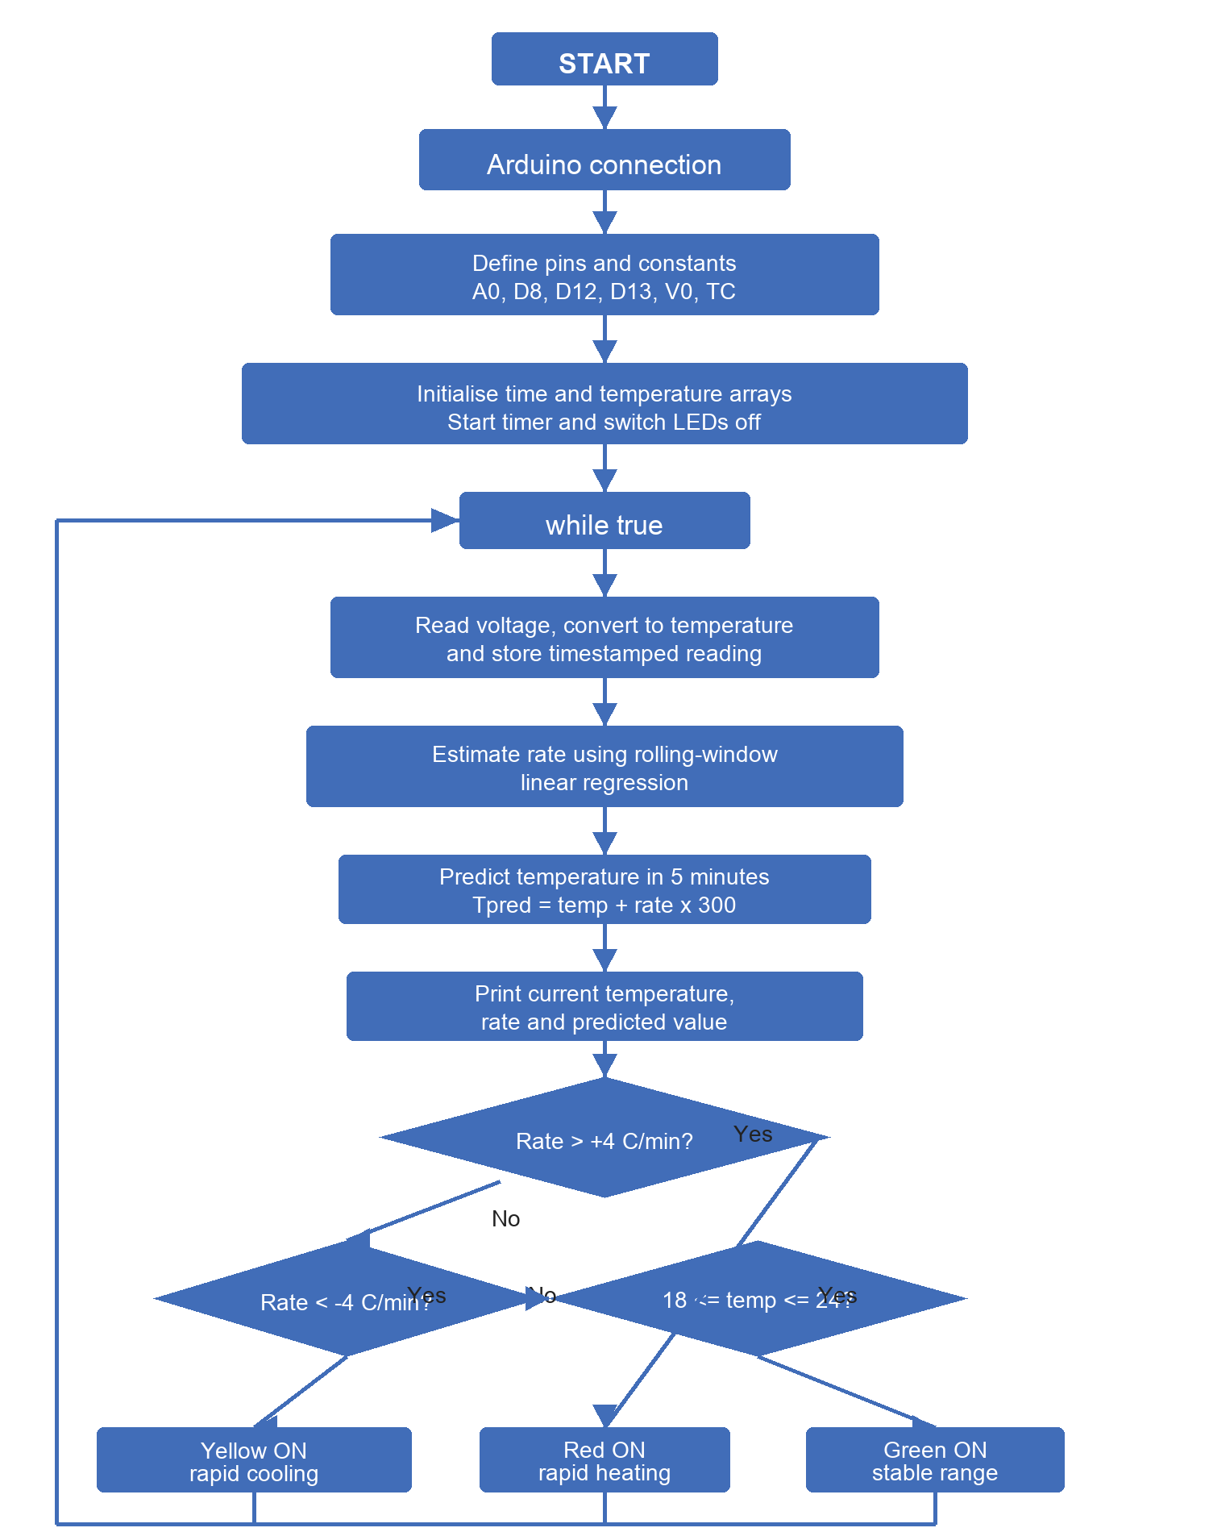
Figure 4. Task 3 prediction and warning algorithm flowchart.

Task 4 - Reflective Statement
This project strengthened my understanding of connecting MATLAB code to physical hardware through an Arduino interface. A key challenge was keeping the timing of sensor readings consistent while also making the LEDs blink at the required rates. The final Task 2 function addresses this by structuring the high-temperature red LED warning so that the blink interval is 0.25 s while the loop still remains close to a one-second acquisition cycle. Another challenge was reducing the effect of short-term sensor noise when predicting future temperature. In Task 3, a rolling-window linear regression was used to estimate the temperature gradient more reliably than using only two adjacent samples.
The main strength of the project is that the work is separated into a main script and two reusable functions, making the monitoring and prediction behaviours easier to test and improve independently. The code also records historical temperature data, produces a plot, and writes a log file for later review. A limitation is that the measured values depend on sensor calibration, wiring quality, and environmental noise from the Arduino supply. Future improvements could include sensor calibration against a reference thermometer, adding error handling for disconnected hardware, saving live monitoring snapshots automatically, and using a clearer user interface to display warnings during the test.

AI Use Disclosure
AI assistance was used to review formatting, organise this Word document, and check that the written submission matched the coursework brief. The MATLAB implementation, hardware testing results, and final submission should be reviewed and verified by the student before submission.

Final Checklist
- Confirm real Task 1 breadboard photograph is inserted.
- Confirm real Task 2 three-LED breadboard photograph is inserted.
- Confirm a live Task 2 monitoring plot snapshot is inserted if required by the marker.
- Run the MATLAB files with the Arduino connected and verify the LEDs behave as described.
- Zip the local repository folder including the .git folder, MATLAB files, Word document, and supporting images.

