Install Chrome (not Chromium) on Ubuntu
See: https://www.google.com/chrome/

Do not install it as a snap package

How to Configure Ubuntu’s Built-In Firewall
See: https://www.howtogeek.com/115116/how-to-configure-ubuntus-built-in-firewall/
Gufw is an easier-to-use front-end for the standard Linux ip-tables commands.

Scanner driver 64bit (deb package)
See: https://support.brother.com/g/b/downloadhowto.aspx?c=za&lang=en&prod=dcp1610w_eu_as&os=128&dlid=dlf105200_000&flang=4&type3=566

Installing Curl on Ubuntu
$ sudo snap install curl

Install MacOS virtual machine on Ubuntu
Follow These steps:
- Qemu/KVM & Virt-manager installation on Ubuntu 22.04

Install MacOS virtual machine on Ubuntu

macOS Simple KVM on virt-manager
- How to enlarge Qemu/kvm virtual disk

Create bootable USB drive
Step 1. Formtat USB drive using the Disks utility
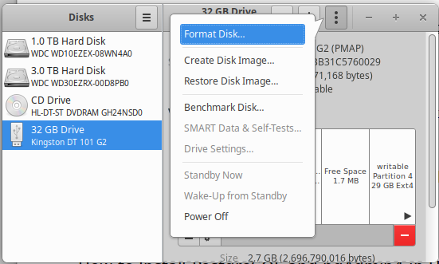

Step 3. Download *.iso file or create disk image (*.iso) file from bootable CD using the Disks utility

Step 2. Download the Startup Disk Creator
$ sudo apt install usb-creator-gtk
and create bootable USB drive from *.iso file using the Startup Disk Utility

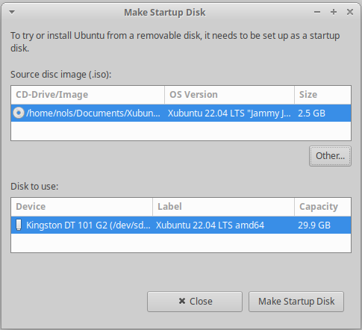

How to Install PostgreSQL and pgAdmin4 in Ubuntu Server 20.04
See: https://www.pgadmin.org/download/pgadmin-4-apt/
Install both for web and desktop

Permanently mounting a remote folder
See: https://www.arubacloud.com/tutorial/how-to-mount-remote-directories-with-sshfs-on-ubuntu-18-04.aspx

Temporarily mount: $ sudo sshfs -o allow_other,default_permissions nols@ubuntuvirtual:/home/nols/fastapi /mnt/fastapi

Install pgAdmin 4
See: https://www.pgadmin.org/download/pgadmin-4-apt/

See: Test PostgreSQL Connection and set the password
During installation, a postgres user is created automatically. This user has full superadmin access to your entire PostgreSQL instance. Before you switch to this account, your logged in system user should have sudo privileges.
$ sudo su – postgres
Let’s reset this user password to a strong Password we can remember.
$ psql -c "alter user postgres with password 'm0r0nsm1tm0r0n'"

Now use that password in pgAdmin 4

How to install Go on Ubuntu 22.04
See: 2. Install Go Using Ubuntu Repository

The installation directory is: /homenols/go

Setups for FastAPI

How To Install Python 3.9 on Ubuntu 20.04|18.04
See: https://techviewleo.com/how-to-install-python-on-ubuntu-linux/
Use: Option 1- Install Python 3.9 on Ubuntu 20.04|18.04 with APT

Don’t – Select python3.9 in virtual environment
Change default python to python 3.9
See: https://askubuntu.com/questions/1272870/how-can-i-change-the-default-python-on-my-ubuntu-20-04-to-python3-8

See answers 6. Edit .bashrc in home/nols
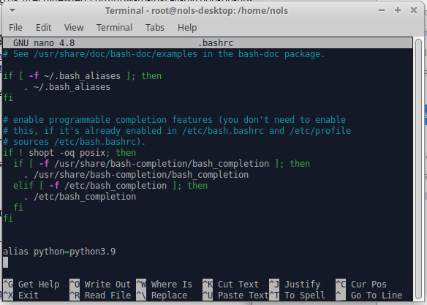

To create the virtual environment, follow steps in:
Creating the Python project.

These steps are:
cd home/nols/<the-project’s-folder>
$ python -m venv venv
Check python version: $ which python3
It will show: Python 3.8.10
Activate virtual environment
$ . venv/bin/activate
It will show: (venv) nols@nols-desktop:~/fastapi$
Check the python version in the virtual environment: $ which python3
It will show: /home/nols/fastapi/venv/bin/python3
Check python version: python -V
It will (and must) show: Python 3.9.9
Check pip version: $ pip list
If it show:
Package Version
---------- -------
pip 21.2.3
setuptools 57.4.0
WARNING: You are using pip version 21.2.3; however, version 21.3 is available.
You should consider upgrading via the '/home/nols/fastapi/venv/bin/python3.9 -m pip install --upgrade pip' command.

Then upgrade pip:
$ pip install -U pip setuptools

Check again pip version: $ pip list
It will show:
Package Version
---------- -------
pip 21.3.1
setuptools 59.2.0

In PyCharm, select the latest installed python version for the virtual environment
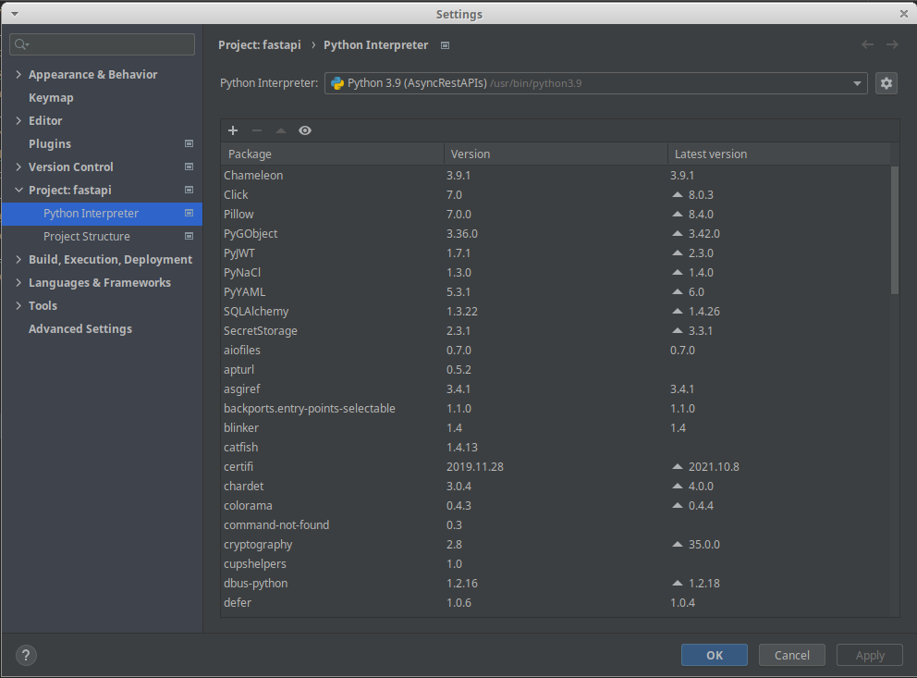

Installing Requirements
$ pip install -r requirements.txt

When complete, PyCharm's terminal must show:

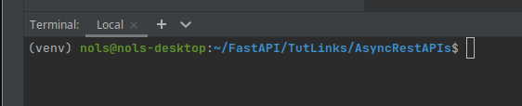

FastAPI error when using postgres:
In terminal: $ python -m pip install psycopg2-binary

How to Install Git on Ubuntu 18.04
See: https://snapcraft.io/git-ubuntu

Install Beekeeper Studio
See: https://snapcraft.io/beekeeper-studio

Using the terminal, in the activated virtual environment, check the python version.
(venv) nols@nols-desktop:~/fastapi$ python3 -V

It will show: Python 3.9.7

Install Oracle’s Java
See: https://www.oracle.com/java/technologies/downloads/

Install Android Studio
See: https://snapcraft.io/install/android-studio/ubuntu

$ sudo snap install android-studio --classic

After the installation, on first run, you will be prompted to install the android SDK

Configure Android SDK Location:
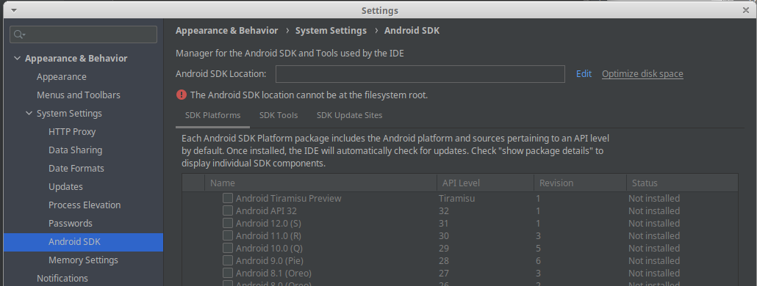
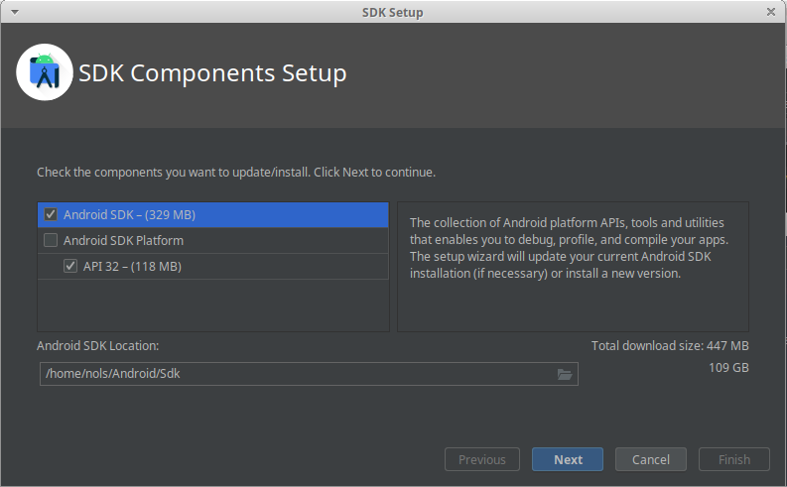
Install JDK Tools:
See: https://www.oracle.com/za/java/technologies/javase/jdk12-archive-downloads.html
To find the installation folder:
$ readlink -f $(which java)

Result: The installation folder:
/usr/lib/jvm/jdk-12.0.2/

Uninstall Android Studio completely
See: https://askubuntu.com/questions/546723/uninstall-android-studio-completely

iOS and Android Setup
See: https://www.youtube.com/watch?v=VPvVD8t02U8&t=17488s&ab_channel=freeCodeCamp.org

See the course contents for entry points in video

Install Flutter on Ubuntu
See: https://snapcraft.io/install/flutter/ubuntu
Also: https://docs.flutter.dev/get-started/install/linux

Snap should already be installed, but the commands are:

$ sudo apt update
$ sudo apt install snapd

To install Flutter, simply use the following command:
$ sudo snap install flutter --classic

Config Android Studio to use latest command line tools

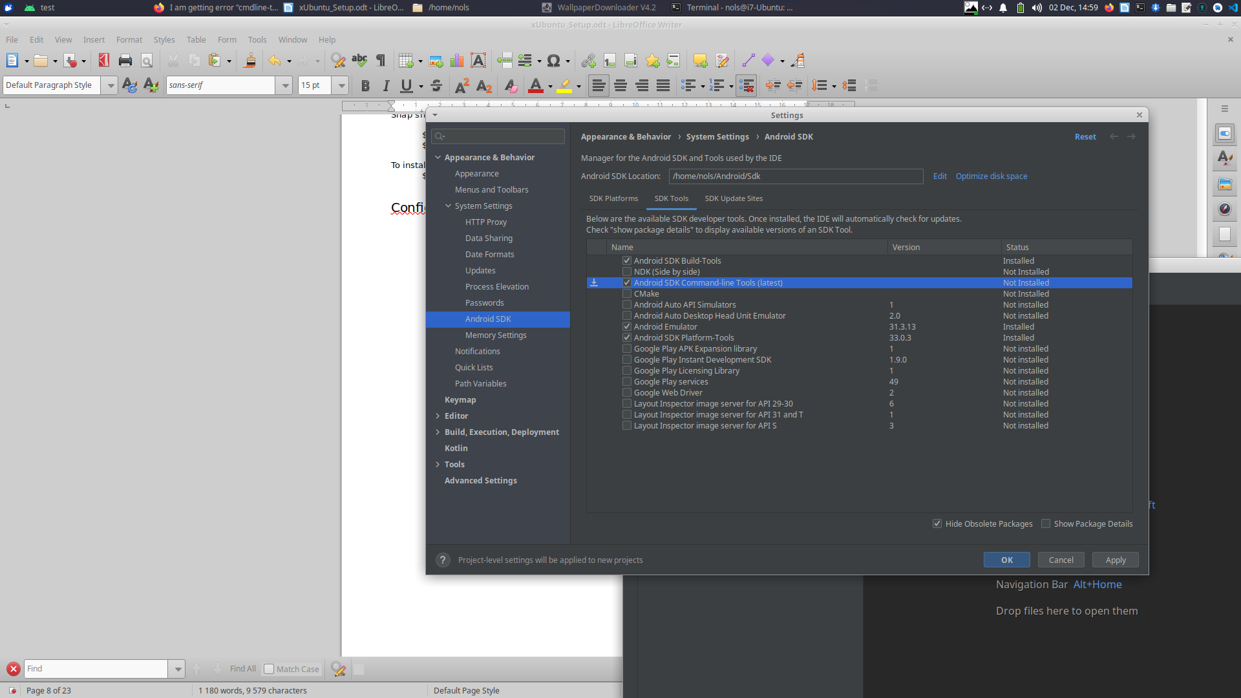
Run Flutter Doctor and solve outstanding installation problems

$ flutter doctor
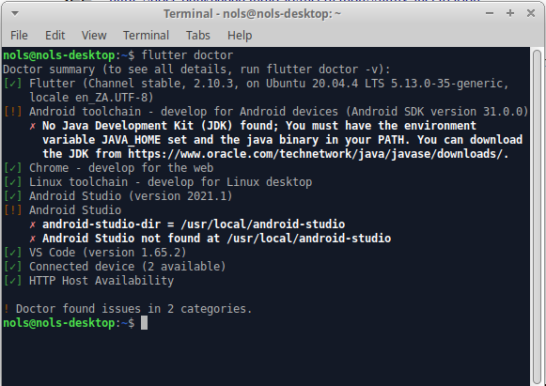

When running a Flutter app resulting the following error:
The minCompileSdk (31) specified in a dependency's AAR metadata (META-INF/com/android/build/gradle/aar-metadata.properties)is greater than this module's compileSdkVersion (android-30)

For sollution, see: https://kotlinlang.org/docs/gradle.html
Then change:
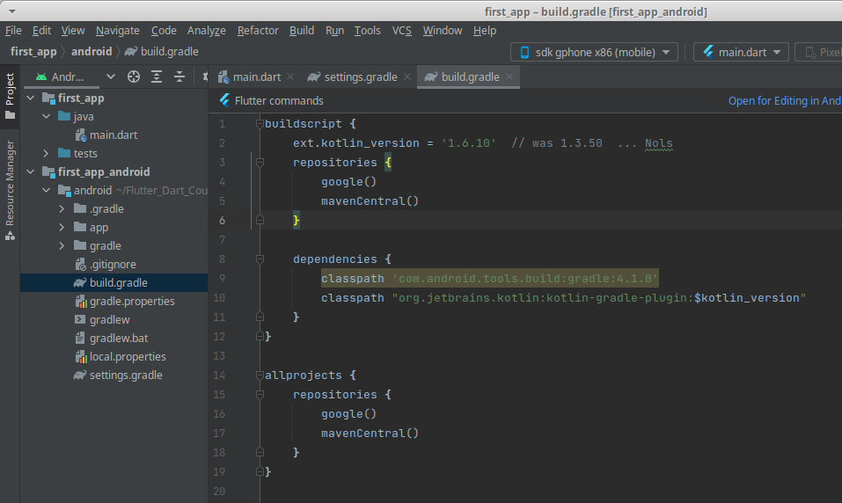

With the issue:
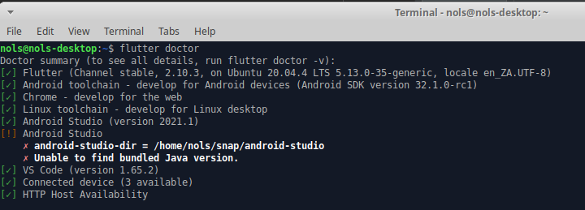
To clear config of: android-studio-dir
$ flutter config --android-studio-dir=

Android Studio does not have write access – You can’t run updates
See: https://stackoverflow.com/questions/58174031/android-studio-does-not-have-write-access

Set your current user as owner of your installation directory, e.g.: /usr/local/android-studio/
This will resolve the issue in long term:
sudo chown -R $USER:$USER /home/nols/Android/android-studio

Then set Access: and Others: to Read & Write

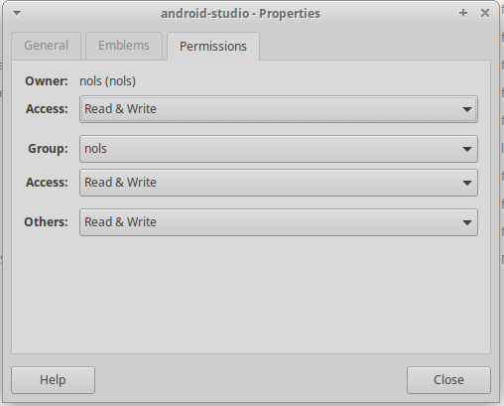

How to remove emulator from tool window android studio
(Make the emulator a floating window which will not close when closing android-studio)
See: https://stackoverflow.com/questions/65403817/how-to-remove-emulator-from-tool-window-android-studio

Go to File -> Setting -> tools -> Emulator and uncheck the checkbox (Launch in tool window) and apply changes. That's it. and restart your emulator
How To Install Visual Studio Code (VSCode)
Warning: Do not do a Snap install. Install the Debian version.
Download the .deb package (64-bit)
In the download folder (Downloads) copy the file name and in a terminal window install with the following command: $ sudo apt install ./<file>.deb

How To Install Git on Ubuntu 20.04
See: https://www.digitalocean.com/community/tutorials/how-to-install-git-on-ubuntu-20-04
Run MacOS on linux
See: https://www.youtube.com/watch?v=6WgjQpm9VWE

Use QEMU/KVM

Step 1: $ sudo snap install sosumi
Step 2: Run sosumi and it will open Clover
Step 3: On Clover, use the option: Boot macOS Install from macOS Base System
Step 4: When it show
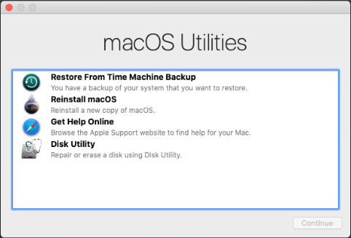

Step 5: Install the qemu-utils
$ sudo apt install qemu-utils

Step 6: Close Clover and the resize the disk with the following command to add en extra 50 GB
$ qemu-img resize macos.qcow2 +50G
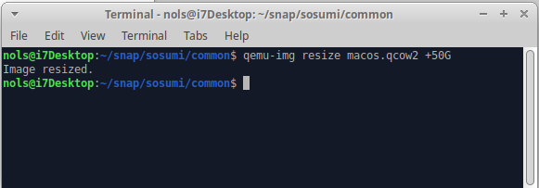

Step 7. Open Sosumi, use the option: Boot macOS Install from macOS Base System, and then select Disk Utility to format the virtual hard disk the VM created
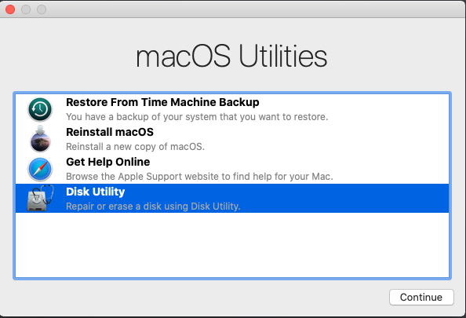

Step 8: Select the disk with size of 68.72 + 50 = 122.41 GB
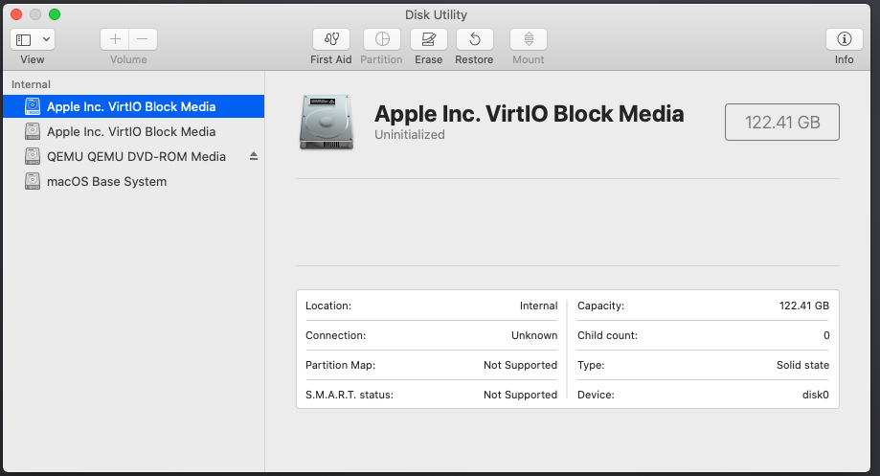

Step 9: Select Erase and change the name to MacOS and Erase
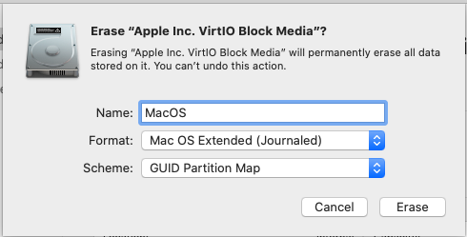

It will now show:
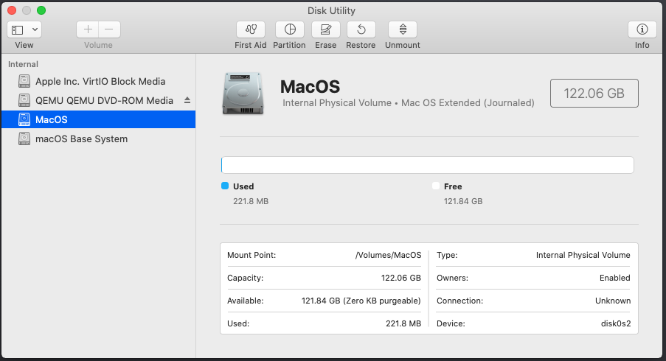

Step 10. Close Disk Utility and select Reinstall macOS
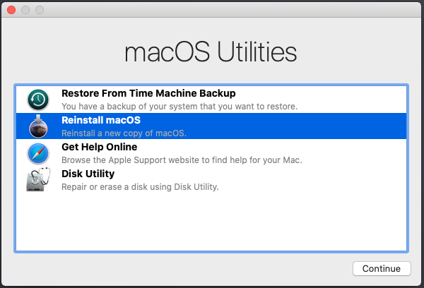

Step 11. Select the formatted hard to install
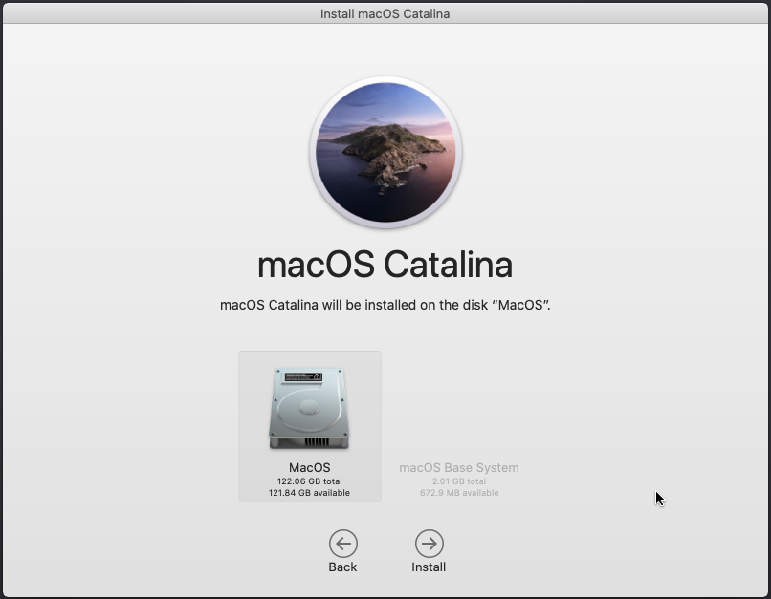

It will take about 23 minutes to install

Step 12. Boot up using this option
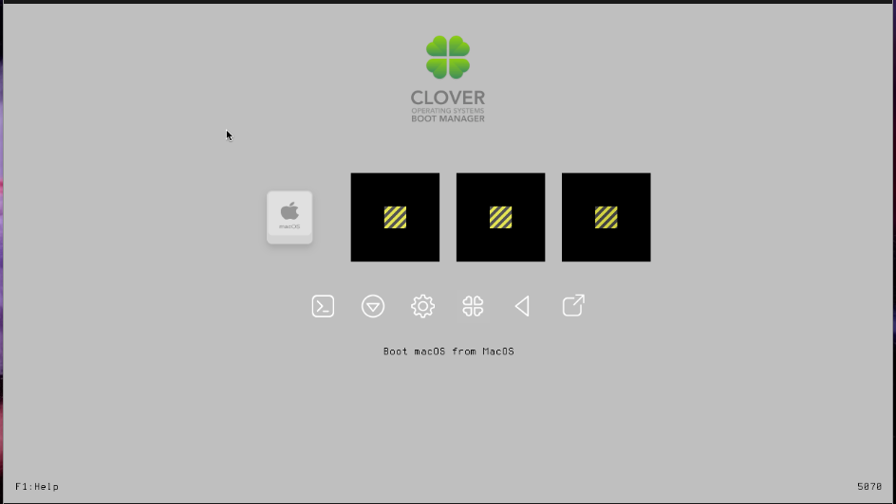

Step 13. Select the setup settings, e.g. country, keyboard. Don’t login to Apple account.

Step 14. Close virtual machine to tweak memory,

In folder nolssnap/sosumi/common
Make a backup of the launch file, e.g. launch_Backup
Edit launch and edit file:
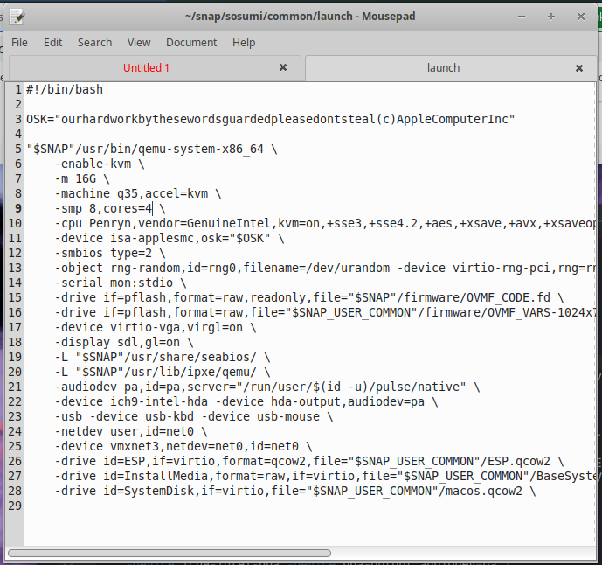

Completely remove sosumi: $ sudo snap remove --purge sosumi

How to update macOS inside sosumi virtual machine (qemu)
See: http://dalvikplanet.blogspot.com/2020/03/how-to-update-macos-inside-sosumi.html

Running Android Apps In Linux With Anbox

See:

Install anbox on Ubuntu

Running Android Apps In Linux With AnBox

How to Install Anbox on Ubuntu 22.04 | Anbox Android on Ubuntu 22.04 | Install Android Anbox Linux

Official Anbox notes: Install Anbox

ANDROID IN A BOX

Google Drive API
See: https://console.cloud.google.com/apis/api/drive.googleapis.com/metrics?project=slimzulu-215707

API/Service Details

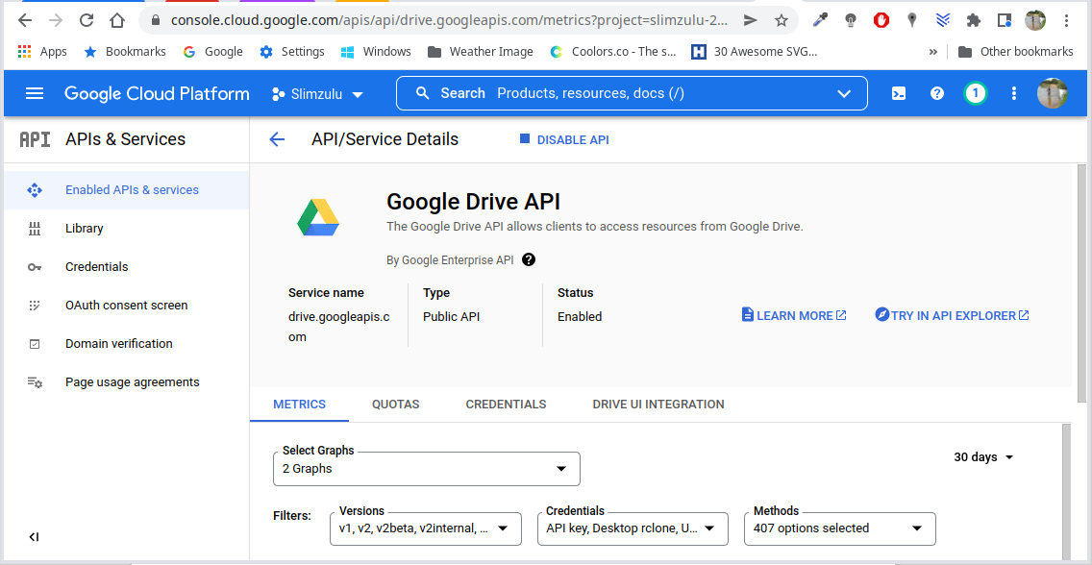

Setting up OAuth 2.0
See: https://support.google.com/cloud/answer/6158849?hl=en&ref_topic=3473162

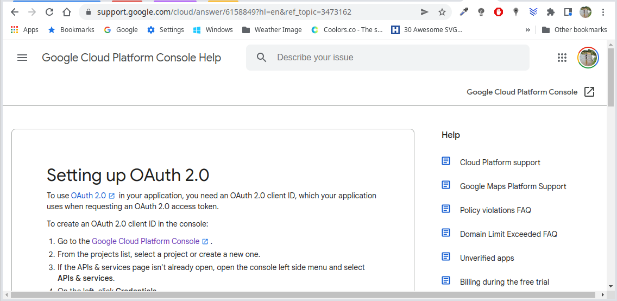

Auth consent screen
See: https://console.cloud.google.com/apis/credentials/consent?project=slimzulu-215707
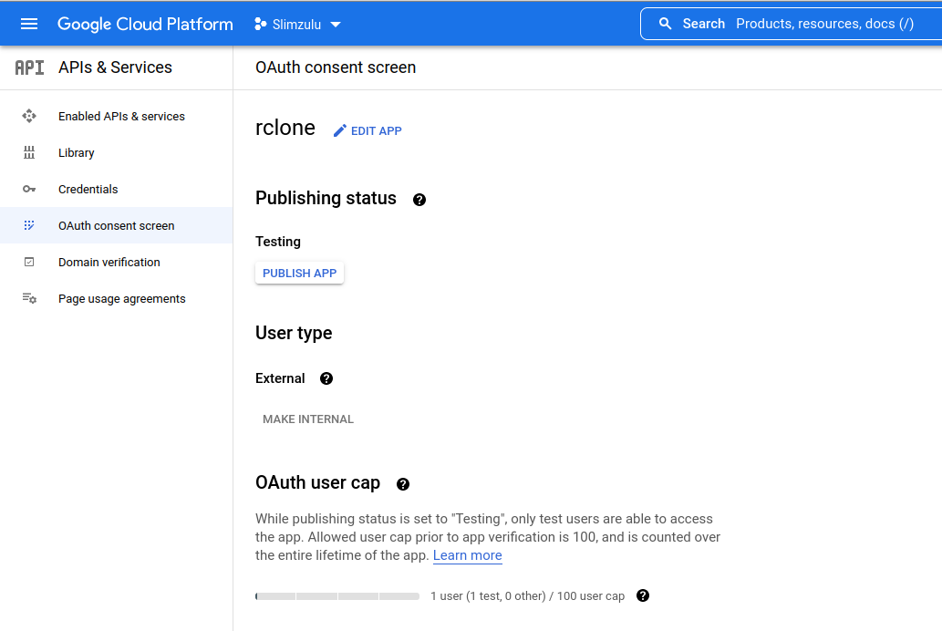

OAuth API verification FAQs
See: https://support.google.com/cloud/answer/9110914#zippy=%2Cdrive-apis
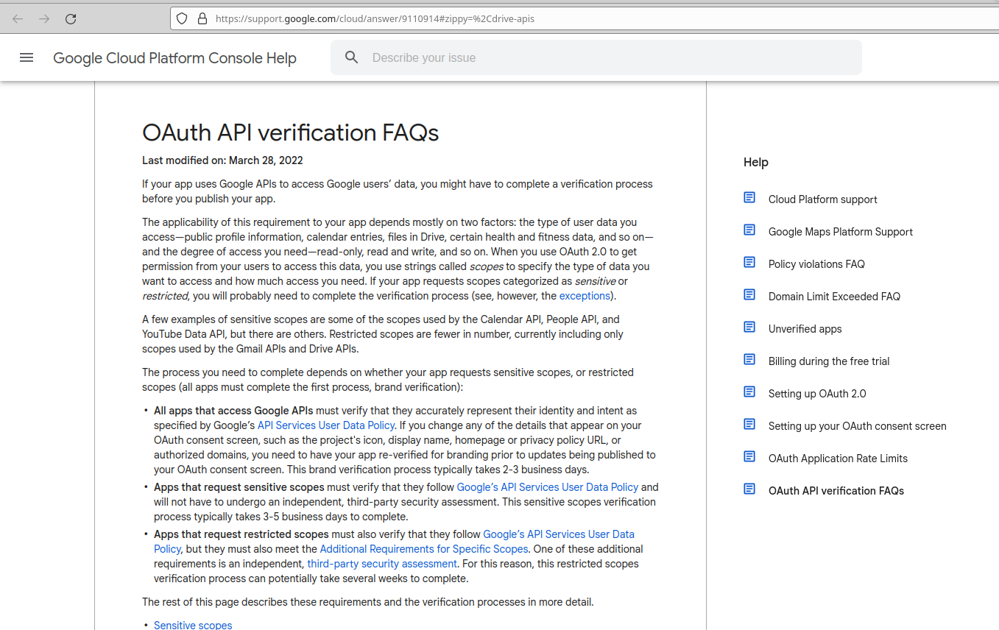

rclone
See: https://rclone.org/

Installing rclone: https://www.howtogeek.com/451262/how-to-use-rclone-to-back-up-to-google-drive-on-linux/

How to Use rclone to Back UP to Google Drive in Linux
See: https://www.howtogeek.com/451262/how-to-use-rclone-to-back-up-to-google-drive-on-linux/

Sync files of SofwareDevelopment to Google Drive:

rclone sync -L -P ./SoftwareDevelopment/ --transfers=8 --fast-list
--exclude-from ./SoftwareDevelopment/exclude_file.txt gdrive:

exclude_file.txt

/FastAPI_Exercises/**
/Tutlinks_FastAPIs/**
*/build/**
*/ios/**
*/android/**
*/linux/**
*/windows/**
*/web/**
*/.dart_tool/**

FireBase Overview
See: https://firebase.flutter.dev/docs/overview/

Install FireBase CLI
See: https://firebase.google.com/docs/cli#install-cli-mac-linux

After installation, login
$ firebase login

Allow Google anything it asks for and close the window.

Configure FireBase
$ flutterfire configure

