Exercise5: Gestalt Laws (20 points)

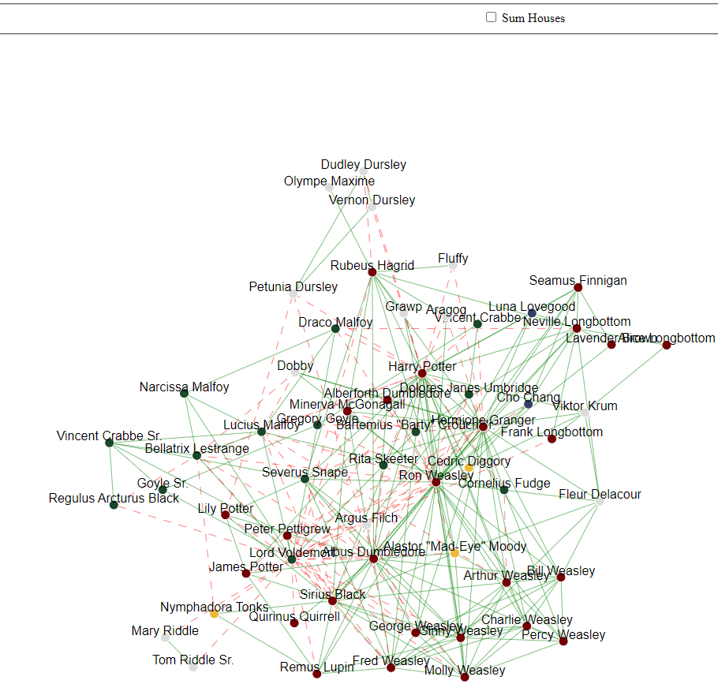**Ein Bild, das Text, Gerät enthält.
Due: 29.05.2023 8AM**

**Task 1: Network graph (12 points)**

The goal of this exercise is to implement an interactive network graph with D3. The graph data should be aggregated to each house (No House is also a house) and updated by clicking the checkbox “sum houses”.

Attached to this exercise, you will find a folder called *harrypotter.* The foldercontains an unfinished implementation of the network graph above. Your task is to finish the implementation such that opening the *index.html* shows the network graph as depicted in the left figure above, and clicking the checkbox transforms the network graph into the one showed in the right.

To finish the implementation, follow the steps described as comments in the dedicated file. Each comment starting with *TASK* indicates a position you have to add code.

The *harrypotter* folder has **5** files:

* **index.html (0 Points)**

The main entry point of the visualization.

* **index.js (12 points)**

The main JavaScript entry point. All the coding tasks are in here.

* **index.css (0 points)**

Implements CSS Rules for specific elements.

* **data.js (0 points)**

Initializes a variable called *data* and reflects the dataset we want to visualize.

* **d3.js (0 points)**

d3 library

**Task 2: Visual Perception (8 points)**

**Task 2a)** Using your own words, describe what is ***pre-attentive processing*** and why it is important for data visualization.

**Answer:**

**Task 2b)** You are asked to evaluate the visualization of **“Biggest Covid-19 worries”** below.

* What is the information that the visualization author wanted to communicate?
* What do you think went wrong during the data encoding phase?
* Critique the visualization design, and propose an alternative representation that would be better (provide a sketch of the alternative visualization)

**Answer:**

* **After completing your answers, export the docx-File to PDF and upload it alongside the source code files.**

**Submission: Zipped harrypotter folder including all files (index.html, index.js, index.css, data.js, d3.js) and a PDF of the completed written exercise.**

Please form a group of **2 Students**. Only 1 member of the group must submit the exercise in ILIAS.

rakotondravony@dbvis.inf.uni-konstanz.de