Exercise7 (20 points)

**Due: 26.06.2023 8AM**

**Contributor 1: Anurag Pacholi**

**Contributor 2: Mohammad Nomaan Husain**

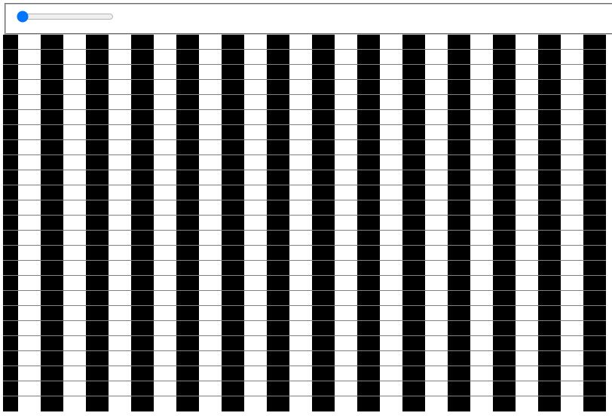

**Ein Bild, das Text enthält.
**

**Task 2: Visual Illusion (12 points)**

For this exercise, your task is to implement a visual illusion as displayed above.

The illusion shall include:

* rectangular shapes allocated and filled with black and white as displayed
* a slider element that moves the bars horizontally and creates a similar illusion

There are no prepared files for your support this time. However, you may use previously written code as orientation.

**Task 2: Color Scales (8 points)**

**Task 2a) (4 points)**

Using your own words, what is a JND? Discuss its relation to marks and information encoding.

**Answer:** JND Stands for Just Noticeable Difference. It refers to the smallest change in a visual element that can be observed/detected by an average person. By taking the JND into consideration, data visualizers can ensure that the visual elements they use effectively communicate the intended information and insights to the users while avoiding unnecessary distractions or misleading representations. JND is inversely related to the size of marks. Bigger marks have lower JND. For example, if the JND for color discrimination is small, using subtle color variations for encoding categories or data values might not be effective as viewers may not perceive the differences accurately. In such cases, it would be advisable to use more distinct colors to ensure perceptual differentiation. The relationship between JND and information encoding in data visualization is centered around the effective representation of data attributes using visual properties that are distinguishable to viewers. For example, consider encoding a quantitative attribute using the length of bars in a bar chart. If the differences in bar lengths are below the JND, viewers may not be able to perceive the differences accurately, and the encoded information loses its effectiveness. However, if the differences exceed the JND, viewers can detect the variations in bar lengths and interpret them as significant differences in the data values being represented.

**Task 2b) (4 points)**

Think of a real-world example on how to use color in a visualization.   
State **data**, **audience**, **task**, **visualization** and **marks**. Decide on its use of color (i.e. as a color scale) and justify your decisions.

**Answer:**

**Data**: Let's consider a dataset that contains information about the population density of various cities around the world.

**Audience**: The audience consists of urban planners who are interested in understanding the population distribution and density patterns across different cities.

**Task**: The task is to visualize the population density of cities in a way that allows the audience to quickly identify high-density areas and observe any spatial patterns or trends.

**Visualization**: A suitable visualization for this task would be a choropleth map, where each city is represented by a geographic region and the color of the region indicates the population density.

**Marks**: The marks used in this visualization would be the boundaries or polygons representing the cities on the map.

**Use of color**: In this case, color can be used as a color scale to represent the population density. The color scale should be designed in a way that effectively communicates the variations in density across cities.

**Justification**:

A sequential color scheme would be appropriate for representing the population density. For example, a color scheme ranging from light to dark shades of a single color can be used. This sequential scheme provides a clear visual progression from low density to high density and allows viewers to perceive the relative differences in density easily. Avoiding highly saturated colors prevents unnecessary visual distractions and maintains the focus on the density patterns. The chosen color scale has sufficient contrast between adjacent colors, making it easy for viewers to differentiate between different density levels. Additionally, considering accessibility guidelines, the chosen colors should be distinguishable by individuals with color vision deficiencies, which can be achieved by using color combinations that have high contrast and are colorblind-friendly.

**After completing your answers, export the docx-File to PDF and upload it alongside the source code files.**

**Submission: Zipped folder including all necessary files and a PDF of the completed written exercise.**

Please form a group of **2 Students**. Only 1 member of the group must submit the exercise in ILIAS. Please state the collaborators in the beginning of the document.