Project ID: 26

Design Document

For

Parking Lot System

Version 1.0

Prepared by

|  |  |  |
| --- | --- | --- |
| Muhammad Khubaib | CS-021 | khubaibhabib@gmail.com |
| Noman Hussain | CS-037 | nomanghanchi_11@yahoo.com |
| Syed Wasiq Hussain | CS-047 | s.wasiqhussain@yahoo.com |
|  |  |  |

Instructor: Sir Kashif Asrar

Date: 17-03-2017

Contents

1 USE CASE dIAGRAM 3

2 DATA FLOW DIAGRAM

2.1 DATA FLOW DIAGRAM LEVEL 0 4

2.2 DATA FLOW DIAGRAM LEVEL 1 4

3 StATE TRANSITION DIAGRAM 5

4 SEQUENCE DIAGRAM 6

4.1 SEQUENCE DIAGRAM FOR CUSTOMER 6

4.2 SEQUENCE DIAGRAM FOR ADMIN 7

5 cOMPONENT DIAGRAM 8

6 dEPLOYMENT DIAGRAM 8

1 Use Case Diagram

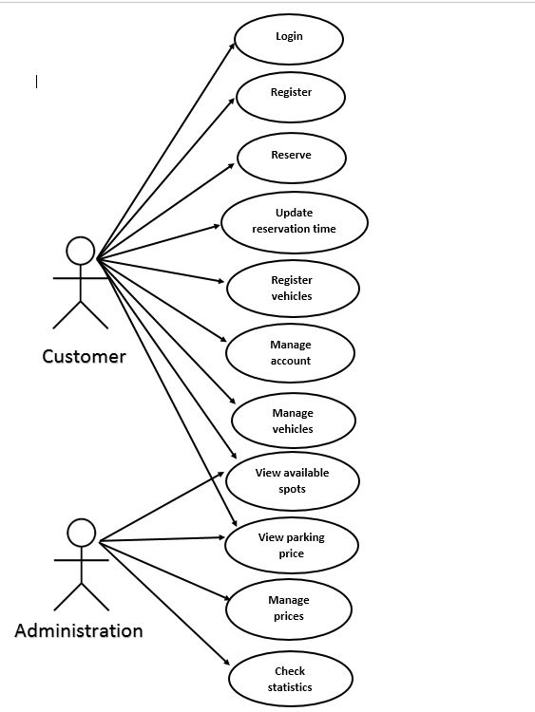

2 Data Flow Diagram

## 2.1 Data Flow Diagram Level-0

## 2.2 Data Flow Diagram Level-1

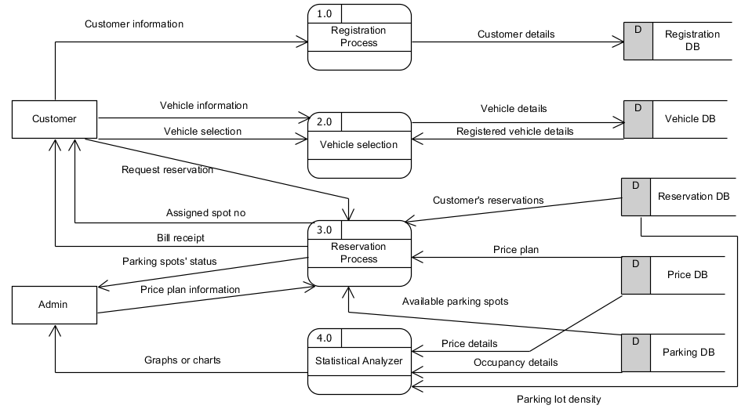

3 State Transition Diagram

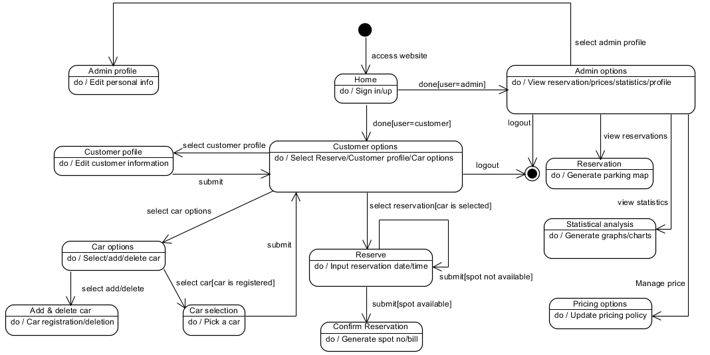

4 Sequence Diagram

## 4.1 Sequence Diagram for Customer

## 4.2 Sequence Diagram for Admin

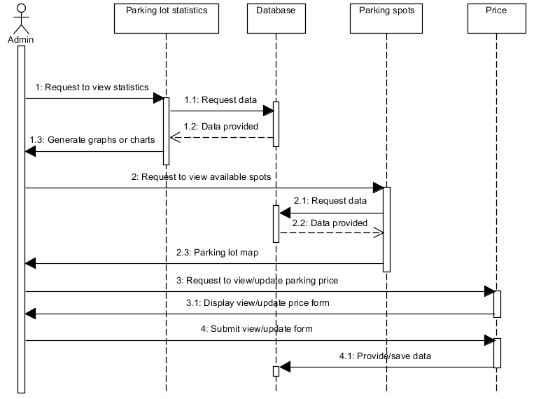

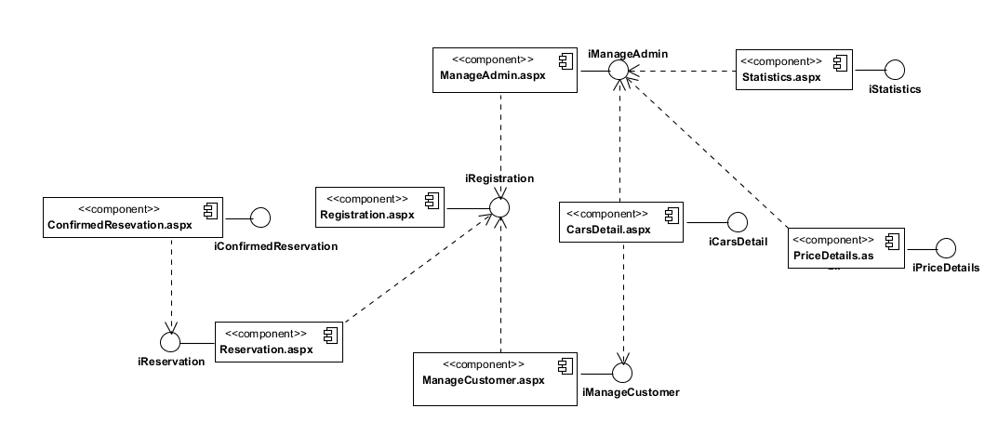5 Component Diagram

6 Deployment Diagram

