Project ID: 26

Software Requirements Specification

For

Parking Lot System

Version 1.0

Prepared by

|  |  |  |
| --- | --- | --- |
| Muhammad Khubaib | CS-021 | khubaibhabib@gmail.com |
| Noman Hussain | CS-037 | nomanghanchi_11@yahoo.com |
| Syed Wasiq Hussain | CS-047 | s.wasiqhussain@yahoo.com |
|  |  |  |

Instructor: Sir Kashif Asrar

Date: 17-02-2017

Contents

Revisions 3

1 Introduction 4

1.1 Document Purpose 4

1.2 Product Scope 4

1.3 Intended Audience and Document Overview 4

1.4 Definitions, Acronyms and Abbreviations 5

1.5 Document Conventions 5

1.6 References and Acknowledgments 5

2 Overall Description 6

2.1 Product Perspective 6

2.2 Product Functionality 6

2.3 Users and Characteristics 6

2.4 Operating Environment 7

2.5 Design and Implementation Constraints 7

2.6 User Documentation 7

2.7 Assumptions and Dependencies 8

3 Specific Requirements 9

3.1 External Interface Requirements 9

3.2 Functional Requirements 11

3.3 Behaviour Requirements 12

4 Other Non-functional Requirements 14

4.1 Performance Requirements 14

4.2 Safety and Security Requirements 14

4.3 Software Quality Attributes 15

5 Other Requirements 15

Appendix A – Data Dictionary 16

Revisions

| Version | Primary Author(s) | Description of Version | Date Completed |
| --- | --- | --- | --- |
| 1.0 | Muhammad Khubaib | Initial version. | 17/02/17 |

# 

# Introduction

## Document Purpose

The System Requirement Specification document for Parking Lot System elaborates functionality of website used in parking garage automation. The document will brief the design and interfaces and limitation of the system operates in a certain environment.

The purpose of the product is to automate the parking lot reservation system through a flexible website that can be applied to most parking garages that utilize valets. The new system will encourage customers to make reservations online and make the parking process a hassle-free experience.

## Product Scope

The purpose of this product is to manage occupancy of a parking lot and allow customers to find and reserve available parking places. The parking garage currently operates without any computerized system. Congestion inside the garage is often caused by drivers searching for vacant spots. In addition, it is well known that a great deal of traffic congestion in cities generally is caused by drivers looking for a parking space. Currently, the management monitors the garage occupancy by having employees walk around the decks to inspect the occupancy of individual spots.

Our product uses a more advanced system to manage the issues encountered in a parking lot. The objective is to design a sophisticated system which will seek to maximize occupancy and profit while allowing the customer quick and easy access to his vehicle

## Intended Audience and Document Overview

This requirement document contains general information about Parking lot system, functions, features and special technologies. It describes in detail all that the system needs to work properly and with safety. This document is intended for:

**Developers:** In order to be sure they are developing the right project that fulfills requirements provided in this document.

**Testers:** In order to have an exact list of the features and functions that have to respond according to requirements and provided diagrams.

**Users:** In order to get familiar with the idea of the project and suggest other features that would make it even more functional.

The rest of this SRS is organized as follows:

* Section 2 gives an overall description of the software. It gives what level of proficiency is expected of the user, some general constraints while making the software and some assumptions and dependencies that are assumed.
* Section 3 contains most important features presented with detailed description, and requirements. It gives specific requirements which the software is expected to deliver. Functional requirements are given in this section. This section is written primarily for the developers and describes in technical terms the details of the functionality of the product.
* Section 4 contains other important non-functional requirements. These are the requirements other than the deliverables but are essential for the system to work in desirable manner.

## Definitions, Acronyms and Abbreviations

**ASP.NET:** ASP.NET is an open source web framework for building modern web apps and services.

**Client-server architecture:** is a network architecture in which each computer or process on the network is either a client or a server.

**HTML:** Hypertext Markup Language.

**HTTP:** The Hypertext Transfer Protocol (HTTP) is an application protocol for distributed, collaborative, and hypermedia information systems.

**LAN:** A local area network (LAN) is a computer network that interconnects computers within a limited area.

**Remote client:** It is a user to remotely log into a networked computer running the terminal services server.

**Reservation:** An arrangement to park in a parking garage for a fixed amount of time at a certain fee per hour.

**SQL Server:** SQL stands for Structured Query Language.

## Document Conventions

In general this document follows the IEEE formatting requirements. Use Arial font size 11, or 12 throughout the document for text. Use italics for comments. Document text should be single spaced and maintain the 1” margins found in this template.

## References and Acknowledgments

* http://www.ece.rutgers.edu/~marsic/books/SE/projects/
* https://www.scribd.com/doc/39542757/Parking-Management-System-SRS
* http://en.wikipedia.org/wiki/Non-functional_requirement
* http://park-a-lot.vacau.com/

# Overall Description

## Product Perspective

The parking lot system uses a website that will be used to allow customers to place online reservations as well as provide the parking garage staff with basic customer information and statistics. The goal is to design a friendly user interface in order to allow the customer to use the website on a computer and possibly a mobile device. The database will be adjusted through this website as customers will enter their account information, register their vehicles, and place reservations.

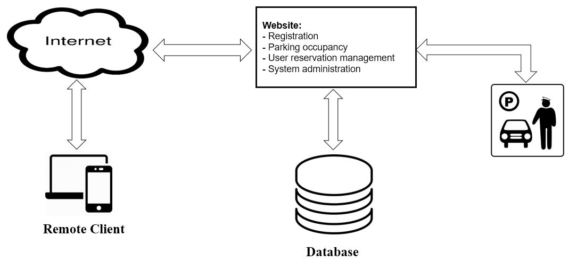

**Figure 1: The general diagram of the parking lot system**

## Product Functionality

* Reservations can be made according to suitable time slot.
* Customers can save personal and vehicle details.
* Customers may edit parking information any time.
* Administration can set parking rates and policies regarding parking lot.
* Number of available slot can be viewed any time.

## Users and Characteristics

**Registered Customer**: A customer who has registered an account on the garage’s website prior to showing up to the garage.

**Contracted Customer**: The system also supports guaranteed reservations, which allow customers to make a contract with the parking lot for a parking spot.

**Administration:** View the registered customers’ profiles and customer statistics and set the various prices and rates for the different services provided.

## Operating Environment

This product is web-based and will be hosted by a web server. This product can be viewed by any web browser namely internet explorer, safari, chrome etc. The minimum operating requirements for the system are:

• Windows 7 and above

• ASP.NET

• SQL-Server 2010

• Processor – Pentium 4

• Hard Disk – 50 GB

• Memory – 1GB RAM

## Design and Implementation Constraints

**Technology used:** The website must be developed on asp.net platform. A client/server architecture is considered during the development.

**Database used:** Databases are to be maintained on sql server.

**Hardware required:** The external hardware interface used for accessing the system is the personal computers.

**Communication:** The communication interface is a local area network through Ethernet.

**Design Constraints:** The needs of the customers and the administrators may keep on changing so the designers must keep this in view and design the product in this way that it is easily updatable.

## User Documentation

The requirements and the services provided to the customer must be unambiguously elaborated in user-manuals. It must contains the details about different mode of operations provided by the website on different events, the working flow of a website, what forms to be appeared and what information is needed while making a reservations. It will ensure the customer that all constraints and business policies are kept into consideration during the entire development cycle.

## Assumptions and Dependencies

* Organizations and companies may register accounts, meaning there may be multiple vehicles and people contained within this account. Also, large organizations might make multiple reservations during the same time period so that multiple employees may utilize the parking garage.
* It is possible that the same vehicle is parked by multiple customers but not at the same time.
* In real time, the occupancy of spot is determined by spot-occupancy recognition system that works correctly 100 % of time, with no errors because of sensor malfunctioning or incorrect sensing. For now, we assume that the reserved spot will be unoccupied after the reservation time is over.
* We assume that the customer will always accept the offered parking spot and will never wish to opt out and leave the parking garage without parking his or her vehicle.
* We assume that the customer will always park at their assigned spot, and will never park at an arbitrary vacant spot.
* Customers are allowed to increase the amount of time their car is in the lot before arrival, as long as there are available time slots.
* We assume that the customer will leave the parking lot within reserved time and no overhead will be charged.
* Payments will be made manually at the time of departure.

# Specific Requirements

## External Interface Requirements

### User Interfaces

**Home Page:** This is the first page users see when the go to the website. This page can’t really do much other than log in and make requests to other pages. In addition to this, this page provides a brief welcome note to provide the user a very brief idea of what they can do here and the number of available spots in the garage.

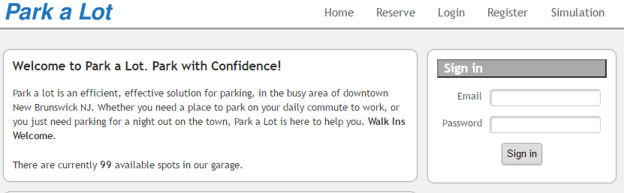

**Registration Page:** In order to keep the registration process quick and painless, there is not much information needed to register. All fields must be entered and the email address has to be unique in order for the account to successfully get created. All passwords stored are encrypted prior to being entered in the database.

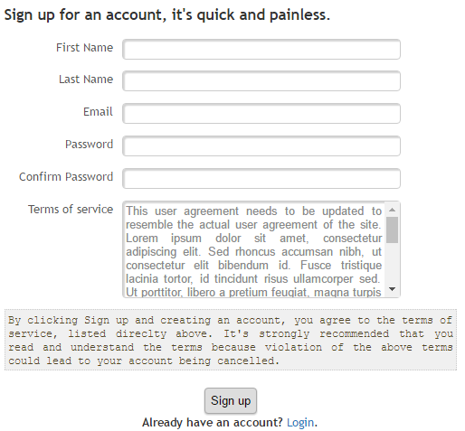

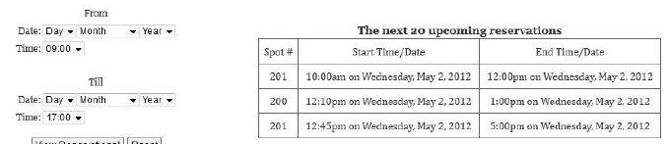**Reservation Page:** If the user is experiencing issues reserving a spot or is curious as to what type of reservations people have previously made, they can access this page. On this page the user can pick a time frame and view previous and/or future reservations. To ensure privacy, only the spot number, start point, and end point are displayed.

### Hardware Interfaces

Since the website is a two-tier architecture so databases are maintained in different machine that shall require to connect using a LAN cable. Other than this, no hardware interface is required.

### Software Interfaces

The product is to be developed using following software interfaces:

* Sql server 2014 is used to store database. The system must provide SQL data table definitions and all commands used in SQL Server 2010.
* ASP.NET is used which provides the front end coding i.e. user login options, graphical analysis, information and designing of the website.

### Communications Interfaces

The website use the HTTP protocol for communication over the internet.

## Functional Requirements

### Requirements for Customers

* To utilize the parking garage service, the customer will have to register an account with their information including name, car details, license plate number, and type of vehicle.
* To make the reservation customer will ask to provide license plate number of vehicle to be parked and arrival and departure time.
* If there are available spot on that day and at the time, the system will assign the customer a parking spot, which he/she will be allowed to use until the end of their reservation.
* Customer can view his/her account details and update their information accordingly.
* Customer can add as many vehicle as required in their account so that at reservation time data entries will be lesser.
* At the end of the customer’s time of stay, the spot is marked as vacant and the customer is then charged for the time he has used the parking lot’s service.

### Requirements for Administration

* The system must distinguish between customers and admins account.
* Admin is provided the option for changing the parking prices of the parking lot.
* Changes made by the admin must be conveyed to the customer on as is where basis is.
* Different statistical data to be provided to the user to review future business policies.

## Behaviour Requirements

### Use Case View

Customer can register or create an account. Registered customers will allow to make a reservation to save a spot for a given period of time as long as there is a vacancy. Customers can manage their personal information and manage their vehicle details. Reservation time can be managed by customers after login into account. Parking rates and policies of parking lot can be viewed at home page of the website.

Administration is allowed to manage prices on any fees that will be charging to customers. Check statistics allows the administrator to obtain statistics of how many people parked in a day and for how long.

# Other Non-functional Requirements

## Performance Requirements

## Response time: The maximum response time for the submission of a registration form will be less than 10 seconds.

## System dependability: If the system loses the connection to the Internet system gets some strange input, the user should be informed.

**Workload:** DB system may easily handle 100 write transaction per minute but only 50 update transactions per minute.

**Data entries:** It is possible that customers want to reserve parking spot during driving. So, data entries must be kept less than 10 fields.

**Efficient searching:** The searching for an available parking spot must be completed within 5 seconds.

## Safety and Security Requirements

### Safety Requirements

**Overlapping of parking spot:** A single parking spot must not be assigned to multiple customers at the same time.

**Extensions:** extension should not be allowed in reservation time if the same spot is assigned to another customer under the span of half an hour.

**Payment policies:** Customers should be charged according to the pre-defined business policies of the organization. Changing in the amount of the bill by anyway is considered as a major hazard to the business.

### Security Requirements

* The system should implement via a secure login screen
* The system should identify and authenticate all the users who attempt to access the system.
* The server-side components and files contained therein shall have their access restricted to authorization personnel.
* The system shall protect the privacy of external communications with users.
* The system shall set up clustering to make the service sustainable when disaster occurs.

## Software Quality Attributes

### Maintainability

### Maintainability means to be consistent in approach in order for future functions to be implemented easily to the website. The website should be easy to extend. The code should be written in a way that it favors implementation of new functions. Same style of designing is to be followed throughout the development.

### Portability

Porting the website from .asp to .html shall not require modifying more than 15% of the lines of non-comment, non-blank source code and shall not exceed two person weeks.

### Robustness

The website shall not have a single hardware point of failure involving the following kinds of hardware components: servers, networks, network connectivity devices and power supplies. The application shall provide a meaningful error message and continue to operate properly when a user provides incorrect inputs or the failure of external system on which it depends.

### Usability

To accomplish simplicity, each page has a navigation bar to access the individual pages. Some pages even include instructions and/or guidelines. There is consistency as all the web pages follow the same template.

### Interoperability

The website shall properly interoperate with the Microsoft SQL Server databases.

# Other Requirements

<This section is not applicable to SRS for parking lot system.>

Appendix A – Data Dictionary

**A**

Abrreviations page 5

ASP.NET page 5

Assumptions and Dependencies page 8

**B**

Behaviour Requirements page 12

**C**

Client-Server Architecture page 5

Constraints page 7

Contents page 2

Communiications Interface page 10

**D**

Definations, Acronyms & Abbreviation page 5

Dependencies page 8

Descriptions page 6

Document Purpose page 4

**E**

External Interface Requirement page 9

**F**

Functional Requirement page 11

**G**

General Constraints page 7

General Description page 6

GUI page 9

**H**

Hardware Interface page 10

Hardware Required page 7

Home Page page 9

HTML page 4

HTTP page 4

**I**

Index page 2

Intended Audience page 4

Interoperability page 15

**L**

LAN page 5

LOGIN page 9

**M**

Maintainability page 15

**N**

Non-Functional Requirement page 14

**O**

Operating Environment page 7

Other Requirements page 15

**P**

Performance Requirement page 14

Portability page 15

Product Scope page 4

Product Perspective page 6

Product Functuiionality page 6

**R**

Remote Client page 5

Reservations page 5

References page 5

Registration Page page 9

Robustness page 15

**S**

Scope of the Product page 4

Safety Requirement page 14

SecurityRequirement page 14

SignUp Page page 9

System Dependability page 14

Software Interface page 10

Specific Requirement page 9

SQL Server page 5

**T**

Technology Used page 7

**U**

Usability page 15

User Characteristics page 7

User Case page 12

User Documentation page 8

User Interface page 9