CSE326 Internet and Web Programming
Prof. Sivagami M

L Sai Siddharth
14BCE1010

1)

<!Doctype html>
<head>
<script>
var st=[];
var i=0;
function Student(a1,b1,c1,d1,e1,f1)
{
this.nam=a1;
this.reg=b1;
this.ca1=parseInt(c1);
this.ca2=parseInt(d1);
this.pb=parseInt(e1);
this.te=parseInt(f1);
this.total=this.ca1+this.ca2+this.pb+this.te;
this.disp=function(){alert("Name:-"+this.nam+" Total:- "+this.total);}
}
function Addstu()
{
a=document.getElementById("nam").value;
b=document.getElementById("regno").value;
c=document.getElementById("cat1").value;
d=document.getElementById("cat2").value;
e=document.getElementById("pbl").value;
f=document.getElementById("tee").value;
st[i]=new Student(a,b,c,d,e,f);
st[i].disp();
i++;
}
function Topper()
{
var max=0;
var pos=0;
for(var j=0;j<st.length;j++)
{
if(st[j].total>max)
{
max=st[j].total;
pos=j;
}
}
alert("Topper is "+st[pos].nam);
}
</script>
</head>
<body>
<br><h3>Name</h3>
<input type="text" id="nam">
<br><h3>Reg No.</h3>
<input type="text" id="regno">
<br><h3>Cat1 Marks</h3>
<input type="text" id="cat1">
<br><h3>Cat2 Marks</h3>
<input type="text" id="cat2">
<br><h3>PBL marks</h3>
<input type="text" id="pbl">
<br><h3>Tee Marks</h3>
<input type="text" id="tee">
<br>
<input type="button" Onclick="Addstu()" value="Submit">
<input type="button" Onclick="Topper()" value="Find Topper">
</body>
</html>

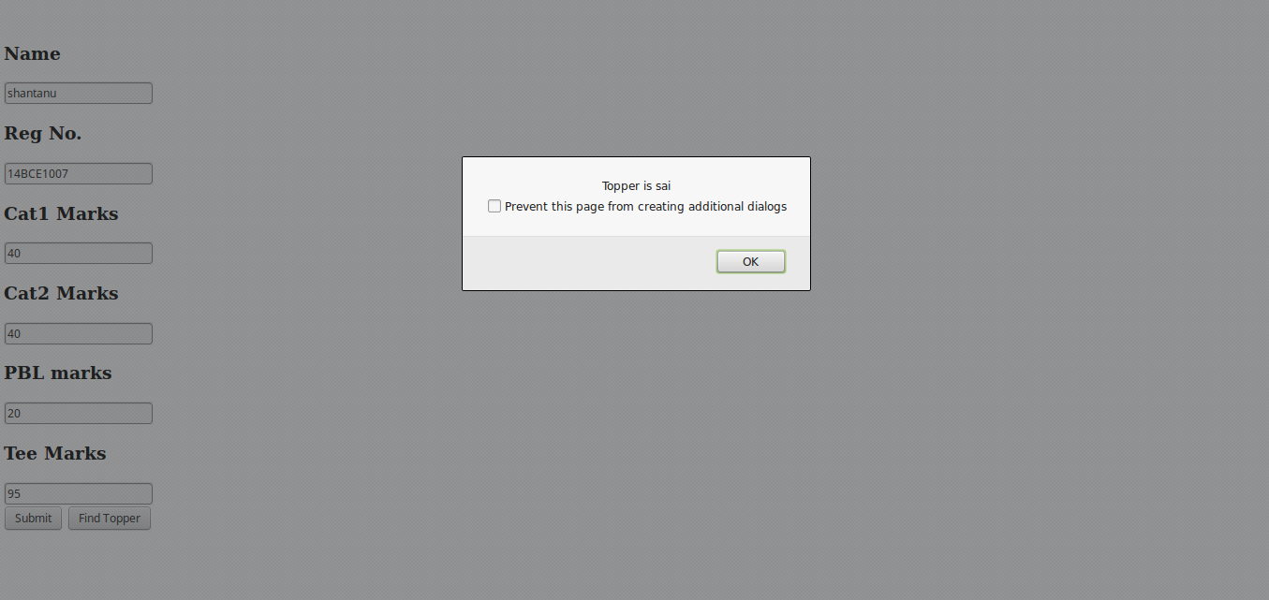

2)

<!Doctype html>
<head>
<script>
var cu=[];
var i=0;
function Cust(a1,b1,c1)
{
this.nam=a1;
this.ano=parseInt(b1);
this.bal=parseInt(c1);
}
function Addcust()
{
a=document.getElementById("nam1").value;
b=document.getElementById("ano1").value;
c=document.getElementById("bal1").value;
cu[i]=new Cust(a,b,c);
i++;
}
function Inbal()
{
for(var j=0;j<cu.length;j++)
{
if(cu[j].bal<50000)
{
alert("Balance Insufficient for "+cu[j].nam);
}
}
}
function Wit()
{
var ano5=parseInt(document.getElementById("ano2").value);
var amt1=parseInt(document.getElementById("amt").value);
for(var g=0;g<cu.length;g++)
{
if(cu[g].ano===ano5)
{
if(cu[g].bal>=amt1)
{
cu[g].bal=cu[g].bal-amt1;
alert("Transaction Complete!!");
}
else
{
alert("Insufficient Balance!!");
}
}
}
}
function Dep()
{
var ano5=parseInt(document.getElementById("ano2").value);
var amt1=parseInt(document.getElementById("amt").value);
for(var g=0;g<cu.length;cu++)
{
if(cu[g].ano===ano5)
{
if(cu[g].bal>=amt1)
{
cu[g].bal=cu[g].bal+amt1;
alert("Transaction Complete!!");
}
}
}
}
</script>
</head>
<body>
<br><h3>Name</h3>
<input type="text" id="nam1">
<br><h3>Account No.</h3>
<input type="text" id="ano1">
<br><h3>Balance</h3>
<input type="text" id="bal1">
<br>
<input type="button" Onclick="Addcust()" value="Submit">
<br>
<input type="button" Onclick="Inbal()" value="Find insufficient balance customers">
<br><h3>Account No.</h3>
<input type="text" id="ano2">
<br><h3>Amount</h3>
<input type="text" id="amt">
<br>
<input type="button" Onclick="Wit()" value="Withdraw">
<br>
<input type="button" Onclick="Dep()" value="Deposit">
</body>
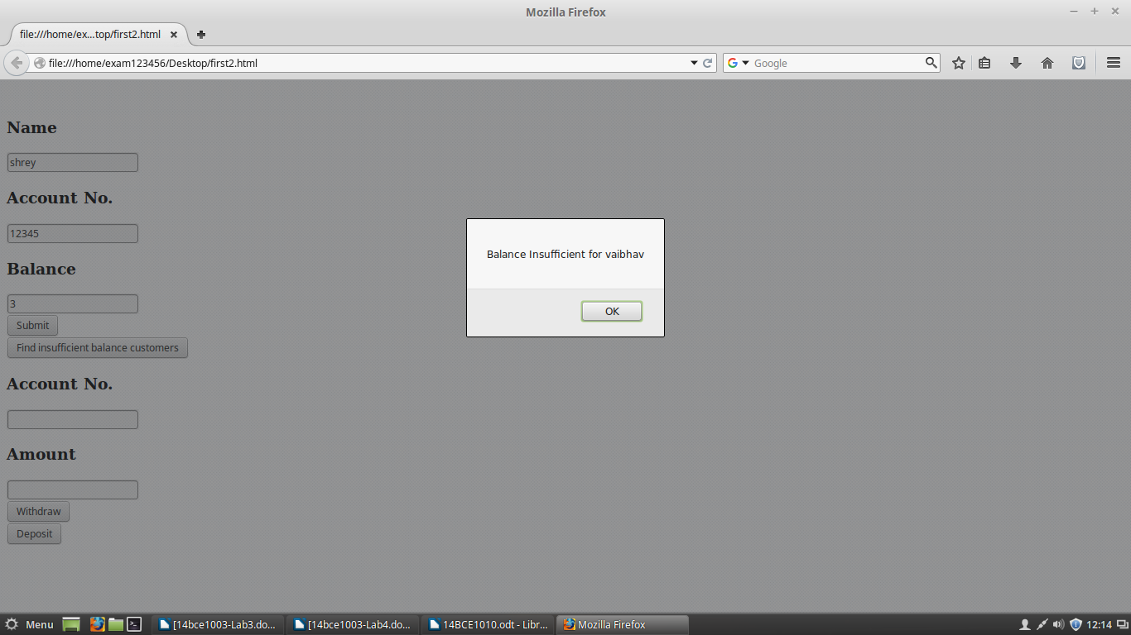
</html>

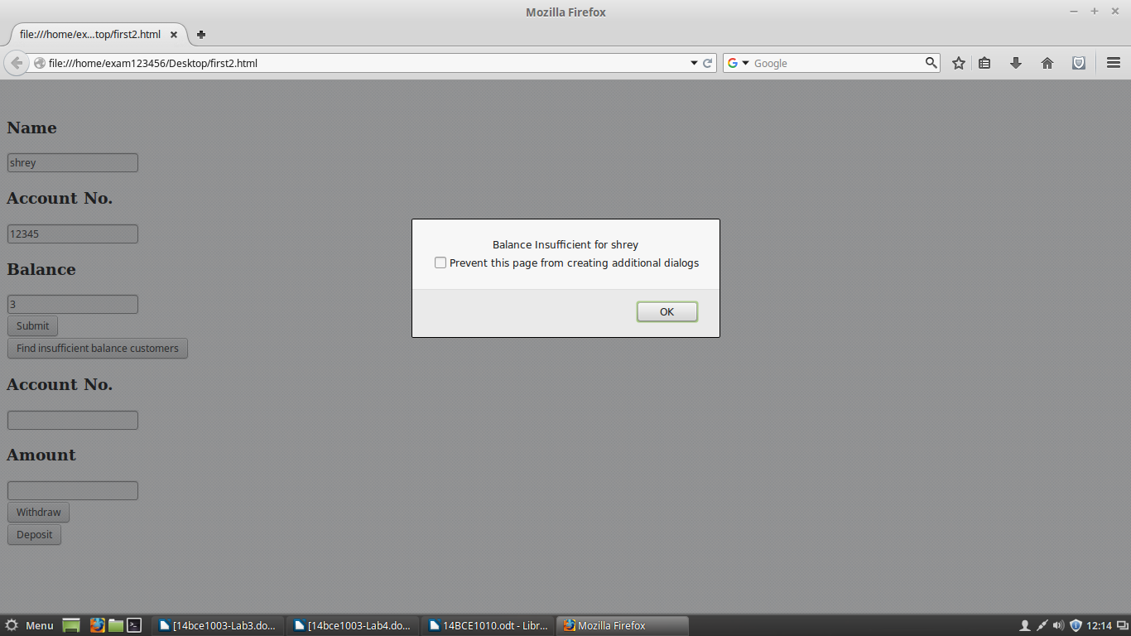

3)

<!Doctype html>
<head>
<script type="text/javascript">
var jsver = 1.0;
</script>
<script language="Javascript1.1">
jsver = 1.1;
</script>
<script language="Javascript1.2">
jsver = 1.2;
</script>
<script language="Javascript1.3">
jsver = 1.3;
</script>
<script language="Javascript1.4">
jsver = 1.4;
</script>
<script language="Javascript1.5">
jsver = 1.5;
</script>
<script language="Javascript1.6">
jsver = 1.6;
</script>
<script language="Javascript1.7">
jsver = 1.7;
</script>
<script language="Javascript1.8">
jsver = 1.8;
</script>
<script language="Javascript1.9">
jsver = 1.9;
</script>
<script>
function myFunction()
{
document.getElementById("demo").innerHTML = "Javascript Version is " + jsver;
}
</script>
</head>
<body>
<p id="demo" onclick="myFunction()">Click to find version</p>
</body>
</html>

