Nomadic Paws Blog Image Standards
A reusable specification for Trail Journal hero images, cards, and social previews
PRIMARY STANDARD • Generate the blog master image at 1600 × 900 pixels (16:9). If the generator cannot produce that exact size, use any true 16:9 output at least 1600 pixels wide. The website now preserves the complete image instead of forcing it into a mismatched crop.

1. Required sizes
Use | Pixels | Ratio | Requirement
Trail Journal hero / card master | 1600 × 900 | 16:9 | Preferred standard
Acceptable minimum | 1200 × 675 | 16:9 | Never smaller for a new hero
Current generator output | 1672 × 941 | ≈16:9 | Acceptable; no repair required
Social sharing export | 1200 × 630 | 1.91:1 | Create separately when possible

2. Safe-area rule
Keep every face, ear, logo, headline, leash connection, and other essential detail inside the central 80% of the canvas. On a 1600 × 900 image, that safe area runs from x=160 to 1440 and y=90 to 810.
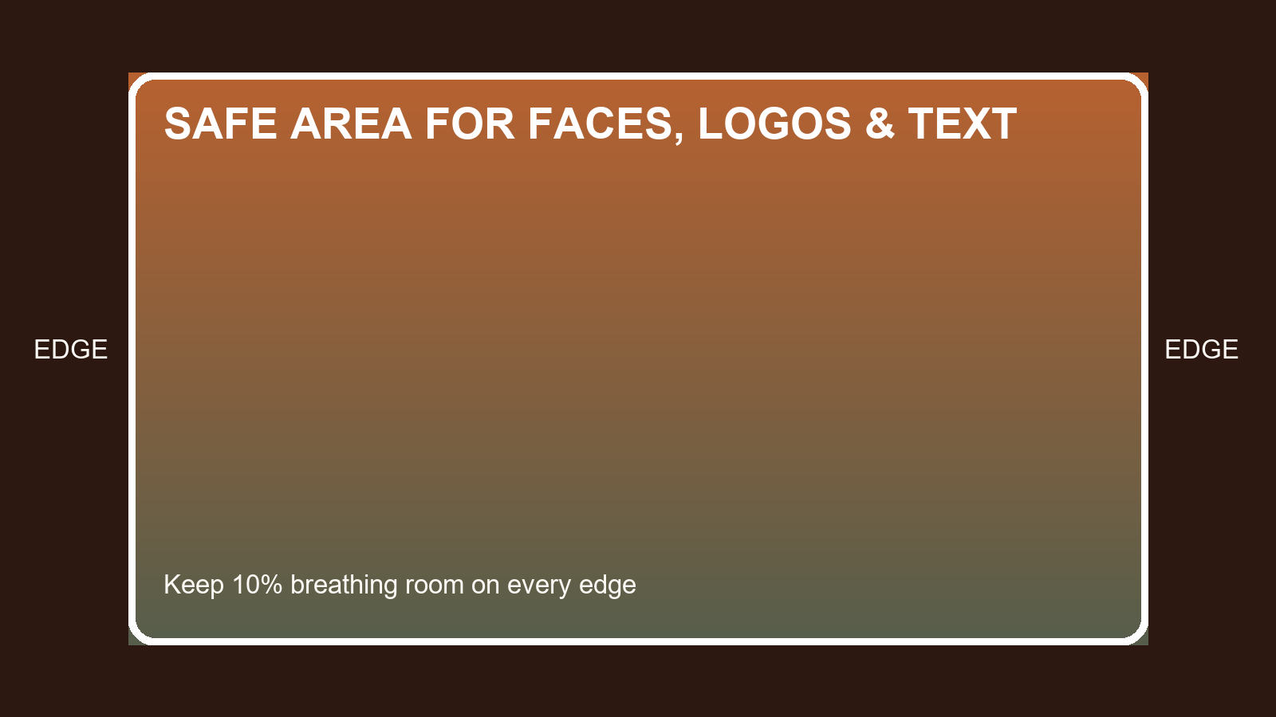
The outer 10% is breathing room. It may be softened by rounded corners or future responsive layouts.

3. Composition rules
Cheeto: Keep the full face and both ears comfortably inside the safe area. Do not let an ear, paw, tail, or harness connection touch the canvas edge.
Text: The website already displays the article title, so an image without embedded title text is the most flexible choice. If branded title text is included, keep all letters inside the safe area and spell the supplied title exactly.
Background: Use the desert or trail as context, not the main subject. Preserve separation between orange fur, product packaging, and warm backgrounds.
Corners: Do not place logos, faces, or small text in the corners. Avoid decorative frames closer than 60 pixels to the outer edge.
Format: Export as PNG for illustrated/title-card artwork or high-quality JPG for photography. Use sRGB color. Do not submit a square, portrait, collage, or screenshot as the hero master.

4. Copy-ready image-generator prompt
Create one horizontal Nomadic Paws Trail Journal hero image at exactly 1600 × 900 pixels (16:9). Keep all essential subjects, Cheeto’s complete face and ears, logos, and any readable text inside the central safe area: x=160–1440 and y=90–810. Leave at least 10% breathing room on every edge and do not place important details in the rounded corners. The image must remain clear at desktop and mobile card sizes. Cheeto is the focal subject; the desert or trail supports the story without overpowering him. Do not crop ears, paws, tail, harness connections, or products. Do not create a collage, portrait image, square image, fake UI, or extra unintended objects. If title text is included, use the exact supplied spelling, high contrast, and large simple lettering fully inside the safe area. Deliver a single finished 16:9 image in PNG or high-quality JPG.

5. Before uploading
- Confirm the image is 16:9 and at least 1200 pixels wide.
- Check that Cheeto’s ears, face, paws, and leash or harness details are not clipped.
- Read every word in embedded artwork and correct spelling before upload.
- Confirm there is no accidental AI anatomy, duplicated gear, or invented product branding.
- Add a useful cover-image description in the Trail Journal CMS.

6. Existing-image note
Older 3:2 photographs may remain 3:2. Their true aspect is recorded in the post metadata, and the website displays them without destructive cropping. All newly generated Trail Journal hero artwork should use 16:9 going forward.

