Guide to installing Insync
Insync is a piece of synchronisation software that is required for syncing data to and from Google Drive as there is no native linux application from Google. Insync also allows partial synchronisation so only folders of relevance need to be synchronised. This guide describes the process of setting up Insync on a NOMADS sequencing laptop. Text typed in bold represents a command line interface command i.e. should be entered in a terminal.

Installation
- Go to https://www.insynchq.com/downloads/linux and follow the installation instructions. Breifly:
  - Identify your ubuntu versio: lsb_release -a
  - Download the appropriate .deb package e.g. insync_3.9.10.60041-noble_amd64.deb
  - Install downloaded package: sudo dpkg -I insync_3.9.10.60041-noble_amd64.deb
- Select to add a Google Drive share and login using your credentials in the browser:
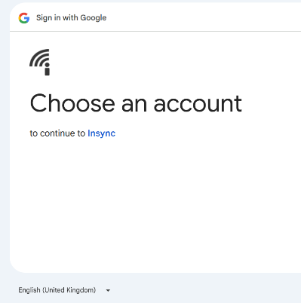
- Authorise access to your account for Insync and close the browser window
- Return to the Insync app window and click on Let’s go:
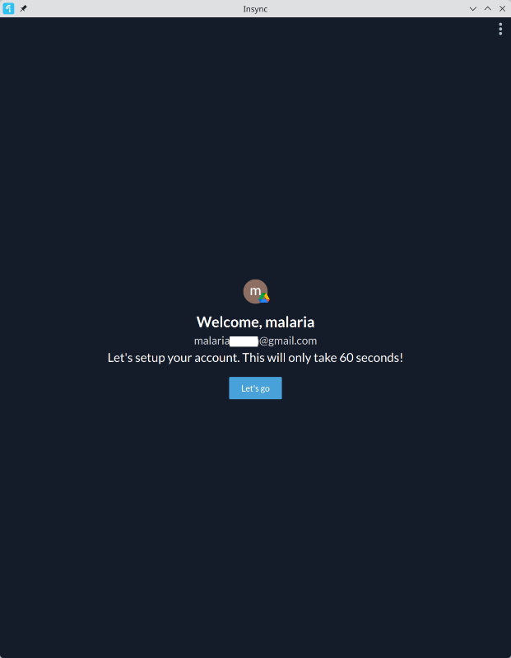
- Then click on the ‘I’ll do this later’ option at the bottom of the window
- Accept all the defaults and click on Finish
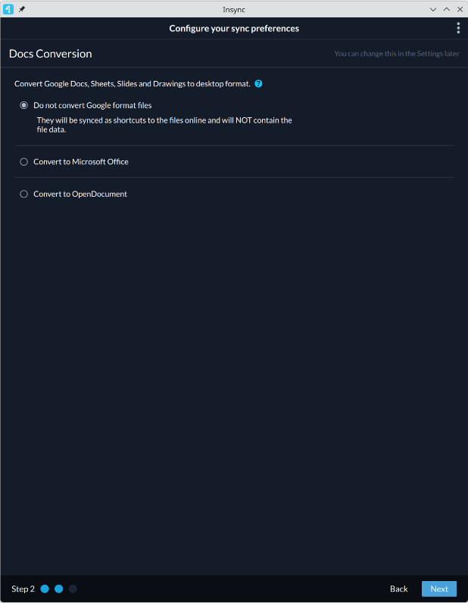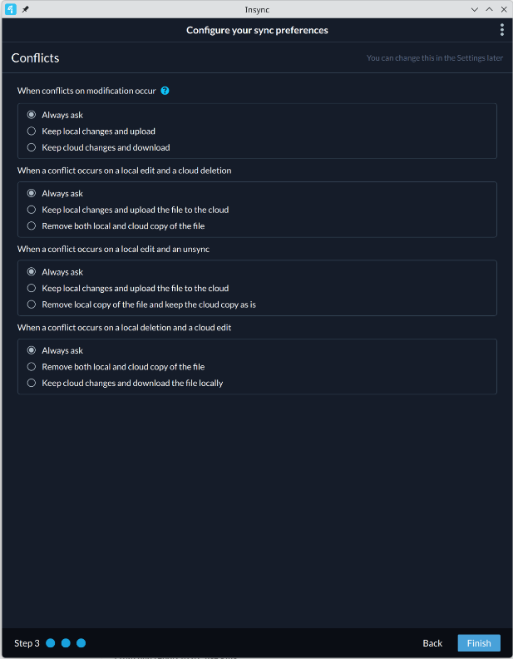

Set-up
The above steps installed insync and established a login to your google account. We now need to set up the specific files / folders to synchronise locally. This guide describes sharing data in a folder that has been shared by the nomads team to your google account.
- Create a shared_folder to house your synchronised data:
  - mkdir ~/shared_folder
- Open Insync window and click on the ‘Shared with me’ icon:
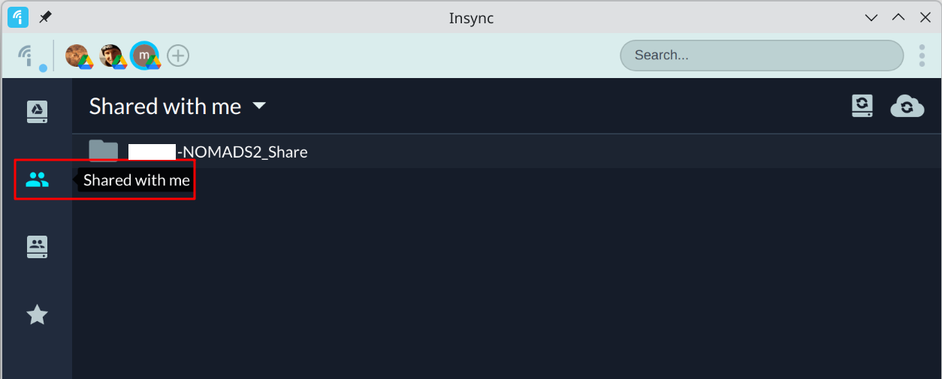
- Expand the shared folder with double clicks and drill down to the folder you want to synchronise and click on the 2-way sync icon
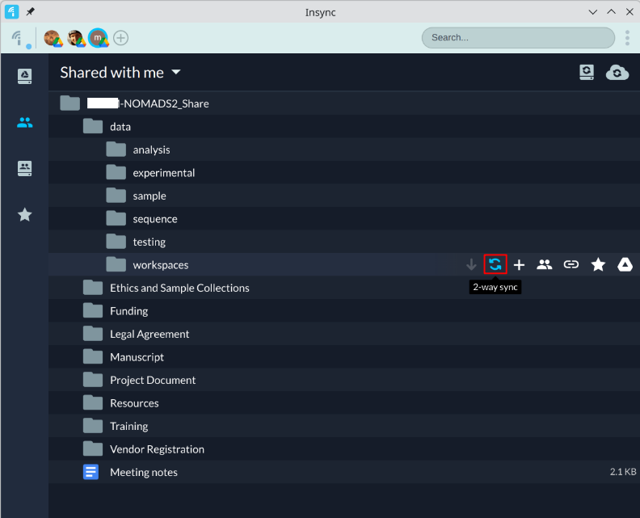
- Select the option to Merge:
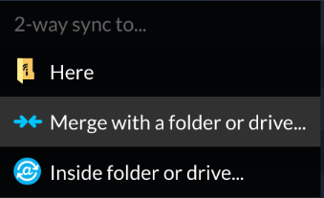
- Select the shared_drive you created in step 1. It may take some time for the data to synchronise , but once complete the icon will be 

