SELECT *

FROM

PortfolioProject..CovidDeaths$

ORDER BY 3,4

-----------------------------------

--TOTAL CASES vs TOTAL LIVES LOST

SELECT

location, date, total_cases, total_deaths, (total_cases/total_deaths)*100 AS percent_lost_lives

FROM

PortfolioProject..CovidDeaths$

WHERE

location like '%states%'

ORDER BY

1,2;

--------------------------------

SELECT

location, date, total_cases, total_deaths, (total_cases/total_deaths)*100 AS percent_lost_lives

FROM

PortfolioProject..CovidDeaths$

WHERE

location = 'Canada'

ORDER BY

1,2;

--------------------------

---TOTAL COVID CASES vs TOTAL POPULATION

SELECT

location, date, population, total_cases, (total_cases/population)*100 AS percent_population_infected

FROM

PortfolioProject..CovidDeaths$

WHERE

location = 'Canada'

ORDER BY

1,2;

-----COUNTRIES WITH HIGHEST COVID RATES vs TOTAL POPULATION

SELECT

location, population, MAX(total_cases) AS infection_count,

MAX(total_cases/population)*100 AS percent_population_infected

FROM

PortfolioProject..CovidDeaths$

GROUP BY

location, population

ORDER BY

percent_population_infected DESC;

-----COUNTRIES WITH HIGHEST LIVES LOSSES PER TOTAL POPULATION

SELECT

location, MAX(CAST(total_deaths AS int)) AS total_lives_lost

FROM

PortfolioProject..CovidDeaths$

GROUP BY

location

ORDER BY

total_lives_lost DESC;

---LIVES LOST BY CONTINENTS

SELECT

location, MAX(CAST(total_deaths AS int)) AS total_lives_lost

FROM

PortfolioProject..CovidDeaths$

WHERE

continent IS NULL

GROUP BY

location

ORDER BY

total_lives_lost DESC;

-----------------------------

--GLOBAL COVID NUMBERS

SELECT

date, SUM(new_cases)AS total_cases, SUM(CAST(new_deaths AS int)) AS total_lives_lost,

SUM(CAST(new_deaths AS int))/ SUM(new_cases)*100 AS percent_total_deaths

FROM

PortfolioProject..CovidDeaths$

WHERE

continent IS NOT NULL

GROUP BY

date

ORDER BY

1,2;

----------------------------

SELECT

SUM(new_cases)AS total_cases, SUM(CAST(new_deaths AS int)) AS total_lives_lost,

SUM(CAST(new_deaths AS int))/SUM(new_cases)*100 AS percent_total_deaths

FROM

PortfolioProject..CovidDeaths$

WHERE

continent IS NOT NULL

ORDER BY

1,2;

--------------TOTAL POPULATION vs TOTAL VACCINATION

SELECT

dea.continent,

dea.location,

dea.date,

dea.population,

vac.new_vaccinations,

SUM(CONVERT(bigint, vac.new_vaccinations)) OVER (PARTITION BY dea.location ORDER BY dea.location, dea.date) AS rolling_num_vac_people

FROM

PortfolioProject..CovidDeaths$ dea

JOIN

PortfolioProject..CovidVaccinations$ vac

ON

dea.location = vac.location

AND

dea.date = vac.date

WHERE

dea.continent IS NOT NULL

ORDER BY

2,3;

----------------------------------

--USING COMMON TABLE EXPRESSION(CTE)

With PopvsVac (continent, location, date, population, new_vaccinations, rolling_num_vac_people)

AS

(

SELECT

dea.continent,

dea.location,

dea.date,

dea.population,

vac.new_vaccinations,

SUM(CONVERT(bigint, vac.new_vaccinations)) OVER (PARTITION BY dea.location ORDER BY dea.location, dea.date) AS rolling_num_vac_people

FROM

PortfolioProject..CovidDeaths$ dea

JOIN PortfolioProject..CovidVaccinations$ vac

ON dea.location = vac.location

AND dea.date = vac.date

WHERE

dea.continent IS NOT NULL

)

---------------

SELECT *, (rolling_num_vac_people/population)*100

FROM PopvsVac;

-----TEMPORARY TABLE---

CREATE TABLE #percentofvacpeople

(continent nvarchar (255),

location nvarchar (255),

date datetime,

population numeric,

new_vaccinations numeric,

rolling_num_vac_people numeric

)

INSERT INTO #percentofvacpeople

SELECT

dea.continent,

dea.location,

dea.date,

dea.population,

vac.new_vaccinations,

SUM(CONVERT(bigint, vac.new_vaccinations)) OVER (PARTITION BY dea.location ORDER BY dea.location, dea.date) AS rolling_num_vac_people

FROM

PortfolioProject..CovidDeaths$ dea

JOIN PortfolioProject..CovidVaccinations$ vac

ON dea.location = vac.location

AND dea.date = vac.date

SELECT *, (rolling_num_vac_people/population)*100

FROM #percentofvacpeople;

--------------------------

DROP TABLE IF EXISTS #percentofvacpeople

CREATE TABLE #percentofvacpeople

(continent nvarchar (255),

location nvarchar (255),

date datetime,

population numeric,

new_vaccinations numeric,

rolling_num_vac_people numeric

)

INSERT INTO #percentofvacpeople

SELECT

dea.continent,

dea.location,

dea.date,

dea.population,

vac.new_vaccinations,

SUM(CONVERT(bigint, vac.new_vaccinations)) OVER (PARTITION BY dea.location ORDER BY dea.location, dea.date) AS rolling_num_vac_people

FROM

PortfolioProject..CovidDeaths$ dea

JOIN PortfolioProject..CovidVaccinations$ vac

ON dea.location = vac.location

AND dea.date = vac.date

SELECT *, (rolling_num_vac_people/population)*100

FROM #percentofvacpeople;

----CREATING VIEW

CREATE VIEW percentofvacpeople AS

SELECT

dea.continent,

dea.location,

dea.date,

dea.population,

vac.new_vaccinations,

SUM(CONVERT(bigint, vac.new_vaccinations)) OVER (PARTITION BY dea.location ORDER BY dea.location, dea.date) AS rolling_num_vac_people

FROM

PortfolioProject..CovidDeaths$ dea

JOIN PortfolioProject..CovidVaccinations$ vac

ON dea.location = vac.location

AND dea.date = vac.date

WHERE

dea.continent IS NOT NULL

--------------------

SELECT *

FROM

percentofvacpeople;

JOIN TABLES

SELECT

    employees.name AS employee_name,

    employees.role AS employee_role,

    departments.name AS department_name

FROM

    employee_data.employees

FULL OUTER JOIN

    employee_data.departments

ON

    employees.department_id = departments.department_id

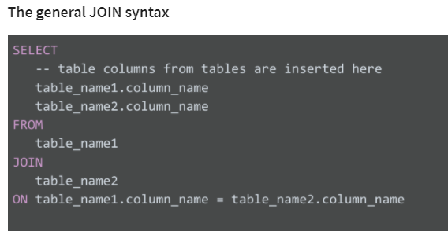

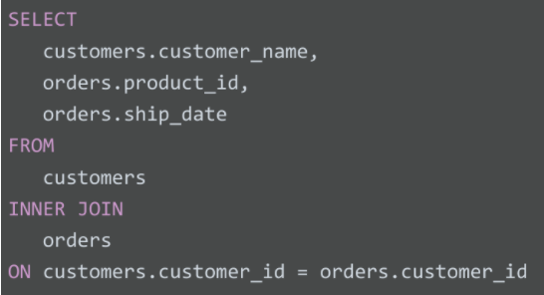

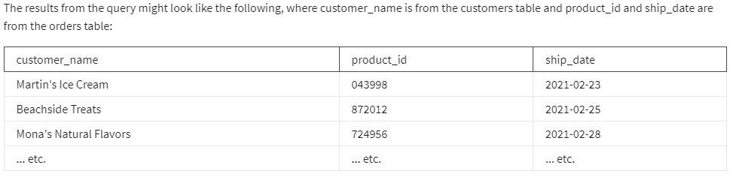

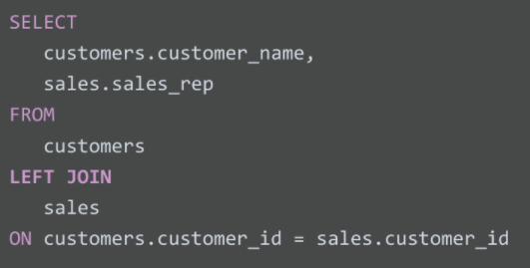

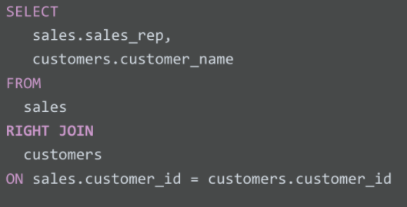

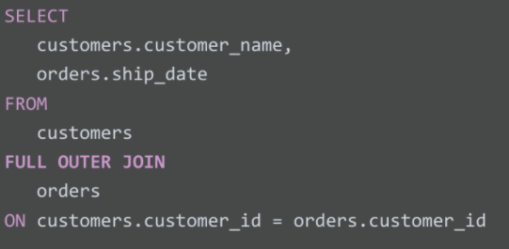

-- Let's say table_1 has 100 rows and table_2 has 10 rows.

-- They share 10 keys in common.

-- Using INNER JOIN --> We get 10 rows in our results.

SELECT

    COUNT(*)

FROM

    table_1

INNER JOIN

    table_2

ON table_1.key = table_2.key;

-- Using LEFT JOIN --> We get 100 rows in our results.

SELECT

    COUNT(*)

FROM

    table_1

LEFT JOIN

    table_2

ON table_1.key = table_2.key;

SQL QUERIES AND SUBQUERIES

NUMBER OF BIKES AVAILABLE AT A STATION TO THE AVERAGE NUMBER OF BIKES AVAILABLE

SELECT

    station_id,

    num_bikes_available,

    (SELECT

     AVG(num_bikes_available)

    FROM bigquery-public-data.new_york_citibike.citibike_stations) AS avg_num_bikes_available

FROM bigquery-public-data.new_york_citibike.citibike_stations

NUMBER OF RIDES THAT HAVE STARTED AT EACH STATION OVER TIME

SELECT

    station_id,

    name,

    number_of_rides AS num_of_rides_starting_at_station

FROM

    (

        SELECT

            start_station_id,

            COUNT(*) number_of_rides

        FROM

            bigquery-public-data.new_york_citibike.citibike_trips

        GROUP BY

            start_station_id

    )

    AS station_num_trips

    INNER JOIN

    bigquery-public-data.new_york_citibike.citibike_stations ON station_id = start_station_id

    ORDER BY

        number_of_rides DESC

LIST OF STATIONS THAT BIKESHARE SUBSCRIBERS USE BIKES

SELECT

    station_id,

    name

FROM

    bigquery-public-data.new_york_citibike.citibike_stations

WHERE

    station_id IN

    (

        SELECT

            start_station_id

        FROM

            bigquery-public-data.new_york_citibike.citibike_trips

        WHERE

            usertype =

        'Subscriber'

    )