Boot process in Linux

BIOS (basic input output system)
Perform POST (perform on self-test) which checks all the hardware RAM, CPU, working properly or in place or not (Detect devices). Search, load bootloader program in disk drive.
- load MBR

MBR (master boot record)
MBR located in the first 512 byte on bootable disk means primary partition, /dev/sda.
MBR job is to discover bootable devices.
- load GRUB2 boot loader into memory and gives control to grub.

GRUB2 (grand unified bootloader) /boot/grub2/grub.cfg
Grub2 search kernel image from boot dir and load vmlinuz kernel image and load initramfs file.
initramfs job is provide initial filesystem and load necessarily needed to boot the OS.
- grub2-mkconfig -o /boot/grub2/grub.cfg (regenerate grub config file after changes)

KERNEL
Start the "systemd" first process with PID of 1.

SYSTEMD
Systemd Job is to start all the necessary process daemons and service required to make OS work. Eg setting hostnames, initialize network, mountfs, initialize selinux, clean up /var, print motd. It read configuration from /etc/systemd.
Load default target file from /etc/systemd/system/default.target and bring the system to the state defined in system target.

https://www.youtube.com/watch?v=8fWWVHJ9Px4&list=PLKqyiDdtB8i5kk1uzG7q5Qm7INPAPy31E&index=14
BOOT Target
single user mode:(Maintenance mode / Rescue mode) for troubleshooting and administration tasks, to perform critical tasks like machine is not booting, break root password.
Multi-user mode: support everything but no graphic
- systemctl list-units --type=target (show you the active targets)
- systemctl list-units --type=target --all (show all targets)
- systemctl get-default (show currently running target)
- systemctl set-default "target-name" (set default target)
- systemctl isolate graphical. target (change boot target temporarily)
https://www.youtube.com/watch?v=8fWWVHJ9Px4&list=PLKqyiDdtB8i5kk1uzG7q5Qm7INPAPy31E&index=14
RUNLEVEL
Run levels are 7 in total from 0 to 6 RHEL 6 https://ostechnix.com/check-runlevel-linux/
- who -r (show you running runlevel)
- echo runlevel
- echo $PRELEVEL (tell you the previous runlevel)
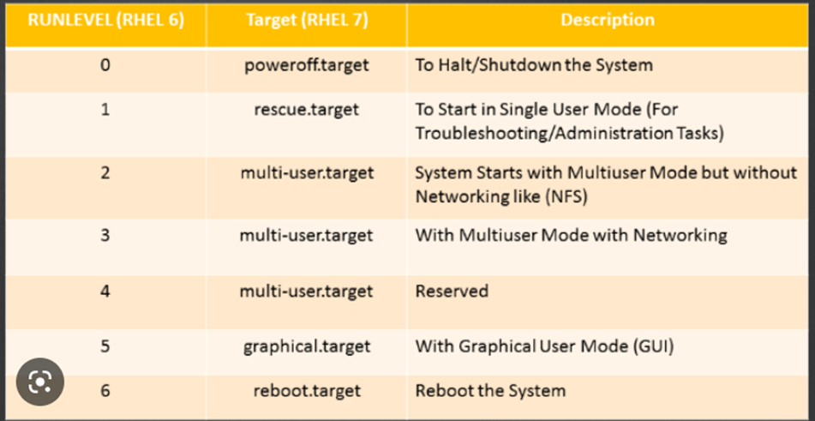
How to change the run level?
Edit the file “/etc/inittab” and change initdefault entry (id:5:initdefault:).

11. Init Levels? What is the main config file? Default init level? What are the RC scripts?
- Init 0-6 /etc/rc.d rc0-6
- /etc/inittab will tell us the default level
- Who -r
- RC scripts are run levels scripts Init executes the RC scripts.
133. Talk to me when the machines go through reboot and comes back (boot process)
- Bios > performs hardware integrity check and loads and execute MBR boot loader.
- MBR> loads and execute Grub boot loader.
- GRUB > loads and execute kernel and initrd image
- Kernel > execute the first process init or systemd
- Init > execute the default init level (run control) RC script.
- Run level > executes the programs associated with the default run level.
134. Boot process difference in RHEL 6 and RHEL 7
Last two parts are different init and run level on rhel 6 while it’s systemd and target on rhel 7.
Rhel 6:
- Init /etc/rc.d which has all run levels and respective scripts
- Default run level is /etc/inittab
- /etc/init.d has all the services installed on the system.
Rhel 7:
- target resides /etc/systemd/system/defaut.target
- All targets and all installed services are under /usr/lib/systemd/system
166. Run levels and how to change it on running system.
0 to 6. Change it on a running system by running cli command init <runlevel> or edit the configuration file. /etc/inittab on rhel 6, but on rhel 7 use systemctl set-default <desired.target>

