Directory Structure

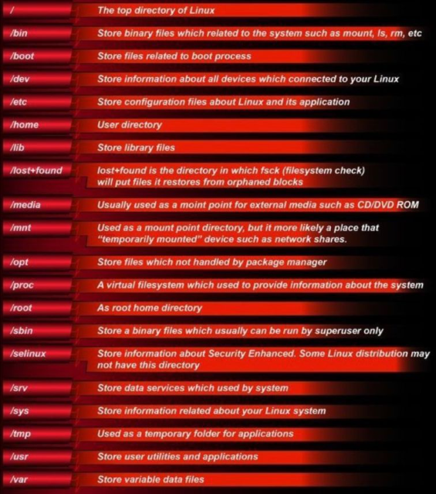

/bin store binary files. All the user commands are store in bin dir. It contains the files of your complete command so when you run command these binary files works.
/sbin system level binaries, commands used by root user. Like boot related commands
/boot all the booting files related to boot process.
/dev store information about all devices connected to your Linux. hard disk, USB printer etc
/etc have all the configuration files.
/home contains the home directory of the user.
/lib contain all the libraries files.
/proc virtual fs. Provide information about process that are currently running and system. 0 size
/var store variable files. The data which change. For example assign a ip address in DCHP way.
https://www.youtube.com/watch?v=W9bC-v3DHHE&t=14s

