Docker

What is a docker?
Docker is a package which provides a platform to run applications with isolated environment with its dependencies.
/var/lib/docker (default data directory)
What are docker images?
A docker image is a template file that contains a set of instructions for creating a container.
What is container?
Container is system level virtualization so that software or app can run in isolated environment.

Difference between VM and Container
Container VM
- Lightweight (takes seconds) heavyweight (take min to boot up)
- OS level virtualization hardware level virtualization
- Less secure more secure
- fast provisioning slow provisioning
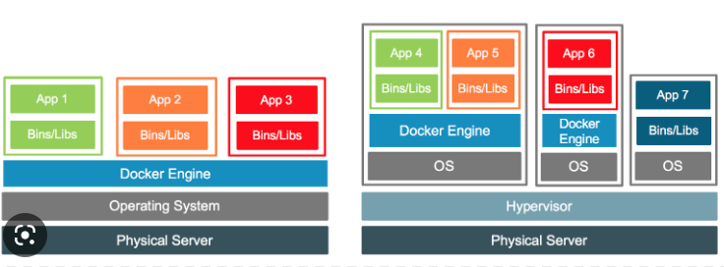

Commands
- yum -y install docker
- systemctl enable docker --now
- docker pull httpd
- docker run -dit --name web-server -p 80:80 httpd (run a container and open container port and also server port outbound)
- docker run -dit --name web-name --volume='/tmp/dc:/usr/local/apache2/htdocs --restart always -p 80:80 httpd
- docker exec -it container-name sh (go in the container)
- docker system prune -a (delete everything)
- docker rm -f (stop the container before removing)
- docker run -dit --name my-db -p 3306:3306 -v /var/db --restart always -e MYSQL_ROOT_PASSWORD=123 mysql
- docker exec -it my-db -uroot -p123
- docker search --filter=stars=4 httpd

FLAGS:
-volume mapping the files from local server to the container
-p server port: container port mapping
-dit detach interactive terminal (container running in the background)
347. Difference between Docker Image and Docker Container
Docker image is the template that contains everything the application needs to run.
Container: once the image gets pulled from the registry and gets run, it becomes a container.

