GIT
What is github? Why do we need it? Difference btw git and github?
GitHub is a code hosting platform for version control and collaboration.
GitHub is a website for developers and programmers to collaboratively work on code. It let people work together on projects from anywhere.
git is package name and github is a repository where u save your codes, it’s a site.

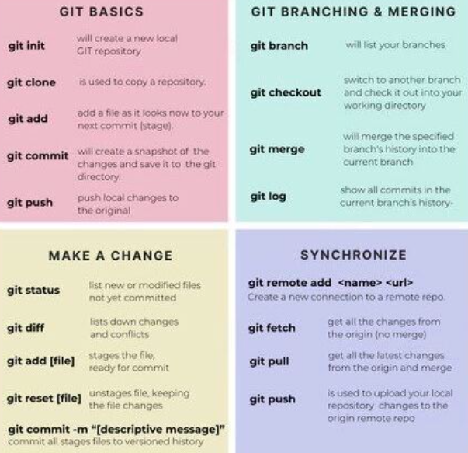
- git clone (to download your project to your command line)
- git pull (pull the code and file to the server, pull changes)
- git add filename (to add a file or stage a file)
- git status (to check the status of files you added)
- git commit 'filename' -m "add-comment"
- git push origin main (push the modified file to git main branch)
- git checkout (checkout from the branch)
Hands On
Add a project to Local server!
- First step copy ssh public key in github, id_rsa.pub of your local server
- Go to browser, go to setting then go to SSH tab in github and paste the SSH key of server.
- create a repositry in github name /first-project.
- yum -y install git
- git --version
- mkdir /git
- copy ssh code from github project and paste after remote add origin
- git remote add origin git@github.com:noman-ghumman/projectgit.git
- git remote -v (to confirm if it’s successful or not)
- git clone git@github.com:noman-ghumman/projectgit.git
- cd /git/project-git
- touch /git/project-git/file1
- git init (initialize a local repositry)
- git add file1 (add the file)
- git status (check the status)
- git commit -m "added" (-m additional message or comment)
- git log (see log of git)
- git push origin master (master is branch name)
- git config --global user.email "noman194@gmail.com"
- git config --global user.name "noman-ghuman"
https://www.youtube.com/watch?v=VQo9dWhVqf0
258. Did you use git repository? Tell how did you use it for?
Yes, we use git repository to push playbooks to the git repository. It’s also connected to the ansible tower to be applied in my projects.
Git Stash
Git stash can be used in cases where we need to switch in between branches and at the same time not wanting to lose edits in the current branch.
git stash apply command is used for bringing the works back to the working directory from the stack where the changes were stashed using git stash command

