Kernel
What is a kernel?
The kernel is the core component of OS which has complete control over everything in a system. It’s an abstract layer between software and hardware. It acts as a bridge between SW and HW. If Software requests the hardware, then the kernel delivers the data btw SW and HW.
What is kernel panic?
When the kernel can’t load itself into memory. It is called kernel panic.
A Linux kernel panic is a system boot issue that occurs when the kernel can't load properly in memory, preventing the system from booting. black screen filled with code.
During a normal boot process, the kernel (vmlinuz) doesn't load directly. Instead, the initramfs file loads in the RAM. The file then points to the kernel which then results in OS booting. However, if the initramfs file is corrupted or deleted, it results in kernel panic.
Such errors can occur due to recent OS updates or patches.
- Dracut (utility to fix kernel panic)
How to reboot in an older kernel version
- yum update kernel
- vim /etc/default/grub
- GRUB_DEFAULT=0 (0 means set to latest)
- GRUB_DEFAULT=1 (change it into older index number)
- grub2-mkconfig -o /boot/grub2/grub.cfg (Regenerate and then reboot)
What is a kernel module?
Kernel module are pieces of code which can be loaded (add) and unloaded(removed) into kernel as per demand or need. They extend the functionality of a kernel without the need to reboot the system.
- extension of kernel module is .ko
- by default, installed in /lib/modules/<kernel version> (location of kernel modules)
- Lsmod (to list the kernel module)
- modprobe lp (install the lp printer module)
- modinfo
- rmmod lp (to delete a module)

What is a kernel Parameter?
Kernel parameters are used to customize the behavior of the OS at boot time.
Kernel parameters are tunable values which you can adjust while the system is running. There is no requirement to reboot the kernel for changes to take effect.
Change Kernel parameter on runtime?
- sysctl -a (to see all kernel parameters values)
- vim /etc/sysctl.conf (to change the parameter value)
- vm.swappiness = 10
- kernel.thread-max = 14444
- sysctl -p (to make boot persistent)
- sudo echo 10 > /proc/sys/vm/swappiness (using echo 2nd way)
How to add and change the Kernel parameters?
First edit the file ‘/etc/sysctl.conf’ after making the changes save the file and run the command ‘sysctl -p’, this command will make the changes permanently without rebooting the machine.
Change Kernel parameter on boot?
- Press e when you see the grub menu.
- Find line “linux” or “linuxefi” and find the kernel parameter. Modify and then Ctrl + X.
Vm. Swappiness
is a process in which the operating system moves inactive pages of memory from RAM to disk storage to free up memory for other processes.
Kernel parameters are used to control the tendency of the system to use swap space. The value ranges from 0 to 100, where higher values mean the kernel is more inclined to use swap space.
KDUMP (kernel Dump) kexec-tools (package name)
kdump investigates the system crash to see what causes the machine to not be working.
Kdump provides a memory dump into a file named Vmcore when the kernel has a critical issue. Vmcore is often required to investigate the issue. Vmcore is a snapshot of system memory at the time of system crash enables further investigation to identify the cause of failure.
https://www.linuxtechi.com/how-to-enable-kdump-on-rhel-7-and-centos-7/
Dmesg (diagnostic message) The dmesg is used to display kernel-related messages retrieved from the kernel ring buffer.
These messages provide information about the hardware, software, and system processes, including errors, warnings, and informational messages generated by the kernel during system startup and operation.
Kernel Panic fix (boot failed)
Recovery or rebuild of damaged initramfs boot image
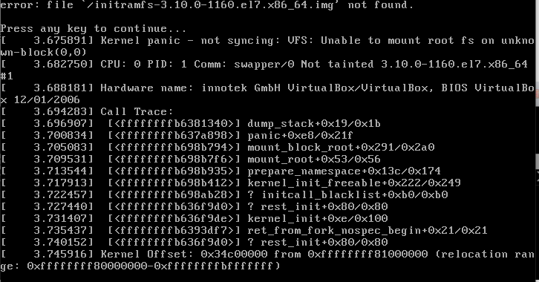

- When you see the screen above, it’s a Linux kernel panic screen.

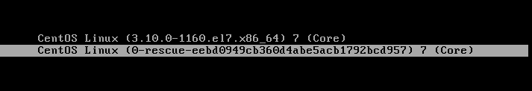

- go to vCenter and reset the host and boot into the Rescue kernel image.

- execute the below command to rebuild the new initramfs image associated with the current kernel version.

- dracut -f /boot/initramfs-3.10.0-693.el7.x86_64.img $(uname -r)

- reboot the system into the normal kernel image.
https://www.cjcheema.com/2019/06/how-to-recover-or-rebuild-initramfs-in-centos-7-linux/
https://www.redhat.com/sysadmin/linux-kernel-panic
Boot Failed

- system is not up, first step is go to console ESXI
- then go to single user mode / emergency mode.

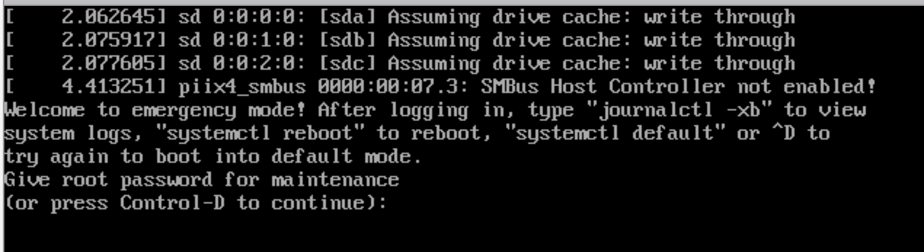

Whenever you see the above screen and you don’t have root password to get into the server.
- Go to vCenter and reset the host.

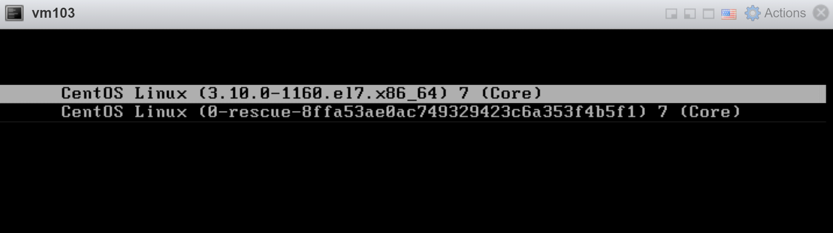

- When you above screen press “e”

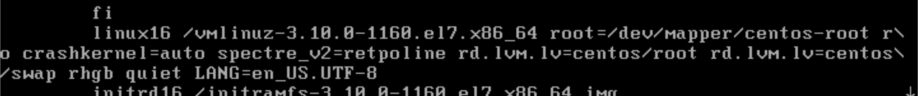

- At the end of the line linux16 after UTF-8 write “init=/bin/bash” and press “ctrl+x”

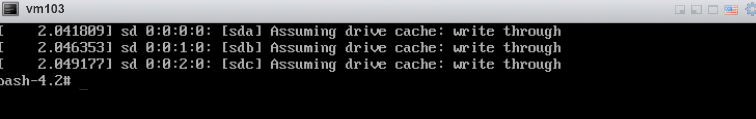

- When you see above screen write “mount -o remount,rw /” and hit Enter.

Option 1
- Passwd root
- Change a password
- Sudo su –
- Cat /var/log/boot.log | grep -I failed
- Fix the error (mostly last 3 entries in fstab create a problem comment them, NFS entry)
- Exit from root
- exec /sbin/init
Option 2
- touch /fastboot (ignore the errors and bring your server up)
- exec /sbin/init (to reboot in a single user mode/emergency mode)

How to Break a Root Password

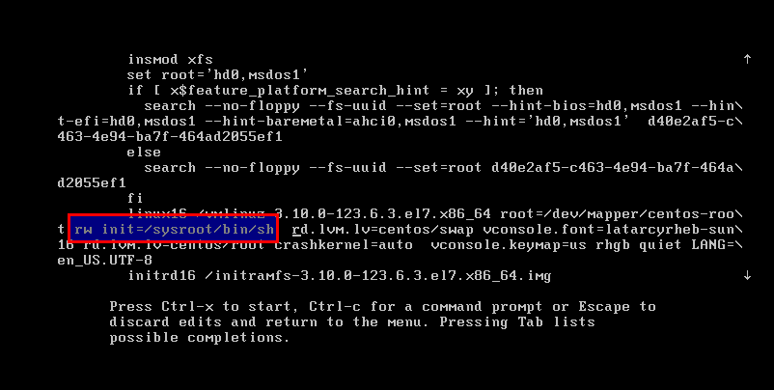
- At the end of the line linux16 console=tty1 rd.break (press ctrl x)-----(old way)

Go to the line of Linux 16 and change ro with rw init=/sysroot/bin/sh And press ctrl+x

- mount -o remount,rw /sysroot (mount hard disk to read write mode)
- chroot /sysroot (move to sysroot)
- passwd
- touch /.autorelabel (need relabeling cause of selinux create a file in root/)
- exit
- reboot
How to go to single user mode
- Reboot and go to the grub prompt
- Go to the end of line which starts with ‘linux16’ and type ‘rd.break’ and hit enter.
- Mount the root file system in rw mode and then do chroot /sysroot.

GRUB PASSWORD

How to secure grub?

- grub2-mkpasswd-pbkdf2 (set the grub password)

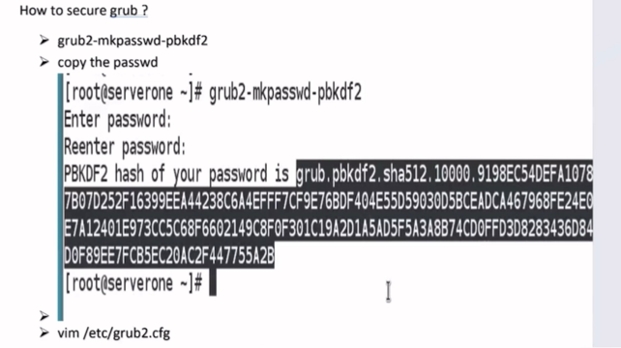

It will generate a hash, copy the hash after from password is
- vim /etc/grub2.cfg
Search for line or block /etc/grub.d/10_linux, the under this block make the entry
- set superusers="NAME-ROOT"
- export superusers
- password_pbkdf2 NAME-ROOT paste-hash
- :wq
Reboot

