OSI vs TCP/IP model

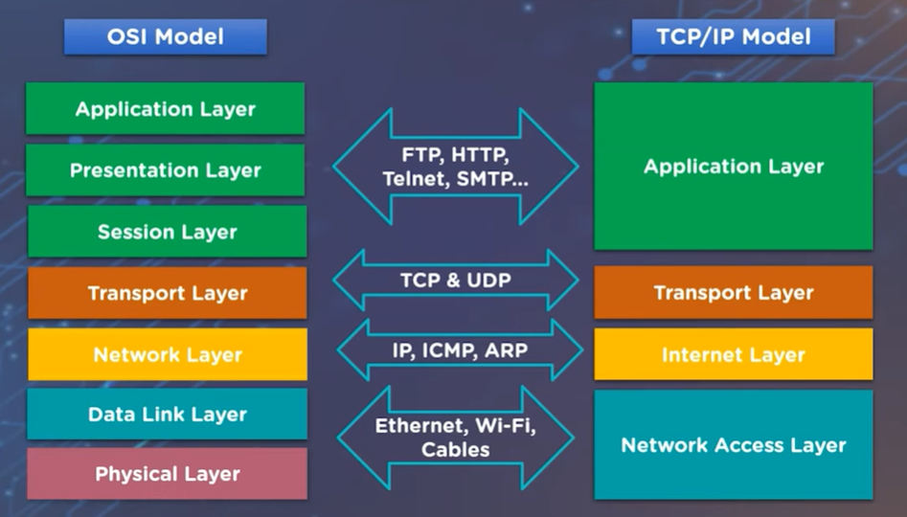

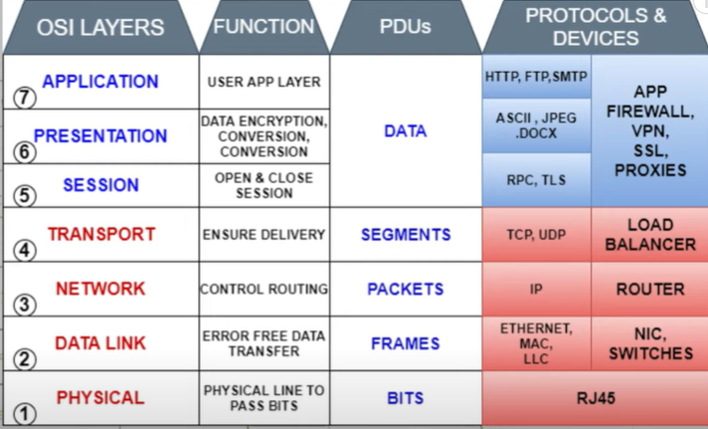

OSI Model:
Application layer: this is a layer where most users interact and communicate with computers. This is the data that users interact with like email, web browser. HTTP,SMTP,DNS,SSH,DTP.
Presentation layer: Responsible for data compresses, data encrypted, data formatting that more understandable and receiving computer can understand. ASSCII JPG etc
Session layer: Open and Establish and end the session btw sender and the receiver. It is also responsible for authentication and reconnection if a network interruption should occur.
Transport layer: Data sent in segments.it ensures that data arrives safely without any error. Data is not damaged when it arrives. TCP/UDP
Network layer Forward traffic with logical address. Data divided into packets and forward with the address on. Find the best route to get its destination. Eg IPV4, Routing
Data link layer: Packages data/bits into frames and transmits those frames to network. Error detection and correction, flow control, uniquely identify network device with MAC address. Eg Switch, Bridges, NIC
Physical layer: This layer is responsible for the actual delivery of data. Transmission of bits across networks. Cable and wires that carry the data from one computer to another. Eg Cables, Wi-Fi.

TCP/IP model:
- The TCP protocol breaks data into packets.
- The packets travel from router to router over the internet according to the IP Protocol.
- The TCP protocol reassembles the packets into the original whole and sends acknowledgements back to sender to confirm packets were received.
TCP handles assembling data into packets and reliable delivery. IP handles addressing and routing the packets. Together they enable communication over interconnected networks.

